TECHNICAL SPECIFICATIONS NON-FOOD items

LOT 1

Blanket 140x200 cm
LOT 1.1 | Denomination and norms | Required minimum values
LOT 1.1 | Material | Minimum 30% wool virgin material. Up to 70% other virgin fibers (e.g. Cotton or cotton/synthetic mix).
LOT 1.1 | Make | Woven, dry raised on both sides
LOT 1.1 | Dimensions / Size | 140 x 200 cm +3% / -1%. To be taken on flat stabilized sample, without folds.
LOT 1.1 | Weight | Min 500 g/m2 Weight determined by total weight/total surface.
LOT 1.1 | Thickness, ISO 5084 | 5 mm minimum
LOT 1.1 | Thermal resistance, ISO 5085-1 | TOG 2.5 (or 0.25mÂ².K/W) minimum, rounded to the nearest 0.1
LOT 1.1 | Finish | Whipped seam at 10 mm from the edge with 10 to 13 stitches/10 cm or stitched ribbon or hemmed on 4 sides.
LOT 1.1 | Organoleptic test | No bad smell, not irritating to the skin, no dust
LOT 1.1 |  | Free from harmful VOC (Volatile Organic Components).
LOT 1.1 |  | Fit for human use.
LOT 1.1 | Colors | Other than black, red, or white, dark uniform color (i.e. dark blue, grey or brown).
LOT 1.1 | Branding | UNHCR visibility logo should be stitched as a label or inserted / printed / heat embossed on the blanket, placing the (long lasting) logo on the center of the blanket or in one corner. The size of the logo on the center of the blanket should be 40 cm wide and 48.88 cm high, and 20 cm wide and 24.44 cm high when placing the logo on a corner of the blanket.  The color of the logo should be white or blue, contrasting with the background of the blanket.  Typeface (Font), Colour specifications for printing:  Font: Helvetica Bold.  Colour specification: Pantone Blue 300 or quadrichrome (CMYK). C = 100%, M = 45%, Y = 0%, K = 0%  Example:  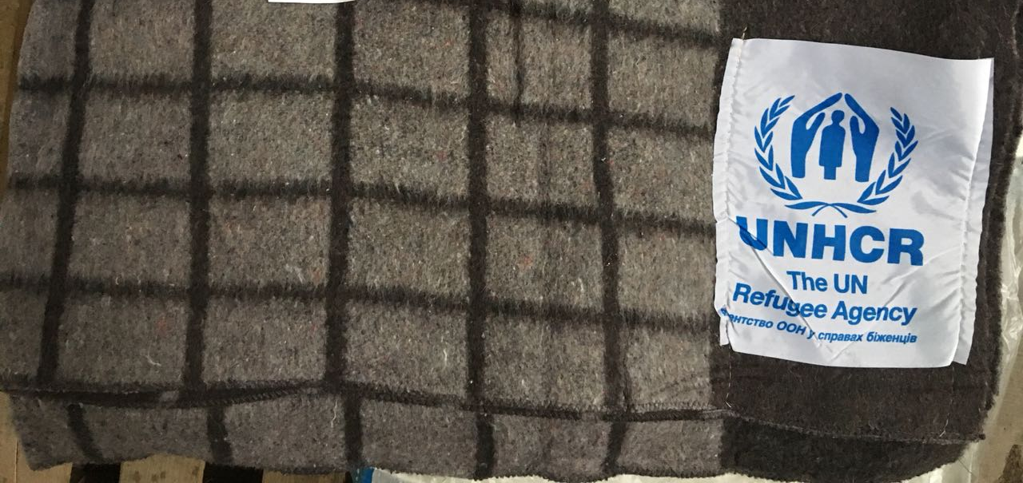

Bed linen set
LOT 1.2 | Denomination and norms | Required minimum values
LOT 1.2 | Material | Minimum 50% cotton. Up to 50% other fibers.
LOT 1.2 | Composition/Dimensions / Size | Sheets 145 x 210 cm +3% / -1%. X2  Pillow case 70 x 70 cm x1
LOT 1.2 | Finish | Sheets hemmed on 4 sides.
LOT 1.2 | Organoleptic test | No bad smell, not irritating to the skin, no dust
LOT 1.2 | Organoleptic test | Free from harmful VOC (Volatile Organic Components).
LOT 1.2 | Organoleptic test | Fit for human use.
LOT 1.2 | Colors | Any

Towel set
LOT 1.3 | Denomination and norms | Required minimum values
LOT 1.3 | Material | Minimum 50% cotton. Up to 50% other fibers.
LOT 1.3 | Composition/Dimensions / Size | Towel 70 x 140 cm +3% / -1%. X1  Towel 50 x 90 cm +3% / -1%. X1
LOT 1.3 | Weight | Min 400 g/m2 Weight determined by total weight/total surface.
LOT 1.3 | Organoleptic test | No bad smell, not irritating to the skin, no dust
LOT 1.3 | Organoleptic test | Free from harmful VOC (Volatile Organic Components).
LOT 1.3 | Organoleptic test | Fit for human use.
LOT 1.3 | Colors | Any

LOT 2

Plastic bag
LOT 2 | Denomination and norms | Required minimum values
LOT 2 | Material for bag | Polypropylene
LOT 2 | Material for handle | Belt braid textile, 250 microns (double 2 x 125 microns)
LOT 2 | Model | Rectangular bag, zip, side pockets availability
LOT 2 | Dimensions / Size | Width 60cm * Height 50cm * Depth 40cm
LOT 2 | Colors | Color of the bag - white, color of the handle - blue
LOT 2 | Branding | The friend of the logo is 1 + 1 (on both sides). The logo must be inserted / printed / hot-stamped in accordance with the above scheme.  Typeface (Font), Color specifications for printing:  Font: Helvetica Bold.  Color specification: Pantone Blue 300 or quadrichrome (CMYK). C = 100%, M = 45%, Y = 0%, K = 0%  Example:  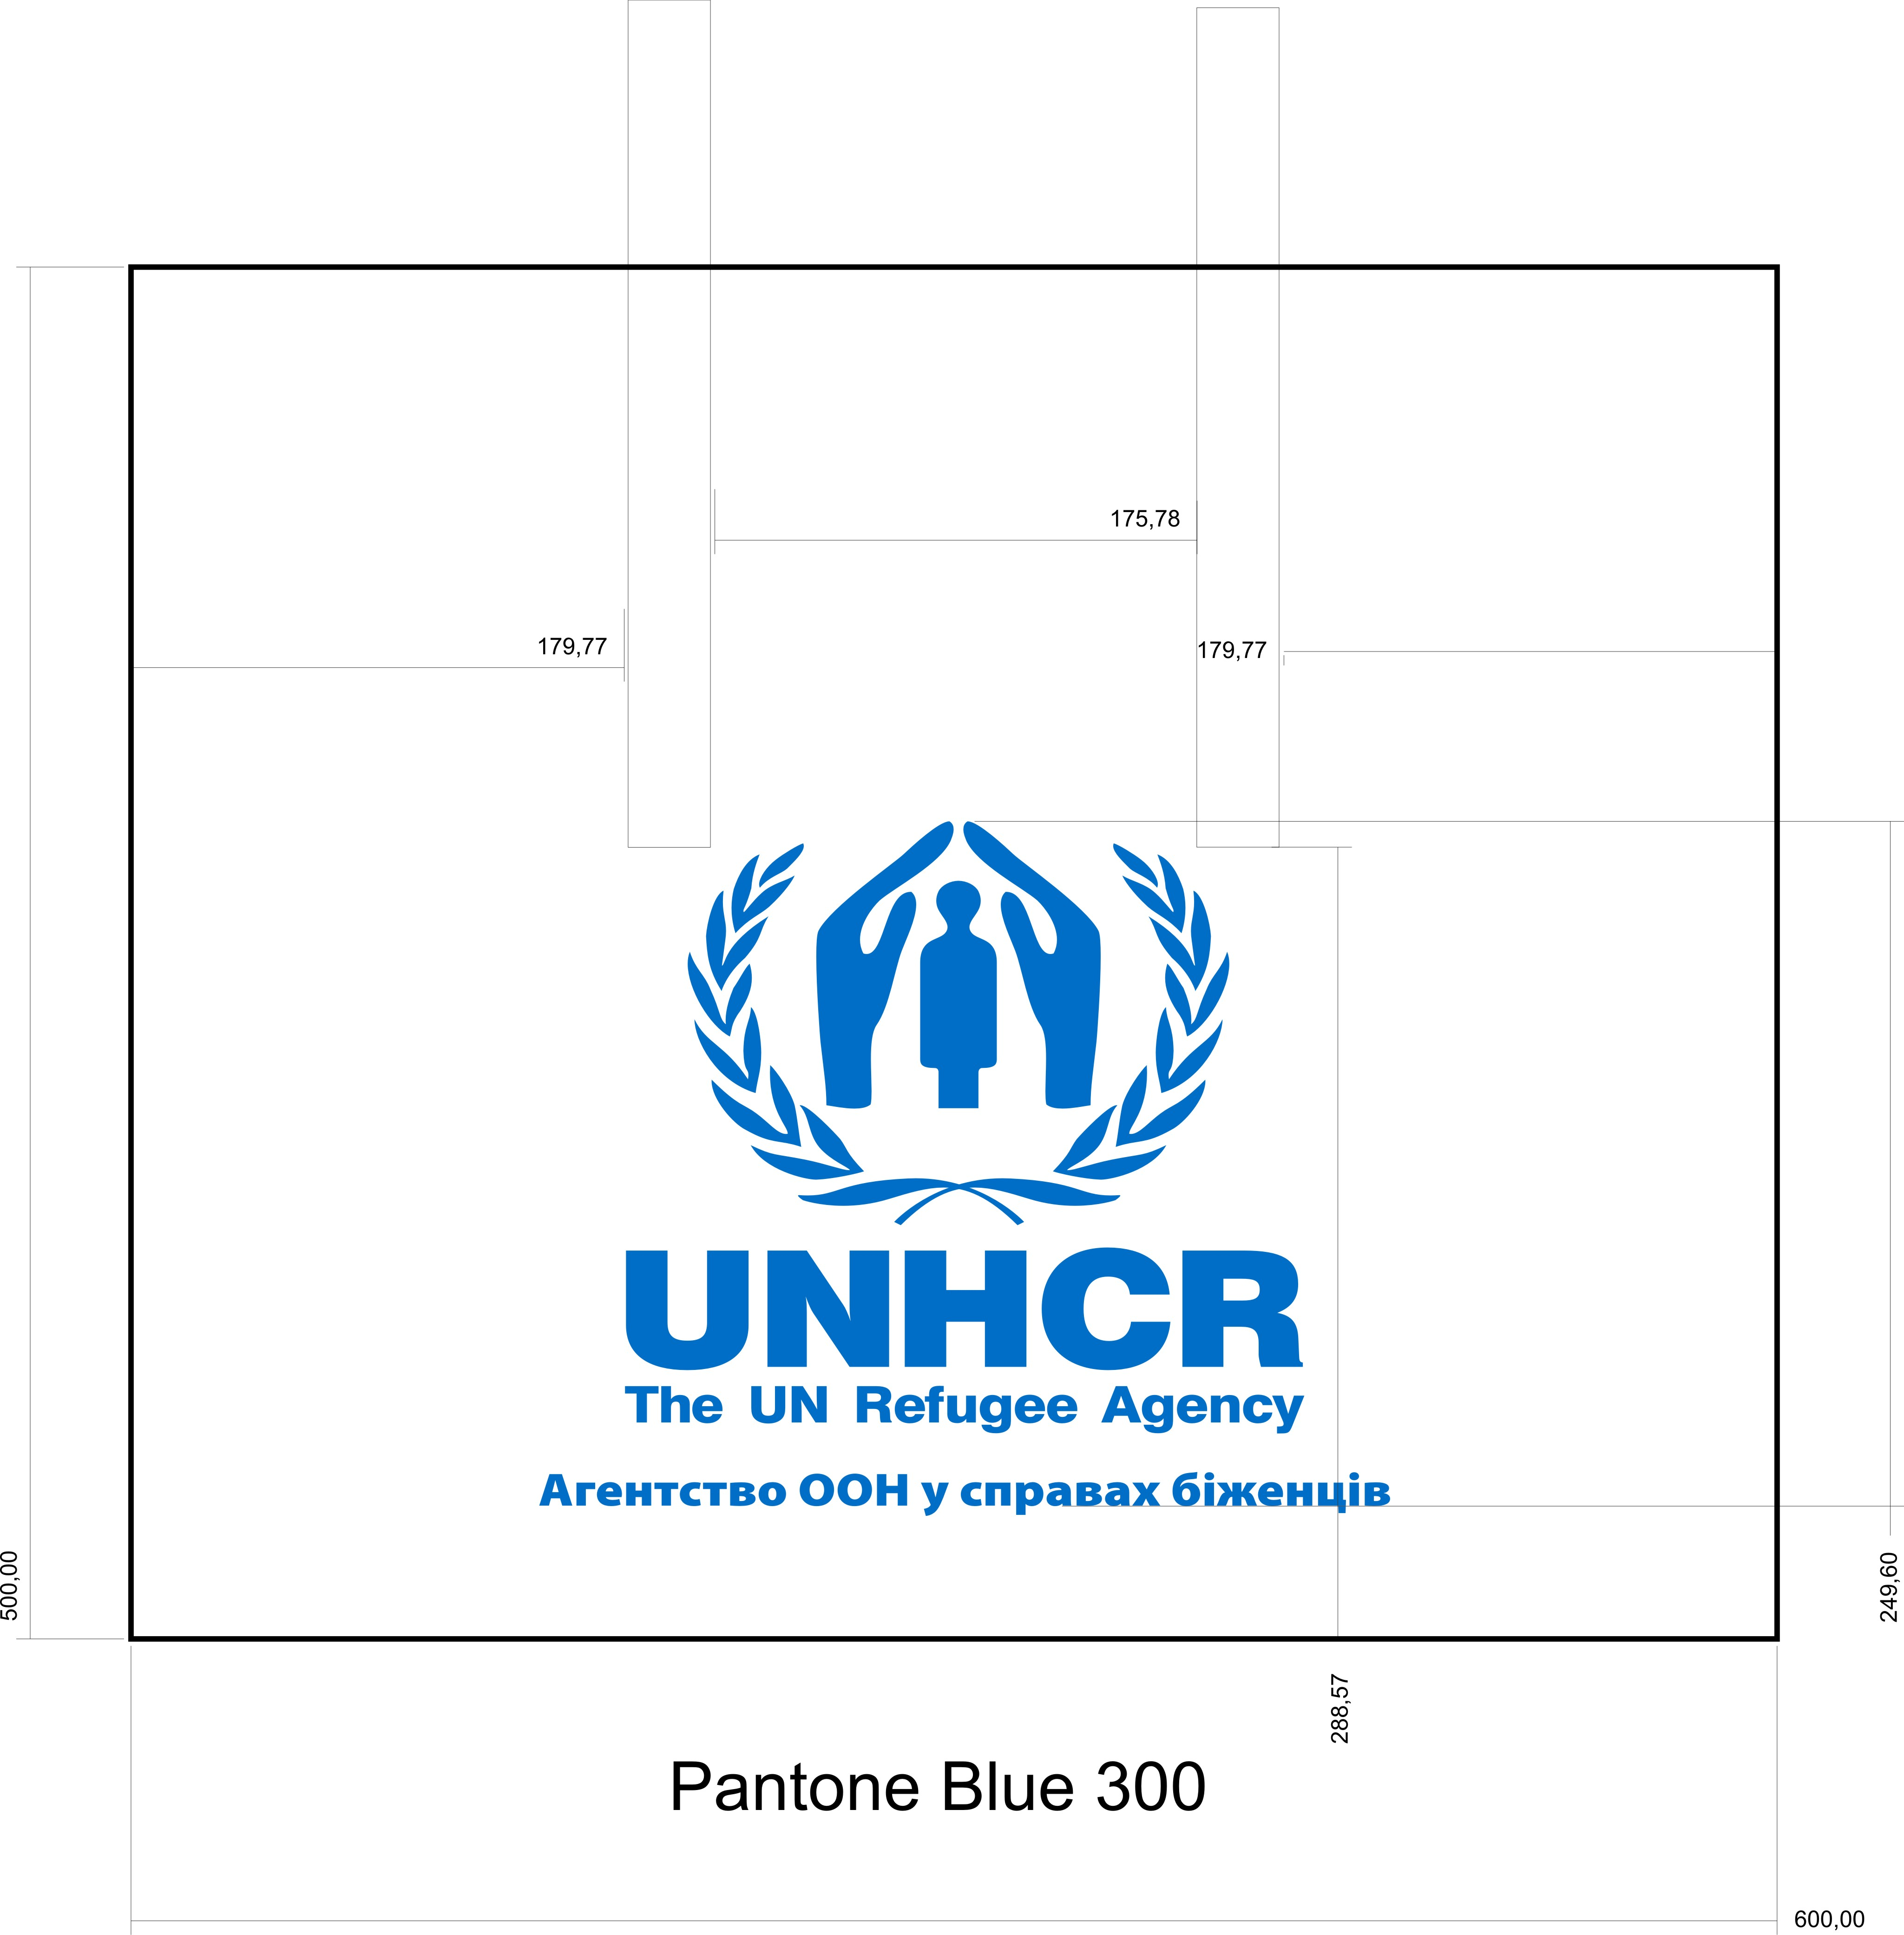  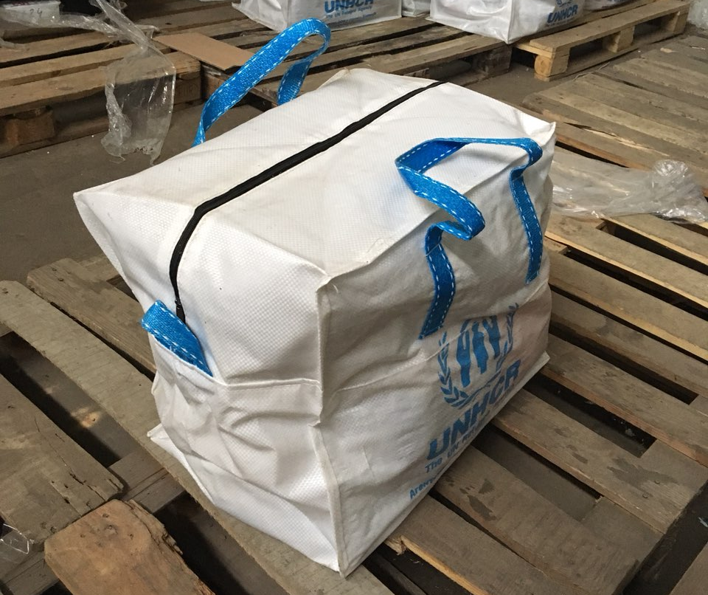

* ALL PICTURES SHOWN ARE FOR ILLUSTRATION PURPOSE ONLY. OFFERED PRODUCTS MAY VARY

