
Activity: Power Walk
Expected duration: 40 mins
Objective: enhance participants’ understanding of unequal power relations and differences in control over decision-making and access to opportunities, services and resources
- It is recommended to adjust the character cards and statements (see below) based on the local context.
- Move participants to an area with enough space for them to line up in one row across the room or space, next to each other.
- Give each participant a character card.
- If the group is mixed, hand out women’s cards to men, and men’s cards to women.
- If possible, ask participants to attach the character card where others can see it.
- Read out a series of statements – see below.
- Explain that if the statement is (expected to be) true for the character on their card, participants may take one step forward. If it is not (expected to be) true, they remain where they are.
- Encourage women to challenge men who step forward inappropriately (as their women characters) - this can be powerful for men in understanding the challenges faced by women, and for women in being able to experience a taste of the freedoms of men.

Statements
- I control the money that I earn.
- My work is paid and generally well-considered.
- I can travel around the camp/settlement/community easily.
- I do not fear for my safety if I move around after dark.
- I have leisure time.
- I am among the first to speak in meetings.
- My children have my family’s name.
- I am not generally afraid of being sexually assaulted or raped.
- My spouse (or someone else) looks after my children.
- I can wear any clothes I like without fear of sexual assault.
- I am of the same sex as the police, community leaders and religious leaders.
- I have had the opportunity to be educated.
- I decide when to have sexual relations with my partner.
- I can get access to services without being forced to engage in sexual acts.
- I do not have to account to my partner for where I have been or how I spend my time.
- I am generally listened to by the leaders in my community.
- I can determine when and how many children I have.
- I can go to the police, be treated respectfully and not be worried about being threatened with arrest or violence.
- I can travel anywhere I like without an escort.

Discussion
- Lead a debrief using the following discussion questions.
- What do we see at the end of this exercise?
- Who is in front? Who is behind?
- What did it feel like to move forward? What did it feel like to stay behind?
- What differences did you notice between women and between men?
- What does this difference mean to you?
- Who has a card with a humanitarian worker? Are they in the front or the back?

Key considerations
- This exercise is about the power and privilege that men enjoy in most societies simply by virtue of the unequal status and power afforded to them at birth.
- These differences are not based on skill or experience, but socialized power inequality, perpetuated by cultures and norms.
- Women experience this inequality throughout their lives, and it is the foundation upon which violence develops and is perpetuated.
- Of course, not all men are the same, and not all women are the same. Even within those groups, there are significant differences of power and privilege – associated with status, physical ability, education, wealth, etc. However, even with those differences it is obvious that men are in general much further ahead than women.
- It is critical for participants to understand power imbalance between humanitarians and the persons we serve, as it explains how difficult it could be for them to approach humanitarian workers to seek help.

Activity derived and adjusted from the Inter-Agency GBV Case Management Training Package (https://www.gbvims.com/gbv-case-management-guidelines/gbv-case-management-training-materials/) and the IASC Guidelines Training Package,
Module 3, 2015 (https://gbvguidelines.org/en/capacity-building/module-3-gbv-in-emergencies/).
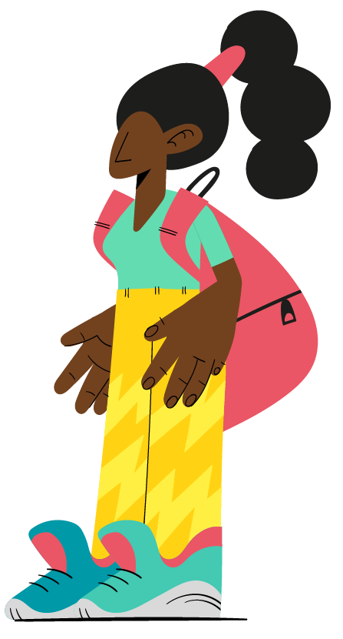
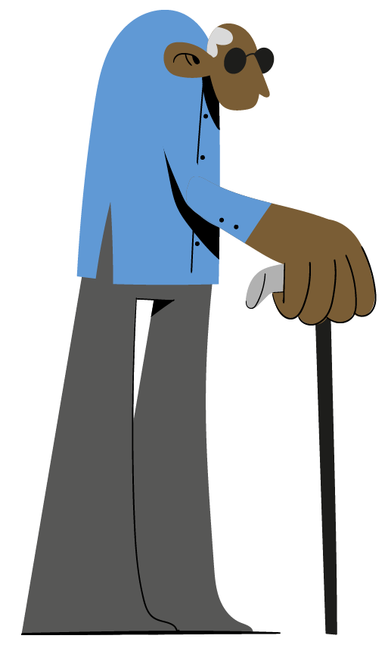
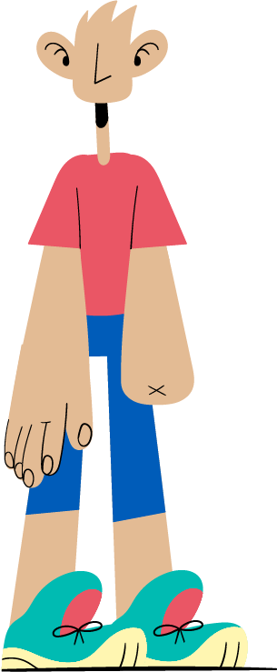
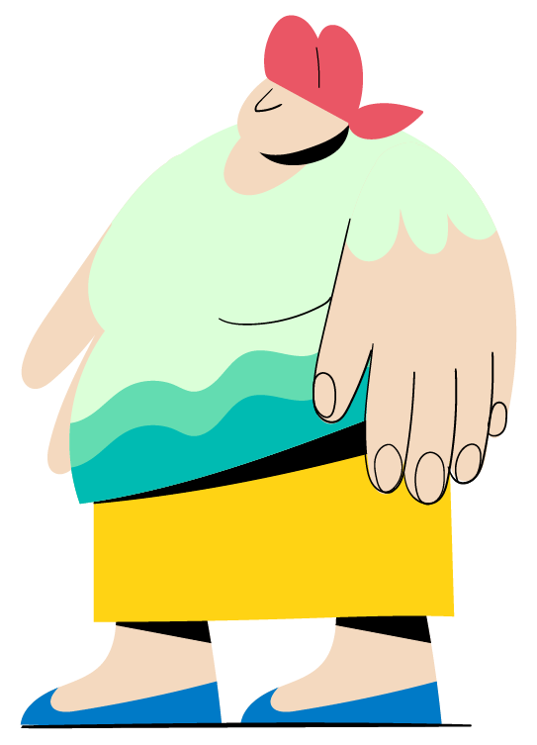
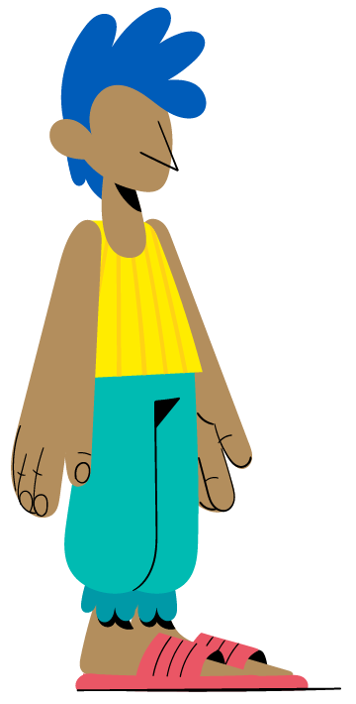


Character cards
Young girl head of household with 2 younger siblings | Female survivor of intimate partner violence
Unemployed man | Police officer (male)
Adolescent girl | An adolescent girl recently married to male adult
Religious leader (male) | Military (soldier/male)
Woman engaged in the sale and exchange of sex | Out-of-school youth (male)
Market shop owner (male) | Transgender woman
School teacher (male) | Older woman with children in her care
Social worker of a local NGO (female) | A man living with a physical disability
Homosexual man | National authority managing the camp (male)
Host community member (female) | Truck driver of food distribution agency (male)
Man living with HIV/AIDS | Minority group member (male)
Widow with 2 children | 10-year old boy
Pregnant woman | Doctor (male)
Breast-feeding woman | WASH committee member (male)
NGO director (male) | Camp leader (male)
International humanitarian worker (female)

