
Discussion: Referral Pathway for
Child Survivors
Expected duration: 15 mins
Objective: familiarize participants with the local version of the referral pathway for child survivors of GBV
- Provide a hand-out of the local version of the referral pathway for child survivors of GBV in order to go in detail through the available services of each of the different service providers – including how to handle urgent cases and/or cases after operating hours of child protection/GBV specialized services.
- Ask participants:
- Have they seen this referral pathway before?
- What are the differences with the referral pathway for adult survivors of GBV?

Key considerations
- Remind participants that it is the role of child protection/GBV specialists to map these services and develop the referral pathway. Frontline workers are expected to be fully familiar with the referral pathway for child survivors and have the contact details of child protection/GBV specialists available to seek support/advice (e.g. a colleague from the Protection team, from another office or a specialized partner).
- Frontline workers should be aware of the contact details, operating hours, locations, etc. of quality and reliable services available for child survivors on the referral pathway.
- It is recommended that all programmes/partners/offices have access to this basic information before starting to work with the community.

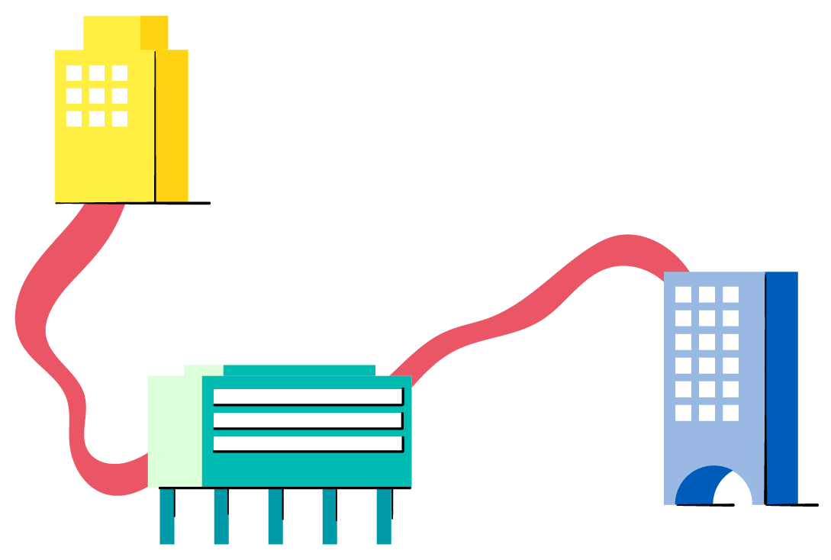
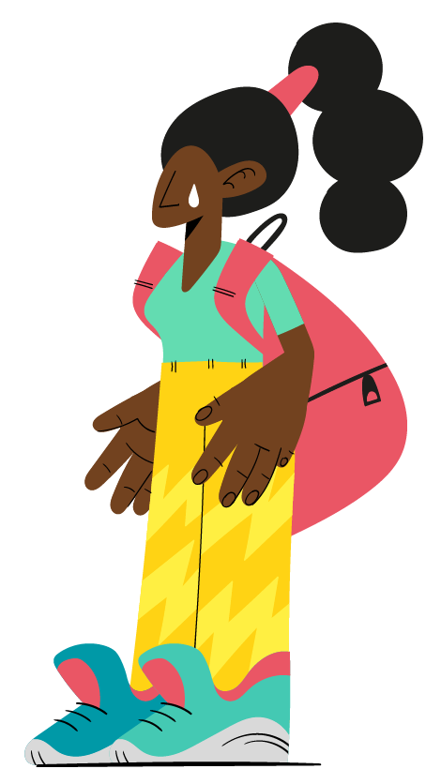
- If there is no referral pathway for child survivors of GBV, the recommended course of action is always to contact a GBV/child protection specialist who can advise on the situation. Remember never to share any identifiable information about the child.

