

Lessons Learned: Assessment and Analysis Activities
(In Support of the RMRP)

Area of Assessment and Analysis: | Key recommendations (lessons learned):
Assessment and analysis Coordination | - Put in place SoP to help guide regional and national level assessment and analysis activities.  - Coordinate assessments where possible in order to improve data coherence, quality, and analysis, and provide clear messages for decision-makers.  - Before beginning an assessment, communicate with other assessment actors in regional and national platforms to see if assessments are already being conducted and if information needs would be covered by ongoing assessment activities.  - Consult the Assessment Registry as the key source and overview of ongoing, and finalized assessments.  - Define core indicators and make them available for planned assessment actors to consult.  - Harmonize indicators across assessments to facilitate analysis
Assessment questionnaires within the region | - Define research questions, scope, information gaps, and information needs at the outset of the assessment process.  - Limit questionnaire and interview length.  - Focus only on information needed for the assessment’s purpose and which you are confident can be reliably and accurately obtained using the assessment approach.  - Engage with experienced enumerators after each data collection exercise to understand which questions do not work well, or have been misunderstood.
Analysis | - Consider analysis and joint analysis as an integral part of any assessment process.  - Plan analysis from the outset.  - Data collection and questionnaires should be designed based on an analysis plan (not the other way around).  - Share data across the response to contribute to joint analysis and a common understanding of the situation and needs.  - Plan early for analysis and allocate enough time and resources for analysis exercises such as joint analysis workshops, multi-sectoral analysis, and severity indices.
Secondary data review | - Always conduct a thorough secondary data review at the beginning of the assessment process in order to identify information gaps and inform the assessment initiative.  - The Regional Platform should be responsible for sharing, storing and promoting the use of the assessment data and reports in an accessible way.
Language and communication | - Use clear and straight-forward language in questionnaires and avoid overly technical and ambiguous terms that may not be easily understood.  - Concepts that are ambiguous or difficult to translate should always be  contextualized and clear, standardized examples should be given.  - Expert review of questionnaires by Spanish speakers can ensure that the affected population can understand them in the same way.  - Collect feedback from enumerators on questionnaires in order to ensure questions are phrased in an unambiguous way and understood by all  enumerators. Test enumerators’ ability to explain terminology and questions  in their own words. Role play during enumerator trainings so that  enumerators repeatedly practice asking and answering the questions  themselves to help ensure consistency and familiarity with questionnaires.  - Promote clear and consistent definitions and terminology throughout the humanitarian community.  - Pilot questionnaires with key informants or focus groups in order to identify which questions are difficult to communicate and/or need revision.
Household interviews | - Prior to conducting assessments, use key informant interviews and focus  group discussions to understand the strata Venezuelan refugee and migrants that need to be considered for sampling.  - The level of representativeness should be informed by the level targeted by  programming.
Key Informant Interviews | - All data is biased. Be conscious about limitations of key informant interviews  and other key people within the governance structures. While  they may be uniquely informed about the general needs in their respective  area of responsibility, they might not be aware of or sufficiently informed  about issues faced by certain population groups, such as women or  minorities, and may have reasons for distorting information.  - Design key informant questionnaires around what expertise the key informant can reasonably provide; do not waste time asking questions that they will likely give unreliable answers to.  - Possible biases and power structures need to be taken into consideration during key informant surveys.
Focus Group Discussions | - Focus group discussions should be gender and age specific to give all participants room to speak.  - Wherever possible, do not allow convenience to limit the opportunity to  participate in FGDs; look beyond obvious locations such as women friendly spaces, health centres, and schools. Avoid conducting FGDs in public to ensure that participants can speak freely.  - Limit size of focus group discussions.  - Conduct qualitative, research-oriented FGDs or CGDs to explore new topics and learn how communities define key issues and needs in their own words when not being prompted with standardized questions.  - Employ FGDs in order to develop, test, and fine tune questionnaires that will have multiple choice options to ensure the language used in the questions  - is understood and the options are appropriate. This will result in a better quality assessment.  - Develop best practices for analysis and sharing of qualitative data gathered in FGDs.
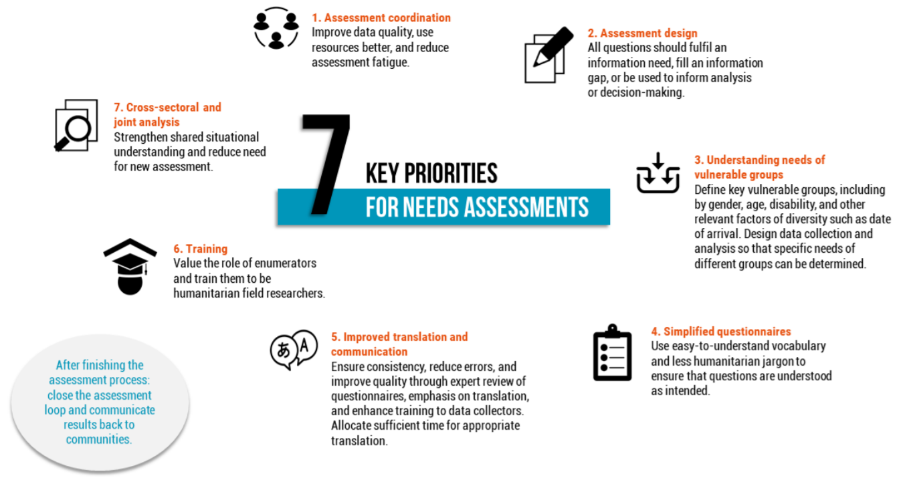

Literature and context review: ACAPS: Direct Observation and Key Informant Interview Techniques for primary data collection during rapid assessments. October 2011. ACAPS: Primary Data Collection Techniques. 2016

