|  |
| --- |
| place  Manila, Philippines  date  1 May 2021 |

|  |
| --- |
| UNHCR Philippines  6F GC Corporate Plaza, 150 Legaspi Street, Legaspi Village, Makati City  www.unhcr.org/ph  @UNHCRPh |

**Atom Araullo marks his third year as UNHCR Goodwill Ambassador by highlighting the plight of forcibly displaced communities in Mindanao**

On his third year as National Goodwill Ambassador for UNHCR, The UN Refugee Agency, Atom Araullo highlights the plight of forcibly displaced families and their host communities in Mindanao, Philippines as they face the multiple threats of conflict, climate crisis, and COVID-19.

In a visit to Maguindanao and North Cotabato, Atom Araullo crossed a marshland, trekked to a COVID isolation facility on a hilltop, and reached remote conflict-affected communities to meet with internally displaced persons (IDPs), community leaders and partners, as well as local authorities who are all doing their part to mitigate the effects of the pandemic amid ongoing conflict and climate change.

“In the middle of this global health emergency, I think it's important to let people know that many of the problems that families here in Mindanao have been facing for generations still exist,” said Atom reflecting on the complexity of the situation faced by forcibly displaced families in southern Philippines. “The violence is cyclical and protracted. They need support because of the pandemic and because environment and climate-related threats and hazards are also worsening,” he stresses.

**Climate change is a threat multiplier for the forcibly displaced**

Atom visited Brgy. Butiren, Kabuntalan, Maguindanao – a remote community hosting families in makeshift houses in the Liguasan wetlands. Despite its vulnerability to climate hazards, families displaced by conflict from surrounding areas sought refuge in Brgy Butiren.

Atom helped distribute solar lamps because the community still has no access to electricity. He also spoke to fisherfolk who recently benefited from the provision of fishing boats and bamboo fish traps as part of UNHCR Philippines’ quick impact livelihood support projects.

One of the fishermen, Mhads Latip, shared his struggles with the overlapping problems of conflict and climate change. *"Sa ngayon, kulang pa yung huli namin kasi apektado kami… Kapag nangingisda kami sa dilim at may nakita silang may ilaw, pinapaputukan nila.”* He also shares that the water levels have become increasingly unpredictable, and this affects their catch and drives them to seek higher and safer grounds. *“Yung mga gamit namin pinapatong tapos naghahanap lang kami ng matitirhan na mataas na bahay. Kapag lalong tumaas yung tubig, hindi na kami makatulog,”* he continues.

**COVID-19 exacerbates health and protection risks for those forced to flee**

Atom also visited Datu Saudi Ampatuan in Maguindanao. At the height of the pandemic, UNHCR installed a water, sanitation, and hygiene (WASH) facility right beside the town's COVID-19 isolation center. The tank now supplies water for forcibly displaced families, the host community, and even those in isolation for their day-to-day water and hygiene needs.

The increased vulnerability of the forcibly displaced was emphasized during Atom’s conversation with Roxane Salipada, an IDP leader who has experienced multiple displacements in her lifetime. The most recent of which was due to the law enforcement operation against non-state actors on March 2021 that displaced approximately 40,100 individuals across 12 municipalities, including Roxane’s community in Datu Saudi Ampatuan.

Roxane’s family temporarily sought shelter in Dapiawan Elementary School, where the fragility of their living conditions is exacerbated by the pandemic. The imminent threat of COVID lingered but escaping the firefight was more pressing. *“Pagod din, kaso wala na kaming magawa. Ang importante safe ang buhay namin ngayon sa school,”* she says. As an IDP leader, she takes responsibility to remind her constituents to practice physical distancing and to maintain cleanliness and hygiene as much as they can.

Hearing Roxane speak about their situation, Atom recalls his previous visits to evacuation centers in lIigan and Marawi. “Even before the health emergency it’s already been difficult. There is no privacy and they become prone to the spread of disease. They don't have a lot of access to potable water, to latrines.”

**Everyone has a role to play in ensuring that no one is left behind**

For communities affected by decades-long armed conflict in Mindanao, the journey to lasting peace and rebuilding their lives in safety and dignity can take many years.

Atom commends the efforts of local authorities, humanitarian actors, host communities, and the IDPs themselves in mobilizing together to mitigate the effects of the pandemic. He shares, *“Sa kabila ng mahirap na pamumuhay, nagagawa pa rin nilang tanggapin at suportahan ang mga kababayan natin na kailangan lumikas. Hanga ako sa kanilang pagiging bukas-palad, at katatagan din sa gitna ng maraming pagsubok.”*

Zulaika Jamat Alamada, one of the community leaders in Brgy. Sambulawan, Midsayap, expressed how they managed their livelihood with the tools given to them as alternative to farming. *“Hindi natutuloy ang corn production dahil tuloy-tuloy na ang baha. Hindi kagaya noon na parang alam mo na ang situation ng climate. Ngayon, Diyos na ang bahala,”* said Zulaika. The women-led group where Zulaika belongs were given sewing machines, an indigenous loom, and other materials for a dressmaking and event rental business that now serves as a more stable source of income for the community.

After visiting the communities and speaking with IDPs like Mhads, Roxane, and Zulaika, Atom wants to highlight that those forced to flee are not just people in need of life-saving assistance – they also bring value to the communities that host them. He reflects, *“Pwede natin silang tignan bilang mga produktibong miyembro ng ating lipunan na makadadagdag sa development ng kanilang host communities.”*

As UNHCR Goodwill Ambassador, Atom Araullo hopes to inspire Filipinos to do their part in making sure that no one is left behind. *“Sa panahong ito na marami tayong iniisip at nabaliktad yung ating buhay dahil sa pagkalat ng virus, hindi pa rin tumitigil yung iba't-ibang mga krisis sa buong mundo, at maitatanong natin ‘dapat pa ba tayo makialam?’* As a goodwill ambassador of the UNHCR, it's important for me to make that connection – *bakit kailangan tayong tumulong, bakit sa minimum kailangan natin makialam at makibalita kung ano yung kanilang mga pinagdadaanan.* And I always say that no one should get left behind, and that doesn’t just mean Filipinos, it means the global community.”

For Atom, it's one thing to tell everyone about the challenge in Mindanao and the representation of all the issues that vulnerable communities are pressed with. But coming out together as a community in times of pain, peril and pandemic defines the Filipino culture better. As exemplified by the communities he visited, “Filipinos always will lend a helping hand and open their doors for people who are in need and we step up each time.”

**About UNHCR**

The United Nations High Commissioner for Refugees (UNHCR), the UN Refugee Agency, is mandated to lead and coordinate international action to protect refugees and resolve refugee issues worldwide. The heart of its operations primarily focuses on protecting displaced persons, families and communities who are forced to flee their places of origin because of war, persecution, violence and even natural disasters. UNHCR delivers life-saving assistance, safeguards fundamental rights, and ensures that those forcibly displaced will settle in communities in dignity and safety.

In the Philippines, UNHCR has maintained a presence for over 30 years, working on three pillars: providing durable solutions to refugees, ending and reducing statelessness, and empowering displaced families.

UNHCR leads the Protection Cluster at the national level within the context of the Humanitarian Country Team. In Mindanao, UNHCR co-leads the Protection Working Group with the Ministry of Social Services and Development in the Bangsamoro Autonomous Region in Muslim Mindanao (BARMM). By working with local and national stakeholders, UNHCR in Mindanao advocates for the passage of an IDP protection law both at the national and BARMM level to identify, prevent, and respond to internal displacement in accordance with the UN Guiding Principles on Internal Displacement. With a clear legislation framework, this will ensure that IDPs will be better protected and served.

**About UNHCR GOODWILL AMBASSADOR ATOM ARAULLO**

Alfonso Tomas “Atom” Araullo, a renowned broadcast journalist in the Philippines, started his support for UNHCR in June 2017 and was officially named as National Goodwill Ambassador in February 2019. Atom has travelled to Azraq refugee camp in Jordan (2018), Kutupalong refugee camp in Bangladesh (2017 and 2019), and to IDP communities in Mindanao, southern Philippines (2017, 2018 and 2021) in support of UNHCR’s advocacy, media, and fundraising work for the refugee cause.

Atom’s voice and presence in multi-media platforms has been instrumental in enriching the positive sentiment and engagement of the Filipino public towards the refugee cause. This includes driving engagement for key milestones like World Refugee Day and campaigns like 2 Billion Kilometers to Safety, as well as mobilizing financial support for UNHCR’s work in the Philippines and the organization’s operations for the Rohingya Response, Syria Situation, and Coronavirus Emergency.

**For more information, please contact:**

Gia Luga

Communications Associate, Private Sector Partnerships

UNHCR Philippines

0917 309 6591

[luga@unhcr.org](mailto:luga@unhcr.org)

**PHOTO PACK**

**01 UNHCR GWA Atom Araullo - Kabuntalan Maguindanao.jpg**UNHCR Philippines Goodwill Ambassador Atom Araullo visits Brgy. Butiren in the Municipality of Kabuntalan, in Maguindanao, Philippines, on Saturday, April 17, 2021. The community has experienced numerous displacements in the past, and has become a host community themselves for other displaced families due to conflict. Brgy. Butiren is also frequently affected by gradually rising flash floods. © UNHCR/Martin San Diego

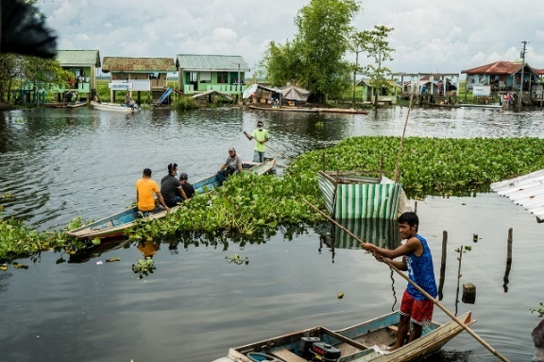

**02 UNHCR GWA Atom Araullo - Kabuntalan Maguindanao.jpg**  
UNHCR Philippines Goodwill Ambassador Atom Araullo visits Brgy. Butiren in the Municipality of Kabuntalan, in Maguindanao, Philippines, on Saturday, April 17, 2021. The community has experienced numerous displacements in the past, and has become a host community themselves for other displaced families due to conflict. Brgy. Butiren is also frequently affected by gradually rising flash floods. © UNHCR/Martin San Diego

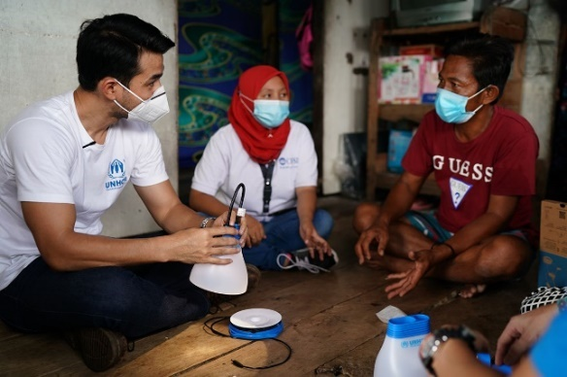

**03 UNHCR GWA Atom Araullo - Kabuntalan Maguindanao**UNHCR Philippines Goodwill Ambassador Atom Araullo visits Brgy. Butiren in the Municipality of Kabuntalan, in Maguindanao, Philippines, on Saturday, April 17, 2021. Araullo took part in the distribution of solar lamps to fisherfolk in the community without access to electricity. A total of 280 households received solar lamps. © UNHCR/Martin San Diego

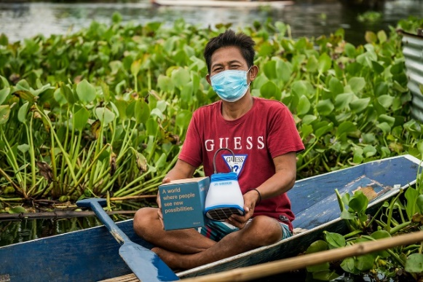

**04 UNHCR GWA Atom Araullo - Kabuntalan Maguindanao.jpg**UNHCR Philippines Goodwill Ambassador Atom Araullo visits Brgy. Butiren in the Municipality of Kabuntalan, in Maguindanao, Philippines, on Saturday, April 17, 2021. Mhads Latip, one of the fisherfolk who received a fishing boat and net as part of UNHCR’s quick impact livelihood support projects, shared his struggles with the overlapping problems of conflict and climate change. © UNHCR/Martin San Diego

**05 UNHCR GWA Atom Araullo – Midsayap.jpg**UNHCR Philippines Goodwill Ambassador Atom Araullo visits Brgy. Sambulawan in the Municipality of Midsayap, in the Bangsamoro Autonomous Region of Muslim Mindanao, Philippines, on Sunday, April 18, 2021. He was warmly welcomed with a showcase of the textiles created with the help of UNHCR’s livelihood support project for the community’s women-led group, implemented in 2020. Brgy. Sambulawan has long been host to forcibly displaced families who flee from conflict in surrounding areas. © UNHCR/Martin San Diego

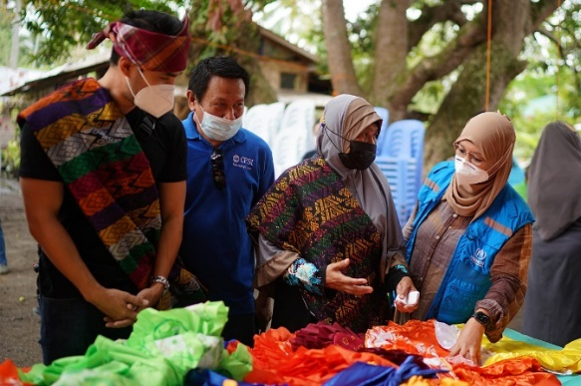

**06 UNHCR GWA Atom Araullo – Midsayap.jpg**UNHCR Philippines Goodwill Ambassador Atom Araullo visits Brgy. Sambulawan in the Municipality of Midsayap, in the Bangsamoro Autonomous Region of Muslim Mindanao, Philippines, on Sunday, April 18, 2021. He was warmly welcomed with a showcase of the textiles created with the help of UNHCR’s livelihood support project for the community’s women-led group, implemented in 2020. Brgy. Sambulawan has long been host to forcibly displaced families who flee from conflict in surrounding areas. © UNHCR/Martin San Diego

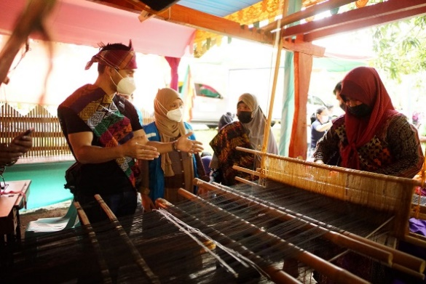

**07 UNHCR GWA Atom Araullo – Midsayap.jpg**  
UNHCR Philippines Goodwill Ambassador Atom Araullo visits Brgy. Sambulawan in the Municipality of Midsayap, in the Bangsamoro Autonomous Region of Muslim Mindanao, Philippines, on Sunday, April 18, 2021. He witnessed UNHCR’s livelihood support project in action, with the women-led group showcasing the “habian” or indigenous loom, sewing machines and other materials for their dressmaking and event rental business. This now serves as a more stable source of income for the community, which hosts forcibly displaced families who flee from conflict in surrounding areas. © UNHCR/Martin San Diego

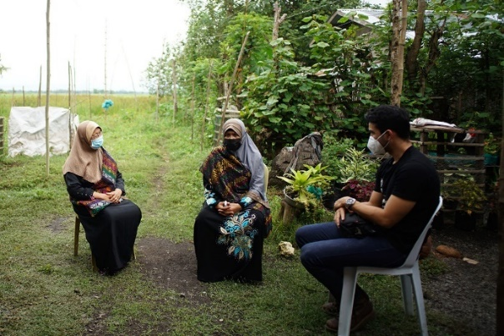

**08 UNHCR GWA Atom Araullo - Midsayap.jpg**  
UNHCR Philippines Goodwill Ambassador Atom Araullo visits Brgy. Sambulawan in the Municipality of Midsayap, in the Bangsamoro Autonomous Region of Muslim Mindanao, Philippines, on Sunday, April 18, 2021. Zulaika Jamat Alamada, one of the community leaders, shared that they managed their livelihood with the tools given to them as alternative to farming. Their dressmaking and event rental business now serves as a more stable source of income for the community, which hosts forcibly displaced families who flee from conflict in surrounding areas. © UNHCR/Martin San Diego

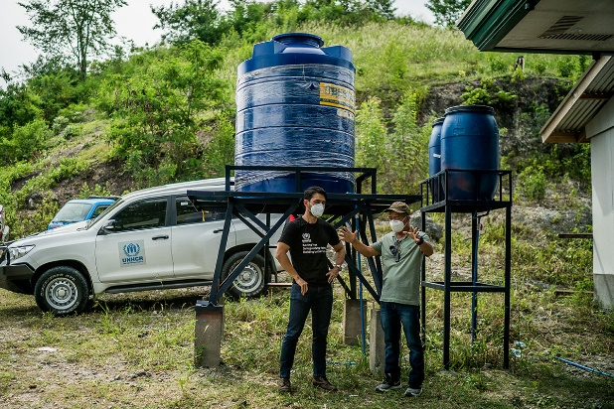

**09 UNHCR GWA Atom Araullo - Datu Saudi Ampatuan.jpg**  
UNHCR Philippines Goodwill Ambassador Atom Araullo visits Brgy. Kabengi in the Municipality of Datu Saudi Ampatuan, in Maguindanao, Philippines, on Sunday, April 18, 2021. Municipal Administrator Musib Uy Tan shows him the water, sanitation, and hygiene (WASH) facility installed by UNHCR right beside the town's COVID-19 isolation center. The tank now supplies water for forcibly displaced families, the host community, and even those in isolation for their day-to-day water and hygiene needs. © UNHCR/Martin San Diego

**10 UNHCR GWA Atom Araullo - Datu Saudi Ampatuan.jpg**UNHCR Philippines Goodwill Ambassador Atom Araullo visits Brgy. Kabengi in the Municipality of Datu Saudi Ampatuan, in Maguindanao, Philippines, on Sunday, April 18, 2021. He met with Roxane Salipada, an IDP leader who has experienced multiple displacements in her lifetime. The most recent of which was due to the law enforcement operation against non-state actors in March 2021 that displaced approximately 40,100 individuals across 12 municipalities, including Roxane’s community. The fragility of their living conditions in evacuation centers is exacerbated by the pandemic. © UNHCR/Martin San Diego

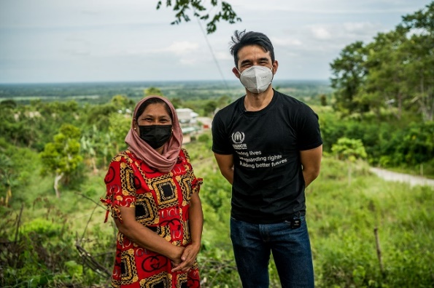

**11 UNHCR GWA Atom Araullo - Datu Saudi Ampatuan.jpg**  
UNHCR Philippines Goodwill Ambassador Atom Araullo visits Brgy. Kabengi in the Municipality of Datu Saudi Ampatuan, in Maguindanao, Philippines, on Sunday, April 18, 2021. He met with Roxane Salipada, an IDP leader who has experienced multiple displacements in her lifetime. The most recent of which was due to the law enforcement operation against non-state actors in March 2021 that displaced approximately 40,100 individuals across 12 municipalities, including Roxane’s community. The fragility of their living conditions in evacuation centers is exacerbated by the pandemic. © UNHCR/Martin San Diego

**12 UNHCR GWA Atom Araullo - Datu Saudi Ampatuan**  
UNHCR Philippines Goodwill Ambassador Atom Araullo visits Brgy. Kabengi in the Municipality of Datu Saudi Ampatuan, in Maguindanao, Philippines, on Sunday, April 18, 2021. The water, sanitation, and hygiene (WASH) facility installed by UNHCR right beside the town's COVID-19 isolation center now supplies water for forcibly displaced families, the host community, and even those in isolation for their day-to-day water and hygiene needs. © UNHCR/Martin San Diego

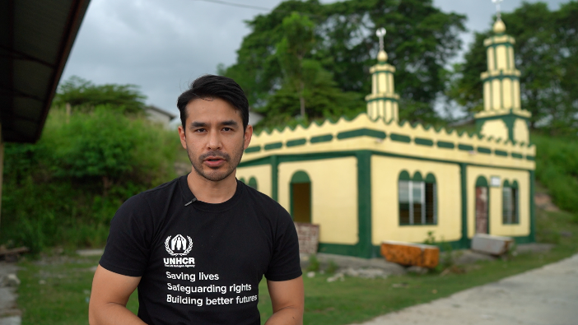

**13 UNHCR GWA Atom Araullo – Mindanao.jpg**In a visit to areas of concern in Maguindanao and North Cotabato, UNHCR Philippines Goodwill Ambassador Atom Araullo crossed a marshland, trekked to a COVID-19 isolation facility on a hilltop, and reached remote conflict-affected communities to meet with internally displaced persons (IDPs), community leaders and partners, as well as local authorities who are all doing their part to mitigate the effects of the pandemic amid ongoing conflict and climate change. © UNHCR/Martin San Diego

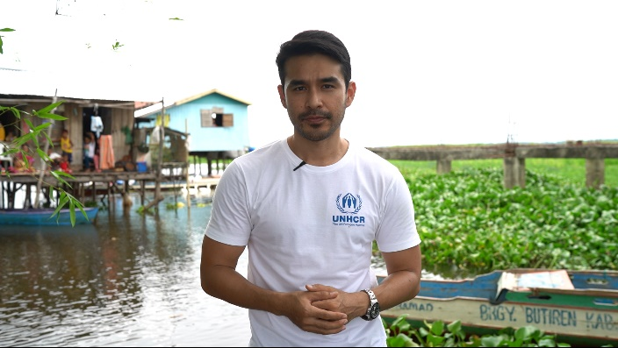

**14 UNHCR GWA Atom Araullo – Mindanao.jpg**In a visit to areas of concern in Maguindanao and North Cotabato, UNHCR Philippines Goodwill Ambassador Atom Araullo crossed a marshland, trekked to a COVID-19 isolation facility on a hilltop, and reached remote conflict-affected communities to meet with internally displaced persons (IDPs), community leaders and partners, as well as local authorities who are all doing their part to mitigate the effects of the pandemic amid ongoing conflict and climate change. © UNHCR/Martin San Diego