DATE: 12 December 2021
PLACE: Bongao, Tawi-Tawi

UNHCR and UNICEF join efforts with local government to address statelessness in Tawi-Tawi

Some 287 Sama Bajaus, of whom 128 are children, finally received their birth certificates today during a handover ceremony spearheaded by the Bongao local government, supported by the United Nations High Commissioner for Refugees (UNHCR) and the United Nations Children’s Fund (UNICEF).
The Sama Bajaus form one of the State-identified populations at risk of statelessness in the Philippines. Because of their itinerant way of living and generations of non-registration among families, they face documentation issues, which in turn puts them at risk of statelessness.
Through the 2019 UNHCR-UNICEF Joint Strategy for Addressing Childhood Statelessness, both UN agencies supported the local government unit of Zamboanga City in piloting birth registration for Sama Bajaus.
In 2021, the project expanded to reach Sama Bajaus in Tawi-Tawi following an assessment conducted in 2019 led by the Geneva-based Joint IDP Profiling Services (JIPS) and UNHCR, which found the prevalence of non-registration of birth among respondents in Bongao.
Sama Bajau children and families who are not registered at birth are excluded from the conditional cash transfer program, have limited access to other social services, and become limited in their movement. Most of the Sama Bajaus in Bongao are also internally displaced due to natural disasters, further heightening their level of vulnerability.
The 2019 exercise, which was conducted in collaboration with key government agencies from the Bangsamoro Autonomous Region in Muslim Mindanao (BARMM), civil society organizations, and other UN agencies. Because they lack awareness on the importance of birth registration, have limited finances, and are unfamiliar about the process, some Sama Bajaus have not been able to register their birth. Cases of multiple birth registration also surfaced as a concern, posing difficulties for the Local Civil Registrar (LCR) in reconciling its records.
Barangay Lamion in Bongao, Tawi-Tawi was identified as a pilot community in coordination with key officials of the municipal government. In response to the report’s finding that health workers play a vital role in transmitting health-related information among Sama Bajau communities, the birth registration activities were conducted with the active participation of health workers in Lamion.
Staff from the Bongao LCR and members of U-Report Philippines from Tau-Social Peace Advocate of Real Tawi-Tawian Active Network (Tau-SPARTAN), KAKASIE, Youth Volunteer Organization and Simunul Youth Guild, Path for Peace and Nutrieskwela Radyo Kasannangan were also trained on birth registration and advocacy ahead of the rollout.
Created by UNICEF, U-Report is a social messaging tool and data collection system to improve adolescent and youth citizen engagement, inform leaders, and foster positive change. The youth volunteers will spearhead the conduct of community-based advocacy on birth registration targeting parents, caregivers, government officials and decision-makers in Bongao.
UNHCR also provided support to the digitization process of the Bongao Local Civil Registrar through the provision of ICT equipment and establishment of a database system to address the issue of multiple birth registration.
“We extend our sincerest appreciation to the municipality of Bongao for its leadership and commitment to the birth registration of Sama Bajaus, a population facing double vulnerability since they are also internally displaced in addition to being at risk of statelessness,” said Maria Ermina Valdeavilla-Gallardo, Head of National Office of UNHCR Philippines. “We also extend our appreciation to partners from the government as well as civil society organizations for the success of this endeavour.”
UNICEF Philippines’ Country Representative Oyunsaikhan Dendevnorov said, “As we celebrate UNICEF’s 75th anniversary, we recognize the clear reminder of UN Convention on the Rights of the Child (UN-CRC), that every child must be registered at birth and given a name and nationality. Children need to be officially registered and be recognized by the Government to where their protection is ensured against any form of violence or exploitation against children. Government as duty-bearer needs to ensure that every child has access to quality basic services like health, nutrition, education, safe water, safe environment and protective family to attain their full potential.”
“We will continue to work with partner agencies such as UNICEF to ensure the protection of Sama Bajaus through their access to documentation,” said Valdeavilla-Gallardo. “Our efforts are in line with the Philippine Development Plan, the National Action Plan to End Statelessness by 2024, and the 2030 Agenda of leaving no one behind.”

END
For more information, please contact:

For UNHCR
Maria Jorica Pamintuan
Senior Communications Assistant
UNHCR Philippines
pamintua@unhcr.org
0917 896 6191

For UNICEF
Marge Francia
Communication Officer
UNICEF Philippines
mfrancia@unicef.org
0920 938 9006

PHOTO PACK

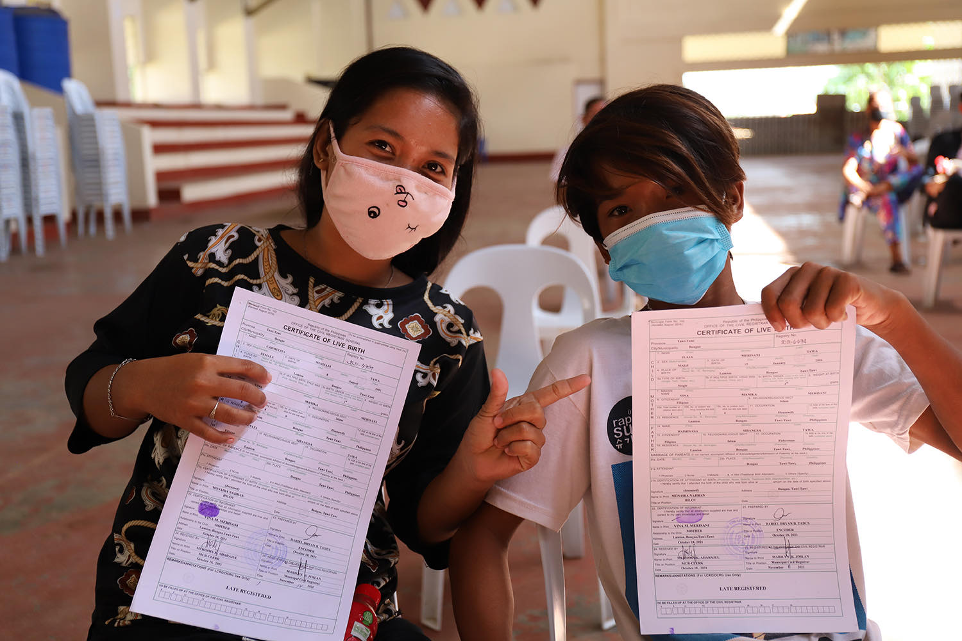

128 children were among the members of the Sama Bajau community who received their birth certificates under the pilot birth registration project in Barangay Lamion. © UNHCR / Althea Gonzales

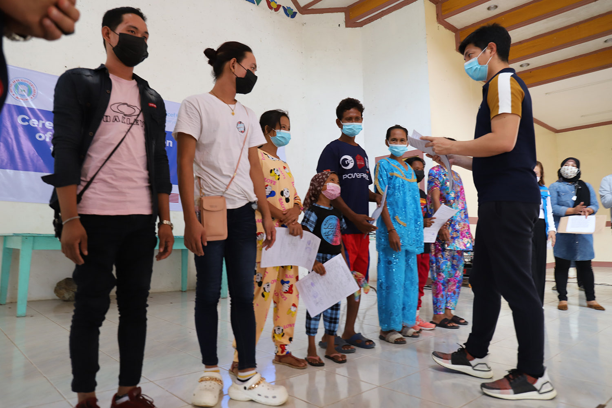
UNHCR and UNICEF joined efforts with the local government of Bongao, Tawi-Tawi during the birth registration drive to reach Sama Bajaus in the pilot community of Barangay Lamion. © UNHCR / Althea Gonzales

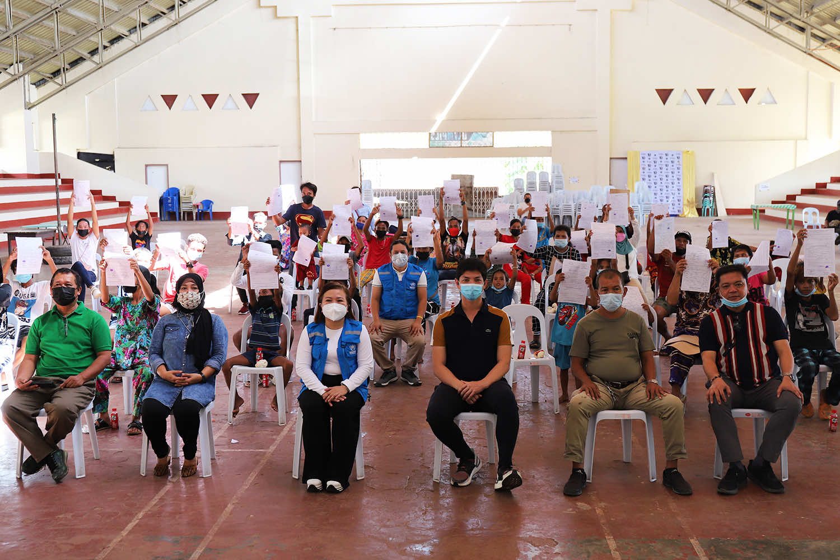
(First row, L-R): Municipal Administrator Roy Saladaga, Municipal Civil Registrar Marilyn Jimlan, UNHCR Philippines Head of National Office Maria Ermina Valdeavilla-Gallardo, Bongao Mayor Jimuel Que, First Councilor Faru Sakkam, and Councilor Acmed Ho Kalbit pose with the Sama Bajau birth registrants who were provided with birth certificates under the Birth Registration Project of the municipality of Bongao with support from UNHCR and UNICEF in line with the implementation of the Joint Strategy to End Childhood Statelessness and the Philippines’ National Action Plan to End Statelessness. © UNHCR / Althea Gonzales

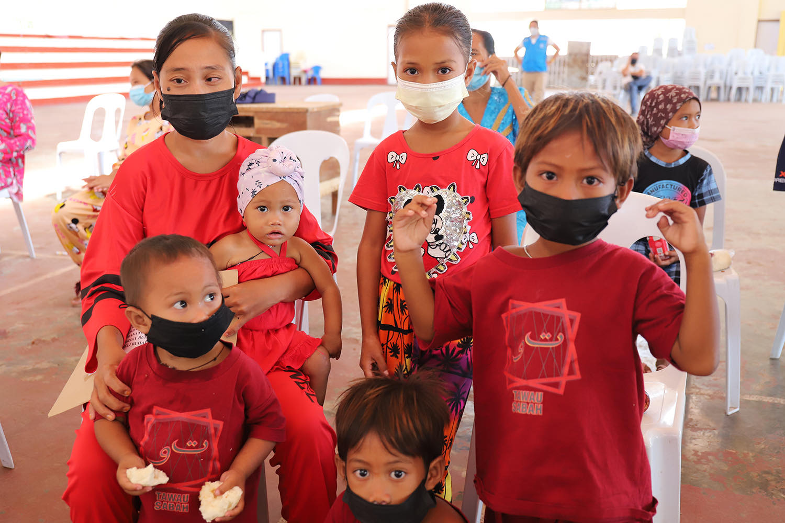
The Luabbayani family was among those who received their birth certificates through the birth registration project spearheaded by the local government of Bongao supported by UNHCR and UNICEF. Juraika registered the birth of her five children between the ages of 11 months and 8 years old to who were given birth certificates under the project. © UNHCR / Althea Gonzales

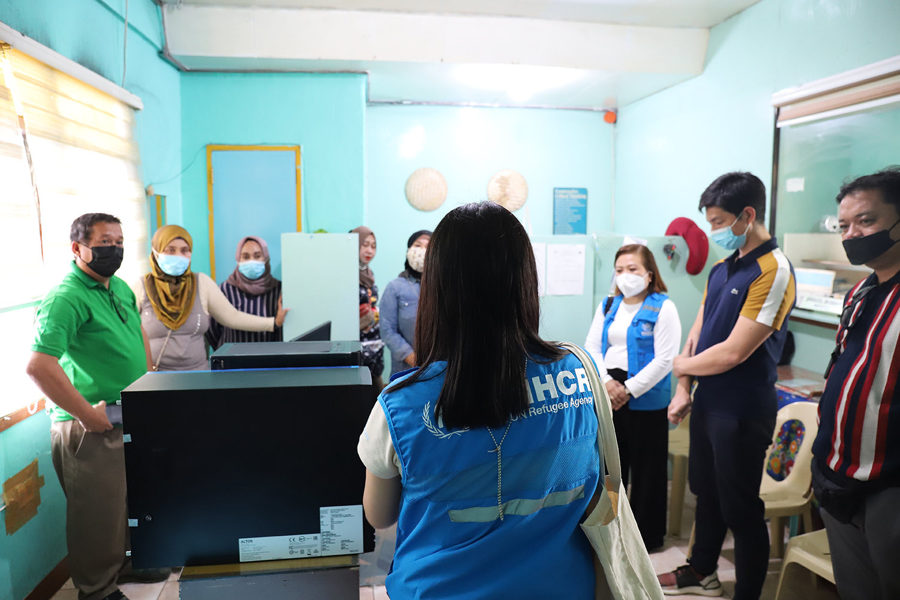
The Local Civil Registrar (LCR) of Bongao, Tawi-Tawi received support from UNHCR Philippines through the provision of ICT equipment and establishment of a database system. UNHCR and UNICEF are jointly supporting the local government of Bongao to address the birth registration issues of Sama Bajaus, one of the State-identified populations at risk of statelessness in the Philippines. © UNHCR / Althea Gonzales

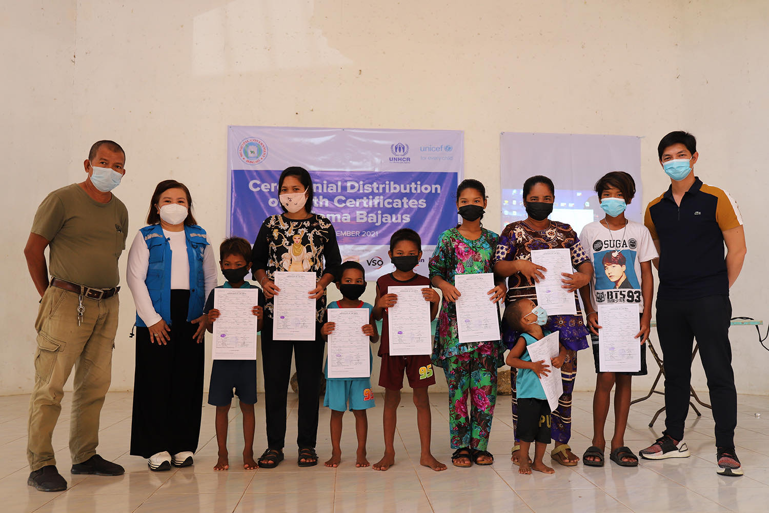
UNHCR and UNICEF joined efforts with the local government of Bongao, Tawi-Tawi during the birth registration drive to reach Sama Bajaus in the pilot community of Barangay Lamion. © UNHCR / Althea Gonzales

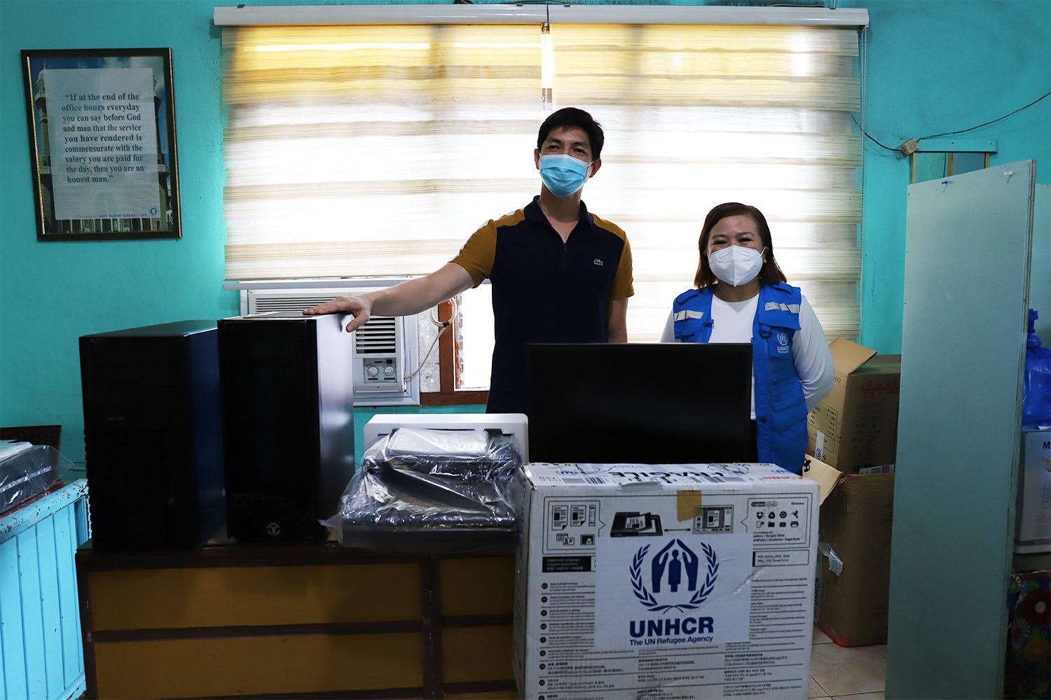
Bongao, Tawi-Tawi Mayor Jimuel Que received ICT equipment from UNHCR Philippines, represented by Head of National Office Maria Ermina Valdeavilla-Gallardo, as part of the rollout of the birth registration project. The provision of ICT equipment and development of a database system will contribute to the digitization of civil registration and vital statistics processes of the Bongao Local Civil Registrar, benefitting not just the Sama Bajaus in Bongao but the whole municipality. © UNHCR / Althea Gonzales

