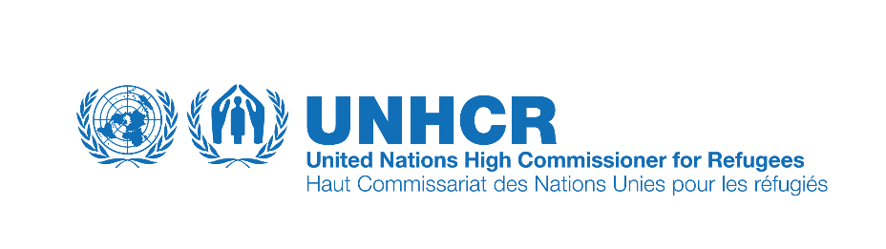

OPERATIONAL CONTEXT
Head of Field Unit, NOA, FU Bihac, UNHCR Bosnia and Herzegovina
(in connection to the Job Opening 32143 and PN 10036245)

This Operational Context provides additional, more specific, information and requirements for the vacant position Head of Field Unit, NOA, in addition to the requirements for the position specified in the position’s standard Job Description and respective Job Opening 32143

Organisational Context
(in addition to what was specified in the standard Job Description/Job Opening)

The Head of Field Unit reports to the Senior Protection Officer based in Sarajevo. The Head of UNHCR Field Unit in Bihac represents UNHCR for all activities based in Una-Sana Canton.

As a part of the Protection Section, the Head of Field Unit also provides functional protection guidance in consultation with the Senior Protection Officer, on all protection/legal matters and accountabilities related to refugees, asylum seekers and other persons in need of international protection in the Una-Sana Canton (USC) within the context of mixed-movements of migrants and refugees. S/he supervises protection standards, operational procedures and practices in the protection delivery in the USC in line with international standards.
The Head of Field Unit is expected to coordinate quality, timely and effective protection responses to the needs of refugees, asylum seekers and other persons in need of international protection who want to seek it in Bosnia and Herzegovina. This includes ensuring that operational responses in all sectors are shaped in a protection optic; mainstream protection methodologies; and integrate protection safeguards. The incumbent also acts as advisor to senior management in Sarajevo; contributes to the design of a comprehensive protection strategy; and represents the Organisation externally, including local and cantonal authorities, partners, UN sister agencies, and donors, on protection doctrine and policy as guided by the supervisor.
The Head of Field Unit will also ensure that asylum-seekers and other persons in need of international protection are meaningfully engaged in the decisions that affect them, whether in accessing their rights or in identifying appropriate solutions to their problems. To achieve this, the incumbent will need to build and maintain effective interfaces with communities of concern to UNHCR, authorities, protection and assistance partners as well as a broader network of stakeholders who can contribute to enhancing protection.

Responsibility (process and functions undertaken to achieve results)
(in addition to what was specified in the standard Job Description/Job Opening)

- Stay abreast of political, social, economic and cultural developments that have an impact on the
protection environment and provide advice to senior management.
- Consistently apply International and National Law and applicable UN/UNHCR and IASC policy,
standards and Code of Conduct.
- Ensure and monitor implementation of UNHCR’s protection strategy in BiH providing regular
feedback to the Senior Protection Officer.
- Contribute to the design, implementation and evaluation of protection related AGD based
programming with implementing and operational partners.
- Contribute to monitoring and evaluating partner’s implementation and facilitate a programme of
results-based advocacy

Authority (decisions made in executing responsibilities and to achieve results)
(in addition to what was specified in the standard Job Description/Job Opening)

- Intervene with authorities on protection issues affecting refugee, asylum seekers and other
persons in need of international protection who are willing to seek it in BiH.

Sarajevo, 06 December 2021

