UNHCR
STANDARDISED EXPANDED
NUTRITION SURVEY (sens) GUIDELINES
FOR REFuGEE POPULATIONS

MODULE 3:
INFANT AND YOUNG CHILD FEEDING (IYCF)

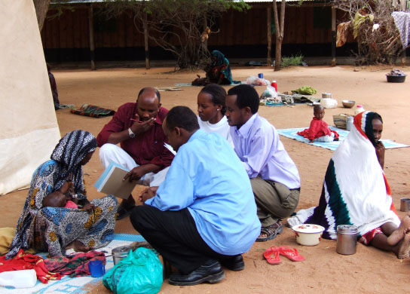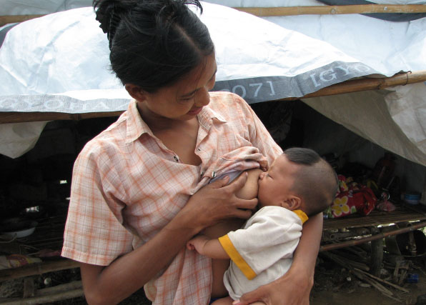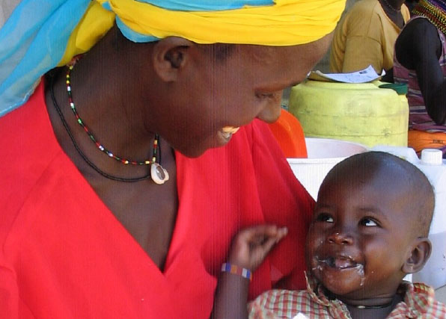
A PRACTICAL STEP-BY-STEP GUIDE VERSION 2 (2013)


Table of Contents

Key messages 4
Definition of some key terms 6
Objectives and target groups 8
Data collection 9
Measurement methods 9
Material needed 10
Ethical considerations 10
Standard procedure and quality assurance 10
Training 11
Theoretical component 11
Practical component 13
Questionnaire and rationale for questions 14
Data cleaning 23
Daily questionnaire check and overseeing interviews 23
Database check 23
presentation of results 24
Results tables and figures 24
Data analysis 27
Analysis procedures 27
Common errors and challenges in data analysis 33
USE of results 34
Recommendations 35
References 36

Annex 1 - SENS IYCF questionnaire 38
Annex 2 - Training ideas 40
Annex 3 - Age guide 43
Annex 4 - Epi info Data Entry 44
Annex 5 - Epi info Data Analysis 46
Annex 6 - Presentation of combined results 67

Key messages

- UNHCR supports the policy of the World Health Organization (WHO) concerning safe and appropriate infant and young child feeding, in particular by protecting, promoting and supporting exclusive breastfeeding for the first six months of life and continued breastfeeding for two years or beyond, with timely and correct use of adequate complementary foods. The use of milk products in refugee settings must conform to the UNHCR milk policy.

- Breastfeeding guarantees food and fluid security in infants for the first six months and provides active immune protection and remains a significant source of energy, nutrients and protection up to two years and beyond.

- Breastfeeding is an unequalled way of providing complete hygienic food for the healthy growth and development of infants, and forms a unique biological and emotional basis for the health of both mother and child. In addition, the active anti-infective properties of breastmilk help to protect infants against disease, and there is an important relationship between exclusive breast-feeding and child spacing. Breastmilk alone (exclusive) satisfies the nutritional and fluid requirements of an infant for the first complete six months of life in all settings and climates. After six months, adequate and appropriate infant complementary foods become necessary to complement breastmilk in order to meet the energy and other nutrient requirements of the infant (timely complementary feeding). Breastmilk remains a significant source of energy, nutrients and protection up to two years and beyond.

- Infant and young child feeding practices directly affect the nutritional status of children under two years of age and, ultimately, impact child survival. Protecting, and where necessary improving on, infant and young child feeding practices in children aged 0-23 months of age is therefore critical to improved nutrition, health and development of children. Infants and young children who are not breastfed – temporarily or long-term – need early identification and appropriate support to minimise risks.

- The inclusion of this IYCF module in routine nutrition surveys will provide information on some priority IYCF indicators among children 0-23 months. If a more detailed analysis of IYCF is needed to assess programme impact, it is recommended to implement a stand-alone IYCF survey using the CARE guidelines (January 2010).
- The majority of questions for this IYCF module are taken from the WHO and CARE Guidelines on IYCF that seek to harmonise the surveys undertaken in the sector. The harmonisation of survey instruments and survey design allows for comparison e.g. between national populations and refugee populations. Providing good quality training to survey teams and supervising them well will help ensure that data are reliable.

- Standard questionnaires should be used for the collection of IYCF indicators and the exact same questions and number of questions should be asked from year to year to allow direct comparisons of results. The questions on liquids and foods should be adapted to the local context (the wording of the actual questions should not be changed). Attention to accurate estimation of age is critical for quality indicator measurement.

- There are standard ways of reporting IYCF indicators that should be followed in all nutrition survey reports produced in refugee contexts.

Definition of some key terms

Infant: a child aged less than 12 months.

Young child: a child aged 12-<24 months (12-23 completed months, 12 through 23 months or 12 up to 24 months). This age group is equivalent to the definition of toddler (12-23 months) as defined in the World Health Report 2005, p.115.

Optimal infant and young child feeding: early initiation (within one hour of birth) of exclusive breastfeeding, exclusive breastfeeding for the first six months of life, followed by nutritionally adequate and safe complementary foods, while breastfeeding continues for up to two years of age or beyond.

Exclusive breastfeeding: an infant receives only breastmilk and no other liquids or solids, not even water, with the exception of drops or syrups consisting of vitamins, mineral supplements or medicines.

Breastmilk substitutes: includes any food being marketed or otherwise presented as a partial or total replacement for breastmilk, whether or not suitable for that purpose. In practical terms, foods may be considered a BMS depending on how they are marketed or represented. These include infant formula, other milk products, therapeutic milk, and bottle-fed complementary foods marketed for children up to two years of age and complementary foods, juices and teas marketed for infants under six months.

Milk products: dried whole, semi-skimmed or skimmed milk; liquid whole, semi-skimmed or skimmed milk; soya milks; evaporated or condensed milk; fermented milk or yogurt.

Powdered milk: dehydrated milk or dried milk in the form of a powder. Powdered milk is different than infant formula (see definition below).

Infant formula: is a breastmilk substitute formulated industrially that should be in accordance with applicable Codex Alimentarius standards.

Complementary feeding (previously called ‘weaning’ and more accurately referred to as ‘timely complementary feeding’): the child receives age-appropriate, adequate and safe solid or semi-solid food in addition to breastmilk or a breastmilk substitute.

Commercial baby foods: industrially produced and marketed infant complementary foods, such as branded jars, packets of dried, semi-solid or solid foods.

Infant complementary food: any food, whether industrially produced or locally prepared, used as a complement to breastmilk or to a breast-milk substitute. The term ‘infant complementary food’ is used to distinguish between complementary food referred to in the context of infant and young child complementary feeding, and complementary food used in the context of Food Assistance, which are foods (beyond the basic food aid commodities) provided to an affected population to diversify their dietary intake and complement the ration, e.g. fresh fruits and vegetables, tinned fish/meat, condiments or spices. Infant complementary foods should not be marketed for infants under six (completed) months.

Food group: a group of foods that have similar nutritional properties and is part of the hierarchy of the food pyramid, such as cereal group, milk group, meat and protein group, fruit and vegetable group, fats and sweets group.

Ready-to-use therapeutic foods (RUTF): these are soft or crushable foods that can be consumed directly from the packet by children from the age of six months. The formula for RUTF is specifically designed for the dietary treatment of SAM before the onset of medical complications or when these are under control after stabilisation. Product brand names include but are not limited to Plumpy’Nut® and eeZeePaste™. RUTF is being increasingly manufactured at a national or sub national scale.

Ready-to-use supplementary foods (RUSF): these are mostly oil seed or peanut-based pastes (although other recipes are being tested in the field). RUSF can be designed to include precise quantities of macro and micronutrients for different target groups. The evidence base is still being developed; however, increasingly RUSF are being used in the field to address MAM. Product brand names include Supplementary’Plumpy® now being called Plumpy’Supp®.

Lipid-based nutrient supplement (LNS): these are a family of products designed to deliver nutrients to vulnerable people. They are considered ‘lipid based’ because the majority of the energy provided by these products is from lipids (fats). All LNS provide a range of vitamins and minerals, as well as energy, protein, and essential fatty acids. LNS formulations can be tailored to meet the nutrient needs of specific groups and to fit in particular programmatic contexts. Product brand names include Nutributter® and Plumpy’doz®.

Micronutrient powder (MNP): MNPs provide no energy (kcal) in the diet. They are usually packaged in individual sachets to provide a dose of selected vitamins and minerals in powder form, to be added to foods directly after cooking. MNPs have been shown to be efficacious in treating and preventing anaemia. Product brand names include Sprinkles™ and MixMe™.

Objectives and target groups

The standard age group to include in an IYCF assessment is children aged 0-23 months (meaning children aged 0 to <24 months).

This IYCF module aims to measure the following priority indicators:

- Timely initiation of breastfeeding in children aged 0-23 months (meaning children aged 0 to <24 months)
- Exclusive breastfeeding under 6 months (meaning children aged <6 months)
- Continued breastfeeding at 1 year in children aged 12-15 months (meaning children aged 12 to <16 months)
- Continued breastfeeding at 2 years in children 20-23 months (meaning children aged 20 to <24 months)
- Introduction of solid, semi-solid or soft foods in children aged 6-8 months (meaning children aged 6 to <9 months)
- Consumption of iron-rich or iron-fortified foods in children aged 6-23 months (meaning children aged 6 to <24 months)
- Bottle feeding in children aged 0-23 months (meaning children aged 0 to <24 months)

Objectives should be worded as follows in the survey protocol and report:

- To investigate IYCF practices among children 0-23 months.

Things to note:

- When IYCF indicators are collected in nutritional surveys based on GAM in children aged 6-59 months, it is not feasible to achieve a large enough sample size for some of the indicators to be estimated as precisely as desired, especially for indicators covering a very narrow age range (e.g. 6-8 months, 12-15 months, 20-23 months). Nevertheless, including this IYCF module in the nutrition survey will provide trend data from year to year for certain priority indicators to monitor programme performance (see Results section) and will flag major problems with IYCF which need further investigation. The confidence intervals are an integral part of the results in this IYCF module.

Data collection

Measurement methods

- IYCF indicators are assessed using interviews with mothers or the main caregiver of young children.

- In order for the measurement methods to be reliable, it is vital that the questions are asked exactly as they are written and that any modification is agreed with all the surveyors so that the methodology is as standardised as possible.

- What people eat varies by geography, wealth and custom. Therefore the locally available liquids and iron-rich / iron fortified foods used in the specific context must be investigated and categorised correctly in the generic SENS questionnaire.

- When adapting the liquid list, it is critical to include all special liquids that may be given to infants under six months of age. Otherwise, estimates of the prevalence of exclusive breastfeeding may be biased (inflated).

- It is crucial to invest time in assessment of infant age as IYCF indicators rely on accurate age assessment. A tendency to round age upwards and to key ages, e.g. rounding age up to 6 months when the child is actually still 5 months of age, will bias the prevalence of exclusive breastfeeding and introduction of solid, semi-solid or soft foods, for example.

- It is crucial to ask the exact same questions from year to year in surveys conducted in the same areas.

- The following steps should be followed to adapt the liquid and iron-rich / iron fortified food lists to the specific refugee contexts:

- Consult staff and nutritionists from health facilities, feeding programmes, UNHCR, WFP, UNICEF and other partners.

- Visit homes and talk with mothers or other primary caregivers.

- Visit markets and stores to look at available brand names of products in the survey area.
- Consult existing liquid and food lists from previous surveys in the refugee settings and in the country (e.g. DHS, WFP / FAO, UNICEF).

- Name specific liquids and foods that your target population is familiar with.

- When asking about commercially available foods, use local brand names.

- Include all common names for items: because beverage and food names can vary significantly, even in the same language, care should be taken during translation. If a popular food has more than one common name, consider including several names in the questionnaire. Therefore it is useful to discuss the liquid and food with individuals familiar with local names used throughout the survey area.

- Consider distributed food commodities: distributed foods in refugee settings often include fortified blended foods such as CSB+ / WSB+, CSB++/WSB++, and may include micronutrient powders or lipid-based nutrition supplements. Children being treated for SAM as an outpatient in the community will be receiving RUTFs and children being treated for MAM will either receive RUSFs or a fortified blended food pre-mix.

Material needed

- IYCF survey questionnaires: 1 per child surveyed (always carry extra copies).

- The SENS IYCF questionnaire for children 0-23 months is shown in Annex 1 or see SENS Pre-Module tool: [Tool 9-Full SENS Questionnaire].

Ethical considerations

- A standard IYCF questionnaire will be administered with the consent of the householder. Refer to SENS Pre-Module Step 13 for guidance on approaching households and seeking informed consent.

Standard procedure and quality assurance

- A standard IYCF questionnaire will be administered at each of the selected households in all children 0-23 months of age, if any, with the consent of the householder (refer to the SENS Pre-Module Step 8).

- The respondent should be the mother or the main carer responsible for feeding the child aged 0-23 months in the household.

Training

- The training needs to contain a mix of theory, practical exercises (especially role plays), a standardising exercise as well as a written or verbal test. Annex 2 provides some training ideas.

- It is crucial that the coordinator(s) refresh their skills before beginning the training and read all of the background material provided.

- The training on the SENS IYCF questionnaire will require at least half a day.

- The IYCF questionnaire should be adapted prior to the training by listing the locally available liquids and iron-rich / iron fortified foods that apply to the specific context.

- The training session is also a useful opportunity to identify any previously unseen problems with the liquid and food lists or question formats.

Theoretical component

The theoretical component of the IYCF module should include:

- Overview of module, questionnaire and procedure to be followed
- The rationale for asking specific questions
- Information on specific liquids and iron-rich / iron fortified foods
- Information to help surveyors distinguish different liquids and foods specific to their area
- A short written or verbal test
Things to watch out for:

- Table 1 describes the most common errors experienced by survey workers in data collection. These should be emphasised during the training and the survey supervisor / coordinator should focus on these when assessing the teams’ performance during supervision visits throughout the survey.

Table 1 Common errors and challenges in data collection

Common errors | Examples | Solution
Wrongly assessing age eligibility of the child | Completing the IYCF interview on a child that is 24 months of age and has reached his / her second birthday. | Ensure that the inclusion and exclusion birthdates and months are clear to the surveyors. Provide the team leader with an age guide where inclusion and exclusion dates are provided for children 0-5 months and 6-23 months. See Age Guide example in Annex 3.
Respondents feel embarrassed to answer the questions | Women may not feel comfortable answering questions if the enumerator is male. | Investigate the likelihood of this being a problem prior to the survey and ensure that there are female interviewers.
Respondents do not understand the questions or the information is too difficult to report | High percentage of ‘don’t know’ categories. | Review questions and translation.  Ensure that the respondent is the main caregiver of the child.
Inconsistencies in data collection | The child has never been breastfed (response no to ‘ever breastfed’) but the child was breastfed yesterday. | The supervisor must check the questionnaires; either in the field or at the end of the day and rectify any errors as quickly as possible.
Question is not read exactly as it is written | The surveyor asks about liquids given the day of the survey and does not use the 24 hour recall period by asking specifically about ‘yesterday, during the day or at night…’. | The training needs to highlight the common pitfalls.  During supervision visits, close attention must be paid to these pitfalls.
Surveyor does not understand the question well enough | The surveyor thinks that a clear broth is a solid or semi-solid (soft, mushy) food as opposed to a water-based liquid. | The training needs to ensure that surveyors are well prepared so that they can explain this question to the respondents in a standardised fashion.
The respondent does not understand the reasons for the survey | The respondent thinks it will entitle them to additional food and hence overestimates the age of the children, biasing the answers. | The training needs to ensure that surveyors understand the purpose of the survey and explain it well to respondents.

Practical component

- The practical component should form the main part of the training and should employ role-play to ensure that surveyors are following standard procedures and that they communicate effectively and respectfully with respondents.

Guidance for coordinators

- Tables 2-5 provide instructions on the questionnaire for adaptation to the local context and instructions to be given to the surveyors.
- The IYCF module training should ensure that surveyors have adequate practice in using the questionnaire.
- Revise the list of liquids and iron-rich / iron-fortified foods to reflect the specific context of the survey.
- Prepare / translate and back translate the questionnaire: do not change the wording of the questions.
- Breastfeeding may be a sensitive topic in some situations and this should be assessed prior to the survey so that acceptable ways of asking the mother or main caregiver about breastfeeding can be determined. It may be necessary to have female surveyors interviewing female respondents.
- Some participants will learn more quickly than others and they should be paired with the less able surveyors both in the training and in the field.

Basic instructions for survey teams

- They need to be trained on interview techniques: introduction, consent, confidentiality etc.
- It is very important that surveyors ask each question exactly as it is written on the questionnaire.
- The question may need to be repeated again but the wording should not be changed too quickly as it may be that the respondent did not hear properly or was not concentrating.

Questionnaire and rationale for questions

- The tables below provide instructions on the questionnaire for adaptation to the local context, explain the rationale of each question and highlight special instructions to be given to the surveyors.

- A standard Epi Info View for data entry is shown in Annex 4. Free guidance on the use of Epi Info for Windows and training material on Epi Info can be found at the following site: http://www.cdc.gov/EpiInfo

Table 2 IYCF Module: Explanation of questions for Section IF1

Question number/  Section IF1 | Suggested variable name | Question | Rationale | Special Instructions
IF1 | SEX | Sex  1=Male  2=Female | Gender is recorded as male or female. | -
IF2 | BIRTHDAT | Birthdate | The exact date of birth (day, month, year) is recorded from either an EPI card, child health card or birth notification if available. | Make sure to record from a valid age documentation. If no valid age documentation is available, leave question blank.
IF3 | MONTHS | Child’s age in months (range 0-23.99) | The age in months is calculated from the exact birthdate recorded in question 1 or is estimated using a local events calendar. | If no reliable proof of age is available for Question 1, age is estimated in months using a local events calendar or by comparing the selected child with a sibling or the child of a neighbour whose ages are known. If the child has not yet reached his / her 2nd birthday, s/he should be included.  Provide surveyors with an age guide (see Annex 2 for an example) to help in the process of selecting eligible children.
IF4 | EVERBF | Has [NAME] ever been breastfed?  1=Yes  2=No  8=Don’t know | The aim of this question is to confirm whether or not the child has ever received breastmilk from his / her own mother or another woman, even if the breastmilk was given by spoon, cup or bottle. For this question, it does not matter how long the child was breastfed for. | If the answer is ‘2’ (No) or ‘8’ (Don’t know), the interviewer should skip to Question IF7.
IF5 | INITBF | How long after birth did you first put [NAME] to the breast?  1=Less than one hour  2=Between 1 and 23 hours  3=More than 24 hours  8=Don’t know | Early initiation (within one hour of birth) of exclusive breastfeeding significantly reduces the risk of neonatal mortality. Infants for whom initiation of breastfeeding is delayed to more than 24 hours after birth are 2.4 times more likely to die during their first month of life. The risk of neonatal death is increased approximately fourfold if milk-based fluids or solids are provided to breastfed neonates. | If respondent reports she put the infant to the breast immediately after birth, select ‘1’ (less than one hour).
IF6 | YESTBF | Was [NAME] breastfed yesterday during the day or at night?  1=Yes  2=No  8=Don’t know | The aim of this question is to confirm whether or not the child received breastmilk from his / her own mother or another woman, even if the breastmilk was given by spoon, cup or bottle in the last 24 hours. | -

Table 3 IYCF Module: Explanation of questions for Section IF2

Question number/  Section IF2 | Suggested variable name | Question | Rationale | Special Instructions
 |  |  | The aim of these questions (IF7: 7A-7I and IF8) is i) to learn if the child is being exclusively breastfed for 6 months, ii) to determine infant formula intake and iii) to assess introduction of solid, semi-solid or soft foods using a 24-hour recall. | -
IF7 |  | Now I would like to ask you about liquids that [NAME] may have had yesterday during the day and at night. I am interested in whether your child had the item even if it was combined with other foods.  Yesterday, during the day or at night, did [NAME] receive any of the following?  1=Yes  2=No  8=Don’t know | The aim of these questions is to learn about different types of liquids the child may have consumed the day before the interview (yesterday during the day or at night). It is extremely important to ask about all the different kinds of liquids listed. This is because if a child consumed any of the liquids, that child 0-5 months was not exclusively breastfed. | These questions are asked to all children aged 0-23 months to determine exclusive breastfeeding in children 0-5 months and to determine infant formula intake in children 0-23 months.  It is crucial that the list of liquids be adapted to the local context.  Read the question slowly and then read through each item in the list. Wait for the response after each item and record whether the child consumed the liquid or not.
7A | WATER | Plain water | When a child is exclusively breastfed, s/he receives only breastmilk and no other liquids or solids, not even water. | This question only applies to plain water. If sugar or sweetened water was given, this is included in question 7I (other water-based liquids).
7B | INFORM | Infant formula | Infant formula is a nonhuman milk product formulated from animal milk or vegetable protein (soy) and adapted to the physiological characteristics of infants. The risks of infection or malnutrition from using breastmilk substitutes are likely to be greater than the risk of HIV transmission through breastfeeding. Therefore, support to help all women to achieve early initiation and exclusive breastfeeding for the first six completed months and the continuation of breastfeeding into the second year of life are likely to provide the best chance of survival for infants and young children in emergencies (Ops Guidance on IFE, section 5.2.8, v2.1, Feb 2007). | Add locally available brand names of fortified and non-fortified infant formula. Make sure that the surveyors distinguish between infant formula and milk powder (see below).
7C | MILK | Milk such as tinned, powdered, or fresh animal milk | Animal milks (in addition to infant formula) are also considered a breastmilk substitute. | Add locally available brand names of tinned and powdered milk. Powdered milk is dehydrated milk or dried milk in the form of a powder. Powdered milk is different from infant formula.
7D | JUICE | Juice or juice drinks | Juice and juice drinks are listed together because it is usually very difficult to distinguish between them in the field. | Add locally available brand names of juice drinks.
7E | BROTH | Clear broth | Clear broths are essentially water-based drinks. | Soups that are thickened in any way or include solid pieces of food should not be included here. They should be included in question IF8 (see below).
7F | YOGURT | Sour milk or yogurt | Thin, liquid yogurt is fed to infants and young children in some countries. However, the question is intended to capture all types of yogurt, not just thin, liquid yogurt.  Sour milk is a food product, distinguished from spoiled milk, and is a general term for milk that has acquired a tart taste, either through the addition of an acid, such as lemon juice or vinegar, or through bacterial fermentation. | Add local names of yogurt, including specific types of yogurt that are given to infants and young children.
7G | THINPOR | Thin porridge | Thin porridge or gruels are often the first semi-solid foods given to infants, including infants less than 6 months of age. Any type of thin porridge should be counted here, regardless of main ingredients (for example, it may be grain-based, root / tuber based, etc.). | In many countries, there are different terms for different consistencies of porridge. Use local terms for thin porridge that are usually fed to infants. Thick porridge (for example, as usually eaten by older children and adults) should be included in Question IF8 (see below).
7H | WHTEACOF | Tea or coffee with milk | Although large amounts of tea and coffee would not be recommended for infants and young children, they are often given either with water alone or with milk. This question will capture tea or coffee given with milk. | If tea or coffee with milk is not given to infants and young children in the survey area, you may delete this question.
7I | WATLQD | Any other water-based liquids | If they are other specific water-based liquids that are fed to infants and / or young children in particular, these should be specified here.  Clear tea with no milk and black coffee should be listed here if given to infants and young children. | List other water-based liquids available in the local setting, for example: sodas, other sweet drinks, herbal infusion, gripe water, clear tea with no milk, black coffee, ritual fluids.
IF8 | FOOD | Yesterday, during the day or at night, did [NAME] eat solid or semi-solid (soft, mushy) food?  1=Yes  2=No  8=Don’t know | Solid / semi-solid foods include family foods, and also many special dishes prepared for infants. | Thick soups and stews should be included. Thick porridges are also included. Very thin, watery soups and gruels should not be included here because infants and young children do not get enough energy (calories) from very thin soups and gruels. These should be included under ‘thin porridge’ in Question 7G.

Note: For the calculation of the optional WHO indicator on predominant breastfeeding under 6 months, the following items from the above list are not ‘allowed’: infant formula, fresh animal milk or any tinned or powdered milk, sour milk or yogurt, thin porridge, tea or coffee with milk, solid or semi-solid food. All other items from the list above are ‘allowed’ under predominant breastfeeding.

Table 4 IYCF Module: Explanation of questions for Section IF3

Question number/  Section IF3 | Suggested variable name | Question | Rationale | Special Instructions
IF9 | BOTTLE | Did [NAME] drink anything from a bottle with a nipple yesterday during the day or at night?  1=Yes  2=No  8=Don’t know | Information on bottle feeding is useful because of the potential interference of bottle feeding with optimal breastfeeding practices, and the association between bottle feeding and increased diarrhoeal disease morbidity and mortality. Bottles with a nipple are particularly prone to contamination.  Spoons, cups and gourds may also be dirty, but bottles with nipples / teats are even more likely to be contaminated and to make the baby sick. | Make sure that the interviewer is aware that this question investigates whether the child received any food or drink from a bottle with a nipple / teat during the previous day including breastmilk, regardless of whether or not the infant was breastfed.

Table 5 IYCF Module: Explanation of questions for Section IF4

Question number/  Section IF4 | Suggested variable name | Question | Rationale | Special Instructions
IF10 | CHELIG | Is child aged 6-23 months?  1=Yes  2=No | This data is not analysed. It is a filter question.  Children with answer ‘1’ (yes) will be asked the questions below (IF11: 11A-H and IF12 where applicable). | If the child has not reached 6 months of age yet, they should be excluded from the following set of questions.
IF11 |  | Now I would like to ask you about some particular foods [NAME] may eat. I am interested in whether your child had the item even if it was combined with other foods.  Yesterday, during the day or at night, did [NAME] consume any of the following?  1=Yes  2=No  8=Don’t know | The aim of these questions is to learn if the child is being fed iron-rich or iron-fortified products using a 24-hour recall.  Products that are specifically fortified to meet the needs of infants and young children can be extremely helpful in filling common nutrient gaps. Fortified products include: iron-fortified foods specifically formulated for infants and young children; ready-to-use therapeutic foods; ready-to-use supplementary foods; lipid-based nutrient supplements (which may be mixed with porridges or other foods); and other home fortification products such as micronutrient powders (or crushable tablets). | It is crucial that the list of iron-rich and iron fortified foods, and distributed commodities be adapted to the local context.  Read the question slowly and then read through each item in the list. Wait for the response after each item and record whether the child consumed the food or not.  Use local names for products.
11A | FLESHFD | Flesh foods | This includes meat, fish, poultry and liver / organ meats as shown below:  -beef, goat, lamb, mutton, pork, rabbit or other large wild (bush meat) or domesticated mammals  -chicken, duck, or other wild or domesticated birds  cane rat, guinea pig, rat, agouti or other small wild (bush meat) or domesticated mammals  -frogs, snakes, and other reptiles  -insects  -liver, kidney, heart or other organ meats or blood-based foods | This group includes different types of flesh foods and red organ meats.  Any processed / cured products made from these organ meats should also be included.  Only include as example the flesh foods and red organ meats commonly used for infants and young children in the local context.
11B | FBF | FBF | This includes fortified blended foods such as corn-soy blend (CSB) and wheat-soy blend (WSB). Most worldwide CSB supplies are now known as CSB+ or CSB Supercereal which contain an improved formulation of vitamins and minerals. | Only include the blended foods being distributed in the local context as examples.  If there are no fortified blended foods being distributed in the local context, you may delete this question.
11C | FBFSUPER | FBF++ | This includes newly developed fortified blended foods for infants and young children such as CSB++ / WSB++. FBF++ contains milk powder and lipids, and has a higher energy density than other types of FBF. | Only include the special blended foods being distributed in the local context as examples.  If there is no FBF++ being distributed in the local context, you may delete this question.
11D | RUTF | RUTF | This includes ready-to-use therapeutic foods such as Plumpy’Nut® and eeZeePaste™. | Only include the products being distributed in the local context as examples.  The sachets of the product should be shown to the respondent to assist in the recall.  If there are no RUTFs being distributed in the local context, you may delete this question.
11E | RUSF | RUSF | This includes ready-to-use supplementary foods such as Plumpy’Sup®. | Only include the products being distributed in the local context as examples.  The sachets of the product should be shown to the respondent to assist in the recall.  If there are no RUSFs being distributed in the local context, you may delete this question.
11F | LNS | LNS | This includes lipid-based nutrient supplements such as Nutributter® and Plumpy’doz®. | Only include the products being distributed in the local context as examples.  The sachets or pot of the product should be shown to the respondent to assist in the recall.  If there are no LNS being distributed in the local context, you may delete this question.
11G | INFORMFE | Infant formula | This includes iron fortified infant formula only. | Note that the brand names may differ from Question 7B because only iron fortified infant formula is included here.
11H | FOODFE | Iron fortified solid, semi-solid or soft foods | This includes any iron fortified solid, semi-solid or soft foods designed specifically for infants and young children available in the local settings that are different than distributed commodities. | Include commercial baby foods that are iron fortified such as industrially produced and marketed complementary foods.
IF12 | MNP | Yesterday, during the day or night, did [NAME] consume any food to which you added a [powder or sprinkles] like this?  1=Yes  2=No  8=Don’t know | This should only be asked in a setting where MNP are used. | The sachets of the product should be shown to the respondent to assist in the recall.  If there are no MNPs being distributed in the local context, you may delete this question.

Data cleaning

Daily questionnaire check and overseeing interviews

- Supervisors will not have the chance to observe every interview conducted but they are responsible for reviewing every questionnaire for errors.

- This should be done in the field, if possible, so that any problems can be resolved immediately and, if not then, at the end of each day.

- Check that consent was given. If consent was not given, ask the surveyors if they know the reasons. If there are many refusals, knowing this information will help clarify any misunderstandings, concerns or misconceptions with the community being surveyed.

- Check for missing data, ‘don’t know’ answers (these should always be minimal) or inconsistencies in data e.g. child was never breastfed (Question IF4) but was breastfed yesterday (Question IF6); child is 3 months old and questions on iron-rich and iron-fortified foods were asked (Questions IF11: 11A-H).

- Check that the age is between 0 and 23 months for children (Questions IF2-IF3).

Database check

- Brief guidance on the data cleaning process is provided in Annex 5 using Epi Info (version 3.5.4 July 2012). Free guidance on the use of Epi Info for Windows and training material on Epi Info can be found at the following site: http://www.cdc.gov/EpiInfo

presentation of results

- IYCF results should be presented as proportions with 95% confidence interval (CI).
- When presenting the results from several camps with a representative sample drawn from each camp into one report, it is recommended to present results from each camp separately. See SENS Pre-Module tools: [Tool 4b-Dolo SENS Survey Report 2013] and [Tool 5-Dadaab Survey Report 2011].

- When several camps are surveyed with a representative sample drawn from each camp, it is not necessary to report combined results for each indicators; see Annex 6 for the recommended combined indicators to report. See the SENS Pre-Module tool that will automatically generate weighed prevalence results: [Tool 14-Weighting Data Tool].

- All survey reports should present results the tables and figure shown below.

- Where an exhaustive (census) survey is conducted, confidence intervals should not be presented.

Results tables and figures

- There is a trend graph that is recommended to be included in the final SENS report. Refer to SENS Pre-Module Step 15 for a description on constructing trend graphs and on how to interpret trends and differences. For a tool that will automatically generate trend graphs, see SENS Pre-Module tool: [Tool 12-Trends and Graphs].

- Showing the recommended figure will allow for the assessment of trends. Note that, to identify a trend, it is advised that prevalence data from at least three time points are obtained.

- When IYCF indicators are collected in nutritional surveys based on GAM in children aged 6-59 months, it is not feasible to achieve a large enough sample size for some of the indicators to be estimated as precisely as desired, especially for indicators covering a very narrow age range (e.g. , 6-8 months, 12-15 months, 20-23 months). Hence, trend analyses need to be interpreted with caution. Nevertheless, trend analyses are useful for assessing the situation and major differences seen from year to year should warrant further investigation.

IYCF indicators

Table 6 Prevalence of Infant and Young Child Feeding Practices Indicators

Indicator | Age range | Number/  total | Prevalence  (%) | 95% CI
Timely initiation of breastfeeding | 0-23 months
Exclusive breastfeeding under 6 months | 0-5 months
Continued breastfeeding at 1 year | 12-15 months
Continued breastfeeding at 2 years | 20-23 months
Introduction of solid, semi-solid or soft foods | 6-8 months
Consumption of iron-rich or iron-fortified foods | 6-23 months
Bottle feeding | 0-23 months

- The prevalence of a few IYCF indicators should be presented from year to year as shown in the example figure below.

Figure 1 KEY IYCF indicators from 2009-2011 (this FIGURE CAN BE automatically GENERATED BY USING sENS pre-module TOOL 12 – TRENDS AND GRAPHS)

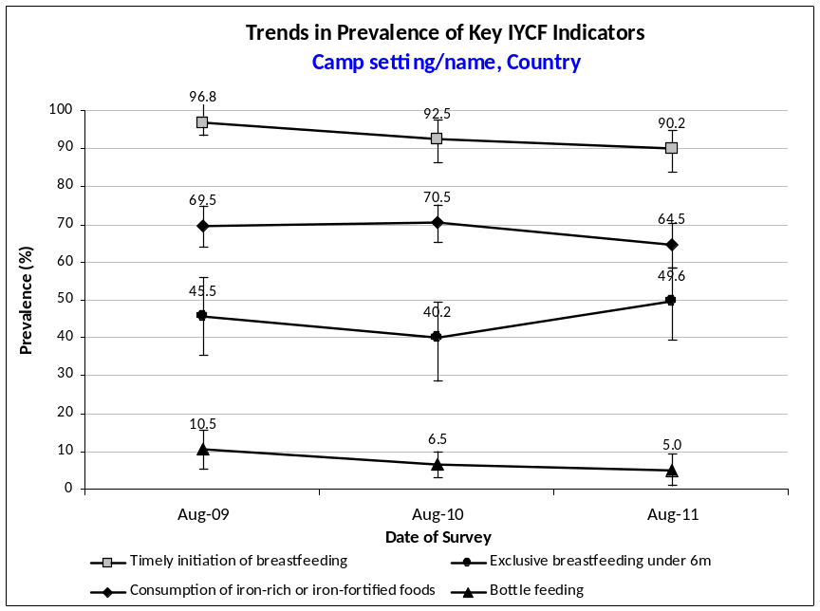
Prevalence of intake

Infant formula

Table 7 Infant formula intake in children aged 0-23 months

 | Number/total | % (95% CI)
Proportion of children aged 0-23 months who receive infant formula (fortified or non fortified)

Fortified blended foods

Table 8 FBF intake in children aged 6-23 months [PRODUCT TO BE ADAPTED: the FBF may be CSB+ for example; DO NOT INCLUDE TABLE IF NO FBF DISTRIBUTED]

 | Number/total | % (95% CI)
Proportion of children aged 6-23 months who receive FBF

Table 9 FBF++ intake in children aged 6-23 months [PRODUCT TO BE ADAPTED: the FBF++ may be csb++ for example; DO NOT INCLUDE TABLE IF NO FBF++ DISTRIBUTED]

 | Number/total | % (95% CI)
Proportion of children aged 6-23 months who receive FBF++

Special nutritional products

Table 10 LNS intake in children aged 6-23 months [PRODUCT TO BE ADAPTED: the LNS product may be Nutributter® or Plumpy’doz® for example; DO NOT INCLUDE TABLE IF NO LNS DISTRIBUTED]

 | Number/total | % (95% CI)
Proportion of children aged 6-23 months who receive LNS

Table 11 MNP intake in children aged 6-23 months [PRODUCT TO BE ADAPTED: the MNP may have a specific name; DO NOT INCLUDE TABLE IF NO MNP DISTRIBUTED]

 | Number/total | % (95% CI)
Proportion of children aged 6-23 months who receive MNP

Data analysis

Analysis procedures

- Age data needs to be calculated to two decimal places for children with a birth date from an official age documentation but Epi Info View module does not have this function. After data entry is finalised in Epi Info View module, export the IYCF database from Epi Info Analysis module to Excel and calculate the age in months for children with a birth date using the following formula: =(SURVDATE-BIRTHDAT)/30.4375. Note that children whose ages were estimated using an event calendar will not have a decimal in their age data. Then, export the database back to Epi Info Analysis module and proceed with analysis.

- The first step in the data analysis process is to classify the categories into more easily manageable variables that relate to the indicators you are trying to measure. This involves recoding some of the responses into ‘new’ variables. Tables 12-13 provide some guidance on calculating the indicators and recoding the variables and on using Epi Info software.

- Make sure that the data has been cleaned before starting the analysis process.

- Brief guidance on using Epi Info software for analysis is provided below. Refer to Annex 5 for standard analysis commands using Epi Info (version 3.5.4 July 2012). Free guidance on the use of Epi Info for Windows and training material on Epi Info can be found at the following site: http://www.cdc.gov/EpiInfo

Table 12 Summary table of indicator definitions, calculation and questions used to construct indicators

Indicator Name | Definition | Calculation, variable names and remarks
- Timely initiation of breastfeeding (children 0-23 months) | Proportion of children 0-23 months old who were put to the breast within one hour of birth | Numerator: Number of children 0-23.99 months who were put to the breast within the first hour of birth (IF5=1 / INITBF=1)  Divided by  Denominator: Number of children 0-23.99 months  Exclude from analysis children with answer 8 (‘Don’t know’) for IF5 (INITBF=8).  Timely initiation of breastfeeding is calculated on living children only; it is different from early initiation (the indicator WHO recommends) which measures the number of living and deceased children who received breastmilk in the first hour of life.
- Exclusive breastfeeding under 6 months | Proportion of infants 0-5 months old who were fed exclusively with breastmilk in the past 24 hours | Numerator: Number of infants 0-5.99 months who received breastmilk in the past 24 hours (IF6=1 / YESTBF=1) and did not receive any other liquids or foods in the past 24 hours (all of IF7: 7A-I=2 and IF8=2 / WATER and INFORM and MILK and JUICE and BROTH and YOGURT and THINPOR and WHTEACOF and WATLQD and FOOD=2)  Divided by  Denominator: Number of infants 0-5.99 months old  Exclude from analysis children with answer 8 (‘Don’t know’) for any of IF6, IF7: 7A-I or IF8 (YESTBF or WATER or INFORM or MILK or JUICE or BROTH or YOGURT or THINPOR or WHTEACOF or WATLQD or FOOD=8)  Exclude from analysis children with answer missing for any of IF7: 7A-I or IF8 (WATER or INFORM or MILK or JUICE or BROTH or YOGURT or THINPOR or WHTEACOF or WATLQD or FOOD=(.) ).
- Continued breastfeeding at 1 year | Proportion of children 12-15 months old who are fed breastmilk | Numerator: Number of children 12-15.99 months who received breastmilk in the past 24 hours (IF6=1 / YESTBF=1)  Divided by  Denominator: Number of children 12-15.99 months  Exclude from analysis children with answer 8 (‘Don’t know’) for IF6 (YESTBF=8).
- Continued breastfeeding at 2 years | Proportion of children 20-23 months old who are fed breastmilk | Numerator: Number of children 20-23.99 months who received breastmilk in the past 24 hours (IF6=1 / YESTBF=1)  Divided by  Denominator: Number of children 20-23.99 months  Exclude from analysis children with answer 8 (‘Don’t know’) for IF6 (YESTBF=8).
- Introduction of solid, semi-solid or soft foods | Proportion of infants 6-8 months old who receive solid, semi-solid or soft foods | Numerator: Number of infants 6-8.99 months who received solid or semi-solid (soft mushy) food in the past 24 hours (IF8=1 / FOOD=1).  Divided by  Denominator: Number of infants 6-8.99 months  Exclude from analysis children with answer 8 (‘Don’t know’) or missing for IF8 (FOOD=8, FOOD=(.) ).
- Consumption of iron-rich or iron-fortified foods | Proportion of children 6-23 months old who receive an iron-rich food or iron-fortified food that is specially designed for infants and young children or that is fortified in the home | Numerator: Number of children 6-23.99 months who received at least one iron-rich or iron-fortified food (from the types of foods listed in IF11: 11A-H and IF12 / FLESHFD or FBF or FBFSUPER or RUTF or RUSF or LNS or INFORMFE or FOODFE or MNP=1)  Divided by  Denominator: Number of children 6-23.99 months  Exclude from analysis children with answer 8 (‘Don’t know’) or missing for any of IF11: 11A-H and IF12 (FLESHFD or FBF or FBFSUPER or RUTF or RUSF or LNS or INFORMFE or FOODFE or MNP=8, (.) ).
- Bottle feeding | Proportion of children 0-23 months old who were fed with a bottle and nipple / teat during the previous day | Numerator: Children 0-23.99 months who were fed with a bottle during  the previous 24 hours (IF9=1 / BOTTLE=1)  Divided by  Denominator: Number of children 0-23.99 months  Exclude from analysis children with answer 8 (‘Don’t know’) or missing for IF9 (BOTTLE=8, BOTTLE=(.) ).

Table 13 Summary table of calculation for prevalence of intake by children

QUESTION | REPORTED RESULTS  (ORIGINAL VARIABLE NAMES) | ACTION
7B. Infant formula  1=Yes  2=No  8=Don’t know | Proportion of children aged 0-23 months who receive infant formula (fortified or non fortified)  (INFORM) | No recoding needed.  Run the ‘Frequencies’/‘Complex Sample Frequencies’ command on the variable termed INFORM to fill out Table 7.  The frequency of answer 1 (‘yes’) is reported.  Exclude from analysis children with answer 8 (‘Don’t know’) or missing for 7B (INFORM=8, INFORM=(.) ).
11B. FBF  1=Yes  2=No  8=Don’t know | Proportion of children aged 6-23 months who receive FBF  (FBF) | No recoding needed.  Run the ‘Frequencies’/‘Complex Sample Frequencies’ command on the variable termed FBF to fill out Table 8.  The frequency of answer 1 (‘yes’) is reported.  Exclude from analysis children with answer 8 (‘Don’t know’) or missing for 11B (FBF=8, FBF=(.) ).
11C. FBF++  1=Yes  2=No  8=Don’t know | Proportion of children aged 6-23 months who receive FBF++  (FBFSUPER) | No recoding needed.  Run the ‘Frequencies’/‘Complex Sample Frequencies’ command on the variable termed FBFSUPER to fill out Table 9.  The frequency of answer 1 (‘yes’) is reported.  Exclude from analysis children with answer 8 (‘Don’t know’) or missing for 11C (FBFSUPER=8, FBFSUPER=(.) ).
11F. LNS  1=Yes  2=No  8=Don’t know | Proportion of children aged 6-23 months who receive LNS  (LNS) | No recoding needed.  Run the ‘Frequencies’/‘Complex Sample Frequencies’ command on the variable termed LNS to fill out Table 10.  The frequency of answer 1 (‘yes’) is reported.  Exclude from analysis children with answer 8 (‘Don’t know’) or missing for 11F (LNS=8, LNS=(.) ).
IF12. MNP  1=Yes  2=No  8=Don’t know | Proportion of children aged 6-23 months who receive MNP  (MNP) | No recoding needed.  Run the ‘Frequencies’/‘Complex Sample Frequencies’ command on the variable termed MNP to fill out Table 11.  The frequency of answer 1 (‘yes’) is reported.  Exclude from analysis children with answer 8 (‘Don’t know’) or missing for IF12 (MNP=8, MNP=(.) ).

Common errors and challenges in data analysis

Table 14 describes the most common errors experienced by survey coordinators / supervisors when conducting the final data analysis.

Table 14 Common errors and challenges in data analysis

Common errors | Examples | Solution
Miscalculating the denominator when reporting on exclusive breastfeeding | One of the liquids is missed and not taken into consideration, or a ‘don’t know’ response is included as a ‘yes’ answer due to a recoding error. | Ensure to include all relevant variables and to recode carefully.
Not taking into consideration a weighting factor when combining prevalence estimates from several camps | When surveying several camps with a representative sample drawn from each camp, combining the samples from all camps to calculate the overall prevalence without taking into consideration a weighting factor. | For a tool that will automatically generate weighed prevalence results, see SENS Pre-Module tool: [Tool 14-Weighting Data Tool].
Reporting IYCF results according to certain aggregates of clusters | Reporting the IYCF results per groups of cluster. | Do not disaggregate cluster surveys according to clusters in the presentation of results. All clusters merged together from all section / blocks of the camp are representative of the camp as a whole and should not be disaggregated.
Reporting a change in IYCF indicators without any evaluation of whether the observed change is statistically significant or real | Using the point estimate results of two surveys (e.g. 56% vs. 59%) and concluding that there has been a change in e.g. exclusive breastfeeding in children less than 6 months without looking at the confidence intervals or conducting a statistical test. | Assess whether the confidence intervals overlap and conduct a statistical test using the CDC IERHB calculator. See SENS Pre-Module tool: [Tool 13-CDC Calculator twosurveys].

USE of results

- Including this IYCF module in the nutrition survey will allow to detect areas of concern where further assessment is needed.

- Special attention should be given to the nutritional value of the food ration distributed to older infants and young children whose particular nutritional requirements are often not covered by the general ration. Where a population is dependent on food assistance, UNHCR advocates that micronutrient-fortified food should also be included within the general ration for older infants and young children where the regular distribution of fresh foods is not an option.

- UNHCR recognises that non-breastfed infants and young children in refugee settings are a particular vulnerable group. Infants and young children who are not breastfed are at heightened risk of malnutrition, increased morbidity and mortality (the level of risk depends on the context). Artificial feeding in refugee settings is a last resort. This requires skilled breastfeeding assessment and support. Where artificial feeding is indicated, infants will need an appropriate breastmilk substitute, adequate and safe solid or semi-solid food to help meet all their nutritional requirements, facilities for food and breastmilk substitute preparation and storage, and supportive health care. To minimise the risks of non-breastfed infants and for the protection of breastfed infants, key conditions must be met if BMS are used for feeding non-breastfed infants.

Recommendations

The IYCF survey results should be used in conjunction with qualitative assessments, IYCF strategies and plans, and monitoring data to help UNHCR and partners plan and prioritise IYCF interventions. For example, the results can:

- Provide a quantitative baseline for subsequent monitoring and evaluation of IYCF programme progress and effectiveness;
- Highlight the need to strengthen the awareness, promotion, and protection of IYCF through for example baby tents and expanded mother to mother support groups;
- Identify areas of concern with regards to IYCF practices used by the refugee populations. For example, determining the proportion of non-breastfed infants that will necessitate identification and skilled assessment and support; detecting low prevalence figures of exclusive breastfeeding or a downward trend in prevalence that will require skilled breastfeeding support; identifying risky IYCF practices to inform areas to target in a population, e.g. bottle feeding; identifying inadequate intake of micronutrient rich foods that will necessitate improving the quality of food available for complementary feeding; investigating the factors determining bottle feeding;
- Help to inform advocacy efforts to improve funding and / or the deployment of resources.
References

Harmonised Training Package (2011) Version 2 Module 17. Infant and young children feeding: www.ennonline.net/ife

Infant and Young Child Feeding Practices (2010): Collecting and Using Data: A Step-by-Step Guide. Cooperative for Assistance and Relief Everywhere, Inc. (Care USA):
www.ennonline.net/ife

WHO Indicators for assessing infant and young child feeding practices Part 1 Definitions (2007) and Part 2 Measurement (2009):
http://www.who.int/nutrition/publications/infantfeeding/en/index.html

UNHCR (2006). Policy of the UNHCR on the acceptance, distribution and use of milk products in refugee settings: http://www.unhcr.org/4507f7842.html

The UNHCR handbook for Emergencies (page 314 - 320): http://www.unhcr.org/cgi-bin/texis/vtx/home/opendocPDFViewer.html?docid=472af2972&query=Handbook%20for%20Emergencies

UNHCR (2009) Guidance on Infant feeding and HIV in the context of refugees and displaced populations Version 1.1: http://www.unhcr.org/4acb0c111b.html

IFE Core Group (2007) Operational Guidance for Emergency Relief Staff and Programme Managers on Infant and Young Child Feeding in Emergencies (referred to as ‘the Operational Guidance on IFE’) Version 2.1: www.ennonline.net/ife

IFE Module 2. Infant Feeding in Emergencies. For health and nutrition workers in emergency situations. Version 1.1 December 2007: www.ennonline.net/ife

annexes

Annex 1 - SENS IYCF questionnaire
See SENS Pre-Module Tool 9 for the full SENS Questionnaire.

No | QUESTION | ANSWER CODES
SECTION IF1

IF1 | Sex  SEX | Male 1  Female 2 |  | |___|
IF2 | Birthdate  RECORD FROM AGE DOCUMENTATION.  LEAVE BLANK IF NO VALID AGE DOCUMENTATION.  BIRTHDAT | Day/Month/Year…..|___|___| /|___|___| / |___|___||___|___|
IF3 | Child’s age in months  MONTHS | IF AGE DOCUMENTATION NOT AVAILABLE, ESTIMATE USING EVENT CALENDAR. IF AGE DOCUMENTATION AVAILABLE, RECORD THE AGE IN MONTHS FROM THE DATE OF BIRTH |  | |___|___|
IF4 | Has [NAME] ever been breastfed?  EVERBF | Yes 1  No 2  Don’t know 8 |  | |___|  IF ANSWER IS 2 or 8 GO TO IF7
IF5 | How long after birth did you first put [NAME] to the breast?  INITBF | Less than one hour 1  Between 1 and 23 hours 2  More than 24 hours 3  Don’t know 8 |  | |___|
IF6 | Was [NAME] breastfed yesterday during the day or at night?  YESTBF | Yes 1  No 2  Don’t know 8 |  | |___|
SECTION IF2

IF7 | Now I would like to ask you about liquids that [NAME] may have had yesterday during the day and at night. I am interested in whether your child had the item even if it was combined with other foods. Yesterday, during the day or at night, did [NAME] receive any of the following?  ASK ABOUT EVERY LIQUID. IF ITEM WAS GIVEN, CIRCLE ‘1’. IF ITEM WAS NOT GIVEN, CIRCLE ‘2’. IF CAREGIVER DOES NOT KNOW, CIRCLE ‘8’. EVERY LINE MUST HAVE A CODE.  Replace and adapt the TEXT HIGHLIGHTED IN GREY TO THE CONTEXT.  The text IN ITALICS NEEDS TO BE DELETED FROM THE FINAL SURVEY QUESTIONNAIRE – THE LIST THAT IS PROVIDED BELOW IS AN EXAMPLE.  Yes No DK
 | 7A. Plain water  WATER |  | 7A………………………1 2 8
 | 7B. Infant formula, for example [INSERT locally available brand names of infant formula, ALL TYPES]  INFORM |  | 7B………………………1 2 8
 | 7C. Milk such as tinned, powdered, or fresh animal milk, for example [INSERT locally available brand names of tinned and powdered milk]  MILK |  | 7C………………………1 2 8
 | 7D. Juice or juice drinks, for example [insert locally available brand names of juice drinks]  JUICE |  | 7D………………………1 2 8
 | 7E. Clear broth  BROTH |  | 7E………………………1 2 8
 | 7F. Sour milk or yogurt, for example [insert local names]  YOGURT |  | 7F………………………1 2 8
 | 7G. Thin porridge, for example [insert local names]  THINPOR |  | 7G………………………1 2 8
 | 7H. Tea or coffee with milk  WHTEACOF |  | 7H………………………1 2 8
 | 7I. Any other water-based liquids, for example [insert other water-based liquids available in the local setting AND USE LOCAL NAMES] (e.g. sodas, other sweet drinks, herbal infusion, gripe water, clear tea with no milk, black coffee, ritual fluids)  WATLQD |  | 7I………………………...1 2 8
IF8 | Yesterday, during the day or at night, did [NAME] eat solid or semi-solid (soft, mushy) food?  FOOD |  | Yes………………....1  No……………….....2  Don’t know….....8 | |___|
SECTION IF3

IF9 | Did [NAME] drink anything from a bottle with a nipple yesterday during the day or at night?  BOTTLE |  | Yes…..................1  No……………….....2  Don’t know….....8 | |___|
SECTION IF4

IF10 | IS CHILD AGED 6-23 MONTHS?  REFER TO IF2 / 1F3  CHELIG |  | Yes…………………1  No…………...…...2 | |___|  IF ANSWER IS 2 STOP NOW
IF11 | Now I would like to ask you about some particular foods [NAME] may eat. I am interested in whether your child had the item even if it was combined with other foods. Yesterday, during the day or at night, did [NAME] consume any of the following?  ASK ABOUT EVERY ITEM. IF ITEM WAS GIVEN,CIRCLE ‘1’. IF ITEM WAS NOT GIVEN, CIRCLE ‘2’. IF CAREGIVER DOES NOT KNOW, CIRCLE ‘8’. EVERY LINE MUST HAVE A CODE.  Replace and adapt the TEXT HIGHLIGHTED IN GREY TO THE CONTEXT.  The text IN ITALICS NEEDS TO BE DELETED FROM THE FINAL SURVEY QUESTIONNAIRE – THE LIST THAT IS PROVIDED BELOW IS AN EXAMPLE.  If a category of IRON-RICH food (11A-11H) is not available in the setting, delete it from the questionnaire BUT KEEP THE original QUESTION NUMBERS and do not change.  Yes No DK
 | 11A. [insert common meat, fish, poultry and liver/organ flesh foods used the local setting] (e.g. beef, goat, lamb, mutton, pork, rabbit, chicken, duck, liver, kidney, heart)  FLESHFD |  | 11A………………………………..1 2 8
 | 11B. [INSERT FBF available in the local setting and USE LOCAL NAMES] (e.g. CSB+, WSB+)  FBF |  | 11B…………………..…………….1 2 8
 | 11C. [INSERT FBF++ available in the local setting AND USE LOCAL NAMES] (e.g. CSB++, WSB++)  FBFSUPER |  | 11C………………..………………1 2 8
 | 11D. [INSERT RUTF products available in the local setting AND USE LOCAL NAMES] (e.g. Plumpy’Nut®, eeZeePaste™)  (SHOW SACHET)  RUTF |  | 11D……………………………..…1 2 8
 | 11E. [INSERT RUSF products available in the local setting AND USE LOCAL NAMES] (e.g. Plumpy’Sup®)  (SHOW SACHET)  RUSF |  | 11E……………………………….…1 2 8
 | 11F. [INSERT LNS products available in the local setting AND USE LOCAL NAMES] (e.g. Nutributter®, Plumpy’doz®)  (SHOW SACHET / POT)  LNS |  | 11F……………………………….…1 2 8
 | 11G. [INSERT locally available brand names of iron fortified infant formula ONLY] (e.g. Nan, S26 infant formula)  INFORMFE |  | 11G……...…………………….....1 2 8
 | 11H. [iNSERTst any iron fortified solid, semi-solid or soft foods designed specifically for infants and young children available in the local setting that are different than distributed commodities AND USE LOCALLY AVAILABLE BRAND NAMES] (e.g. Cerelac, Weetabix)  FOODFE |  | 11H………………………………....1 2 8
IF12 | In a setting where micronutrient powders are used: Yesterday, during the day or at night, did [NAME] consume any food to which you added a [INSERT LOCAL NAME FOR Micronutrient powder or sprinkles] like this?  (SHOW MICRONUTRIENT POWDER SACHET)  MNP |  | Yes………………………....…1  No…………………….……....2  Don’t know…............….8 |  | |___|

Annex 2 - Training ideas

EXERCISE

Exercise 1: The questionnaire

- Divide participants into pairs and ask them to go through the questionnaire taking turns to be the respondent and the surveyor.
- Ask them to note any problem they have as they go along. Discuss in plenary.

ROLE PLAYING

Role Play 1

- Divide the participants into their interview teams.
- The coordinator will set up a simulation household with various mothers feeding their children differently the previous day.
- The coordinator takes the role of the respondent and asks each interview team to practice delivering the IYCF questionnaire and recording their answers.
- The coordinator uses this opportunity to identify the possible pitfalls or to identify issues that might be a problem.
- After each questionnaire, review the answers and discuss any problem identified such as poor communication or showing displeasure at a particular response.
- The other survey teams will take the opportunity to observe their colleagues and contribute with feedback.

Role Play 2

- Two sets of interview teams will be paired together to practice delivering and answering the questions.
- The coordinator will provide each survey team with a scenario to re-enact where there will be different challenges that may be encountered in the field:
  - Refusal to enter the house to observe the tin of Infant Formula or type of fortified infant complementary food.
  - Respondent delivers conflicting information.
- After the questionnaires have been completed, the coordinator will review the questionnaires with the interview teams and compare them with the scenario given to assess whether the data recording has been performed properly.
- Ask the participants to identify the problems in each role-play once they have been performed and clarify the correct procedure.
FIELD PRACTICE

- Interview teams will go to the field in a location where the survey will not be taking place.
- Teams will practice delivering the questionnaire to the households.
- Field practice will assist the coordinator and interview teams in identifying any additional difficulties that may be faced in the field.

Test

- The questions in the training test shown below can be used as a basis for the written test and can be adapted according to circumstances.
- A passing grade of at least 70% should be achieved to continue as a surveyor.
- The results of the test can help the coordinator to assess which of the surveyors will need more support in the field. The weaker surveyors can also be paired with stronger ones.
- The questions should be given out with a copy of the finalised questionnaire so that participants can refer to this.
Table 15 Training Test

IYCF Module
PRACTICE
If a mother tells you during the interview that she has never breastfed her child, should you council her during the interview and tell her that she should breastfeed her child?
Answer: No
What do you do if the mother or the primary caregiver responsible for feeding the child 0-23 months is absent from the household?
Answer: Return to the household when the mother / main caregiver is back
If the mother tells you that she fed breastmilk to her baby by spoon, does this mean that the child was breastfed?
Answer: Yes
If the mother tells you that her baby was breastfed by another woman, does this mean that the child was breastfed?
Answer: Yes
What do you do if the mother says repeatedly that she does not know what liquids her child received the previous day?
Answer: Probe and explain the question in a different way
If there are two children aged 0-23 months in the household, do you have the fill out a questionnaire for each child?
Answer: Yes
If the mother tells you that the child received yesterday during the day a broth with some pieces of vegetables and potatoes. Is this a liquid or a semi-solid food?
Answer: Semi-solid food
If the child is 24 months and has reached his / her second birthday, should s/he be included in the IYCF questionnaire?
Answer: No
When asking about all liquids the child received, what is the recall period to use?
Answer: 24 hours or yesterday during the day and at night
When assessing the liquids that the child received, do all liquids count?
Answer: Yes
Annex 3 - Age guide

Inclusion and exclusion dates

On each day of the survey, use the following guide to determine eligibility of children 0-5 months and 6-23 months. Any child born between these dates should be included in the relevant questionnaire as they fall within the desired age range e.g. on day 1 of the survey (1st September) a child whose birthday falls after March 2nd 2011 should be included and is between 0-5m; on day 3 of the survey (3rd September) a child whose birthday falls between September 4th 2009 and March 3rd 2011 should be included and is 6-23m.

Children 0-5

Survey Day | Survey Date | Inclusion date
Day 1 | Thursday 1st September 2011 | March 2nd 2011 | Thursday 1st September 2011
Day 2 | Friday 2nd September 2011 | March 3rd 2011 | Friday 2nd September 2011
Day 3 | Saturday 3rd September 2011 | March 4th 2011 | Saturday 3rd September 2011
Day 4 | Sunday 4th September 2011 | March 5th 2011 | Sunday 4th September 2011
Day 5 | Monday 5th September 2011 | March 6th 2011 | Monday 5th September 2011
Day 6 | Tuesday 6th September 2011 | March 7th 2011 | Tuesday 6th September 2011
Day 7 | Wednesday 7th September 2011 | March 8th 2011 | Wednesday 7th September 2011

Children 6-23 months

Survey Day | Survey Date | Inclusion date
Day 1 | Thursday 1st September 2011 | 2nd September 2009 | March 1st 2011
Day 2 | Friday 2nd September 2011 | 3rd September 2009 | March 2nd 2011
Day 3 | Saturday 3rd September 2011 | 4th September 2009 | March 3rd 2011
Day 4 | Sunday 4th September 2011 | 5th September 2009 | March 4th 2011
Day 5 | Monday 5th September 2011 | 6th September 2009 | March 5th 2011
Day 6 | Tuesday 6th September 2011 | 7th September 2009 | March 6th 2011
Day 7 | Wednesday 7th September 2011 | 8th September 2009 | March 7th 2011

Annex 4 - Epi info Data Entry

Below is the standard Epi Info view available in the Epi Info mdb file entitled HUN1207IFBUDA in the SENS IYCF tool: [Tool 1-IF Data]. To access the view, go to the Make View module and open the corresponding View entitled IFSENS.

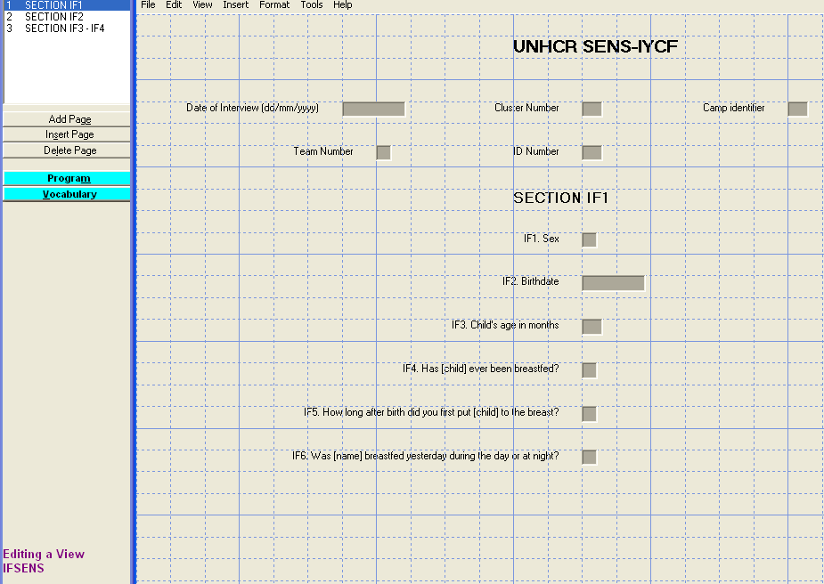

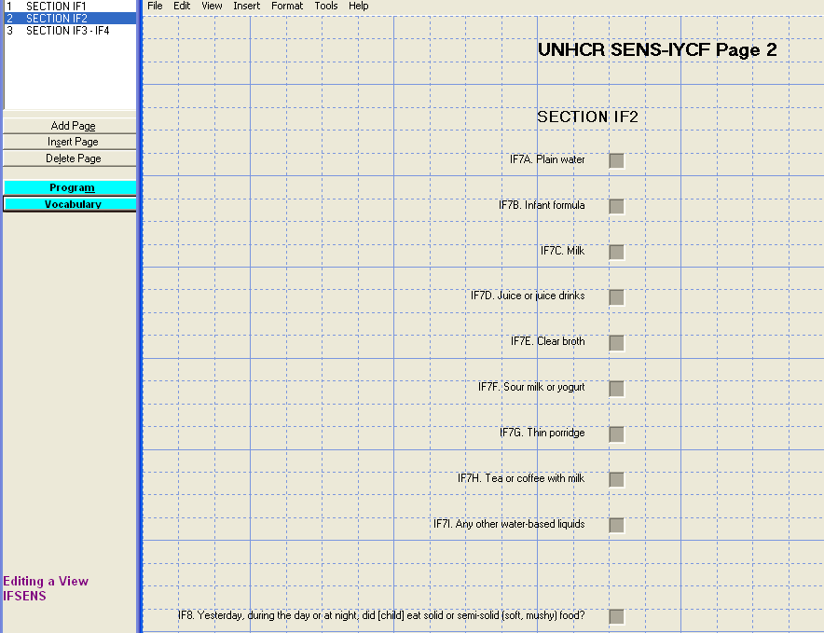
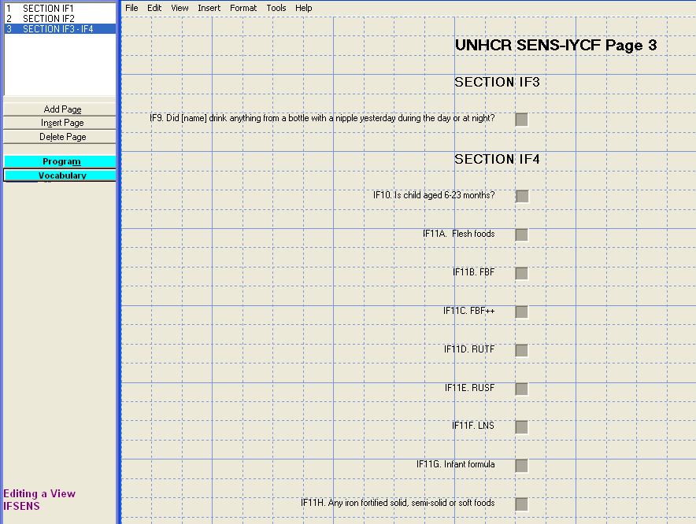
Annex 5 - Epi info Data Analysis

Below are the standard Epi Info codes to use for analysis. The standard PGM files containing these Epi Info codes can be found in the Epi Info mdb file entitled HUN1207IFBUDA in the SENS IYCF tool: [Tool 1-IF Data]. To access the PGM files, go to Program Editor window and open the corresponding PGM file needed for the analysis.

Refer to the fictitious dataset available for practical purposes; Go to SENS IYCF Tool 1, and see the Excel database HUN_1207_IF_BUDA.

The practical Excel database HUN_1207_IF_BUDA is from a survey using cluster sampling.

Data cleaning

Run these commands (together or separately; regardless of the survey design) and make sure that the ranges of the variables entered in the database match the standard codes shown in Tables 2-5 above.

FREQ SEX

MEANS MONTHS

FREQ EVERBF
FREQ INITBF
FREQ YESTBF
FREQ WATER
FREQ INFORM
FREQ MILK
FREQ JUICE
FREQ BROTH
FREQ YOGURT
FREQ THINPOR
FREQ WHTEACOF
FREQ WATLQD
FREQ FOOD
FREQ BOTTLE
FREQ CHELIG

For the following variables, only include the variables collected in the survey context:

FREQ FLESHFD
FREQ FBF
FREQ FBFSUPER
FREQ RUTF
FREQ RUSF
FREQ LNS
FREQ INFORMFE
FREQ FOODFE
FREQ MNP

You should check the missing data in your database and double-check that this was not a data entry oversight. The commands below need to be run separately, one by one. After selecting the variable using the code shown below, use the LIST command to view the specific records with missing data and double-check with the original data collection questionnaire. Then cancel the selected variable by typing SELECT and proceed with checking another variable.

SELECT MONTHS=(.) (note that children with missing age value should not be included in any of the IYCF indicators)
SELECT (this will cancel the selected variable)

SELECT EVERBF=(.)

SELECT EVERBF=1 AND INITBF=(.)

SELECT EVERBF=1 AND YESTBF=(.)

SELECT WATER=(.)

SELECT INFORM=(.)

SELECT MILK=(.)

SELECT JUICE=(.)

SELECT BROTH=(.)

SELECT YOGURT=(.)

SELECT THINPOR=(.)

SELECT WHTEACOF=(.)
SELECT WATLQD=(.)

SELECT FOOD=(.)

SELECT BOTTLE=(.)

SELECT CHELIG=(.)

For the following variables, only include the variables collected in the survey context:

SELECT CHELIG=1 AND FLESHFD=(.)

SELECT CHELIG=1 AND FBF=(.)

SELECT CHELIG=1 AND FBFSUPER=(.)

SELECT CHELIG=1 AND RUTF=(.)

SELECT CHELIG=1 AND RUSF=(.)

SELECT CHELIG=1 AND LNS=(.)

SELECT CHELIG=1 AND INFORMFE=(.)

SELECT CHELIG=1 AND FOODFE=(.)

SELECT CHELIG=1 AND MNP=(.)

Data analysis

Results from the practical dataset are illustrated below.

Infant and young child feeding indicators ANALYSIS

Prevalence of Infant and Young Child Feeding Practices Indicators

Indicator | Age range | Number/  total | Prevalence  (%) | 95% CI
Timely initiation of breastfeeding | 0-23 months | 231/284 | 81.3 | 75.3-87.4
Exclusive breastfeeding under 6 months | 0-5 months | 45/95 | 47.4 | 35.4-59.4
Continued breastfeeding at 1 year | 12-15 months | 30/48 | 62.5 | 47.3-77.7
Continued breastfeeding at 2 years | 20-23 months | 4/31 | 12.9 | 2.3-23.5
Introduction of solid, semi-solid or soft foods | 6-8 months | 16/36 | 44.4 | 28.3-60.6
Consumption of iron-rich or iron-fortified foods | 6-23 months | 99/138 | 71.7 | 62.3-81.2
Bottle feeding | 0-23 months | 24/289 | 8.3 | 3.9-12.7

Timely initiation of breastfeeding (0-23 months)

DEFINE INITBF_c

IF INITBF=1 THEN
INITBF_c="YES"
ELSE
INITBF_c="NO"
END

IF INITBF=8 THEN
INITBF_c=(.)
END

IF EVERBF=1 AND INITBF= (.) THEN
INITBF_c=(.)
END

SELECT MONTHS<24

FREQ INITBF_c PSUVAR=CLUSTER

If you are analysing a simple random survey, the code is as follows:

FREQ INITBF_c

SELECT (this will cancel the selected variable(s); only to be executed after the analysis is done and the results recorded)

INITBF_c | TOTAL
NO | 53
Row % | 100.000
Col % | 18.662
SE % | 2.993
LCL % | 12.579
UCL % | 24.745
YES | 231
Row % | 100.000
Col % | 81.338
SE % | 2.993
LCL % | 75.255
UCL % | 87.421
TOTAL | 284
Design Effect | 1.670

Exclusive breastfeeding under 6 months (0-5 months)

This is the programme that should be written, however Epi Info (version 3.5.4 July 2012) finds it too complex to be run at once. Therefore, the following steps (Steps 1-4) need to be followed.

DEFINE EBFSUM

ASSIGN EBFSUM=WATER+INFORM+MILK+JUICE+BROTH+YOGURT+THINPOR+WHTEACOF+WATLQD+FOOD

DEFINE EBF

IF EBFSUM=20 AND YESTBF=1 THEN
EBF="YES"
ELSE
EBF="NO"
END

IF WATER= (.) OR INFORM= (.) OR MILK= (.) OR JUICE= (.) OR BROTH= (.) OR YOGURT= (.) OR THINPOR= (.) OR WHTEACOF= (.) OR WATLQD= (.) OR FOOD= (.) THEN
EBF=(.)
END (this command may be used with any analysis; however if you have no missing data for any of these variables, you may delete this command or if you only have a few variables with missing data, you may only include these variables in the command)

IF YESTBF=8 OR WATER=8 OR INFORM=8 OR MILK=8 OR JUICE=8 OR BROTH=8 OR YOGURT=8 OR THINPOR=8 OR WHTEACOF=8 OR WATLQD=8 OR FOOD=8 THEN
EBF=(.)
END

IF EVERBF=1 AND YESTBF= (.) THEN
EBF=(.)
END

SELECT MONTHS<6

FREQ EBF PSUVAR=CLUSTER

If you are analysing a simple random survey, the code is as follows:

FREQ EBF

SELECT (this will cancel the selected variable(s); only to be executed after the analysis is done and the results recorded)

The following steps should be followed for analysis:

STEP 1

DEFINE EBFSUM

ASSIGN EBFSUM=WATER+INFORM+MILK+JUICE+BROTH+YOGURT+THINPOR+WHTEACOF+WATLQD+FOOD

DEFINE EBF

IF EBFSUM=20 AND YESTBF=1 THEN
EBF="YES"
ELSE
EBF="NO"
END

Step 2

Right after running the PGM codes from Step 1, write (export) the data table under a new name in Epi Info format in the respective mdb file (e.g. hun1207EBF1). Then read (import) the results back into Epi info. Continue with the analysis and coding as follows:

IF WATER= (.) OR INFORM= (.) OR MILK= (.) OR JUICE= (.) OR BROTH= (.) THEN
EBF=(.)
END (this command may be used with any analysis; however if you have no missing data for any of these variables, you may delete this command or if you only have a few variables with missing data, you may only include these variables in the command)

IF YOGURT= (.) OR THINPOR= (.) OR WHTEACOF= (.) OR WATLQD= (.) OR FOOD= (.) THEN
EBF=(.)
END (this command may be used with any analysis; however if you have no missing data for any of these variables, you may delete this command or if you only have a few variables with missing data, you may only include these variables in the command)
IF EVERBF=1 AND YESTBF= (.) THEN
EBF=(.)
END

Step 3

Right after running the PGM codes from Step 2, write (export) the data table under a new name in Epi Info format in the respective mdb file (e.g. hun1207EBF2). Then read (import) the results back into Epi Info. Continue with the analysis and coding as follows:

IF YESTBF=8 THEN
EBF=(.)
END
IF WATER=8 OR INFORM=8 OR MILK=8 OR JUICE=8 OR BROTH=8 THEN
EBF=(.)
END

IF YOGURT=8 OR THINPOR=8 OR WHTEACOF=8 OR WATLQD=8 OR FOOD=8 THEN
EBF=(.)
END

SELECT MONTHS<6

FREQ EBF PSUVAR=CLUSTER
If you are analysing a simple random survey, the code is as follows:

FREQ EBF

SELECT (this will cancel the selected variable(s); only to be executed after the analysis is done and the results recorded)

Step 4

Right after running the PGM codes from Step 3, write (export) the data table under a new name in Epi Info format in the respective mdb file (e.g. hun1207EBF3). Do not forget to cancel the selected variable before exportation! Then read (import) the results back into Epi Info. Continue with the analysis of the other IYCF indicators.

EBF | TOTAL
NO | 50
Row % | 100.000
Col % | 52.632
SE % | 5.895
LCL % | 40.638
UCL % | 64.626
YES | 45
Row % | 100.000
Col % | 47.368
SE % | 5.895
LCL % | 35.374
UCL % | 59.362
TOTAL | 95
Design Effect | 1.310

Continued breastfeeding at 1 year (12-15 months)

DEFINE CONTBF

IF YESTBF=1 THEN
CONTBF="YES"
ELSE
CONTBF="NO"
END

IF YESTBF=8 THEN
CONTBF=(.)
END

IF EVERBF=1 AND YESTBF= (.) THEN
CONTBF=(.)
END

SELECT MONTHS>=12 AND MONTHS<=15.99

FREQ CONTBF PSUVAR=CLUSTER

If you are analysing a simple random survey, the code is as follows:

FREQ CONTBF

SELECT (this will cancel the selected variable(s); only to be executed after the analysis is done and the results recorded)

CONTBF | TOTAL
NO | 18
Row % | 100.000
Col % | 37.500
SE % | 7.379
LCL % | 22.303
UCL % | 52.697
YES | 30
Row % | 100.000
Col % | 62.500
SE % | 7.379
LCL % | 47.303
UCL % | 77.697
TOTAL | 48
Design Effect | 1.092

Continued breastfeeding at 2 years (20-23 months)

Use the newly generated variable named ‘CONTBF’ defined above to conduct the following analysis.

SELECT MONTHS>=20 AND MONTHS<=23.99

FREQ CONTBF PSUVAR=CLUSTER

If you are analysing a simple random survey, the code is as follows:

FREQ CONTBF

SELECT (this will cancel the selected variable(s); only to be executed after the analysis is done and the results recorded)

CONTBF | TOTAL
NO | 27
Row % | 100.000
Col % | 87.097
SE % | 5.009
LCL % | 76.530
UCL % | 97.664
YES | 4
Row % | 100.000
Col % | 12.903
SE % | 5.009
LCL % | 2.336
UCL % | 23.470
TOTAL | 31
Design Effect | 0.670

Introduction of solid, semi-solid or soft foods (6-8 months)

SELECT FOOD<>8 (this is equivalent to SELECT FOOD=1 OR FOOD=2)

SELECT MONTHS>=6 AND MONTHS<=8.99

FREQ FOOD PSUVAR=CLUSTER

If you are analysing a simple random survey, the code is as follows:

FREQ FOOD

SELECT (this will cancel the selected variable(s); only to be executed after the analysis is done and the results recorded)

FOOD | TOTAL
1 | 16
Row % | 100.000
Col % | 44.444
SE % | 7.807
LCL % | 28.254
UCL % | 60.635
2 | 20
Row % | 100.000
Col % | 55.556
SE % | 7.807
LCL % | 39.365
UCL % | 71.746
TOTAL | 36
Design Effect | 0.864

Consumption of iron-rich or iron-fortified foods (6-23 months)

This is the programme that should be written, however Epi Info (version 3.5.4 July 2012) finds it too complex to be run at once. Therefore, the following steps (Steps 1-3) need to be followed. Delete the variables that were not measured in the survey; for example, if RUSF, LNS or MNP are not used in the survey setting, these variables need to be deleted from the PGM shown below.

DEFINE FERICH

IF FLESHFD=1 OR FBF=1 OR FBFSUPER=1 OR RUTF=1 OR RUSF=1 OR LNS=1 OR INFORMFE=1 OR FOODFE=1 OR MNP=1 THEN
FERICH="YES"
ELSE
FERICH="NO"
END

IF FLESHFD=8 OR FBF=8 OR FBFSUPER=8 OR RUTF=8 OR RUSF=8 OR LNS=8 OR INFORMFE=8 OR FOODFE=8 OR MNP=8 THEN
FERICH=(.)
END

IF FLESHFD=(.) OR FBF=(.) OR FBFSUPER=(.) OR RUTF=(.) OR RUSF=(.) OR LNS=(.) OR INFORMFE=(.) OR FOODFE=(.) OR MNP=(.) THEN
FERICH=(.)
END (this command may be used with any analysis; however if you have no missing data for any of these variables when CHELIG=1, you may delete this command or if you only have a few variables with missing data when CHELIG=1, you may only include these variables in the command)

SELECT MONTHS>=6 AND MONTHS<=23.99

FREQ FERICH PSUVAR=CLUSTER

If you are analysing a simple random survey, the code is as follows:

FREQ FERICH

SELECT (this will cancel the selected variable(s); only to be executed after the analysis is done and the results recorded)

The following steps should be followed for analysis:

STEP 1

DEFINE FERICH1

IF FLESHFD=1 OR FBF=1 OR FBFSUPER=1 OR RUTF=1 OR RUSF=1 THEN
FERICH1="YES"
ELSE
FERICH1="NO"
END

DEFINE FERICH2

IF LNS=1 OR INFORMFE=1 OR FOODFE=1 OR MNP=1 THEN
FERICH2="YES"
ELSE
FERICH2="NO"
END

DEFINE FERICH

IF FERICH1= "YES" OR FERICH2="YES"THEN
FERICH="YES"
ELSE
FERICH="NO"
END

Step 2

Right after running the PGM codes from Step 1, write (export) the data table under a new name in Epi Info format in the respective mdb file (e.g. hun1207FERICH1). Then read (import) the results back into Epi info. Continue with the analysis and coding as follows:

IF FLESHFD=8 OR FBF=8 OR FBFSUPER=8 OR RUTF=8 OR RUSF=8 THEN
FERICH=(.)
END

IF LNS=8 OR INFORMFE=8 OR FOODFE=8 OR MNP=8 THEN
FERICH=(.)
END

Step 3

Right after running the PGM codes from Step 2, write (export) the data table under a new name in Epi Info format in the respective mdb file (e.g. hun1207FERICH2). Then read (import) the results back into Epi Info. Continue with the analysis and coding as follows:

IF FLESHFD=(.) OR FBF=(.) OR FBFSUPER=(.) OR RUTF=(.) OR RUSF=(.) THEN
FERICH=(.)
END (this command may be used with any analysis; however if you have no missing data for any of these variables when CHELIG=1, you may delete this command or if you only have a few variables with missing data when CHELIG=1, you may only include these variables in the command)

IF LNS=(.) OR INFORMFE=(.) OR FOODFE=(.) OR MNP=(.) THEN
FERICH=(.)
END (this command may be used with any analysis; however if you have no missing data for any of these variables when CHELIG=1, you may delete this command or if you only have a few variables with missing data when CHELIG=1, you may only include these variables in the command)

SELECT MONTHS>=6 AND MONTHS<=23.99

FREQ FERICH PSUVAR=CLUSTER

If you are analysing a simple random survey, the code is as follows:

FREQ FERICH

SELECT (this will cancel the selected variable(s); only to be executed after the analysis is done and the results recorded)

FERICH | TOTAL
NO | 39
Row % | 100.000
Col % | 28.261
SE % | 4.634
LCL % | 18.844
UCL % | 37.678
YES | 99
Row % | 100.000
Col % | 71.739
SE % | 4.634
LCL % | 62.322
UCL % | 81.156
TOTAL | 138
Design Effect | 1.451

Bottle feeding (0-23 months)

SELECT BOTTLE<>8 (this is equivalent to SELECT BOTTLE=1 OR BOTTLE=2)

SELECT MONTHS<24

FREQ BOTTLE PSUVAR=CLUSTER

If you are analysing a simple random survey, the code is as follows:

FREQ BOTTLE

SELECT (this will cancel the selected variable(s); only to be executed after the analysis is done and the results recorded)

BOTTLE | TOTAL
1 | 24
Row % | 100.000
Col % | 8.304
SE % | 2.161
LCL % | 3.913
UCL % | 12.696
2 | 265
Row % | 100.000
Col % | 91.696
SE % | 2.161
LCL % | 87.304
UCL % | 96.087
TOTAL | 289
Design Effect | 1.766

Prevalence of intake ANALYSIS

Infant formula

Infant formula intake in children aged 0-23 months

 | Number/total | % (95% CI)
Proportion of children aged 0-23 months who receive infant formula (fortified or non fortified) | 63/285 | 22.1 (15.3-28.9)

SELECT INFORM<>8 (this is equivalent to SELECT INFORM=1 OR INFORM=2)

SELECT MONTHS<24

FREQ INFORM PSUVAR=CLUSTER

If you are analysing a simple random survey, the code is as follows:

FREQ INFORM

SELECT (this will cancel the selected variable(s); only to be executed after the analysis is done and the results recorded)

INFORM | TOTAL
1 | 63
Row % | 100.000
Col % | 22.105
SE % | 3.341
LCL % | 15.316
UCL % | 28.894
2 | 222
Row % | 100.000
Col % | 77.895
SE % | 3.341
LCL % | 71.106
UCL % | 84.684
TOTAL | 285
Design Effect | 1.841

FBF intake

FBF intake in children aged 6-23 months [PRODUCT TO BE ADAPTED: the FBF may be CSB+ for example]

 | Number/total | % (95% CI)
Proportion of children aged 6-23 months who receive FBF | 95/188 | 50.5 (42.0-59.1)

SELECT FBF<>8 (this is equivalent to SELECT FBF=1 OR FBF=2)

SELECT MONTHS>=6 AND MONTHS<24

FREQ FBF PSUVAR=CLUSTER

If you are analysing a simple random survey, the code is as follows:

FREQ FBF

SELECT (this will cancel the selected variable(s); only to be executed after the analysis is done and the results recorded)

FBF | TOTAL
1 | 95
Row % | 100.000
Col % | 50.532
SE % | 4.212
LCL % | 41.973
UCL % | 59.091
2 | 93
Row % | 100.000
Col % | 49.468
SE % | 4.212
LCL % | 40.909
UCL % | 58.027
TOTAL | 188
Design Effect | 1.327

FBF++ intake

FBF++ intake in children aged 6-23 months [PRODUCT TO BE ADAPTED: the FBF++ may be CSB++ for example]

 | Number/total | % (95% CI)
Proportion of children aged 6-23 months who receive FBF++ | 37/191 | 19.4 (13.1-25.7)

SELECT FBFSUPER<>8 (this is equivalent to SELECT FBFSUPER=1 OR FBFSUPER=2)

SELECT MONTHS>=6 AND MONTHS<24

FREQ FBFSUPER PSUVAR=CLUSTER

If you are analysing a simple random survey, the code is as follows:

FREQ FBFSUPER

SELECT (this will cancel the selected variable(s); only to be executed after the analysis is done and the results recorded)

FBFSUPER | TOTAL
1 | 37
Row % | 100.000
Col % | 19.372
SE % | 3.093
LCL % | 13.087
UCL % | 25.657
2 | 154
Row % | 100.000
Col % | 80.628
SE % | 3.093
LCL % | 74.343
UCL % | 86.913
TOTAL | 191
Design Effect | 1.164

Special nutritional product-LNS intake

LNS products intake in children aged 6-23 months [PRODUCT TO BE ADAPTED: the LNS product may be Nutributter® for example]

 | Number/total | % (95% CI)
Proportion of children aged 6-23 months who receive LNS | 73/163 | 44.8 (38.2-51.3)

SELECT LNS<>8 (this is equivalent to SELECT LNS=1 OR LNS=2)

SELECT MONTHS>=6 AND MONTHS<24

FREQ LNS PSUVAR=CLUSTER

If you are analysing a simple random survey, the code is as follows:

FREQ LNS

SELECT (this will cancel the selected variable(s); only to be executed after the analysis is done and the results recorded)

LNS | TOTAL
1 | 73
Row % | 100.000
Col % | 44.785
SE % | 3.223
LCL % | 38.236
UCL % | 51.334
2 | 90
Row % | 100.000
Col % | 55.215
SE % | 3.223
LCL % | 48.666
UCL % | 61.764
TOTAL | 163
Design Effect | 0.680

Special nutritional product-MNP intake

MNP intake in children aged 6-23 months [PRODUCT TO BE ADAPTED: the MNP MAY HAVE A SPECIFIC NAME]

 | Number/total | % (95% CI)
Proportion of children aged 6-23 months who receive MNP | 147/190 | 77.4 (70.9-83.9)

SELECT MNP<>8 (this is equivalent to SELECT MNP=1 OR MNP=2)

SELECT MONTHS>=6 AND MONTHS<24

FREQ MNP PSUVAR=CLUSTER

If you are analysing a simple random survey, the code is as follows:

FREQ MNP

SELECT (this will cancel the selected variable(s); only to be executed after the analysis is done and the results recorded)

MNP | TOTAL
1 | 147
Row % | 100.000
Col % | 77.368
SE % | 3.204
LCL % | 70.857
UCL % | 83.880
2 | 43
Row % | 100.000
Col % | 22.632
SE % | 3.204
LCL % | 16.120
UCL % | 29.143
TOTAL | 190
Design Effect | 1.108

Annex 6 - Presentation of combined results

- Weighting the data will need to be done if you have conducted surveys in a number of different camps or areas, and need to combine the results for reporting or planning purposes.

- It is not required to report the combined results for all indicators or to report the confidence intervals for the combined estimates. The table below outlines the indicators that should be reported during a combined analysis and included in the SENS report.
- For a tool that will automatically generate weighed prevalence results, see SENS Pre-Module tool: [Tool 14-Weighting Data Tool].

Combined prevalence of Infant and Young Child Feeding practices indicators

Indicator | Age range | Prevalence (%)
Timely initiation of breastfeeding | 0-23 months
Exclusive breastfeeding under 6 months | 0-5 months
Continued breastfeeding at 1 year | 12-15 months
Continued breastfeeding at 2 years | 20-23 months
Introduction of solid, semi-solid or soft foods | 6-8 months
Consumption of iron-rich or iron-fortified foods | 6-23 months
Bottle Feeding | 0-23 months

The ‘precision’ of the estimate is measured by a statistical term known as the confidence interval (CI). This reflects the error introduced by the sampling method and the sample size. Confidence intervals are usually associated with a probability of 95 per cent, which is equivalent to saying that if the survey is done 100 times the true population value will be within the range of the confidence interval 95 times out of 100.

