UNHCR
STANDARDISED EXPANDED
NUTRITION SURVEY (sens) GUIDELINES
FOR REFuGEE POPULATIONS

PRE-MODULE: Survey steps and sampling
Module 1: Anthropometry and Health
Module 2: Anaemia
Module 3: Infant and Young Child Feeding (IYCF)
Module 4: Food Security
Module 5: Water, Sanitation and Hygiene (WASH)
Module 6: Mosquito Net Coverage

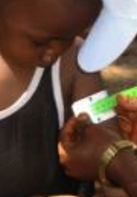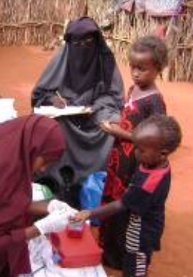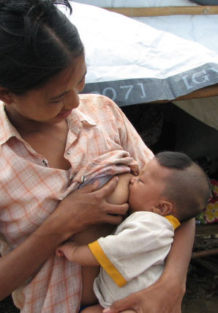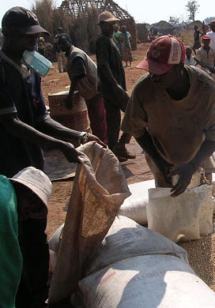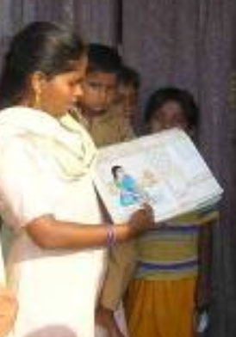
A PRACTICAL STEP-BY-STEP GUIDE VERSION 2 (2013)


PREFACE

Nutritional outcomes continue to be of concern in most refugee contexts. UNHCR recommends the measurement of anthropometric status, anaemia and other associated indicators (including infant and young child feeding, food security, WASH and mosquito net coverage) on an annual basis in order to monitor the situation, react in a timely manner to nutritional problems, and complement the already existing assessments, monitoring or surveillance data.

This is a guidance document for UNHCR health and nutrition coordinators and partners which aims to standardise the way annual nutrition surveys are conducted. A 2009 review of UNHCR nutrition surveys worldwide highlighted a lack of standardisation in data collection methods, the type of information collected, and in the ways it was analysed and presented. In order to measure trends over time, surveys need to be replicable and the same definitions, geographic boundaries and methodologies need to be used from year to year. To help overcome these challenges, UNHCR encourages the adoption of the internationally recognised SMART (Standardised Monitoring and Assessment of Relief and Transitions) methods for survey design and anthropometric assessments. In refugee contexts, there are often very limited opportunities to conduct household surveys other than nutrition surveys. Hence the nutrition survey is an opportunity to collect other types of key data needed for programme planning and improvement. Refugee settings, especially in camps, differ from ‘normal’ settings in a number of ways, including the provision of monthly food aid rations, free primary health care services, proximity to health centres, proximity to water collection points, and free distribution of mosquito bed nets, but also often limited livelihood opportunities as well as limited access to other food sources than the general food aid ration. The guidelines are designed to cover most emergencies and all stable, protracted situations. Some adaptation may be needed for use in certain emergencies and urban settings. In the future, these guidelines will be updated and improved as lessons are learnt on their application and usefulness, and the field of survey methodology evolves.

These guidelines are divided into seven components: one pre-module entitled Survey Steps and Sampling and six individual survey modules namely, Anthropometry and Health, Anaemia, Infant and Young Child Feeding, Food Security, Water Sanitation and Hygiene, and Mosquito Net Coverage. The pre-module is a quick reference guide and focuses on the practical steps for conducting UNHCR Standardised Expanded Nutrition Survey (SENS). The pre-module is not meant to replace already existing survey manuals. To avoid duplication, the user is referred to pre-existing material on certain aspects of survey design and implementation. The individual survey modules provide information for training, data collection, data entry, data analysis, interpretation and reporting.

Some countries may have national guidelines or minimum reporting standards for conducting nutrition surveys that slightly differ from the ones proposed here. The user of these guidelines should adapt them, where appropriate, to ensure local standards are met. Moreover, in recent years, electronic data collection on the field (as opposed to paper-based data collection) using mobile phones is being pursued to ease the process of data collection, data quality checks and data entry. UNHCR is moving towards integrating the use of mobile phones for data collection and entry as part of the SENS guidelines. Separate guidelines are available for this.

Comments, feedback and requests for further guidance should be directed to:

HQPHN@unhcr.org

For more details on the SENS guidelines, its associated tools and reference material, refer to:

www.sens.unhcr.org

ACKNOWLEDGEMENTS

VERSION 2 (2013)

The guidelines Version 2 were updated by UNHCR based on the lessons learnt on the use of Version 1 in the following refugee operations in 2011-2012: Bangladesh, Kenya (Dadaab and Kakuma), Djibouti, Ethiopia, Liberia, Malawi, Mozambique, Nepal, Rwanda, East Sudan and Zimbabwe.

Thanks are due to participants from the UNHCR nutrition survey training workshops (Budapest, July 2012 and Naivasha, November 2012); Jillian Waid (HKI Bangladesh); field staff from Bangladesh, Kenya, Djibouti, Ethiopia, Liberia, Malawi, Mozambique, Nepal, Rwanda, East Sudan and Zimbabwe; ENN and UCL consultants who worked on the nutrition surveys in Dadaab and Kakuma camps in 2012; and participants of the UNHCR Anaemia Technical Meeting (December 2012).

VERSION 2 CONTRIBUTORS:

UNHCR: Caroline Wilkinson, Ellen Andresen, Allison Oman, Hanna Mattinen, Dominique Porteaud, Marian Schilperoord, Paul Spiegel

UNHCR consultants: Mélody Tondeur (all modules), Ismail AR Kassim (all modules)

Module 2 reviewed by: Kevin Sullivan, Emory University, Atlanta

Sampling and Epi Info guidance reviewed by: Oleg Bilukha, CDC, Atlanta

Additional photographs contributed by: Claudia Perlongo

Version 1 (2011)

The guidelines Version 1 were compiled by the Emergency Nutrition Network, Oxford, UK, on behalf of UNHCR. The initial version of the guidelines covered the measurement of anaemia and was prepared by the UCL Centre for International Health and Development.

The contributions made by all those involved in providing content, reviewing, and commenting on the various drafts of this document is gratefully acknowledged. Thanks are due to participants from the UNHCR nutrition survey training workshops (Naivasha, October 2010 and Budapest, May 2011); field staff from Ethiopia and Kenya; Andrea Cippa; Christophe Grange; Jean McCluskey; and members of the UNHCR Technical Advisory Group.

These guidelines, specific to refugee contexts, are based on the SMART methods and various other manuals and documentation, including those published by the UCL Centre for International Health and Development, Action Contre la Faim, Care, Concern, HKI, IRC, MI, MSF, Save the Children, ILSI, Sphere, CDC, FANTA, FAO, WFP, WHO, UNICEF and UNHCR. A list of key manuals and materials is provided in each module. Technical guidance was adapted, where necessary, to make it appropriate to refugee settings and a series of modules developed to cover the set of indicators required for the assessment and monitoring of refugee programmes. Additional material was developed to provide guidance where gaps were identified.

In the great majority of areas, the technical content of these guidelines reflect the consensus view of the contributors. In the instances where technical consensus was not achieved, the content reflects the view of UNHCR.

Version 1 contributors:

Emergency Nutrition Network: Mélody Tondeur, Andrew Seal, Carlos Grijalva-Eternod, Ismail AR Kassim, Sarah Style, Carmel Dolan

UNHCR: Caroline Wilkinson, Allison Oman, Paul Spiegel, Dominique Porteaud, Hanna Mattinen, Ellen Andresen, Marian Schilperoord, Heiko Hering

UNHCR consultants: Suzanne Ferron (WASH module), Sarah Hoibak (Mosquito net coverage module)

Modules 1-3 and 5-6 reviewed by: Oleg Bilukha, CDC, Atlanta

Module 3 reviewed by: Marie McGrath, ENN

Photographs contributed by: N Berry, S Hoibak, IAR Kassim, M Lung’aho, A Seal, M Tondeur, World Vision, the WASH Visual Aids Library

Table of Contents

Survey Steps and Sampling

The following is intended to provide practical guidance for undertaking a nutrition survey in a refugee context. The steps may not always be conducted in the order presented below but all of them should be considered during planning and implementation.

Step 1: Decide on the need for a survey 12
Step 2: Gather background information 15
Step 3: Define the survey objectives 16
Step 4: Define geographic area and population group to include 24
Step 5: Communicate with Stakeholders 26
Step 6: Decide on timing 28
Step 7: Decide on what measurements to make and data to collect 30
Step 8: Design the Survey 32
Step 9: Obtain equipment and supplies 44
Step 10: Design questionnaire 46
Step 11: Select and train teams 49
Step 12: Field test questionnaire and procedures 53
Step 13: Conduct and supervise field work 55
Step 14: Enter and clean data 61
Step 15: Check data quality and analyse 69
Step 16: Write and disseminate report 73

Annex 1-Conducting full immuniSation assessment 78
Annex 2 - Correction for small population size 80
Annex 3- Sample size calculation and sampling example 82
Annex 4- Data collection control sheet 88
Annex 5-Ordering information 90
Annex 6-Guidance on key Epi Info commands 92
Annex 7-Assessing trends and changes 95
Annex 8-Statistical comparisons between two surveys 98
Annex 9-CE-DAT Checklist 99

Survey Modules

Module 1: Anthropometry and Health
Module 2: Anaemia
Module 3: Infant and Young Child Feeding (IYCF)
Module 4: Food Security
Module 5: Water, Sanitation and Hygiene (WASH)
Module 6: Mosquito Net Coverage

A number of tools are available to assist at each step of the survey
process and are indicated in the text by the following icon:


All the tools and guideline documents can be downloaded from:

www.sens.unhcr.org
List of acronyms

AGDM | Age Gender and Diversity Mainstreaming
ANC | Antenatal Care
CDC | Centres for Disease Control and Prevention
CSAMPLE | Complex Samples, an analysis function within Epi Info that takes into account cluster sampling and thus adjusts confidence intervals
CI | Confidence Interval
CRED CE-DAT | Centre for Research on the Epidemiology of Disasters, Complex Emergency Database
DSA | Daily Subsistence Allowance
ENA | Emergency Nutrition Assessment
ENA for SMART | Name of the SMART nutrition survey software
ENN | Emergency Nutrition Network (Oxford, UK)
EPI | Expanded Programme on Immunisation
Epi Info | Name of CDC software for epidemiological investigations including nutrition surveys
FANTA | Food and Nutrition Technical Assistance
FAO | Food and Agriculture Organisation
GAM | Global Acute Malnutrition
Hb | Haemoglobin
HH | Household
HIS | Health Information System
HQ | Headquarters
ICH UCL | Institute of Child Health of the University College of London
ID | Identification
IERHB CDC | International Emergency and Refugee Health Branch of the CDC
IYCF | Infant and Young Child Feeding Practices
JAM | Joint Assessment Mission
LLIN | Long-lasting Insecticidal Net
MOH | Ministry of Health
MSG | Multi-Storey Garden
MUAC | Mid-Upper Arm Circumference
NCHS | National Centre for Health Statistics
NICS | Nutrition Information in Crisis Situations
PPS | Probability Proportional to Size
ProGres | Registration database for refugee population data
PSU | Primary Sampling Unit
RC | Replacement or reserve cluster
SAM | Severe acute malnutrition
SENS | Standardised Expanded Nutrition Survey
SMART | Standardised Monitoring and Assessment of Relief and Transitions
U5 | Children under 5 years old
UNHCR | United Nations High Commissioner for Refugees
UNICEF | United Nations Children’s Fund
WASH | Water, Sanitation and Hygiene
WFP | World Food Programme
WHO | World Health Organisation

Step 1: Decide on the need for a survey

- Why should a nutrition survey be conducted?
- What other possible ways are there to assess the nutrition situation?
- What budget is required for a nutrition survey?
- What support can UNHCR HQ / Regional Offices provide
for a nutrition survey?

a. Why should a nutrition survey be conducted?

Nutrition surveys should be considered in order to:
- Establish baseline data and estimate if a nutritional emergency or the risk of a nutritional emergency exists;
- Estimate the severity and geographical extent of the nutritional emergency and possibly the groups most affected or at risk;
- Assess the needs for nutrition interventions and identify the most effective measures to prevent or minimize the nutritional emergency;
- Determine the need to establish or expand existing surveillance, so that the effectiveness of interventions can be monitored over time; and
- Assess the likely evolution and impact of the emergency on health and nutritional status, taking into account secondary information, including food security, food distributions and response to the crisis.
b. What other possible ways are there to assess the nutrition situation?

- Nutrition surveys remain the best way to accurately estimate the prevalence of malnutrition at the population level.
- Records of cases of malnutrition at health centres or during routine or rapid screening cannot be considered representative of the population. They can, however, give an indication of trends in the number of cases of malnutrition. This is the same with data of admissions to feeding centres. Any significant increase should trigger further investigation.

c. What budget is required for a nutrition survey?

- Budgets should cover staff time, logistical and dissemination costs. In order to account for all costs, sample size calculation and sampling must be considered very early on in the survey planning process. For an example of a survey budget, see SENS Pre-Module tool: [Tool 1-Survey Budget].

- As a general rule, and depending on the context and the available survey equipment, conducting one nutrition survey would cost about 15,000-30,000 USD. Survey coordinator consultants, if required, are recruited at an additional cost. When more than one survey is conducted, additional budget is needed.

- The budget should reflect salaries and/or daily subsistence allowance (DSA) determined by the number of days and staff outlined in the survey timeframe. Additional costs that should be built into the budget include, but are not limited to:

- Renting space (training, data entry, dissemination of results, other needs)
- Printing and photocopying
- Office supplies such as pens, notepads, flip chart paper, folders, staplers
- Communication including SIM cards for mobile phones, satellite phones, radios, e-mail, local and international calls
- Computer rentals, usb sticks or external hard drive
- Car rental for data collection and for travel between survey sites, and cost of drivers
- Car maintenance and fuel costs
- Accommodation, if appropriate
- Participant incentives or DSA, if appropriate
- Supplies for field staff e.g. caps or T-shirts with agency logos for visibility purpose, folders to carry questionnaires, back-packs / bags, umbrellas to keep off rain / sun, rain boots and raincoats
- Name tags or badges to identify survey members and their affiliation to local leaders and survey participants
- Meals during training and other activities
- Certificates
- Survey equipment [more details given in SENS Pre-module Step 10]

Things to note:

- At times, external support may be required due to limited availability of qualified personnel and additional funds will be required for this. For an example of a survey consultant TOR, see SENS Pre-Module tool: [Tool 2-Survey Consultant TOR]. Ample time will be needed to secure availability of a qualified person as most of the time there is high demand for such services.
d. What support can UNHCR HQ / Regional Offices provide for a nutrition survey?

- UNHCR HQ / Regional Offices can provide remote technical guidance on nutrition surveys, such as methodology, data analysis, interpretation, advice on equipment, and identification of external resources.

- Sharing implementation plans including protocols (see SENS Pre-module Step 8), and draft reports of survey findings with UNHCR HQ / Regional Offices in time for feedback and validation is required.

Step 2: Gather background information

- What background information should be gathered?

a. What background information should be gathered?

Before starting a survey, it is important to find out as much as possible about the population to be surveyed from existing sources (this is often called secondary information). This includes:

- Population characteristics and figures including country of origin of refugees, demographic figures from UNHCR ProGres (average household size, percentage of under-5), population head counts or household listings done by partners, and languages spoken.

- Administrative divisions and structure of camps (e.g. blocks, shelters, clusters, sections, sheds).

- Previous surveys and assessments including nutrition surveys, rapid assessments, mass screening, malaria surveys, water sanitation and hygiene (WASH) surveys, Age Gender and Diversity Mainstreaming (AGDM), and Joint Assessment Mission (JAM) reports.

- Health statistics from UNHCR Health Information Systems (HIS), health centres and selective feeding programmes.

- Food security and livelihood programmes in place including Multi-Storey Gardens (MSG), kitchen gardens, fresh food vouchers, cash-transfer, income generating activities etc.

- Situation reports on security and political situation including Country Situation Reports (Sitreps).

- Food basket composition and monitoring data (Post-distribution monitoring reports and food basket monitoring reports).

- Maps.

Step 3: Define the survey objectives

- What are the objectives of UNHCR Standardised Expanded Nutrition Survey (SENS)?
- Why are these objectives recommended to be included in UNHCR SENS?
- When should these recommended objectives be included in UNHCR SENS?
- What additional objectives can be included?

a. What are the objectives of UNHCR Standardised Expanded Nutrition Survey (SENS)?

UNHCR Standardised Expanded Nutrition Survey (SENS) for refugee settings is comprised of six modules (Modules 1-6) covering standardised objectives. For the full list of indicators measured through these standardised objectives, see SENS Pre-Module tool: [Tool 3-SENS List of Indicators].

Three modules are individual-based modules (Modules 1-3) whereas three modules are household-based modules (Modules 4-6). The following objectives are covered:

Individual-based modules (Modules 1-3: Anthropometry and Health, Anaemia and IYCF)

Primary objectives

- To measure the prevalence of acute malnutrition in children aged 6-59 (see Module 1).

- To measure the prevalence of stunting in children aged 6-59 months (see Module 1).

- To determine the coverage of measles vaccination among children aged 9-59 months (or context-specific target group e.g. 9-23 months) (see Module 1).

- To determine the coverage of vitamin A supplementation received during the last 6 months among children aged 6-59 months (see Module 1).

- To assess the two-week period prevalence of diarrhoea among children aged 6- 59 months (see Module 1).

- To measure the prevalence of anaemia in children aged 6-59 months and in women of reproductive age between 15-49 years (non-pregnant) (see Module 2).

- To investigate IYCF practices among children aged 0-23 months (see Module 3).
Secondary objectives

- To determine the coverage of targeted supplementary and therapeutic feeding programmes for children aged 6-59 months (see Module 1).

- To determine enrolment into Antenatal Care clinic and coverage of iron-folic acid supplementation in pregnant women (see Module 2).

Household-based modules (Modules 4-6: Food Security, WASH and Mosquito Net Coverage)

- To determine the coverage of ration cards and the duration the general food ration lasts for recipient households (see Module 4).

- To determine the extent to which negative coping strategies are used by households (see Module 4).

- To assess household dietary diversity (see Module 4).

- To determine the population’s access to, and use of, improved water, sanitation and hygiene facilities (see Module 5).

- To determine the ownership of mosquito nets (all types and LLINs) in households (see Module 6).

- To determine the utilisation of mosquito nets (all types and LLINs) by the total population, children 0-59 months and pregnant women (see Module 6).

- To determine the household coverage of indoor residual spraying (see Module 6).

b. Why are these objectives recommended to be included in UNHCR SENS?

Malnutrition (See Module 1)
- Ensuring adequate nutrition and eliminating malnutrition have long been recognised as integral to fulfilling UNHCR’s protection mandate.
- Children under 5 years old (U5) are growing rapidly and are considered to be the most sensitive to nutritional stress and particularly vulnerable to disease and food shortages.
- High prevalence of acute malnutrition in children aged 6-59 months has been associated with high mortality rates in refugee contexts.

Measles vaccination (See Module 1)
- Whenever there are crowded emergency settings, large population displacements and high levels of malnutrition, there is a high risk of a measles outbreak. Measles is one of the most contagious viruses and is associated with high mortality rates.
- Acute malnutrition is often associated with increased case fatality rates from these communicable diseases, especially among U5’s.
- Because measles has high potential for outbreaks and mortality, mass vaccination of children against the disease is a high priority among disaster-affected populations, especially those who are displaced and/or affected by conflict.

Vitamin A supplementation (See Module 1)
- Vitamin A deficiency among young children results in loss of vision, night-blindness and reduced immunity, with an increased chance of dying from infectious diseases.
- Pre-school children are the most at-risk population group for vitamin A deficiency.
- Universal vitamin A distribution involves the periodic administration of high supplemental doses to all pre-school age children every six months. Supplementation with high dose vitamin A capsules can reduce the number of children who die from infectious diseases and prevent vitamin A deficiency.

Diarrhoea (See Module 1)
- Diarrhoea caused by poor water, sanitation and hygiene accounts for the annual deaths of over two million children U5.
- Diarrhoea contributes to high infant and child morbidity and mortality by directly affecting children’s nutritional status.
- Diarrhoea is a major cause of admission to stabilisation centres for children with severe malnutrition. Infections compromise the nutritional status of children because of higher nutrient requirements and appetite suppression. Malnourished children are prone to infections because of a compromised immune system.

Anaemia (See Module 2)
- Anaemia is a serious public health problem among refugee populations especially affecting young children and women due to inadequate iron intake, lack of appropriate complementary foods and high rates of infection like malaria and worm diseases.
- The high prevalence of anaemia in young children (besides increasing mortality risk in its severe form) negatively affects cognitive development and the immune system.
- Interventions targeted to women (especially pregnant and lactating women) as well as young children, can improve health and nutrition outcomes in these groups.

IYCF (See Module 3)
- It is the youngest children, between six months and two years old who tend to be the most affected by acute malnutrition and anaemia, conditions that co-exist in refugee settings.
- There is currently limited systematic IYCF information collected from households in refugee contexts.
- Improving IYCF practices in refugee context is a priority for UNHCR.

Food security (See Module 4)
- Food insecurity is a key underlying cause of malnutrition.
- There is currently limited systematic food security information collected from households in refugee contexts.
- Resources are often not available to carry out routine food security assessments in refugee contexts.

WASH (See Module 5)
- There is currently limited systematic WASH information collected from households in refugee contexts, although UNHCR is increasingly implementing regular WASH camp-level monitoring systems.
- Resources are often not available to carry out routine WASH household surveys in refugee contexts.
- The quality of WASH practices is an important determinant of malnutrition and improvement of WASH indicators is a priority for UNHCR.

Mosquito net coverage (See Module 6)
- Universal coverage of mosquito nets at the household level is currently being pursued in areas where there is malaria transmission.
- Resources are often not available to carry out routine mosquito net coverage surveys in refugee contexts.
- Malaria is related to anaemia levels and acute malnutrition is often associated with increased mortality from malaria, especially among young children.

c. When should these recommended objectives be included in UNHCR SENS?

- UNHCR recommends that all nutrition surveys conducted in refugee contexts are standardised and follow the present SENS guidelines, questionnaires and reporting format.

- The guidelines are designed to cover most emergencies and all stable, protracted situations. Some adaptation may be needed for use in certain emergencies and urban settings.

- There may be certain contexts where it is not needed, not applicable or not feasible to include all six modules in the nutrition survey. In contexts where it is not needed, not applicable or not feasible to include all six modules in the nutrition survey, the Anthropometry and Health module (Module 1) should always take priority over the other modules.

- Table 1 below describes varying scenarios where it may not be needed to include all modules in the annual nutrition survey, and these should be discussed and agreed upon with UNHCR HQ / Regional offices at the survey planning stage.

Table 1 Inclusion and exclusion of standardised modules based on needs

Module | Possible reasons for not including standard module in nutrition survey | Notes
1: Anthropometry and Health | None | The indicators from Module 1 comprise the basic reporting requirements that should be included in all UNHCR SENS nutrition survey reports.
2: Anaemia | Prevalence of anaemia in children aged 6-59 months and / or in women of reproductive age below 30% for two consecutive years. | If prevalence is below 30% include anaemia in alternate years only for monitoring purposes.
3: IYCF | Large scale IYCF assessment or IYCF household survey conducted prior to nutrition survey. | -
4: Food Security | Large scale food security assessment or food security household survey conducted prior to nutrition survey. | -
5: WASH | Large (1) Large scale WASH assessment or WASH household survey conducted prior to nutrition survey.  (2) WASH monitoring system is in place with indicators stable and meeting targets. | -
6: Mosquito Net Coverage | (1) Refugee setting is in a malaria free environment.  (2) There has been no mosquito net distribution.  (3) Large scale mosquito net coverage household survey conducted prior to nutrition survey. | -

- Table 2 below describes varying scenarios that can be encountered in an unsecure context where it may not be feasible to include all modules in the annual nutrition survey and these should be discussed and agreed upon with UNHCR HQ / Regional offices at the survey planning stage.

Table 2 Inclusion and exclusion of standardised modules due to insecurity and available options

UN Phase | Security Outlook | Options
≤ 3 | Stable or improving | All SENS modules | - | -
≤ 3 | Unstable or deteriorating | Possibly exclude SENS modules 2, 3, 4, 5 and/or 6 – reduced SENS | - | -
4 | Stable or improving | All SENS modules | Possibly exclude SENS modules 2, 3, 4, 5 and/or 6 – reduced SENS | -
4 | Unstable or deteriorating | Possibly exclude SENS modules 2, 3, 4, 5, and/or 6 – reduced SENS | No SENS nutrition survey possible; conduct rapid anthropometric assessment | No SENS nutrition survey or rapid anthropometric assessment possible; develop surveillance system as alternative method for collection of anthropometric data
5 | Stable or improving | No SENS nutrition survey possible; conduct rapid anthropometric assessment | No SENS nutrition survey or rapid anthropometric assessment possible; develop surveillance system as alternative method for collection of anthropometric data | -
5 | Unstable or deteriorating | No SENS nutrition survey possible | No other additional anthropometric data collection activities possible | -
Source: adapted from Dadaab nutrition surveys planning (August 2012), ENN, UCL & UNHCR.

d. What additional objectives can be included?

Additional objectives may be included where there is a clear need for the information to assist decision making. For an example of a SENS nutrition survey protocol and report including additional objectives such as mortality and deworming, see SENS Pre-Module tools: [Tool 4a-Dolo SENS Survey Protocol 2013] and [Tool 4b-Dolo SENS Survey Report 2013]. The following additional data may be collected where justified:

- Deworming;
- Mortality;
- Coverage of blanket feeding programmes in specific age groups;
- Anthropometric status in other age groups (0 – 5 months old, children 5-9 years, women);
- Morbidity other than diarrhoea;
- Coverage of other vaccinations. For guidance on how to collect and report other vaccine coverage, see Annex 1.

If additional data collection is needed, the objectives of adding more information need to be clearly set out. In addition, it must be possible for the information to be quickly and reliably obtained during a short visit to the household. The following questions need to be considered for each additional data that is considered for inclusion in the annual SENS survey:

- Can the data be obtained from other sources e.g. from the compiled secondary background information (see SENS Pre-module Step 2), or UNHCR HIS?
- Was the data collected in the last nutrition survey? Is it necessary to collect the same data in the current survey?
- If additional data are collected, can the results be used to guide implementation?
- Can analysis of the results impact on overall programme interventions and management?
- Is there a plan for presentation of the data in the final nutrition survey report (i.e. table of results, graphs, figures??

Things to watch out for:

- Questions should not be added simply because the answers will be interesting.
- Some information collected in isolation will not be very informative.
- Each additional piece of data that is collected will prolong the training and the survey itself, thereby requiring more financial resources and complicating the analysis.
- If too much additional data is added to the survey, it might undermine the quality of the whole survey due to surveyor and respondent fatigue.
- The required sample size and the population to be surveyed may vary for different information.

Step 4: Define geographic area and population group to include

- At what level should a nutrition survey be conducted?
- Who is the survey population?
- What are the target group(s) for each standard module?

a. At what level should a nutrition survey be conducted?

- Depending on the objectives and on the context, nutrition surveys can be conducted in each camp in a country, or alternatively several camps from the same country can be combined into one representative survey.

- In most refugee contexts (camp-based), one representative sample is usually drawn from each camp. When the surrounding villages are also surveyed, a separate representative sample is usually drawn from the host community.

- In certain contexts, a nutrition survey combining several camps into one survey is implemented if camps are in the same area and if there is no indication that the nutritional situation is different between camps. For example, the latter can be shown from previous nutrition survey reports or from similar admission trends to selective feeding programmes.

- When conducting a nutrition survey combining several camps into one survey, it is necessary to consider the objectives of the nutrition survey carefully and whether it would be applicable and meaningful to include the household-based modules on Food Security, WASH and mosquito net coverage. In these particular contexts, a careful analysis of the situation is needed during the survey planning stage because the present household-based SENS modules were designed for conducting a representative survey in a camp where there are moderate differences in context and access to services available in and around the camp. UNHCR HQ / Regional offices should be contacted for expert guidance on setting the objectives of these combined surveys.

  - For example, the following factors need to be investigated: whether the various locations have different access to general food rations and cycles, different types of markets, agricultural activities or livelihoods; whether the various locations have different access to WASH facilities and different water sources; whether the mosquito net distribution modalities or timing differs between the various camps.

b. Who is the survey population?

- The population to be assessed when using the present SENS Guidelines are refugees living in camps. All present SENS modules (individual-based and household-based) are applicable to populations living in camps.

- For assessing populations who live in towns or villages, urban refugees or mobile populations (e.g. emergency situation with high influx and movement of refugees in and around camps), UNHCR HQ / Regional offices should be contacted for expert guidance on planning the survey. All present individual-based modules (Modules 1-3) are applicable to these situations whereas the present SENS sampling guidance and the household-based SENS modules (Modules 4-6) may not always be applicable to these situations.

c. What are the target group(s) for each standard module?

- Module 1 (individual-based) - Anthropometry and Health: children aged 6-59 months.

- Module 2 (individual-based) - Anaemia: children aged 6-59 months and women of reproductive age (15-49 years).

- Module 3 (individual-based) - IYCF: children aged 0-23 months.

- Module 4 (household-based) - Food Security: all persons of concern (household as a whole).

- Module 5 (household-based) - WASH: all persons of concern (household as a whole).

- Module 6 (household-based) - Mosquito Net Coverage: all persons of concern (household as a whole).

Step 5: Communicate with Stakeholders

- Who should be informed about the nutrition survey?
- What partners are usually involved in a nutrition survey?

a. Who should be informed about the nutrition survey?

- To ensure technical quality of the nutrition survey and to be able to provide support where needed, UNHCR Regional and HQ nutrition and health focal points should be informed about the planned nutrition survey.

- It is essential to communicate with refugees, host populations and government authorities about the purpose of the survey to ensure they understand why the survey is being carried out, how they can assist with planning and implementation and to resolve any timing, access, participation and security issues at the start.

Things to watch out for:

- The target survey population may be working, at school, engaged in household tasks, at feeding centres or at the GFD site and less likely to be present or able to interrupt their activities when the survey team arrives. It is necessary to determine before data collection begins when the optimal time for reaching participants is, and to keep in mind that these times may be different for the populations residing in different parts of the camps and those in the host communities.

b. What partners are usually involved in a nutrition survey?

Main partners for planning and implementing nutrition surveys are:

- UNHCR Regional or HQ technical focal points;
- NGO partners in health and nutrition;
- WFP; and
- UNICEF.

Other partners are:

- Ministry of Health.
- Centres for Disease Control and Prevention (CDC, Atlanta).
- University College of London.
- Emergency Nutrition Network (ENN Oxford, UK).

Things to note:

- An experienced consultant can be appointed to conduct the survey after seeking technical views of UNHCR Regional / HQ focal points (see section on budget and TOR in SENS Pre-module Step 1).

- In-country nutrition agencies / universities / national bodies that are used to carrying out surveys might also be approached. Their ability should be checked by reviewing their profile.

Step 6: Decide on timing

- When should a nutrition survey be conducted?
- What key issues should be considered in determining the timing of the survey?
- How much time should be allocated to the nutrition survey?

a. When should a nutrition survey be conducted?

- Once each year in stable situations (annual nutrition surveys are done to assist evaluation of the effectiveness of response and recovery);

- Within two months after the start of a new operation/arrival of new refugees; or

- In the event of a change in the situation which might affect the nutritional situation (e.g. mass influx, alteration or reduction in food basket, disease outbreak).

b. What key issues should be considered in determining the timing of the survey?

- Annual nutrition surveys should be conducted at the same time (similar months) each year, so that direct comparisons can be made. The timing of a yearly nutrition survey should not be altered without a clear justification.
  - Ensuring that routine nutrition surveys are conducted at the same time
each year requires planning well in advance.

- Nutrition surveys should be conducted at periods of the highest nutrition and food security risk, e.g. during the hunger gap.

c. How much time should be allocated to the nutrition survey?

- Each activity from the planning of the nutrition survey to dissemination of the final SENS report should indicate the number of days and number of staff necessary for its completion.
  - For example, a timeframe for the survey field work is provided below with an indicative number of days for some activities. These may vary depending on the context.
  - Orders for necessary equipment and supplies should be ordered three months prior to the survey.

Example of nutrition survey schedule
Activity
Survey preparation | Week 1
Finalise draft budget
Finalise review of secondary information
Finalise objectives and select SENS modules to be included with all partners and UNHCR HQ / Regional Offices
Confirm populations and geographic areas
Communicate with stakeholders and sensitise community
Develop draft timeframe
Survey design | Week 2 - 3
Determine sampling method, calculate sample size and select cluster if applicable
Send preliminary survey protocol to UNHCR HQ / Regional Offices for review
Survey protocol
Finalise survey protocol
Finalise staff numbers
Finalise budget
Finalise timeframe
Equipment and supplies
Organise equipment and supplies (ordering should be done three months prior to the survey start)
Questionnaires
Adapt standardised SENS questionnaires to context
Circulate questionnaires to all partners involved
Translate questionnaires
Field test questionnaires
Back translate questionnaires
Finalise and print questionnaires for training
Finalise database for data entry
Finalise all field and training documents
Training and field test | Week 3 - 4
Final recruitment of team members | Prior to training
Organise training
Train field staff | 3-5 days * 20 staff
Conduct field test | 1 days * 20 staff
Finalise logistics for data collection
Print all questionnaires
Data collection | Week 5 |  | Week 6 | Week 7 | Weeks 8-14
Field work | 20 staff and 5 drivers * 4-7 days
Data management
Data entry | 2-4 clerks * 4-7 days
Daily data cleaning
Final data cleaning
Data analysis
Preliminary SENS report writing and dissemination |  |  |  | After 2 weeks of survey completion
Final SENS report writing and dissemination |  |  |  | On-going after results are completed and after 2 months of survey completion

Step 7: Decide on what measurements to make and data to collect

- What data to collect?
- Should demographic data be collected?

a. What data to collect?

More detailed information and definitions of indicators are provided in the individual
survey modules. These can be downloaded from www.sens.unhcr.org

Module 1: Anthropometry and Health: children aged 6-59 months
- Consent;
- Sex;
- Birth date or age in months;
- Weight;
- Height / Length;
- Oedema;
- MUAC;
- Child enrolment in a treatment feeding programme;
- Measles vaccination;
- Vitamin A supplementation in last 6 months; and
- Diarrhoea in last 2 weeks.

Module 2: Children Anaemia: children aged 6-59 months
- Consent;
- Sex;
- Birth date or age in months; and
- Haemoglobin concentration.

Module 2: Women Anaemia: women of reproductive age (15-49 years)
- Consent;
- Age;
- Pregnancy status;
- ANC enrolment, and iron and folic acid pills coverage (pregnant women only); and
- Haemoglobin concentration (excluding pregnant women).

Module 3: IYCF: children aged 0-23 months
- Consent;
- Breastfeeding initiation, exclusivity and duration;
- Feeding practices; and
- Bottle feeding.

Module 4: Food Security: all persons of concern (household as a whole)
- Consent;
- Access to food distribution;
- Duration of the general food ration;
- Use of negative coping strategies; and
- Level of household dietary diversity.

Module 5: WASH: all persons of concern (household as a whole)
- Consent;
- Access to improved drinking water sources;
- Storage of water;
- Quantity of water used per household;
- Satisfaction with water supply;
- Type of excreta disposal facility used; and
- Disposal of young children’s stools.

Module 6: Mosquito Net Coverage: all persons of concern (household as a whole)
- Consent;
- Mosquito net ownership (all type and LLINs);
- Members of household (all, U5, pregnant) who slept under a mosquito net last night (all type and LLIN); and
- Indoor residual spraying (when implemented in the last six months).

b. Should demographic data be collected?

- Demographic data do not need to be collected in all nutrition surveys conducted in refugee contexts. The type of demographic data to collect depends on the context. In emergency situations, it is usually more important to collect demographic data.

- Relevant demographic information includes:
  - Registration of individual household members as refugees (emphasize that this is not in connection with food rations);
  - Time spent in camp in number of years or months;
  - Nationality of the household; and
  - Household status (e.g. refugee, host population or displaced).

Step 8: Design the Survey

- Which sampling methods should be used (Sampling Decision Tree)?
- How should a household be defined?
- How is the required sample size calculated?
- If using cluster sampling, how is the number of clusters chosen?
- If using cluster sampling, how are clusters selected?
- How are the households selected?
- How is sub-sampling of households performed for the different modules?
- What should be done if the target sample size or target number of clusters is not achieved?
- What should be included in the nutrition survey protocol?

a. Which sampling methods should be used (Sampling Decision Tree)?

- If the total size of the population being surveyed is below approximately 2,500 people (or approximately <600 households), no sampling is necessary and an exhaustive (census) survey can be conducted, whereby all households within the camp or surrounding villages are surveyed. If the population size is bigger than this, a sample should be selected for the survey.

The three sampling methods that can be considered for use in nutrition surveys in refugee contexts are:

- Simple random sampling:
  - used when there is an up-to-date list of all households in the population, with enough information to allow them to be located. This may be available in some camps or settlements from UNHCR ProGres database or from population head counts or household listings from partners.
  - when using population head counts or household listings from partners, ensure that it will be politically acceptable to use in the survey context. The number of refugees can sometimes differ significantly between these listings and ProGres due to some refugees living outside of the camps for example.
  - when deciding on whether or not to use household lists from ProGres, watch for inaccurate lists where some people i) are registered but do not live in the camp, ii) are registered at a certain ‘address’ in the camp but actually live at another one or iii) are living in the camp but are not registered at all, thus possibly causing problem during sampling and bias in survey results. When there is hesitation on whether or not to use the ProGres household lists, you can check if registration of household matches ProGres by visiting a few random houses throughout the camp to see if it matches.
  - If the available household lists from ProGres are thought to be inaccurate for sampling, all households in the camps can be labelled /enumerated prior to the survey following a labelling convention and using the definition of the household used in the survey (see next section on household definition). This is usually feasible in relatively small camps with enough staff available who know the different sections of the camp.

- Systematic random sampling (interval sampling) with a list:
  - used when there is an up-to-date list of all households in the population, with enough information to allow them to be located. This may be available in some camps or settlements from UNHCR ProGres database or from population head counts or household listings from partners (refer to explanation given above for simple random sampling).

- Systematic random sampling (interval sampling) without a list:
  - used when there is no up-to-date list of all households in the population, but when the total number of households in the camp or settlements is known and there is an orderly layout of the households that make it possible to go systematically from household to household, without omitting any. This is feasible in camps where households are laid-out in an organised manner or when maps are available and it is possible to easily identify the location of households.

- Cluster sampling:
  - used when there is no up-to-date list of all households in the population and there is no orderly layout of the households, but when the total number of individuals or households in the camp or settlements is known. It requires far less detailed information about the population being sampled. Cluster sampling involves selecting sections (also called geographic areas or enumeration areas) from a camp, settlement or surrounding villages from which clusters of households are then sampled. This is known as a two-stage cluster survey.
  - random allocation of clusters should be done using probability-proportional-to-size (PPS).
  - randomly selecting the households to form each cluster should be done using conventional random methods: (1) simple random sampling; (2) systematic random sampling; or (3) the EPI method. Segmentation may also need to be done in cluster surveys as outlined in the Sampling Decision Tree shown below.

Refer to the SMART Standardised Training Package or the other survey manuals and guidelines listed in the references for more details on how to apply the methods listed above.

Things to note:

- In an emergency situation (i.e. influx and poor security), some geographical areas may need to be excluded and conventional sampling methods may need to be adapted. In these situations, external guidance from an expert consultant or agency will be needed in the planning stage, especially when deciding on the sampling methodology. For an example of a nutrition survey conducted in an emergency with high influx of refugees, additional target groups and a modified sampling methodology using Google Earth and GPS devices, see SENS Pre-Module tool: [Tool 5-Dadaab Survey Report 2011]

Figure 1 Sampling Decision Tree
(Also included as a pdf file for printing in SENS Pre-Module tool: [Tool 6-Sampling Decision Tree])
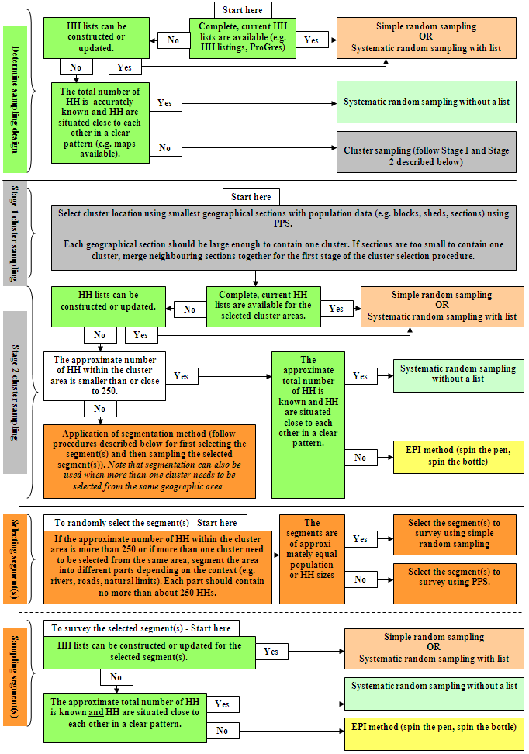
b. How should a household be defined?

- There is no universal definition of a household. However, a classic definition used in nutrition surveys to define a household is: a group of people who live together and routinely eat out of same pot. For example, if one or two families share the same pot, they should be assessed as one household.

- In ProGres, a household is defined as members sharing a ration card. If accurate and updated household lists are available from ProGres for sampling, a household should be defined as it appears in ProGres. The following procedure should be followed when using ProGres list for sampling:

  - To complete modules 1-3 (the individual-based modules), select only the children and women from the household according to the definition on the ProGres list, i.e. sharing one ration card.
  - To complete modules 4-6 (the household-based modules), select all household members who live together and routinely eat out of the same pot. It is possible that you find households, who live together and routinely eat out of the same pot, but who share more than one ration card and some households who only share one ration card.

Things to watch out for:

- It can become very confusing for survey teams if there is no clear definition of the household before the survey starts (especially in polygamous settings).

- If the surveyors do not understand the definition of the household, they may use different definitions in the same survey. Ensure the same definition and same procedures are used in the same survey and in surveys from year to year in the same setting. This will allow direct comparisons to be made.

c. How is the required sample size calculated?

- UNHCR SENS nutrition surveys measure several indicators at the individual-level in different target groups, and several indicators at the household-level.

- To simplify the planning process and to standardise the way surveys are conducted, UNHCR recommends calculating sample size based on GAM only using ENA for SMART software and SMART recommendations. The key variables for sample size calculation are: expected prevalence of GAM, desired precision, design effect (if cluster sampling used), average household size, percentage of children under 5 years of age, percentage of non-response and total population (when the population of children U5 is less than 10,000; see correction for small population size below).
The steps for calculating sample size are shown below.

(1) Calculate sample size by number of children needed to assess the prevalence of acute malnutrition in children aged 6-59 months using the ENA software and the SMART recommendations.

The following information should be entered into the ENA for SMART software to calculate the sample size:

- The estimated prevalence of acute malnutrition in the survey area: This can be deduced from for example previous nutrition surveys, admissions to supplementary feeding programmes, or HIS data. If you really do not know the likely prevalence, a ‘safe’ approach is to use the highest prevalence that is anticipated with the widest confidence interval that is acceptable (i.e. the lowest acceptable precision) and the largest design effect that is likely to be encountered (see below information on design effect). E.g.: 20% prevalence, 5% precision and a design effect of 2.

- The precision you require for your estimate: The required precision can vary – the more precise you want your estimate to be, the more children you will need to survey. The following table shows the precision recommended at various levels of acute malnutrition prevalence:

Table 3 Recommended precision at various prevalence levels
to be adapted to context

Acute malnutrition prevalence | Desired precision +/- %
≤5 | 2.0-2.5
5-10 | 3.0
10-15 | 3.0-3.5
15->15 | 4.0-5.0

- The design effect (if cluster sampling is used): The design effect is basically a multiplication factor used when calculating sample sizes for cluster surveys which takes into account the particular issues that arise from using a cluster design. In some settings you can calculate design effects from previous surveys. In others we assume it is between 1.3 and 2, i.e. you have to increase your sample size by ×1.3 to ×2. In most stable refugee settings, the design effect for wasting will rarely be above 1.5. Never use a design effect below 1.3 in your sample size calculation. The following table gives examples of design effects that can be used depending on the context.

Table 4 Example of design effects

Design effect | Context
1.3 | Population is homogeneous
1.5 | Slight differences seen between clusters
2.0 | Differences seen between clusters
>2.0 | High variation between clusters, some clusters are not affected while others are severely affected.

Things to watch-out for:

- When the population of children U5 is less than 10,000, it is necessary to use a correction factor in the sample size calculation that will decrease the survey sample size. Guidance on how to apply this correction factor using ENA for SMART is shown in Annex 2.

- When calculating sample size, precision is the only factor that you can manipulate and decide on based on the needs. The prevalence of GAM and the design effect are based on ‘reality’ and should not be manipulated to modify sample size to suit your needs.

Refer to the SMART Standardised Training Package for further guidance on how to calculate sample size using the ENA software.

(2) Convert the sample size in number of children into number of households using ENA software. Include a non-response rate of 5-15%, depending on the context. This is the total household sample size for the survey.

- Two critical population characteristics of the survey area need to be available to make this conversion: (1) the average household size and (2) the proportion of children U5 in the total population. In addition, a clear definition of a household needs to be used (Refer to SENS Pre-module Step 7 described above). As described previously, for emergency situation where reliable demographic data cannot be found because of new influx or newly established camps, external guidance from an expert should be sought in the planning stage.

- The average household size to use will depend on the method of sampling and the definition of the household used in the survey.
  - If simple random sampling or systematic random sampling from ProGres list is used, a household is always defined as it appears on the ProGres list, i.e. a group of people sharing one ration card. In this case, the average household size from ProGres is used.
  - If simple random sampling or systematic random sampling from household headcounts / household listings is used, if systematic random sampling without a list is used or if cluster sampling is used, a household is usually defined as a group of people who live together and routinely eat out of same pot. In this case, the average household size based on this definition known from partners, previous surveys or other assessment needs to be used.

- The proportion of U5 in the total population is usually always derived from UNHCR ProGres database, as long as ProGres is more or less up-to-date. This data is not affected by the definition of the household used in the survey.

- There will often be some degree of uncertainty about the average household size and the proportion of U5 in the population. It is thus recommended to use the lower values of both variables, which would produce larger sample sizes in terms of households. For example, if it is thought that the average household size in a given refugee setting is about 5.5-6, and the proportion of U5 is about 15-18%, it is advisable to take the lower values (5.5 and 15%) for calculation of the sample size. Overestimation of the household size and of the proportion of U5 may result in a situation where the achieved sample size in terms of households will not provide the required number of children.

- The final stage in sample size calculation is adjustment for non-response to account mainly for refusal and absentees. Use a non-response rate of 5-10% if you have quite reliable demographic data and no major problems with refusal, accessibility and absentees are expected. Use a non-response rate of 15% (up to 20%) if you are uncertain about the demographic data or if it is anticipated that there may be issues with refusal, accessibility and absentees based on previous experience.

Refer to the SMART Standardised Training Package for further guidance on how to convert number of children into number of households for sample size calculation.

(3) Decide on the household sample size required for collecting the data from the different standard modules:

- Module 1: Anthropometry and Health (children 6-59 months): With any survey design, all eligible children within all of the sampled households will be assessed for module 1.

- Module 2: Children Anaemia (children 6-59 months): The sample size should be selected according to one of the scenarios below.
    - Anaemia assessment scenario 1: You need to measure the prevalence of anaemia in children aged 6-59 months for surveillance purposes but you do not need to assess the impact of an intervention and are not planning to intervene with a direct anaemia intervention (e.g. use of special nutrition products) in the immediate future:
      - With any survey design, half of the sampled households (sub-sample) should be randomly selected and all eligible children found in these households should be assessed for anaemia.

    - Anaemia assessment scenario 2: You are planning to implement/have been implementing a direct intervention (e.g. use of special nutrition products) to reduce anaemia in children aged 6-59 months and you need to assess the baseline prevalence and impact of the intervention:
      - With any survey design, all eligible children from all randomly selected households will be assessed for anaemia.

- Module 2: Women Anaemia (women of reproductive age 15-49 years): With any anaemia scenario (as described above) and any survey design, half of the sampled households (sub-sample) should be randomly selected and all eligible women found in these households should be assessed for anaemia.

- Module 3: IYCF (children 0-23 months): With any survey design, all eligible children within all of the sampled households will be assessed for IYCF practices.

- Module 4: Food Security (household as a whole): With any survey design, half of the households (sub-sample) should be randomly sampled for the assessment of food security.

- Module 5: WASH (household as a whole):
  - When using simple or systematic random sampling as the survey design, half of the sampled households should be randomly selected for the assessment of WASH indicators.
  - When using cluster sampling as the survey design, all sampled households should be assessed for WASH indicators.

- Module 6: Mosquito Net Coverage (household as a whole): With any survey design, half of the households (sub-sample) should be randomly sampled for the assessment of mosquito net coverage.

Things to note:

- With exhaustive surveys you may still need to do sampling for some of the standard modules. Contact UNHCR HQ / Regional offices for guidance on this.

d. If using cluster sampling, how is the number of clusters chosen?

- If you are using cluster sampling, you will need to decide on the cluster size (i.e. total number of households per cluster) and the total number of clusters. Never sample less than 25 clusters (same as SMART recommendations). Usually the number of clusters should not exceed 45 clusters in one survey unless there is good reason to do differently.

- When following the SMART recommendations, the number of clusters is determined after calculating sample size and after determining the cluster size. The cluster size is determined by estimating the number of households that a team can survey in one day. It makes it much easier in terms of logistics for the teams and for the coordinator if one cluster is surveyed per team each day. For example:
  - If you estimate that it takes a team on average 35 minutes to complete the survey in each household and to walk from one selected household to another, and you know you will be working in the field on average for 7 hours per day (not including breaks and travel to / from the central site), you can estimate that each team could measure 12 households per day (7 hours multiplied by 60 min=420 min; 420min divided by 35min=12 households). If your total sample size requirement is 450 households, you will need to visit 38 clusters (450 households divided by 12 households per day=37.5) to achieve your overall sample size in number of children.

Things to note:

- The planning process in refugee settings will sometimes differ from the planning process in large rural areas. In refugee context where there are often short travel times involved, it is sometimes feasible for teams to spend less than one day completing a cluster (for surveys with limited indicators) or conversely, spend more than one day completing a cluster (for survey with a large number of indicators). Hence, the planning process described in SMART may need to be adapted.

e. If using cluster sampling, how are clusters selected?

- If cluster sampling is used, you then need to allocate the clusters to the sections of the camp / settlement using PPS and the cluster allocation table in ENA software.

- You will need to have a list of the approximate population sizes of each geographic area (e.g. block / section) in the camp(s) of interest. The smallest available geographic unit is usually chosen, as long as population data are available, the geographic unit has a name/code and the area is large enough to contain one cluster.
f. How are the households selected?

- Refer to the sampling decision tree (Figure 1) for general guidance.

g. How is sub-sampling of households performed for the different modules?

- As is described above, depending on the survey design, sub-sampling of households needs to be done for some of the standardised modules included in the nutrition survey.

- When using a list, randomly select half of the households originally selected to be sampled.

- If a list is not being used for sampling then sample every other household.

Things to note:

- A worked out example of a sample size calculation and sampling strategy is provided in Annex 3.
- A data collection control sheet should be used by survey teams to keep track of surveyed households, see Annex 4 or see SENS Pre-Module tool: [Tool 7-Data Collection Control Sheet]. Note that the information recorded on the data collection control sheet is not entered into the database, is not analysed and is mainly used to aid survey team members and the survey coordinator in the daily management of data collection for each module.

h. What should be done if the target sample size or target number of clusters is not achieved?

Additional sampling may need to be done when the target sample size has not been reached or when the target number of clusters has not been reached.

Procedure to follow when the target sample size has not been reached:

If less than 80% of the target sample size of children aged 6-59 months was achieved by the end of the survey, the following should be done. Otherwise, no additional sampling is needed:

- For simple or systematic random sampling surveys, another sample of households from the whole population should be taken to boost the sample size of children. This sample should be 25% of the original sample size.
- For cluster sampling surveys, all of the replacement clusters (RC) automatically selected by ENA for SMART software should be sampled.

Procedure to follow when the target number of clusters has not been reached:

- All of the replacement clusters (RCs) automatically selected by ENA for SMART in the planning stage should be sampled if 10% or more of your original clusters were not completed for various reasons (including security, refusal or problems with access). Otherwise, no additional sampling is needed.

- When conducting additional sampling, if the same household is re-selected by chance from the list or within the cluster area, it should be skipped and not surveyed twice. Another one should not be selected in its place. Note that it is possible that a replacement cluster (RC) is sampled from the same area as an original cluster.

- See Module 1 for more details.

i. What should be included in the nutrition survey protocol?

- A survey protocol should be written to explain the methods that will be used. The protocol should be shared with UNHCR HQ / Regional Offices and other key stakeholders in time for them to provide feedback before the survey field work begins. Key elements of the survey protocol include.

  - Names of staff involved, affiliations and contact information
  - Background and rationale
  - Survey objectives
  - Definitions of survey populations and inclusion criteria
  - Geographic boundaries of survey
  - Sample size calculation
  - Sampling methodology
  - Data collection and measurements
  - Survey team composition
  - Training plans
  - Field monitoring and quality control checks
  - Informed consent
  - Questionnaires
  - Data management and analysis
  - Preliminary survey schedule
- For an example of a SENS nutrition survey protocol, see SENS Pre-Module tool: [Tool 4-Dolo SENS Survey Protocol 2013].

Step 9: Obtain equipment and supplies

- What equipment and supplies are needed?
- How much equipment and supplies should be obtained?
- Where can equipment and supplies be ordered?

a. What equipment and supplies are needed?

- The equipment and supplies needed to implement UNHCR SENS are listed in the individual survey module.

- Supplies should be ordered well ahead of time (at least three months prior to the survey start whenever feasible) or be borrowed from various bodies including WFP, UNICEF, local health centres and partners, provided they are in good condition to be used for a survey.

- UNHCR recommends that a ‘survey equipment kit’ containing good quality survey equipment and supplies be kept aside in each branch or field office and be dedicated for the sole purpose of data collection for nutrition surveys.

Things to watch out for:

- Often, the procurement of equipment and supplies is not considered early enough during planning for a nutrition survey, and this can cause significant delays in the field work.

b. How much equipment and supplies should be obtained?

- A supplies planning tool is provided to help in calculating the amount of equipment and supplies needed and to estimate the overall cost. See SENS Pre-Module tool: [Tool 8-Survey Supplies Planning Tool].

- There should always be extra equipment available to ensure replacement of faulty equipment during the survey (e.g. scale, height boards, MUAC tape, HemoCue Machines) or where the survey sample has been underestimated (e.g. HemoCue microcuvettes for anaemia assessment).

Things to watch out for:

- Ensure to factor in a higher number of anaemia supplies for each survey when measuring anaemia in children and in women in case the available demographic data is not up-to-date. It is recommended that you factor in an additional 40% of anaemia supplies, especially where demographic data are uncertain. This is automatically calculated in the Supplies Planning Tool mentioned above (Tool 8).

c. Where can equipment and supplies be ordered?

- A list of international suppliers is provided in Annex 5. Up-to-date information on local suppliers from within each country / region may be found on the companies’ websites.

Step 10: Design questionnaire

- Which questionnaire should be used?
- How should answers be coded (where applicable)?
- How should the questionnaire be translated?
- How should the questionnaire be labelled?

a. Which questionnaire should be used?

- The recommended SENS questionnaire should be used without altering or removing questions. For the full UNHCR SENS questionnaire, see SENS Pre-Module tool: [Tool 9-Full SENS Questionnaire].

- It is essential to adapt the SENS questionnaire to the local context. See guidance provided in Module 3 (IYCF), Module 4 (Food Security), Module 5 (WASH) and Module 6 (Mosquito Net Coverage) for local adaptation of some of the questions and answer options.

Things to note:

- Many of the questions have been designed to measure trends over time in the same region as well as across regions and populations, and to conform to international reporting requirements.

b. How should answers be coded (where applicable)?

- Answers to survey questions will be either a continuous number (e.g. weight recorded in kg, also known as a continuous variable), or a categorical response (e.g. Yes / No / Don’t know; also known as a categorical variable).

- The answer codes outlined in the UNHCR SENS questionnaire should be used so that nutrition survey data sets are harmonised as much as possible and the standard Epi Info analysis guidance provided in each module can be used.

c. How should the questionnaire be translated?

- The UNHCR SENS questionnaire currently exists in French and English. The SENS website will contain more validated translations in different languages in the future (e.g. Arabic, Somali).

- The surveyed population should be interviewed in the language they speak most comfortably, though second languages can be used among populations that are truly bilingual.

- It is important to carefully document all languages spoken in the survey area and what proportion of the study population speaks what language. This will not only impact the decision on what languages the questionnaire must be translated into, but also how many copies of each questionnaire will be needed in the field for each language. It will also influence the choice of the surveyors.

- When the questionnaire has been satisfactorily translated, it should then be back-translated to its original language by someone other than the person who did the original translation in order to minimise bias. The back-translated questionnaire should then be reviewed against the original tool to make sure that the meaning of each question and terms were not altered during the translation process.

- After a thorough translation has been done, the questionnaire should be field tested among the survey population. Field testing should be done before the questionnaire is finalised and before the surveyors are trained.

Things to watch out for:

- Local terms that most clearly explain the question should be used.

- Whenever possible, interviewers should not translate the questionnaire into another language during the interviewing process.

- Translators should not reformat the document during the translation process as this creates confusion and can lead to missed questions and mistakes in skip patterns.
d. How should the questionnaire be labelled?

- It is important to have a labelling format for the questionnaire, especially when multiple questionnaire sheets or modules are used in order to correctly identify each sheet in case they become mixed-up.

- Each questionnaire sheet should have the same identifier at the top as suggested below (note that the identifier should be adapted to the context; e.g. the cluster number should not appear in a simple or systematic random survey; if ‘zones’ are used rather than ‘section’, this should be changed; if there is only one camp surveyed, the camp code is not needed):

Section code / number:_________Block code / number: _________Consent: yes / no / absent

Camp code (where there are multiple camps)
|___|___|
Date of interview (dd/mm/yyyy) | Cluster Number (in cluster survey only)
|___|___|/|___|___|/|___|___||___|___| | |___|___|
Team Number | HH Number
|___| | |___|___|

Step 11: Select and train teams

- How should the survey teams be structured?
- How many teams should be included?
- How should the teams be trained?
- What reference documentation should be provided to teams?

a. How should the survey teams be structured?

- There should be at least one survey coordinator supported by survey supervisors. The survey coordinator should be experienced in undertaking nutrition surveys, training, handling and analysing data, writing reports and managing logistics and people.

- The survey supervisors should be experienced in training, managing logistics and people, and supervising surveyors during data collection.

- Each team should consist of 4-5 people, one of whom is the team leader. The team leader in each team should take responsibility for the quality and reliability of the data collected by the team, records the data from the measurements and/or administers questionnaires. Two people are needed to take the anthropometric measurements, at least one person is required for taking the haemoglobin measurements, and at least one person to help the team leader administer the questionnaires. Depending on the extent of the survey, the team leader can administer the questionnaires and record the data from the measurements, however in many contexts, it is recommended to have one additional person specifically assigned for administering the household questionnaires. For an example of job descriptions for each team member, which should be adapted to each context, see SENS Pre-Module tool: [Tool 10-Survey Team Job Descriptions].

- If mobile phones are used for data collection, the mobile phones should be handled by one or two team members specifically trained on this. The chosen team members should preferably be familiar with smartphones and mobile technology, or at least have the capability to quickly acquire the needed skills. Normally the team leader will handle one phone with the individual questionnaires (Anthropometry and Health-Module 1, Anaemia-Module 2, IYCF-Module 3), while another team member will handle one phone with the household questionnaires (Food Security-Module 4, WASH-Module 5, Mosquito Net Coverage-Module 6).

- In addition to the data collection staff, data entry clerks can also be recruited for paper-based surveys. If travelling by car is necessary, then drivers need to also be considered.

- The composition of teams needs to be sensitive to the local context in terms of gender, ethnicity and language skills as well as local knowledge of the survey area. It is best practice to include at least one woman in each team. It is also useful to include members in each team who will be able to easily carry the height boards and other equipment.

- Whenever possible, use surveyors who will be considered unbiased by the survey population and other stakeholders.

Things to watch out for:

- The team leader must always oversee the anthropometric and haemoglobin measurements and be responsible for writing down the results. Ensuring the quality of anthropometric and haemoglobin measurements should be the priority focus for the survey team leader while in the household.

b. How many teams should be included?

- Four to six teams should be used in a survey depending upon the budget, sample size, time allocated to complete the survey, and the size and accessibility of the area covered.

- It is recommended to limit the number of teams to six at a maximum.

Things to watch out for

- Although it is faster with more teams, it is much more difficult to train, supervise, and recruit good reliable team leaders for each team, provide transport and equipment, and organise a large number of teams.

- The more surveyors there are, the harder it is to supervise them adequately and the more risk there is to have poor quality results.

c. How should the teams be trained?

- The training for the full UNHCR SENS (i.e. all 6 modules included) is recommended to last at least 5 days, depending on context and team experience (including the standardisation tests for anthropometry and haemoglobin measurements, and the pilot test).

- Extra staff should be trained in case someone is unable to perform the field work.

- If mobile phones are used for data collection, specific training will be required for team members handling the mobile phones and one extra training day will be necessary.

- Recommendations for training and tips are provided in the individual survey modules for the different levels of responsibility (i.e. team leader, measurer, and interviewer).

The main topics to cover in training of data collectors (note that team leader may be provided with a more in-depth training than some of the data collectors) are as follows:

- Reason / objectives for nutrition survey
- Composition of survey teams
  - Roles and responsibility
- Sampling procedure
  - Why sample, explained in a way that surveyors can later on explain to community members when asked
  - Rationale and importance of representativeness
- Questionnaire and sheets
  - Introduction to the household and obtaining informed verbal consent
  - Household-level information
  - Child-level information
  - Woman-level information
- Interviews and observations
  - Interview questions and interviewing techniques - go through each question for clarity, answer options, cultural appropriateness, gender sensitivities, avoid suggestive questioning but probe where necessary
- Measurements
  - Age recording and use of local events calendar
  - Measurement techniques (anthropometry and Hb) and practicing with real children and/or adults
  - Standardise measurements among team members
- Survey logistics
  - Equipment
  - Communication
  - Travel
  - Incentives / salary / allowances
  - Food and drinks
  - Accommodation, etc.

Things to note:

- Training is fundamental for the quality of the survey information collected and preparation for the training and survey will take time, especially the first year the full UNHCR SENS is implemented.

d. What reference documentation should be provided to teams?

- The data collection process must be standardised so that teams understand their responsibilities and do not have to improvise in the field.

- In addition to developing a survey protocol prior to data collection, it is also necessary to provide to teams simple instructions that explain the step-by-step process of data collection, with a particular emphasis on the roles and responsibilities of each team member.

  - Teams should have copies of this information to reference when they are out in the field. A survey folder containing plastic pockets for inserting the documents should be provided to each survey supervisor and team leader.

- Teams should be given the following documents for example: job descriptions; images depicting best practice techniques for anthropometric measurements; assignment of clusters; equipment checklist; events calendar; case definitions; inclusion and exclusion dates for age estimation; referral forms; contact details of coordinator(s), supervisors and team leaders; camp map.

Step 12: Field test questionnaire and procedures

- How should the field test be conducted?
- How long should the questionnaire take to administer?
- Who should be checking and doing the measurements, and recording the information?
- Who should be conducting the interviews and recording the information?

a. How should the field test be conducted?

- After the training is completed, teams should visit a location in the camp or the surrounding villages that is not part of the real survey but is similar, and should run through all the steps whilst under close supervision.

- At the end of the field test (also known as the pilot test or pre-test), the team members, the survey coordinator and the survey supervisor(s) should be confident that they can undertake the survey accurately and know how long it will take to complete the survey.

The field test includes practicing on the following:
- Working as a team
- Organising equipment / logistics
- Sampling procedures for selecting households and individuals
- Introducing the team and the survey to participants
- Obtaining consent
- Conducting interviews and observations
- Taking and recording measurements
- Filling out the questionnaire and the different sheets

b. How long should the questionnaire take to administer?

- As a rule of thumb, completion of the full UNHCR SENS questionnaire in a household is expected to take approximately 30-45 minutes on average with an experienced survey team: 5-10 minutes for the anthropometric measurements, 5-10 minutes for haemoglobin measurements and 20-25 minutes for the questionnaires on health, IYCF, food security, WASH and mosquito nets.

- However, at the start of the survey, it may take significantly longer for the teams to complete the questionnaires (maybe >1hr). As the teams become familiar with their work, their speed will increase. As a result, the time taken to complete each household (and cluster, where applicable) will decrease as the survey goes on.
c. Who should be checking and doing the measurements, and recording the information?

- The team leader should at all times check and supervise the anthropometric and haemoglobin measurements, and record the data.

- The anthropometric measurements should be done by two people trained on anthropometric measurements and having been tested in a standardisation test: one measurer and one assistant measurer, or two measurers who alternate their role as measurer and assistant. The mother or the team leader can help to position difficult children during these measurements (weight, height / length, MUAC, oedema).

- The haemoglobin measurements should be done by one person trained on haemoglobin measurements and having been tested in a standardisation test. One of the anthropometric measurer can assist in the process of haemoglobin measurements.

d. Who should be conducting the interviews and recording the information?

- In most full SENS surveys, the team leader should be responsible for handling the individual questionnaires (Anthropometry and Health-Module 1, Anaemia-Module 2, IYCF-Module 3) and another team member should be responsible for handling the household questionnaires (Food Security-Module 4, WASH-Module 5, Mosquito Net Coverage-Module 6). The team member handling the household questionnaires should be able to be independent because, in many settings, it will be possible for the team leader to move ahead to the next randomly selected households with the measurers, while the team member handling the household questionnaires stays behind to complete the household-level interviews and joins the team when done. Note that the team leader should supervise regularly the team member handling the household questionnaires in all contexts.

Step 13: Conduct and supervise field work

- How should field work be scheduled and the community informed?
- How should supervision be conducted?
- How should individual households be approached and informed consent
sought?
- What special cases may be encountered in the field and which procedures
to follow?

a. How should field work be scheduled and the community informed?

- Prior to going to the field, it is important to develop a detailed data collection schedule taking into consideration the local events (e.g. food distribution days, selective feeding programme days, market days - in most contexts, data collection should not take place during those days).

  - With cluster sampling surveys, this schedule should include the cluster location and name, the assigned cluster number, the date it will be surveyed and the team number assigned to that particular cluster.

  - With simple or systematic random sampling surveys with a list, this schedule should include the team number assigned to specific sections of the camp, the date each section will be surveyed and the number of households to survey per section.

- This schedule should be provided to the refugee leaders, host population leaders (where applicable) and other relevant local authorities in order for them to sensitise the community and inform them to remain near their house on the day of the survey in that specific location.

- The data collection schedule may need to be adjusted once fieldwork begins.

b. How should supervision be conducted?

- There should be regular supervision of survey teams by the coordinator and supervisors throughout the survey. Detailed recommendations, tips and common errors to watch for are provided in the individual survey modules.

- Teams usually need the most support from the coordinator and supervisors at the early stages of the survey, when many of the procedures are new, as well as at the end of the survey as team members tire and tend to rush, and make more mistakes.

- The coordinator and supervisors should always concentrate on providing support to the weakest teams and should remind the teams to take enough time for appropriate rest periods, and have refreshments and food with them.

- There should be a daily ‘wrap up’ session with each team to discuss any problems that have arisen during the day. This often brings out important points.

Survey coordinators and supervisors should focus on the following elements:

- Correct techniques are used for selecting the households;
- The definition of the household is used appropriately;
- The respondent is selected correctly;
- The team introduces themselves correctly;
- Informed consent is asked at the beginning of the interview process;
- Correct techniques are used for measuring weight, height, MUAC and haemoglobin of children and/or women, and assessing oedema and age;
- Daily testing of measuring equipment is carried out and the equipment is in order (check of anthropometry and anaemia equipment; see Modules 1-2 for more details on how to record and keep track of these equipment quality checks);
- The vitamin A capsule and iron-folate pill is shown to the respondent to help them recall accurately;
- The proper definition of diarrhoea is used;
- Appropriate interviewing and direct observation techniques are used when asking the questions (interviewer speaks clearly, no leading questions are asked that might influence the respondent’s answers, question is read exactly as written, skip patterns followed correctly);
- The data are correctly and clearly recorded on the questionnaires and there are no discrepancies of interrelated questions; and
- Survey respondents and the community are treated with respect at all times.

c. How should individual households be approached and informed consent sought?

- The teams should be trained on the consent process just as they are on administering the questionnaire.
- When the survey team reaches the selected household, the team leader should introduce him / herself and the study team, clearly explain the objectives of the survey, what the information will be used for, that the survey is anonymous and participants’ confidentiality will be upheld, how long the questionnaire will take, and obtain permission from the head of the household for the measurements and interviews.
- First, the household must choose to participate, then each individual should be given the opportunity to agree or decline him / herself.
- After completing the measurements and questionnaire, each person and household should be thanked for providing their time and assistance. The team leader should answer any additional questions that the household might have, including those about the survey itself and should refer the household to available services for questions regarding nutrition and health care.

Informed consent includes the following elements:

- An explanation of the purpose of the survey, how the person was selected to participate and how the results will be used in terms that the survey participant can understand;
- An explanation about the right to refuse to participate: all participants have the right to refuse participation in the nutrition survey without giving a reason for her / his decision;
- An explanation of the procedure and risk involved: fears about taking blood need to be addressed prior to testing in order to make the survey participants comfortable and cooperative. The survey workers should be familiar with local beliefs about blood collection before beginning the survey;
- An explanation about confidentiality: in some refugee settings, the community is concerned when personal information is collected about them as they fear that this can affect the services provided to them in the camp. Survey participants should be reassured that the information will be kept confidential.
Example of a voluntary informed consent form:

(Read this statement to the head of the household or, if they are absent, another adult member of the house before the interview)

My name is _____________ and I work with [organisation/institution].

- We would like to invite your household to participate in a survey that is looking at the nutrition and health status of people living in this camp. UNHCR is sponsoring this nutrition survey.
- Taking part in this survey is totally your choice. You can decide to not participate, or if you do participate you can stop taking part in this survey at any time for any reason.
- If you stop being in this survey, it will not have any negative effects on how you or your household is treated or what assistance you receive.
- If you agree to participate, I will ask you some questions about your family and I will also measure the weight and height of all the children in the household who are older than 6 months and younger than 5 years. I will test a small amount of blood from the finger of the children and women to see if they have anaemia.
- Before we start to ask you any questions or take any measurements, we will ask you to give us your verbal consent. Be assured that any information that you will provide will be kept strictly confidential.
- You can ask me any question that you have about this survey before you decide to participate or not.
- If you do not understand the information or if your questions were not answered to your satisfaction, do not declare your consent on this form. Thank you.

Things to watch out for

- Survey teams often forget to ask for consent or thank the family after surveying their household. Make sure that teams always ask for consent and always thank the family for their time.

d. What special cases may be encountered in the field and which procedures to follow?

- Absences: If an individual or an entire household is absent, the team leader should record this information and determine another time to return on the same day. The team should return to an absent household or revisit an absent individual up to two times, if it is logistically feasible, on the same survey day. If they are unsuccessful after this, the individual or household should be recorded as an absence and they should not be replaced with another household or individual.

- Refusals: If an individual or an entire household refuse to participate, then it will be considered a refusal and this information should be recorded. The individual or household should be recorded as a refusal and they should not be replaced with another household or individual.

- Abandoned households: A household will be considered abandoned if neighbours report that nobody has lived in that household for more than one month (or another context-specific timeline) or if the inhabitants have been repatriated. This household should be replaced by another household and it should be considered as abandoned. In populations where there is a great deal of long term travel out of the camp, then the criteria may be altered to include only those people who have been residing in the household in the past two weeks, past month or another context-specific timeline. A note should be made in the final report about the criteria for inclusion used.

- Household with no children: If it is determined that a selected household does not have any eligible children, the questionnaire should still be administered to the household and any eligible women.

- Child in nutrition / health centre: It is important to measure the children who are located in nutrition or health centres. The team should go to the centre if it is feasible to do so to take the measurements and information from the child. If it is impossible to visit the centre, the child should be given an ID number and should be considered as absent and not replaced. A note should be made that the child was in a nutrition / health centre at the time of the survey. This recommendation differs from the standard SMART recommendation which considers nutrition surveys that are usually conducted in large geographic areas and where it is often not possible to go to the nutrition or health centres for measurement of the admitted children.

- Disabled child: If a physical deformity prevents the measurement of child’s weight or height, the child should be given an ID number and the data should be recorded as missing for these variables and a note made that the child was disabled. The child should be included for the assessment of the other indicators (e.g. oedema, measles vaccination, vitamin A supplementation).

- Not enough households in the cluster area (cluster surveys only): If after visiting all the households in a cluster area, it is determined that there are not enough households to complete the cluster, the closest neighbouring section / area should be used to complete the cluster making sure that it is not already part of another cluster. When arriving at the neighbouring area, the same sampling procedure should be repeated for selecting the first household until the cluster is complete.

Things to note:

- If your sample size in number of children aged 6-59 months is significantly reduced due to the above situations, you may need to re-sample. Refer to SENS Pre-module Step 8, Point ‘h’ and Module 1 for detailed guidance on how to proceed.

Step 14: Enter and clean data

- What is the recommended software to use?
- Where can we find software available for analysing nutrition surveys?
- How should the databases be created?
- How should the survey data files be named and managed?
- How should questionnaires be checked before data entry?
- When and how should data be entered?
- Why should data be cleaned?
- How should data be cleaned?

a. What is the recommended software to use?

Various software programmes can be used to enter the data and can be divided into two types:

  - Those where an entry mask is used that replicates the format of the questionnaire. These include Epi Info / ENA hybrid, Epi Info, Epi Data Entry, and MS Access. All those software are widely available. Epi Info / ENA hybrid, Epi Info and Epi Data Entry can be downloaded for free.

  - Those where information is entered onto a data spreadsheet. These include ENA for SMART, MS Excel and statistical packages (SPSS, STATA). Note that SPSS and STATA are not freely available.

UNHCR currently recommends the use of ENA for SMART software and Epi Info for Windows (version 3.5’s), or the use of ENA / Epi Info hybrid software for the following reasons:

  - These software allow for both data entry and analysis, and take into account the complex design of cluster surveys for analysis;
  - ENA for SMART and Epi Info for Windows software appear to be the most commonly used software in nutrition surveys by different actors, and good guidance material on their use is available (see below);
  - ENA for SMART, Epi Info for Windows and ENA / Epi Info software are freely available from the internet and no license is needed for their use.

b. Where can we find software available for analysing nutrition surveys?

  - As part of the SMART initiative, a software package called Emergency Nutrition Assessment (ENA) was developed.
  - ENA provides a standardised analysis of anthropometry and mortality surveys and contains many of the necessary calculations in one programme. The software has different sheets (planning, training, data entry, results, and options) which follow the steps of a survey. It allows the generation of anthropometric indices using both WHO and NCHS growth reference populations, produces automated analyses of key mortality and nutrition indicators, conducts automated anthropometric data quality checks, and generates reports that include results of these automated analyses.
  - However, ENA for SMART software can only be used for entry and analysis of data from children U5 (and not from women of reproductive age).
  - It can be downloaded freely at http://www.nutrisurvey.de/ena2011/ Note that the food security analysis option, that is available in some versions of ENA, is not currently recommended for use in UNHCR SENS surveys. Refer to Module 4 on Food Security for the recommended method to follow in refugee situations.

- Epi Info software can be used to analyse nutrition surveys. Epi Info for Windows is available for free download from CDC at http://wwwn.cdc.gov/epiinfo/html/prevVersion.htm
  - This software package does not provide automated analysis of nutrition and mortality surveys, but allows for the calculation of 95% confidence intervals taking into account the design of cluster surveys.

- Combined Epi Info / ENA software has recently been developed by CDC to facilitate the planning, design, data entry, management, analysis, interpretation and quality control of nutrition and mortality surveys conducted in humanitarian emergencies.
  - By combining Epi Info and ENA for SMART, a hybrid software package was created that has the advantages described above for ENA for SMART but also provides users with the tools to manually analyse data from other population groups.
  - The software, user manual and training films are freely available at: http://www.cdc.gov/globalhealth/gdder/ierh/ResearchandSurvey/enasoftware.htm

c. How should the databases be created?

- A different database should be created for each population target group and module to be included in the survey. For example, for the full UNHCR SENS, the following databases would be created in the following software:

  - ENA for SMART or ENA-Epi Info: Anthropometry, Health and Anaemia data from children aged 6-59 months (see Modules 1-2)
  - Epi Info: Anaemia data from women (see Module 2)
  - Epi Info: IYCF data from children aged 0-23 months (see Module 3)
  - Epi Info: Food security data from households (see Module 4)
  - Epi Info: WASH data from households (see Module 5)
  - Epi Info: Mosquito net coverage from households (see Module 6)

- In the database, it is important to put data fields in the same order as the questionnaire. This makes data entry much easier.

- For data entry, it is recommended to insert error codes when values are outside of the expected range. Some error codes, known as flags, are automatically created in ENA for SMART (refer to the modules for more details on the standardised variable names to use).

Things to watch out for:

- When using mobile phones for data collection, the database will be in Excel format after collected data is uploaded to the server and then transferred to the survey computer as csv files. Excel files can easily be copied and used in the various analysis software recommended above. See specific guidance on mobile phone data collection for more detailed explanations.

d. How should the survey data files be named and managed?

- A slightly modified version of the SMART naming convention is recommended to be used to name the survey files as follows:

  - The name of the file should start with a three letter code for the country (e.g. SUD for Sudan, NEP for Nepal, BAN for Bangladesh);

  - Then, the file name should have the date of the survey in YYMM format (e.g. 1204 if the survey was conducted in April of 2012 or 1209 if the survey was conducted in September of 2012);

  - The data file name should indicate the letters corresponding to the type of information collected:

    - Children anthropometry, health and anaemia data should be described with ‘CH’
    - Women anaemia data should be described with ‘WM’
    - IYCF information should be described with ‘IF’
    - Food security information should be described with ‘FS’
    - WASH information should be described with ‘WS’
    - Mosquito net coverage information should be described with ‘TN’

  - The region, type of participant (refugee, host) or the agency involved can be usefully included in the name of all the files; and

  - Then, there is a code for the type of file: REP for report, DAT for the data files etc. For example:

    - A file named BAN_1005_NYP_ACF_REP_FINAL.doc would contain the final version of a report on a survey undertaken in 2010 (10) during May (05) in Nayapara refugee camp, Bangladesh by ACF.
    - The Excel data file named BAN_1005_CH_NYP_ACF_DAT.xls would contain anthropometry, health and anaemia data from children aged 6-59 months (a version number or date may be added to the title).
    - The Excel data file named BAN_1005_WS_NYP_ACF_DAT.xls would contain the WASH data from the households (a version number or date may be added to the title).
    - The Excel data file named BAN_1005_IF_NYP_ACF_DAT.xls would contain the IYCF data from children aged 0-23 months (a version number or date may be added to the title).
    - The ENA for SMART database named BAN_1005_CH_NYP_ACF.as would contain the anthropometry, health and anaemia data from children aged 6-59 months.
    - The Epi Info project file named
BAN1005WMNYPACF.mdb would contain the anaemia data from women. Note that it is recommended not to use under-scores in the file name with Epi Info.
    - The Epi Info project file named
BAN1005FSNYPACF.mdb would contain the food security data. Note that it is recommended not to use under-scores in the file name with Epi Info.
    - The Epi Info project file named
BAN1005TNNYPACF.mdb would contain the mosquito net coverage data. Note that it is recommended not to use under-scores in the file name with Epi Info.

- It is good practice to keep all files related to one survey including data files, planning documents, final questionnaire, training documents, survey tools etc. in one unique folder named using the same convention for naming files (e.g. a folder entitled BAN_1005_NYP_ACF with sub-folders entitled Planning, Training, Survey Tools, Data, and Report containing the corresponding files).

Things to watch out for:

- It is important to be consistent in naming files and directories, and to give all files a name that can be recognised later by anybody looking into the survey documentation.
- Under no circumstances should the survey files be called report.doc, SurveyData.xls etc. with no details in the title of the file.
- Mistakes are often made while saving, recoding variables or correcting error codes.
- All files should have a version number or date included in their title. Without this errors can easily be made, for example, by copying an older file over a more recent file with the same name!
- Always save and keep backups of your files in different locations regularly, such as on your laptop in the office and on a memory stick that you keep with you.
- Never store your paper copies and electronic copies of the database in the same place.

e. How should questionnaires be checked before data entry?

- Questionnaires should be collected and checked manually on a daily basis for consistency, clarity and for missing data, whenever feasible. Detailed recommendations, tips and common errors to watch for when checking questionnaires are provided in the individual survey modules.

- Any queries should be directed to the concerned team members and addressed to minimise duplication of errors and oversights as the survey is still on-going.

- Questionnaires should be safely stored in a central location.

f. When and how should data be entered?

- Whenever feasible, data should be entered on a daily basis to detect recording errors, unlikely results (also known as error codes or outliers) and other problems with the data which can then be addressed while the survey is still on-going.

- If any team is getting a large number of error codes or flags, the survey coordinator should accompany the team to the field to provide support in improving the measuring techniques and press for high quality data collection.

- If a laptop is used, an external number keypad and an external mouse is highly recommended to ease the process of data entry.

- If mobile phones are used for data collection, data should be uploaded to the server and saved on the survey computer every night. Completed and uploaded questionnaires should be deleted from the mobile phones before the next day’s data collection.
Things to watch out for:

- The data entry person should not rush data entry, should take regular breaks and should work in a conducive atmosphere, e.g. not too loud, with adequate seating arrangements, and using a well organised system so as to not get questionnaires confused. It is very important to provide regular supervision during this process.

g. Why should data be cleaned?

- Data entered onto the database have undergone a process of measurement, interview, interpreting, listening, recording, reading and typing. There will always be mistakes in (1) measurements, (2) reply error (incorrect information heard), (3) data recording and (4) data entry. If any of these mistakes occur then the data in the database will not be ‘true’ data.

- Data cleaning aims to identify and correct as many mistakes as possible and to check where there are missing data.

  - Of course, it is never possible to be sure that data is completely cleaned because some errors will not look like mistakes. For example, if we record a child’s weight as 9.8kg when in fact it is 9.4kg it is quite possible that this will not show up during the checks.

  - This emphasises the need to have well trained teams with strong team leaders / supervisors using good quality equipment that is regularly checked during the survey and regular supervision providing support to the ‘weakest’ teams.

- In general, if the data cannot be corrected then it is deleted during final analysis.

Things to watch out for:

- Under no circumstances should a value be ‘made up’, for example, because other questions suggest a certain value is true.

h. How should data be cleaned?

Steps to follow during data cleaning are shown below:

(1) Review data set for completeness (for all modules).

- The final sample size reached for households and children should be equal to or exceed the planned sample size. If this is not the case, you may have results that are less precise than what was hoped for. It may be problematic if results need to be compared with future surveys to measure trends or look at differences between surveys.
- Missing values are caused by refusals, absence, data entry errors, or values that are excluded from analysis because of error flags, but do not include cells that are empty because a question had a ‘skip’ pattern.
- The number of missing data due to refusals and absent household / children / women should normally be minimal. If there are large numbers of missing values, make sure that these are not a result of data entry errors.

(2) Investigate logical errors.

For example:

- The date of birth should not be after the child was surveyed.
- There should be no obvious disagreement with expected answers.
- The number of children U5 and pregnant women in a household should match between the children and women questionnaires, and the mosquito net questionnaire household listing.

(3) Screen for outliers. Outliers are numbers in your data set that are not within the possible or plausible range of answers, or they may be correct answers that could skew the results. Perform a frequency (for categorical variables e.g. sex and oedema) and calculate means (for continuous variables e.g. age, height, weight, haemoglobin) of every variable to ensure that the values are within the acceptable ranges. Where an outlier or flag appears, the original questionnaire should be checked to ensure that it is not a data entry error. If it is not a data entry error, it should then be assumed that it was either a data recording error or a measurement error. These data will need to be excluded from final analysis and the number of outliers and flags excluded from final analysis should be mentioned in the final SENS report (refer to the individual survey modules for more details).

Step 15: Check data quality and analyse

- How should the data be analysed and checked for quality?
- How should the survey sample be described?
- How is a graph of trends made?
- How to determine if there is a difference between two surveys?
- How should the results from different camps be presented and combined?

a. How should the data be analysed and checked for quality?

- Data analysis should be done after data cleaning.

- Standard analysis commands using Epi Info for Windows (version 3.5.4 July 2012) are available in each individual module Annexes. Annex 6 contains guidance on the main Epi Info commands to use for analysing SENS nutrition survey data. Free guidance on the use of Epi Info for Windows and training material on Epi Info can be found at the following site: http://www.cdc.gov/EpiInfo

- Refer to the individual survey modules to view the UNHCR recommended tables and graphs to be included in the final SENS report.

  - Whenever possible, use the recommended tables and graphs without altering or removing columns or rows.

  - Many of the tables and graphs have been designed to allow the measurement of trends over time in the same region as well as across regions and populations, one of the core purposes of the surveys, and to conform to international reporting requirements.

Things to watch out for:

- Often people immediately jump directly from data entry into their analysis and correct errors as they come across them. Data cleaning should always be done prior to starting analysis.

- Recoding of variables should be done in a separate data file and you should always keep the original raw data file with the original variable names.
- For a description of common errors and tips to follow during the analysis process, see SENS Pre-Module tool: [Tool 11-Data analysis tips].
b. How should the survey sample be described?

- The obtained survey sample size in number of children aged 6-59 months should be presented in the final SENS report to see whether the numbers were as expected. If using a cluster design, the obtained number of clusters should also be shown. See Module 1 for more details.

- The percentage of U5 and average household size should be derived if Module 5 (WASH) or Module 6 (Mosquito net coverage) are used in the survey and presented as shown in Table 5. This will help in the planning future assessments.

Table 5 Demographic Characteristics of the survey population

Total households surveyed | [Exclude absent households and refusal; only include households with data]
Total population surveyed
Total U5 surveyed
Average household size | [Total population surveyed divided by total households surveyed]
% of U5 | [Total 0-59 months surveyed divided by total population surveyed × 100]

- The observed non-response rate should be added at the bottom of Table 5 in the final SENS report.

Things to watch out for:

- Often people disaggregate the results by children’s age, nationality or even cluster to conduct statistical analyses and compare results without considering the limitations of doing so. These analyses need to be interpreted with caution since sample size may not be large enough to detect differences if they exist or differences may be identified when there are none in reality. However, major differences in results between different groups should be looked into and warrant an in depth investigation following the nutrition survey to try to understand if the difference is real and if it is, why there is a difference.

c. How is a graph of trends made?

- Graphs of trends covering several years for each key indicator should be presented in the final SENS report. To identify a trend, it is advised that prevalence data from at least three time points are obtained from nutrition surveys carried out at similar times of the year. See Annex 7 for guidance and examples on how to interpret changes and trends.

- See the individual survey modules for the recommended graphs of trends to include in the final SENS report. These include:

  - Prevalence of GAM and SAM in children aged 6-59 months from year to year.
  - Coverage of measles vaccination and vitamin A supplementation in last six months (by card or recall) in children U5 from year to year.
  - Prevalence of anaemia and mean haemoglobin levels in children aged 6-59 months and women of reproductive aged 15-49 years (non-pregnant) from year to year.
  - Prevalence of key IYCF indicators in children under-2 from year to year.
- For a tool that will automatically generate trend graphs, see SENS Pre-Module tool: [Tool 12-Trends and Graphs].

Things to note:

- The prevalence figures (e.g. acute malnutrition, anaemia) or the coverage figures (e.g. measles vaccination, vitamin A coverage) obtained from the survey sample represent an estimate of the overall prevalence or coverage data in the population at a given point in time. Therefore the month and year of the survey should always be reported. It is not sufficient to know the year of the survey alone when assessing trends.

- The ‘precision’ of the estimate is measured by a statistical term known as the confidence interval (CI). This reflects the error introduced by the sampling method and the sample size. Confidence intervals are usually associated with a probability of 95 per cent, which is equivalent to saying that: (1) if the survey is done 100 times the true population value will be within the range of the confidence interval 95 times out of 100; or (2) we are 95% confident that the true population value lies between the lower and upper value of the confidence interval. Confidence intervals are therefore an integral part of the results, should be shown in the trend graphs and be interpreted when assessing trends (see section below).

d. How to determine if there is a difference between two surveys?

- The simplest way to determine whether two survey results are significantly different is to look at the CIs for each survey.

  - If the CIs around the prevalence or coverage estimate do not overlap, then it can be concluded that there is a statistically significant difference between the two cross-sectional surveys. However, in some cases, the CIs may overlap slightly and there may still be a statistically significant difference between the two surveys. In these cases, a statistical test needs to be conducted.

  - The CDC IERHB calculator entitled ‘CDC calculator two surveys’ can be used to assess statistical differences between two surveys. For the CDC calculator, see SENS Pre-Module tool: [Tool 13-CDC Calculator twosurveys]. To know whether there is a statistically significant difference between two survey estimates, a statistical test is conducted and a p-value calculated. If the p-value is >0.05, then there is no statistically significant difference whereas if it is <0.05, then there is a statistically significant difference in the survey results. For a worked out example on how to use the CDC Calculator see Annex 8. For detailed instructions on the CDC calculator, see SMART documentation.

e. How should the results from different camps be presented and combined?

- When presenting the results from several camps with a representative sample drawn from each camp into one report, it is recommended to present results from each camp separately. See SENS Pre-Module tools: [Tool 4b-Dolo SENS Survey Report 2013] and [Tool 5-Dadaab Survey Report 2011].

- When surveying several camps with a representative sample drawn from each camp, it is not appropriate to simply combine the samples from all camps to calculate the overall prevalence without taking into consideration a weighting factor. Weighting factors should be calculated based on the total population in each camp and in each sample, and taken into consideration during analysis of combined results. For a tool that will automatically generate weighed prevalence results, see SENS Pre-Module tool: [Tool 14-Weighting Data Tool]. Refer to the individual standard modules to view the key indicators that should be reported in a combined weighted analysis.

Step 16: Write and disseminate report

- What should be included in the final SENS report?
- How should the data be interpreted and information triangulated?
- How should the results of the nutrition survey be disseminated?

a. What should be included in the final SENS report?

- After the standard results tables and figures have been completed, the results need to be explained and contextualised in a manner that is beneficial to the end-users and conclusions should be developed with specific recommendations that can be acted upon.

- The results should be presented in a standard way:
  - To allow comparison of different surveys.
  - To ensure that no important information is omitted.
  - To allow the reader who is familiar with this format to quickly find particular information s/he is searching.

- The following is a summary of important areas to cover in reporting survey results as is recommended by SMART. The SENS report should include all the information necessary to evaluate the quality of the survey:

- Executive summary
- Introduction
- Survey objectives
- Partners involved
- Methodology: sample size, size of clusters, sampling procedures, case definitions and inclusion criteria, questionnaire, training, supervision, data cleaning, data analysis
- Results
- Limitations
- Discussion (comparison with previous surveys and trends, seasonal variation on nutrition status, information from secondary sources, e.g. HIS, rapid assessment, national surveys)
- Conclusions and recommendations
- Appendices: SMART plausibility report, assignment of clusters, standardisation test results, maps, questionnaire

- Recommendations should be:

  - Directly justified and supported by data included in the SENS report.
  - Linked to the objectives of the survey.

- A template preliminary report and template final report are provided to be used as a standard. The final report is based on the SMART automated report generated by the ENA for SMART software. For a copy of the UNHCR preliminary SENS report template, see SENS Pre-Module tool: [Tool 15-Preliminary SENS Report Template]. For a copy of the UNHCR SENS full report template, see SENS Pre-Module tool: [Tool 16-Full SENS Report Template]. For a copy of model reports see, SENS Pre-Module tools: [Tool 17-Zimbabwe Preliminary SENS Report 2012] & [Tool 18-Kakuma Final SENS Report 2012].

- The Complex Emergency Database (CE DAT) survey completeness checklist from the Centre for Research on the Epidemiology of Disasters (CRED) and the SENS Nutrition Survey Checklist should be used as a guide in making sure the report is complete. For the CE DAT completeness checklist, see Annex 9 or see SENS Pre-Module tool: [Tool 19- CE-DAT Completeness Checklist]. For the SENS Nutrition Survey checklist, see SENS Pre-Module tool: [Tool 20-SENS Report Checklist].

b. How should the data be interpreted and information triangulated?

- Interpreting and using the nutritional survey results is a group activity that should involve nutritionists, public health teams, food security teams, WASH teams, malaria teams etc…, and the community members themselves.

- The following factors should be considered in interpretation:

  - Trends and changes
  - Confidence Intervals (CI)
  - Seasonality
  - Intervention cut-offs and benchmarks
  - Aggravating factors or risks e.g. general ration below 2,100kcal, epidemic like measles or whooping cough, high incidence of respiratory or diarrheal disease, crude mortality rate>1/10,000/day
  - Baseline or “normal” prevalence
  - Prevalence of other types of malnutrition e.g. multiple micronutrient deficiencies, chronic malnutrition

- The Conceptual Framework of malnutrition shown below should also be used when interpreting nutrition survey results.
Figure 2 Conceptual framework of malnutrition (Lancet, 2008)

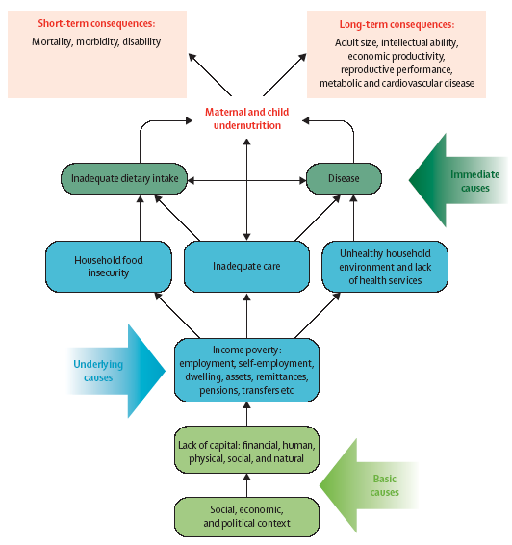

c. How should the results of the nutrition survey be disseminated?

- The preliminary SENS report with key findings should be available within one to two weeks after finishing data collection and shared initially with UNHCR counterparts for comments before wider dissemination.

- The full SENS report should be written and disseminated as soon as possible after completion of the survey and no later than two months after the assessment is completed to enable timely intervention where necessary. Often the preliminary results need to be presented to stakeholders verbally to help get the messages across quickly. It is also important to inform the surveyed population about the results.

- Draft reports of SENS nutrition surveys should be shared with Regional Offices and/or UNHCR HQ for comments before finalisation and release.

- The raw data files should be saved and maintained at country level for any future reference, and should also be sent to UNHCR HQ / Regional Offices.

- Results of SENS nutrition surveys are recorded in a Global SENS Database at UNHCR HQ and are used, along with other information, to report on situations and trends, and to trigger actions.

- If the survey is conducted in collaboration with other agencies, all parties must agree on how the data will be stored and protected according to UNHCR refugee data protection guidelines.

- All related publications or presentations will need to be agreed upon beforehand by all parties involved in the data collection.

- Communications with the media regarding the nutrition situation should be shared with Regional Office / UNHCR HQ focal points before release.

- SENS nutrition survey reports will be shared via UNHCR HQ with a wider audience through the quarterly reports on Nutrition Information in Crisis Situations (NICS) of the UN Standing Committee on Nutrition and through the CEDAT data base of Centre for Research on the Epidemiology of Disasters (CRED).

Where can the SMART manual and training material be found?

SMART (2006) Measuring Mortality, Nutritional Status, and Food Security in Crisis Situations - SMART Methodology version 1 April 2006
- A manual detailing a basic integrated method for assessing nutritional status and mortality rate in emergency situations. It includes details of how to use the ENA software for analysing data. The manual is aimed at host government partners and humanitarian organisations as part of the SMART initiative enhancing capacity and draws from core elements of several existing methods and best practice. It includes an optional chapter of food security which is based on a simplified version of the Household Economy Approach.
- Availability: Free, downloadable in pdf form in English.
- Contact: www.smartmethodology.org

Standardised Training Package: SMART Methodology- ACF-Canada, 2010
- The Standardised Training Package (STP) is a modular based training package for individuals and organisations interested in using SMART with a user-friendly and comprehensive tool when building capacity of survey teams. Following the survey process from start to finish, the STP provides the following information:
  - Application to different contexts and different participant competency levels, allowing you to structure your training accordingly.
  - Pedagogical approach with easy-to-follow presentations and trainer’s tips
  - Adult-education tools such as case studies, videos demonstrating practical techniques and helpful assessment tools.
  - The annexes to these modules provide useful tools and guidance to teams when planning training events.
  - Availability: free, package downloadable in English, French, Spanish.
  - Contact: www.smartmethodology.org

annexes

Annex 1 - Conducting full immuniSation assessment

- UNHCR SENS Guidelines recommend measuring the coverage of measles vaccination in children aged 9-59 months (or other context-specific target group e.g. 9-23 months) in all nutrition surveys. There may be contexts where a full immunisation assessment will be needed, especially in protracted, stable refugee operations. Follow the steps outlined below in order to plan your immunisation data collection.

Step 1: Since the Expanded Programme on Immunisation (EPI) protocol depends on the country / camp, obtain the most current immunisation schedule for children.
  - An example is shown in the table below (Source: UNICEF MICS4 Survey Design Workshop, 2010)

Age group | Vaccine* | Usual location of delivery
At birth or by 2 months | BCG  OPV (“zero” dose) | Left shoulder (usually leaves a scar)  By mouth
2 months or 8 weeks | 1st dose of Oral polio Vaccine (OPV)  1st dose of pentavalent (Hepatitis B, DPT + Hib) | By mouth  Began Pentavalent in 1999  Upper thigh
4 months or 16 weeks | 2nd dose of OPV  2nd dose of pentavalent | By mouth  Upper thigh
6 months or 24 weeks | 3rd dose of OPV  3rd dose of Pentavalent | By mouth  Upper thigh
12 months or 1 year | Measles Mumps Rubella (MMR)  Yellow Fever (YF) | Upper right arm
18 months or 1 year 6 months | Booster OPV  DPT vaccine | By mouth  Upper thigh
45 months or 3 years  9 months | Booster OPV  DPT  MMR | By mouth  Upper Thigh  Upper right arm
15 years plus | DT vaccines for pregnant women | Upper right arm
*Yellow fever vaccination may also be given in some countries. It is recommended to be given at the age of 9 months (sometimes given at the same time as the measles vaccine).

Step 2: Find out about any recent immunisation campaigns including:

  - Polio National Immunisation Days
  - Measles campaigns
  - Other vaccine campaigns (e.g. Yellow Fever)

Step 3: Adapt the standard questionnaire by adding other vaccines as appropriate.

Additional points to consider: The date the vaccine was given may be useful to determine so that the proportion who are fully immunized before reaching a specified age (e.g. the first birthday) can be calculated.
Annex 2 - Correction for small population size

When the population of children U5 is less than 10,000, it is necessary to use a correction factor in the sample size calculation that will decrease the survey sample size. The ENA for SMART software automatically applies this correction factor if the relevant information is entered onto the Planning screen.
After entering the total population size of the camp on the first row of the table, the Population Size box automatically shows the same population as the one manually entered. By clicking on ‘Correction small population size’, the ENA for SMART software then automatically applies the correction factor to the sample size calculation by deriving the total number of U5 children. In this example, the total number of U5 children is: 6700 x 18.5%=1239.5 U5 which is <10,000. Hence it is necessary to apply the correction factor which will decrease the sample size needed.

Simple random sampling

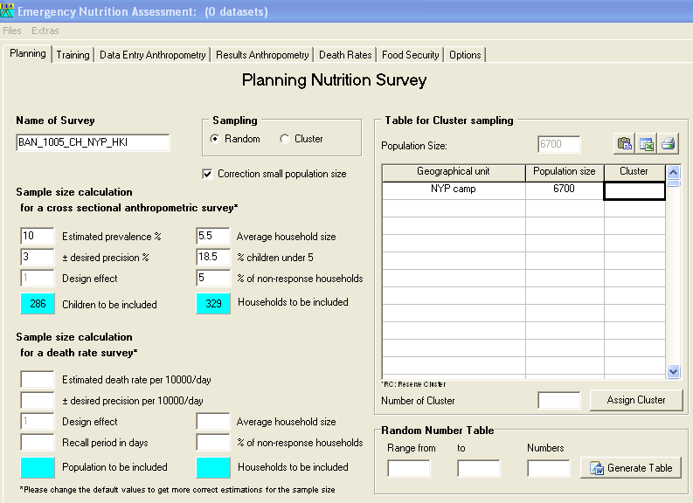
Enter the total population of the camp on the first row of the ‘Table for Cluster sampling’. Use this table for simple random surveys even though it says that it is for cluster sampling.

Fill out the sample size calculator with the relevant information and click on ‘random’ when conducting a simple random survey.
Cluster sampling
After entering the total population size per geographic unit in the table, the Population Size box automatically shows the total population of the camp by adding the population per block that was entered. By clicking on ‘Correction small population size’, the ENA for SMART software then automatically applies the correction factor to the sample size calculation by deriving the total number of U5 children. In this example, the total number of U5 children is: 6650 x 18.5%=1230.3 U5 which is <10,000. Hence it is necessary to apply the correction factor which will decrease the sample size needed.

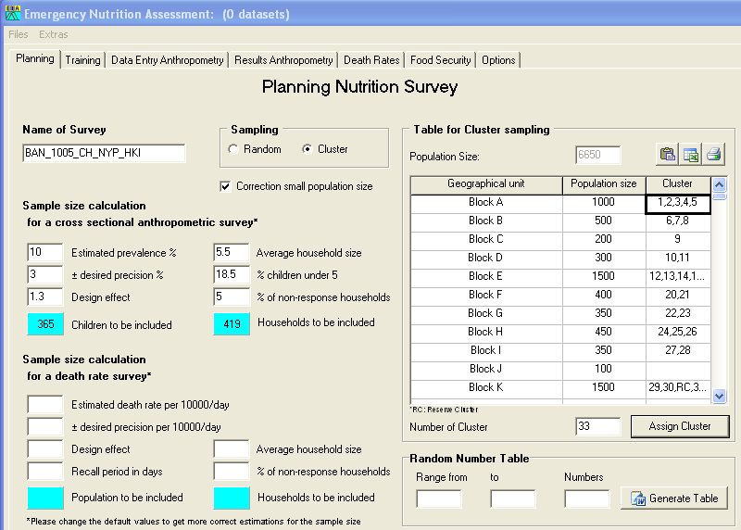
Fill out the sample size calculator with the relevant information and click on ‘cluster’ when conducting a cluster survey.
Choose the smallest geographic units in the camp with available population data. In this example, population size per Block was available and entered.

Refer to the SMART Standardised Training Package for further guidance on how to correct for small population size.

Annex 3 - Sample size calculation and sampling example

Step-by-step procedure to follow
CLUSTER SAMPLING
Step 1: Calculating the sample size

- The sample size by number of children needed is first calculated to assess the prevalence of acute malnutrition in children aged 6-59 months using the ENA for SMART software and the SMART recommendations. Include a non-response rate ranging between 5-15%, depending on the context.

- Fill out Table 6 shown below with the information from the survey context. An example is provided for illustration purpose. This table can be included in your survey protocol and/or final SENS nutrition survey report.

Table 6 Sample size calculation

Survey site(s) | Survey design chosen | Survey target group (indicator) | Total current estimated population and % children U5 (source of information) | GAM prevalence (%) from previous survey with confidence intervals (source of information) | Assumed current value | Desired precision | Assumed design effect | Sample size needed (individuals) | Average HH size (source of information) | Number of HH* to include (e.g. including a 15% non-response rate)
E.g. Refugee camp name | Cluster sampling because no complete, current HH list is available. | Children 6-59 months (acute malnutrition) | 17,000 total population and 18% of children U5  (Source: UNHCR ProGres) | 7.2% (5.4-9.5 95% CI)  (Source: SENS Report June 2009) | 7% | 3% | 1.5 | 454 | 6  (Source: Partner population headcount) | 549
*Include definition of HH corresponding to the average HH size figure used. In this survey, the standard definition will be used i.e. a group of people who live together and routinely eat out of the same pot.
ENA for SMART software should be filled out as shown in Figure 3.

Figure 3 ENA for SMART software screen-cluster sampling

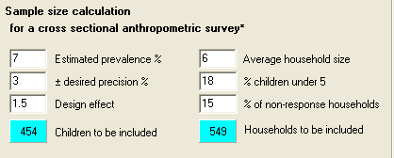

Step 2: Choosing the number of clusters to include in the survey

- If you are using cluster sampling, you now need to decide on the cluster size and the total number of clusters. To follow with the example, let’s say that the final survey design is a 32×17, meaning that you will survey 32 clusters of 17 households.

Step 3: Deciding on the sample size and sampling procedure for each module

- After calculating the sample size needed in number of households as illustrated above, you need to decide on the household sample size for measuring the indicators in the different modules. In addition, you need to plan how the households will be randomly selected and how the sub-sampling of households will be performed. Refer to the Sampling Decision Tree (SENS Pre-module Step 8) for guidance on how to perform second stage sampling.

- SENS Pre-Module Tool 5 (Data Collection Control Sheet) should be adapted depending on the total number of households to be surveyed per day for each module. See Annex 3 for the recommended data collection control sheet format.

- Fill out Table 7 shown below with the information related to your survey (e.g. select whether Scenario 1 or Scenario 2 is followed for the assessment of anaemia in children; select the most appropriate sampling method). An example is provided for illustration purposes for a 32x17 cluster survey (32 clusters of 17 households). This table can be included in your survey protocol and/or final SENS nutrition survey report.

Table 7 HH SAMPLE SIZE AND SAMPLING – CLUSTER SURVEY

Module | Sample size |  | Cluster size | Sampling
1: Anthropometry and health | 544 HHs |  | 17 HH per cluster | all eligible children within all of the sampled HH will be assessed for anthropometry and health indicators as outlined in Module 1.
2: Children Anaemia | Scenario 1: You need to measure the prevalence of anaemia for surveillance purposes but you do not need to assess the impact of an intervention and are not planning to intervene in the immediate term | 544/2=  272 HHs | 17/2=8.5 ≈9 HHs per cluster | half of the selected HH (sub-sample) should be randomly assessed for anaemia and all eligible children found in these HH should be assessed for anaemia indicators as outlined in Module 2.
2: Children Anaemia | Scenario 2: You are planning to implement / have been implementing an intervention to reduce anaemia in young children and you need to assess the baseline prevalence and impact of the intervention | 544 HHs | 17 HHs per cluster | eligible children from all selected HH will be assessed for anaemia indicators as outlined in Module 2.
2: Women Anaemia | 544/2=272 HHs |  | 17/2=8.5 ≈9 HHs per cluster | half of the selected HH (sub-sample) should be randomly assessed for anaemia and all eligible women found in these HH should be assessed for anaemia indicators as outlined in Module 2.
3: IYCF | 544 HHs |  | 17 HHs per cluster | all eligible children within all of the sampled HH will be assessed for IYCF indicators as outlined in Module 3.
4: Food Security | 544/2=272 HHs |  | 17/2=8.5 ≈9 HHs per cluster | half of the HH (sub-sample) should be randomly assessed for food security indicators as outlined in Module 4.
5: WASH | 544 HHs |  | 17 HHs per cluster | all sampled HH should be assessed for WASH indicators as outlined in Module 5.
6: Mosquito Net Coverage | 544/2=272 HHs |  | 17/2=8.5 ≈9 HHs per cluster | half of the HH (sub-sample) should be randomly assessed for mosquito net as outlined in Module 6.

Step 4: Deciding on the best method to use to sub-sample the households to survey

- Within each cluster, when using a list, randomly select half of the household originally selected to be sampled.

- If a list is not being used for sampling then sample every other household.
SIMPLE OR SYSTEMATIC RANDOM SAMPLING

Step 1: Calculating the sample size

- The sample size by number of children needed is first calculated to assess the prevalence of acute malnutrition in children aged 6-59 months using the ENA for SMART software and the SMART recommendations. Include a non-response rate ranging between 5-15%, depending on the context.

- Fill out Table 8 shown below with the information from the survey context. An example is provided for illustration purpose. This table can be included in your survey protocol and/or final SENS nutrition survey report.

Table 8 Sample size calculation

Survey site(s) | Survey design | Survey target group (indicator) | Total current estimated population and % children U5 (source of information) | GAM prevalence (%) from previous survey with confidence intervals (source of information) | Assumed current value | Desired precision | Assumed design effect | Sample size needed (individuals) | Average HH size (source of information) | Number of HH* to include (e.g. including a 15% non-response rate)
E.g. Refugee camp name | Simple random sampling because a complete, current HH list is available. | Children 6-59 months (acute malnutrition) | 17,000 total population and 18% of children U5  (Source: UNHCR ProGres) | 7.2% (5.4-9.5 95% CI)  (Source: SENS report June 2009) | 7% | 3% | - | 302 | 6  (Source: Partner population headcount) | 366
*Include definition of HH corresponding to the average HH size figure used. In this survey, the definition used in UNHCR ProGres was used (i.e. a group of people who live together and share the same ration)

ENA for SMART software should be filled out as shown in Figure 4

Figure 4 ENA for SMART software screen-simple or systematic random sampling

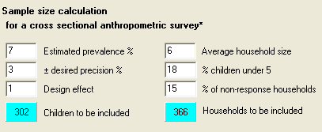

Step 2: Deciding on the sample size and sampling procedure for each module

- After calculating the sample size needed in number of households as illustrated above, you need to decide on the household sample size for measuring the indicators in the different modules.

- Fill out Table 9 shown below with the information related to your survey (e.g. select whether Scenario 1 or Scenario 2 is followed for the measurement of anaemia in children). An example is provided for illustration purpose. This table can be included in your survey protocol and/or final SENS nutrition survey report.

Table 9 HH sample size and sampling-Simple and systematic random sampling

Module | HH sample size |  | Notes
1: Anthropometry and health | 366 HHs |  | all eligible children within all of the sampled HH will be assessed for anthropometry and health indicators as outlined in Module 1.
2: Children Anaemia | Scenario 1: You need to measure the prevalence of anaemia for surveillance purposes but you do not need to assess the impact of an intervention and are not planning to intervene in the immediate term | 366/2=183 HHs | half of the selected HH (sub-sample) should be randomly assessed for anaemia and all eligible children found in these HH should be assessed for anaemia indicators as outlined in Module 2.
2: Children Anaemia | Scenario 2: You are planning to implement / have been implementing an intervention to reduce anaemia in young children and you need to assess the baseline prevalence and impact of the intervention | 366 HHs | eligible children from all selected HH will be assessed for anaemia indicators as outlined in Module 2.
2: Women Anaemia | 366/2=183 HHs |  | half of the selected HH (sub-sample) should be randomly assessed for anaemia and all eligible women found in these HH should be assessed for anaemia indicators as outlined in Module 2.
3: IYCF | 366 HHs |  | eligible children from all selected HH will be assessed for IYCF indicators as outlined in Module 3.
4: Food Security | 366/2=183 HHs |  | half of the sampled HH (sub-sample) should be randomly selected for the assessment of food security indicators as outlined in Module 4.
5: WASH | 366/2=183 HHs |  | half of the sampled HH (sub-sample) should be randomly selected for the assessment of WASH indicators as outlined in Module 5.
6: Mosquito Net Coverage | 366/2=183 HHs |  | half of the HH (sub-sample) should be randomly assessed for mosquito net coverage as outlined in Module 6.

Step 3: Deciding on the best method to use to sub-sample the households to survey

- When using a list, randomly select half of the household originally selected to be sampled.
- If a list is not being used for sampling then sample every other household.
Annex 4- Data collection control sheet

Example: Survey design is 32 × 15 (32 clusters of 15 HHs, giving a total of 480 HHs to be surveyed); anaemia scenario 1 is followed for children (See Sample Size and Sampling example in Annex 3 and SENS Pre-Module Step 8 for more details).

USE 1 SHEET PER DAY PER TEAM / PER CLUSTER. Grey cells mean that those measurements should be skipped in that specific HH; it is used to aid survey team members and survey coordinator in the daily management of data collection for each module. This is not entered into the database.

Date of sampling: dd / mm / yyyy |  |  |  | Section No.: |  |  | Block No.: |  |  | Cluster No. (if applicable): |  |  | Team No.:
HH No. | Anthropometry and health  Children 6-59 mo. |  |  | Anaemia  Children 6-59 mo. |  |  | Anaemia  Women 15-49 y |  |  | IYCF  Children 0-23 mo. |  | WASH  1=completed  2=absent  3=refused | Food Security  1=completed  2=absent  3=refused | Mosquito Net  1=completed  2=absent  3=refused
HH No. | No. in HH | No. surveyed | No. referred | No. in HH | No. surveyed | No. referred | No. in HH | No. surveyed | No. referred | No. in HH | No. surveyed | WASH  1=completed  2=absent  3=refused | Food Security  1=completed  2=absent  3=refused | Mosquito Net  1=completed  2=absent  3=refused
01
02
03
04
05
06
07
08
09
10
11
12
13
14
15
 | Add referral criteria for MAM and SAM |  |  | Add referral criteria for severe anaemia |  |  | Add referral criteria for severe anaemia
Comments (e.g. head of household name and HH No. when re-visit is necessary):
Note: (1) If eligible child or woman, or entire HH are absent, team should re-revisit the household at least twice before leaving the cluster site to conduct the interview and/or measure the child or woman; (2) If there are pregnant women in the HH, the number of women in the HH is expected to be greater than the number surveyed for anaemia.
Example: Survey design is 32 × 15 (32 clusters of 17 HHs, giving a total of 480HHs to be surveyed); anaemia scenario 2 is followed for children (See Sample Size and Sampling example in Annex 3 and SENS Pre-Module Step 8 for more details).

USE 1 SHEET PER DAY PER TEAM / PER CLUSTER. Grey cells mean that those measurements should be skipped in that specific HH; it is used to aid survey team members and survey coordinator in the daily management of data collection for each module. This is not entered into the database.

Date of sampling: dd / mm / yyyy |  |  |  | Section No.: |  |  | Block No.: |  |  | Cluster No. (if applicable): |  |  | Team No.:
HH No. | Anthropometry and health  Children 6-59 mo. |  |  | Anaemia  Children 6-59 mo. |  |  | Anaemia  Women 15-49 y |  |  | IYCF  Children 0-23 mo. |  | WASH  1=completed  2=absent  3=refused | Food Security  1=completed  2=absent  3=refused | Mosquito Net  1=completed  2=absent  3=refused
HH No. | No. in HH | No. surveyed | No. referred | No. in HH | No. surveyed | No. referred | No. in HH | No. surveyed | No. referred | No. in HH | No. surveyed | WASH  1=completed  2=absent  3=refused | Food Security  1=completed  2=absent  3=refused | Mosquito Net  1=completed  2=absent  3=refused
01
02
03
04
05
06
07
08
09
10
11
12
13
14
15
 | Add referral criteria for MAM and SAM |  |  | Add referral criteria for severe anaemia |  |  | Add referral criteria for severe anaemia
Comments (e.g. head of household name and HH No. when re-visit is necessary):

Note: (1) If eligible child or woman, or entire HH are absent, team should re-revisit the household at least twice before leaving the cluster site to conduct the interview and/or measure the child or woman; (2) If there are pregnant women in the HH, the number of women in the HH is expected to be greater than the number surveyed for anaemia.
Annex 5 - Ordering information
Refer to SENS Pre-Module Tool 06 (Survey Supplies Planning Sheet) for more details on quantity to be ordered based on the number of teams included in the survey.

Anthropometric equipment

UNICEF supply division (for electronic scales, MUAC tapes and wooden height measuring boards)
UNICEF plads, Freeports
DK-2100 Copenhagen
Denmark
Tel: +45 35 27 35 27
Fax: +45 35 26 94 21
E-mail: supply@unicef.org
Website: www.supply.unicef.dk

Shorr Productions (for electronic scales and wooden height measuring boards)
17802 Shotley Bridge Place
Olney, Maryland 20832
USA
Tel: +301-774-9006
Fax: +301-774-0436
E-mail: ijshorr@shorrproductions.com

TALC
PO Box 49,
St Albans,
Herts
AL1 5TX
UK
Tel: +44 1727 853869
Email: info@talcuk.org
Website: www.talcuk.org/accessories/small-insertion-tape.htm

HemoCue supplier information

The following HemoCue supplies should be available for each survey: HemoCue 301 Analysers, HemoCue 301 Analyser Cases, HemoCue cleaning spatula packs, safety lancets (sizing of at least 2.25mm), microcuvettes, Eurotrol Hb 301 Control solutions: High, Low and Normal.

Contact the following supplier or your local supplier to place your order. Give ample time (at least 8 weeks) between ordering of supplies and survey implementation.

HemoCue AB
Box 1204
262 23 Ängelholm
SWEDEN

Phone: +46 77 570 02 10
Fax: +46 77 570 02 12
E-mail: info@HemoCue.se
Website: http://www.HemoCue.com/

They have several offices around the world that can be found on the website.

Note: HemoCue machines need to be serviced regularly to ensure they are working accurately. Moreover, Eurotrol Hb 301 Control solutions are needed for each survey to perform a check of the entire HemoCue system, i.e. both HemoCue machine and microcuvettes; this check is different than the internal electronic self test and Eurotrol Hb 301 Control solutions must be purchased for each survey.
Annex 6 - Guidance on key Epi Info commands

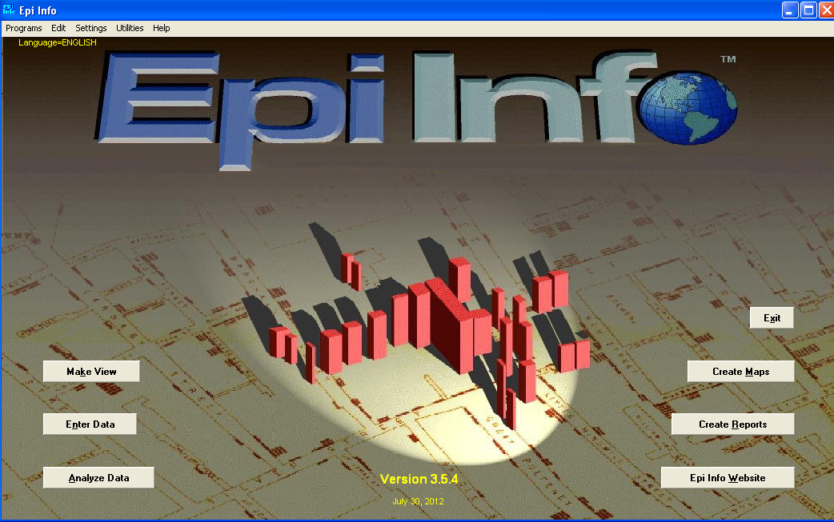
The Make View module in Epi Info is used to design survey questionnaires. Note that there are standard Views (questionnaires) available and ready to be used after adaptation for each SENS module. See details in each module.

The Enter Data module in Epi Info is used to enter the survey data into each View (questionnaire) of each SENS module included in the survey.

The Analyse Data module in Epi Info is used to analyse the survey data from each SENS module included in the survey. Note that there is standard analysis guidance ready to use for each SENS module. See details in each module.

g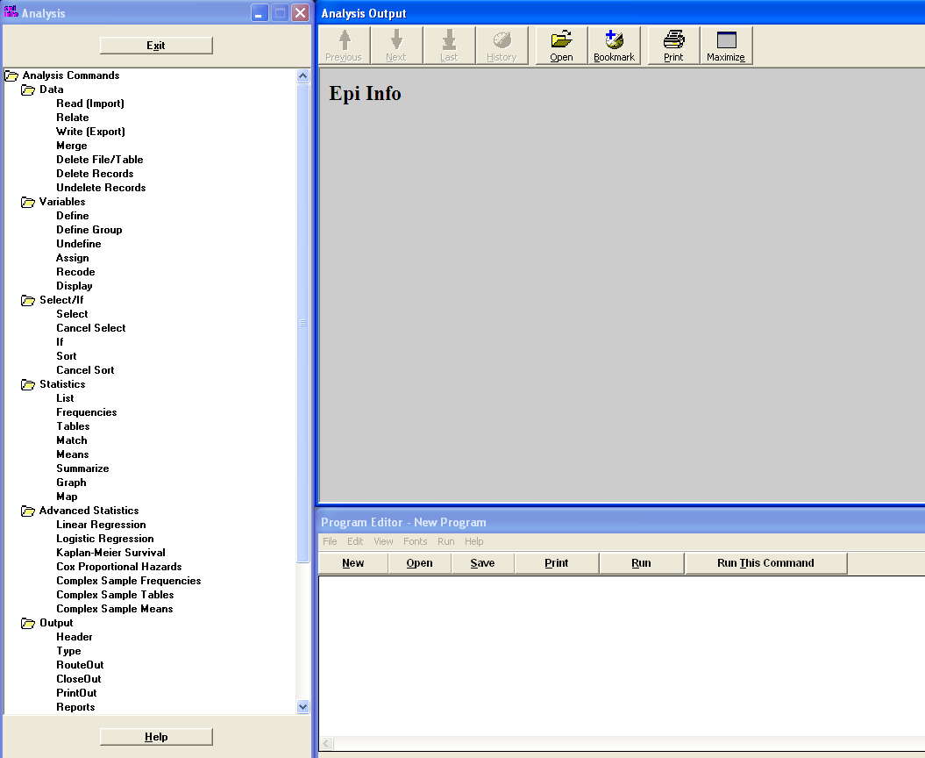
This section of the Analysis module shows the outputs (results) of the analysis performed. You may cut and paste the outputs in a Word document for future reference.

This section of the Analysis module shows the programme files or PGM files containing the Epi Info codes to perform each analysis. Note that there are standard Epi Info codes included in each SENS module. See details in each module.

The following analysis commands are needed to analyse a SENS Nutrition Survey:

1. Read (Import)
2. Write (Export)
3. Define
4. Assign
5. Recode
6. Select
7. Cancel Select
8. If
9. Frequencies (with simple random sampling surveys)
10. Means (with simple random sampling surveys)
11. Complex Sample Frequencies (with cluster surveys)
12. Complex Sample Means (with cluster surveys)
Setting the Options for analysis cluster surveys
Click on Set in the Options command.

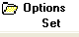

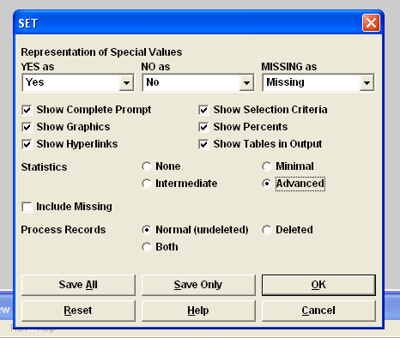
Select <Advanced>: this will ensure that confidence intervals are shown when using the Complex Sample Frequencies command.

Click Ok.

Free guidance on the use of Epi Info and training material on Epi Info can be found at the following site: http://www.cdc.gov/EpiInfo
Annex 7 - Assessing trends and changes

When interpreting trends and changes, the following two questions need to be asked:

Question 1: Is the situation stable or persistent, or has the situation improved or deteriorated in comparison to surveys conducted using similar methods on the same target population?

Figure 5 Prevalence Trend Classifications

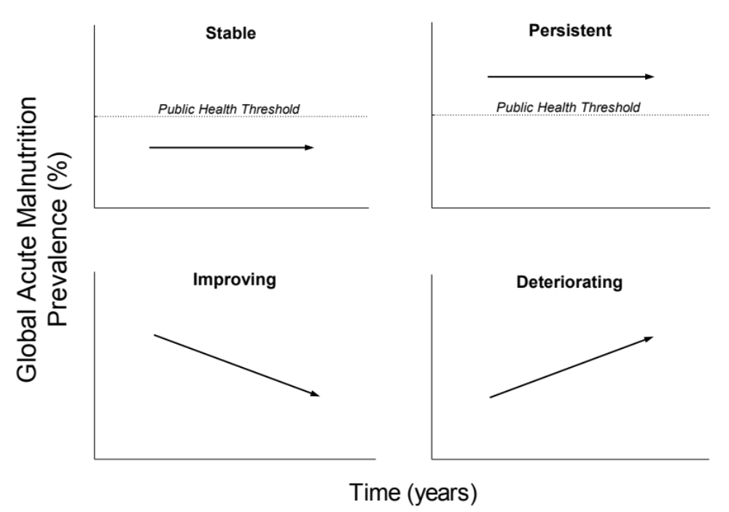

Question 2: Is the observed change a “significant” change? A significant change is shown by the 95 % CI. In the following figures, the point prevalence of a survey result is shown and the bars show the upper and lower limit of the CI. When the CIs overlap, this would suggest that there is no statistically “significant” change. However, in some cases, the CIs may overlap slightly and there may still be a statistically significant difference between the two surveys. In these cases, a statistical test needs to be conducted.

Examples

Was there a significant improvement in the nutritional situation between November 2010 and November 2011 (Figure 6)?

Figure 6 Trend in prevalence of acute malnutrition in children 6-59 months from 2009-2011

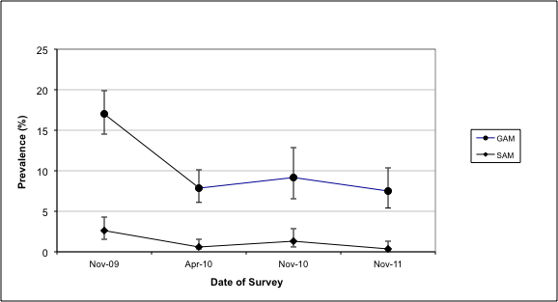

Answer: No, the CIs overlap. We can see the situation is similar and has been stable since April 2010 in terms of acute malnutrition.

Is the nutritional situation significantly worse in August 2011 in comparison with August 2010 (Figure 7)?

Figure 7 Trend in prevalence of acute malnutrition in children 6-59 months from 2009-2011

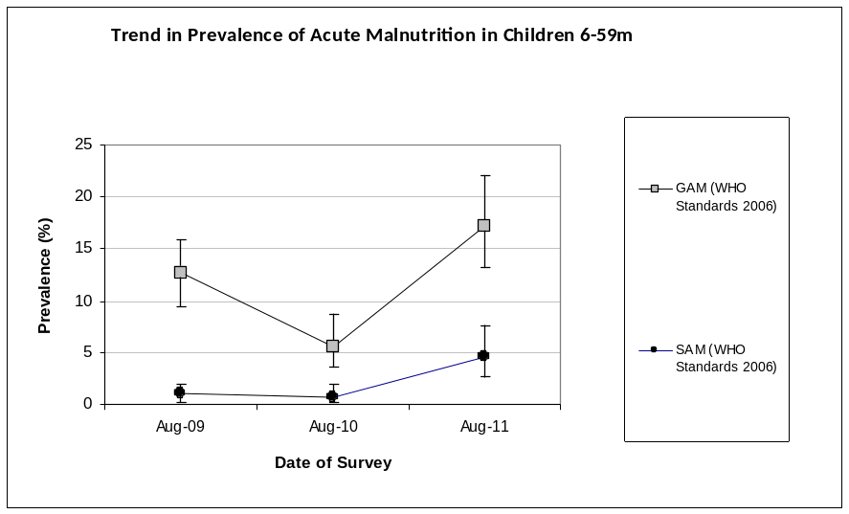

Answer: Yes, the CIs do not overlap. We can see that the situation has deteriorated in terms of acute malnutrition.
Was there a significant improvement in the nutritional situation between August 2010 and August 2011 (Figure 8)?

Figure 8 Trend in prevalence of acute malnutrition in children 6-59 months between 2009 and 2011.

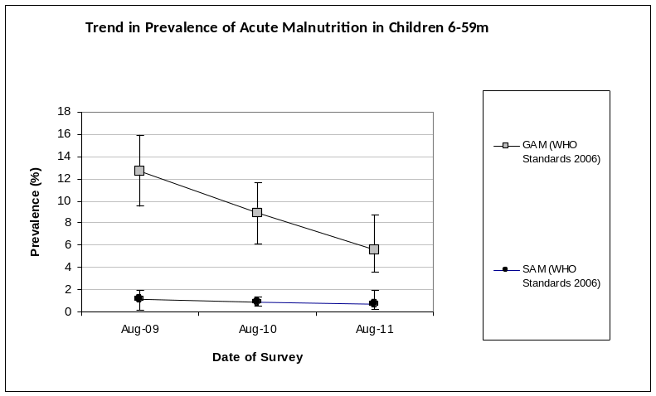

Answer: The CI overlap, however it is possible that the change is statistically significant between August 2010 and August 2011. A statistical test needs to be done to see if the change in GAM prevalence is statistically significant (see Annex 5 for an example on how to use the CDC Calculator). We can see that there has been a decreasing trend in the past three years in the prevalence of acute malnutrition in the surveyed population.

Has there been a significant improvement in anaemia prevalence from August 2010 to August 2011 (Figure 9)?

Figure 9 Anaemia categories in children 6-59 months from 2009-2011

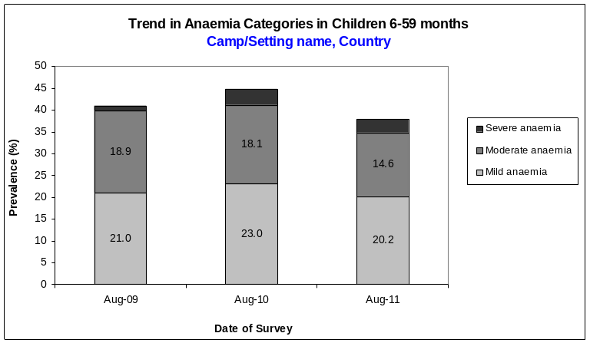

Answer: The CIs are not shown on the figure and hence we cannot conclude by looking at the Figure alone. A statistical test needs to be done to see if the change in anaemia prevalence is statistically significant (see Annex 5 for an example on how to use the CDC Calculator).
Annex 8 - Statistical comparisons between two surveys
 | Survey 1  (33x14) | Survey 2  (35x14)
Anaemia – Children 6-59 months | October 2008  n = 502 | October 2009  n =568
Total Anaemia (Hb<11.0 g/dL) | 43.6%  (39.3-48.1 95% CI ) | 35.9%  (32.0-40.0 95% CI)

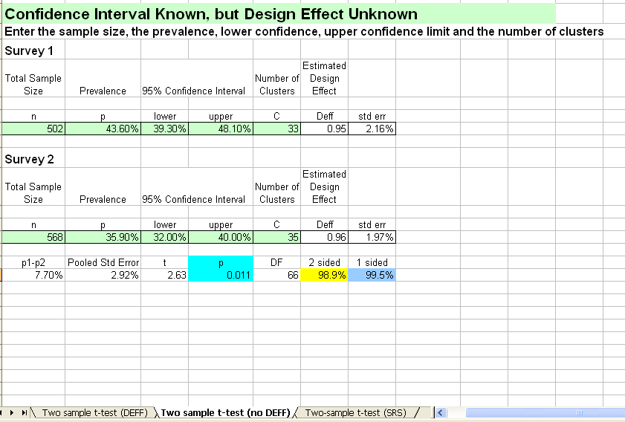
Fill out the details (green cells) from the two surveys you wish to compare.
-If the p-value is >0.05, there is no statistically significant difference between the two surveys. In the survey report, simply report the p-value as follows: ‘p>0.05’.

- If the p-value is <0.05 (as shown in this example), there is a statistically significant difference between the two surveys. In the survey report, simply report the p-value as follows: ‘p<0.05’.
Use this sheet when you are comparing two surveys which used simple random sampling or systematic random sampling (SRS). There is therefore no design effect.

Use this sheet when you are comparing two surveys which used cluster sampling and when you know the design effect for anaemia, or the indicator being measured.
Use this sheet when you are comparing two surveys which used cluster sampling and when you do not know the design effect for anaemia or the indicator being measured, like in this example.

Annex 9 - CE-DAT Checklist

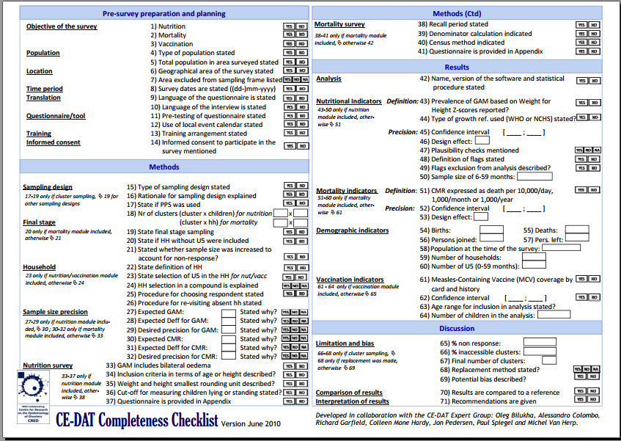

Note that survey coordinator is used throughout these guidelines. Other commonly terms used to describe this position include: survey manager or survey consultant.
The CDC calculator can also be downloaded from: http://www.cdc.gov/nceh/ierh/ResearchandSurvey/calculators.htm.
www.unsystem.org/SCN Quarterly report with updates of nutrition situations. Each report presents the summarised results of nutrition surveys around the world.
http://www.cedat.org. CE-DAT is a global database on the human impact of conflicts and other complex humanitarian emergencies and serves as a unique source of health indicators for monitoring conflict-affected populations and for the production of trend analysis, impact briefings and policy recommendations.

