Tutorial 2 – Exporting data for analysis
  - (KOBO, and ODK Aggregate on Raspberry PI or VM Server)
Tutorial version: 3.5
System used: Kobo ToolBox; ODK Aggregate (all versions since v1.4.2); ODK Briefcase (v1.17.0)

This tutorial is going introduce how to export data from Kobo ToolBox and ODK Aggregate (running on Raspberry Pi or VM server will be the same process on exporting data via using ODK Briefcase), depending on which platform you have used for deploying the questionnaire. For the VM server (offline server deployed since January 2013), there is an application called ODK Briefcase that can be used to post data on the server or retrieve data from the server. Using the Briefcase to retrieve data from ODK Aggregate is highly recommended for all questionnaires and mandatory for questionnaires containing loops (ex. Food security/Mosquito/WASH Questionnaire, Infant/Child Questionnaire, Women Questionnaire and Demography questionnaires).
The second part of this tutorial explains how to use the Briefcase. The first section explains the more direct process used with Kobo Toolbox.

Kobo ToolBox Process

Login into Kobo
For those using the Kobo ToolBox, exporting directly from the website is recommended and only this first section of the document is relevant. For those using ODK Aggregate, please skip this section and go to page 3

Go to Data
To access Kobo go to https://kobo.unhcr.org/ and log in with your username and password. Once logged in, click on the name of the form which you wish to analyse. If the form already contains data you will see four options (Summary, Form, Data and Settings). If the form does not yet contain any data, the data option will not be displayed in the menu. If data has been recently sent to Kobo for the first time, you may need to refresh the browser page.
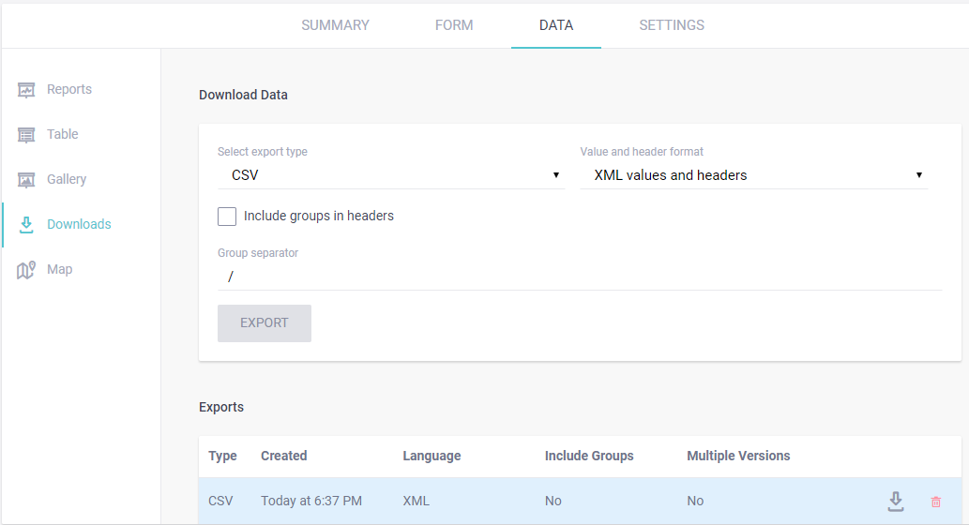
1.
3.
2.
4.
5.

Downloading
As shown in the image above please click on Data at the top of the screen and downloads on the left hand side. It is then necessary to select the options as displayed in the screen shot. The export type is “CSV” and the value and header format is “XML values and headers”.

The other options can be left as default and you can click export. Please note that depending on the size of the data set the export may take a few seconds to run. The exported data should display at the bottom of the screen as shown in the screenshot with a type of CSV and a language of XML. These settings are important as any other format will not be compatible with the analysis tools.

Storing the data
Finally click on the download icon (the downward facing arrow) in order to download the data to your desktop and store it in the correct folder.

Please follow the following folder structure for the data export, with one folder per form and per day. Repeat for all forms. Don’t forget to have one download folder per form and per day.

ODK Aggregate Process

To pull data from your server to a local folder
First, launch ODK briefcase by double clicking on the application file (.jar). You can search for the file in your start menu if you don’t remember where it is located on your computer.
Once in the program, first go to the right tab: Settings (see below illustration).
Set your Briefcase Storage location if not already done. You can also leave the automatic location (this is not the folder in which you will download your data from the server – it is intermediate download folder only used by the application). Please note that if you are using an older version of ODK Briefcase the user interface may look different from the screenshots. In this case you will likely find the storage location at the top of the “Pull” tab.
If you are starting a new survey on a computer already used for another survey, make sure to create a new folder using the Clear button.
To change the location, click on the Clear button in the top-right of the window, and then click Choose.
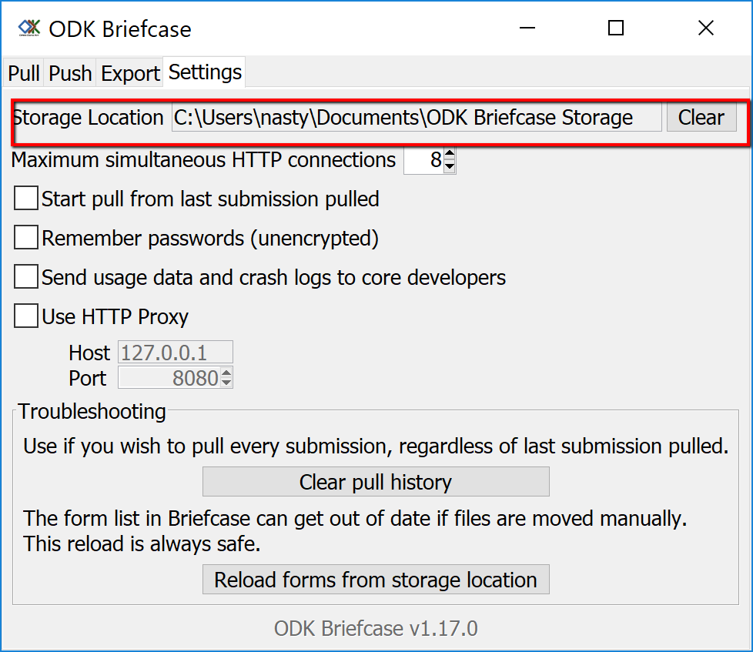

Next is to set the server’s IP address (URL) in the Pull tab. Set this to your server IP address: http://192.168.X.XXX (the IP may change from one server to another). This is the same IP address that appears when you start up the VM and that you copied into your web browser to log into Aggregate. You must put the http:// at the beginning of the address, otherwise it will give you an error. The below login information is an example which may change from one location to another.
URL: http://192.168.X.XXX
Login: root
Password: aggregate
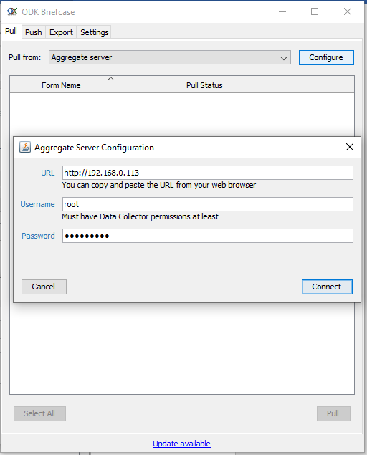
- If you have allowed anonymous access as “Data Viewer” on the Site Admin then repeating the Password will not be necessary.

You can then pull the forms from your server. The forms need to be pulled from the server prior to exporting the data from it. This mean every time you want to export data, you need to pull the form.
In the pull tab, select the forms and then press Pull.
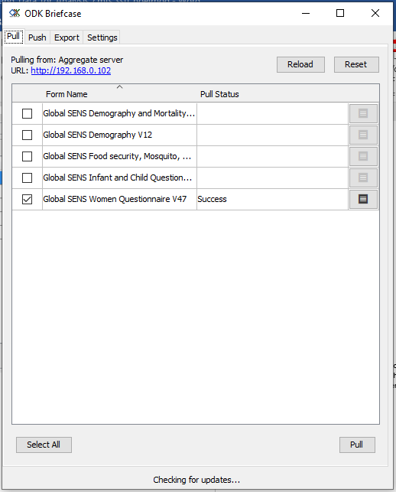

2. To export data to a local folder (export your csv files)
Once you have pulled your forms, you can then export data from the server. Go to the export tab of the Briefcase.
Choose the form from which you want to download data and specify the folder to which this data should be downloaded to (this is the folder from which you will access the data for analysis). Please follow the following folder structure for the data export, with one folder per form and per day. To select the correct folder please click on the settings icon (2.) beside the relevant form as indicated by the arrow on the left of the ODK Briefcase screenshot below.

Figure 1 In blue are folder, in yellow files. XXX is the ISO3 country code, YYMM is for year and month
You can then click on Export and your data should get downloaded. Repeat for all forms. Don’t forget to have one download folder per form and per day. Also, do not forget you need to pull the forms every evening before exporting the data. To export multiple forms you can check the box beside each form, making sure the folder destination is set and click Export. As a recent feature, folder destination settings will be stored in ODK Briefcase for future exports and do not necessarily need to be re-entered each time.
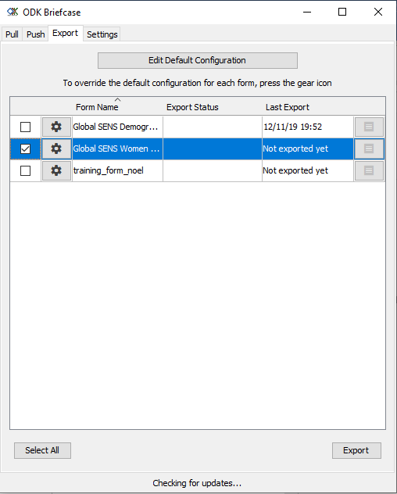
1.
2.
3.

To import data from your phone to your server using USB connection
If for any reason you are unable to connect your phones to your server using the WiFi network (normal procedure), you can synchronize your phones with the server using a USB connection and ODK Briefcase.
For example, you want to upload onto your server a finalized version of Global SENS Food security, Mosquito, WASH V22. You will need to make sure that:
- The blank form has been uploaded on your ODK Aggregate server (VM).
- The same form has been downloaded and filled on your mobile ODK Collect app (smartphone).

You will need to first Pull the data from the phone to Briefcase, then to Push it from Briefcase to Aggregate.
Plug in your phone with the USB cable in the same way.
Using your normal Windows Explorer, click on your phone. It should be similar to when you plug in a normal USB key. It can take a few moments before your computer detect your phone, be patient.
If the folder doesn’t appear automatically on screen you can go to the “My Computer” folder and you should see it there. Click on it, and look for an “odk” folder in the directory.
Copy this folder on your computer. If you have a folder already set up to store your forms and other relevant documents, use it (otherwise your Desktop is fine).

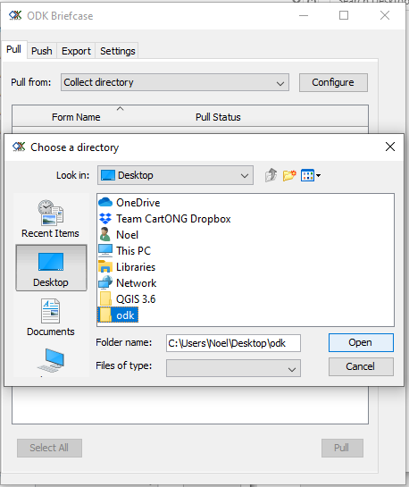
Next, you will need to tell Briefcase to look in this folder to pull the data.
Go to the Pull tab, then choose “Collect Directory”. In this example, the copy of the folder “odk” from the phone is on the Desktop (C:\Users\Noel\ Desktop\odk). Then select the forms you want to pull.

Once your forms are in Briefcase, you can just push them to Aggregate like you normally would.

- Don’t forget to check if the ODK Briefcase Storage Location is set to your personal storage directory.
Once the ODK folder is chosen, the forms within this folder can be pulled into Briefcase (select the forms you want and click on Pull).
The “Pull” status will change to SUCCESS!
You can now go to the Push tab to load the finalized form to your Aggregate server. Like in the first part of this tutorial, you will need to connect Briefcase to the server by entering its URL, your login (Aggregate only, remember Google account do not work with Briefcase), and your password.
URL: http://192.168.X.XXX
Login: aggregate
Password: aggregate
Note: If your VM server has been set up to allow anonymous download, you don’t need the password for downloading.
The form you previously pulled into Briefcase will appear, select it and click on Push. The Push Status Column will then change to Successful Upload.
Note: If you test this with a spare or a test phone and you tick “Select All”: all blank forms will be uploaded too, even if they are an older version. Therefore make sure you only select those forms you really want to upload.

