Tutorial - Launching and using the server
Tutorial version: 2.4
System used: ODK Aggregate version 1.4.2 to 1.7.1; ODK Collect version 1.23.3; https://kobo.unhcr.org, based on release 2.019.39.
Contents
I. Kobo Online Server 1
I.1. First KoBo Account creation 1
I.1.A. What is Kobo Toolbox? 1
I.1.B. Create a UNHCR KOBO account: 2
I.2. Accessing the online KoBo Platform and managing your projects 2
I.3. Adding a new project 3
II. Using Offline Server: Aggregate VM on Computer 5
II.1. Overview 5
II.2. Launch your server using a UNHCR computer and router 5
Step 1: Before Launching the VM server 5
Step 2: Launching the server 6
II.3. Use your ODK server on the computer 9
III. Using Offline Server: Aggregate VM on Raspberry Pi Mini Server 10
IV. Configure your phones to connect them to the server 10
IV.1. Connect the phone to the Wi-Fi network 10
IV.2. Configure ODK Collect 11
IV.3. Download new forms from server 13
IV.4. Send filled forms to server 13
V. Troubleshooting 14

Kobo Online Server

First KoBo Account creation

What is Kobo Toolbox?
KoBo is the survey management tool that is supported by UNHCR. It is recommended to use the online UNHCR KoBo platform (https://kobo.unhcr.org) rather than OCHA's (http://kobo.humanitarianresponse.info) to ensure that all SENS surveys are carried out on the same server in such a way that data can be shared more easily from one user account to another if it is necessary. You will also be able to ask for support from the UNHCR KoBo team if you have issues with the website. To access the UNHCR KoBo website go to: https://kobo.unhcr.org. You will have to start by creating an account (you cannot use the same username as the OCHA platform if you have created an account on that platform already).

Create a UNHCR KOBO account:
If you do not have any account on the UNHCR KoBo website you can create one; to do so, follow the steps below:
- Go to http://kobo.unhcr.org
- Click on “Create an account”

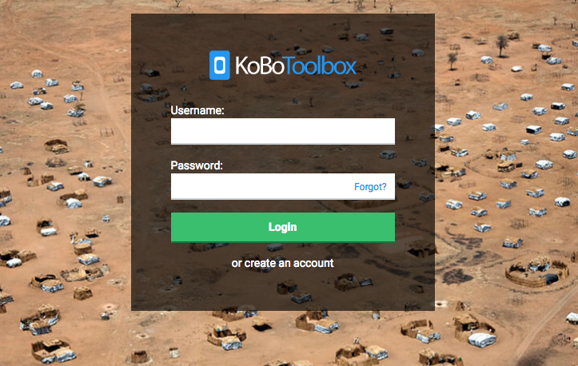

- Fill in form with the necessary information and then check your emails to get the validation email.
- Remember to define a descriptive username (i.e., “sens_country_organisation_role_region”) to facilitate data sharing at a later stage.

- Once you received the email, click to activate the account
  - Be careful not to click on the link twice by mistake
  - Check your spam if you cannot see the email in your inbox.

Your Kobo Toolbox account is now ready to use

Accessing the online KoBo Platform and managing your projects
By default, you will be directed to the Homepage.
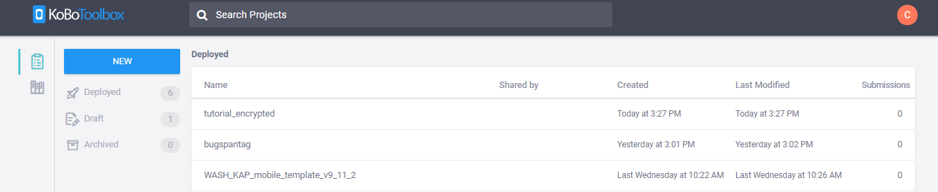
Your projects (when you have some) are organized into three categories:
- Deployed
- Drafts (projects that have not been deployed yet, still at the design stage)
- Archived (finished projects)

Adding a new project
The standard SENS form is in Excel, in what we call XLSForm format.
To import the contextualized SENS form (XLSForm file, for more information on how to contextualize the form, please refer to the MDC coding webinar):
- Click on “New”; this will open a "Create Project" window. Then, click on "Upload an XLSForm»; select the XLSForm you will need for your survey.
- Then click on "Create project"
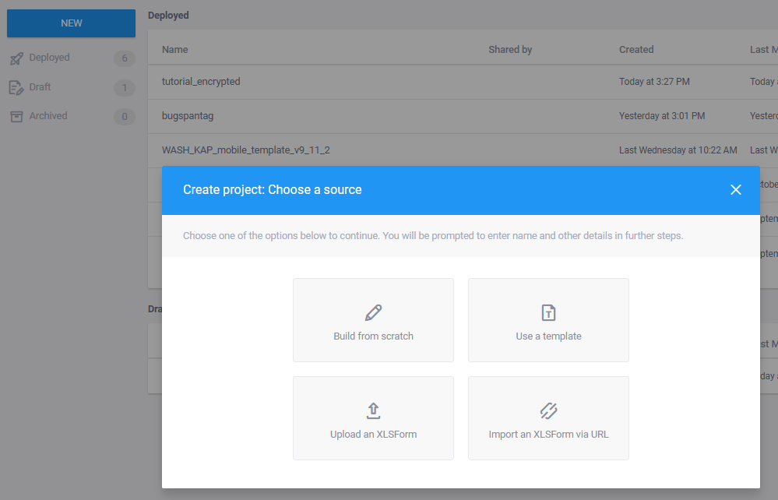
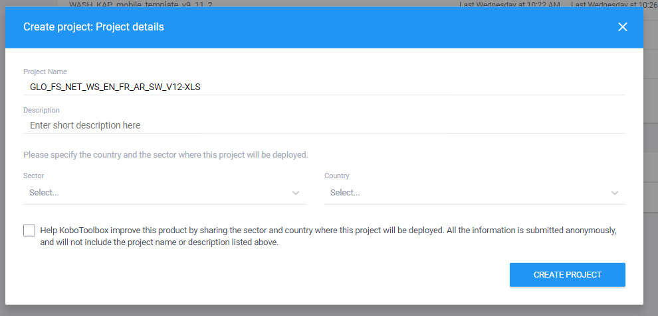
Once the Import is over, your form will appear on the home screen: it means that the import has been successful. If nothing appears on the screen, it means that the download has failed. An error message will appear shortly, helping you to understand what went wrong. Most of the time, it will be because you have made a change that is not allowed in the XLS form. Ask your HQ Nutrition focal point if it is the case.

- You can now click on "Deploy" to view the form from your mobile.
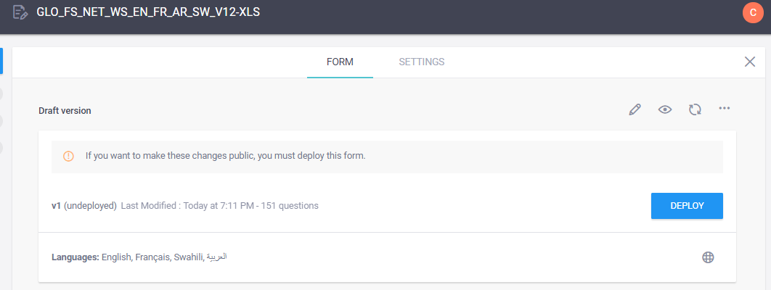
- If you do not want to deploy your form now, it will be saved automatically in your drafts.

- On KOBO you can find the link which allows to open your form on MDC Tools such as ODK Collect (see below) in the form page:
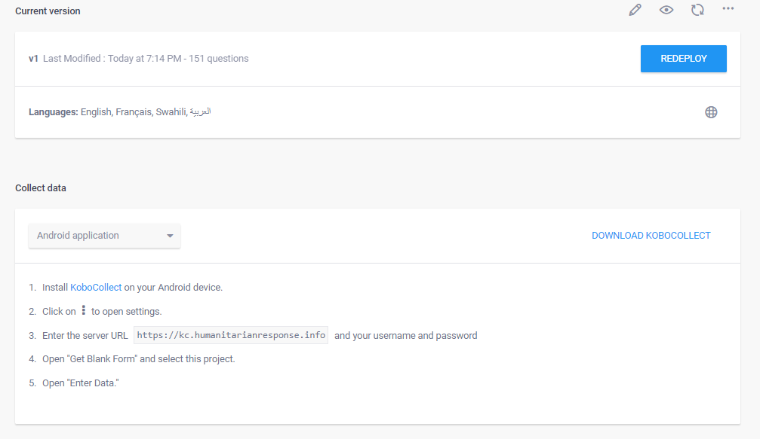

Using Offline Server: Aggregate VM on Computer

Overview
To download your data from the phones to the computer, you will need to
- Launch your server using a UNHCR computer and router,
- Use your ODK server on the computer
- Configure your phones to connect them to the server

This document also contains a section on how to troubleshoot at the end. Downloading data from the server is covered in another tutorial called Exporting Data for Analysis. Installing the server for the first time, and reinstalling the server in case of a problem is covered in another tutorial called Installing a new server.

Launch your server using a UNHCR computer and router
Every evening, in order to transfer the data from the phones to the ODK server, the survey manager needs to launch the VM server.

Step 1: Before Launching the VM server
- Ensure your router is running. The VM server CAN NOT run without the router being turned on.
- Make sure your computer is connected to the router.
- You can find an example below. Be careful, login will depend of the setup, it’s just a placeholder to fill. Get in touch with the person who manages/set up the router to receive your login.
Name: UNHCRAndroid
Password: UNHCR_Android

Step 2: Launching the server
- Launch the VM player from the icon on your desktop (see icon). If the icon is not on the desktop, look into your programs under name: vmware.
- In the VM player, on the left panel select your ODK aggregate VM (1.) and then play your virtual machine (2.). You can also double-click on the VM that you want to open. Depending on the VM version that has been installed on your survey computer, the version number can vary slightly, but the way to operate the VM is the same for all versions.
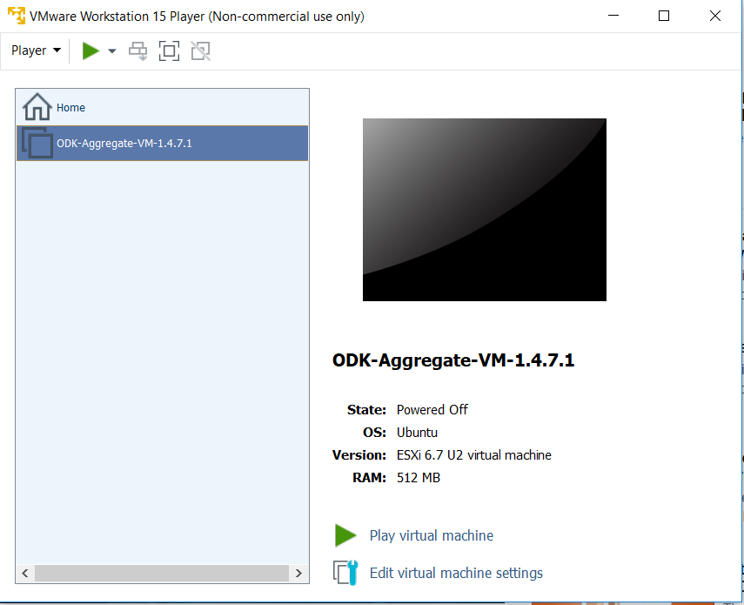

1.
2.
1

- Once you have launched your virtual server, the window will go black for a moment… your server is launching, be patient, it can take up to 10 minutes.

- If a pop-up shows up suggesting to apply updates, reject them.

- Once your server is running, the VM window should look like this:

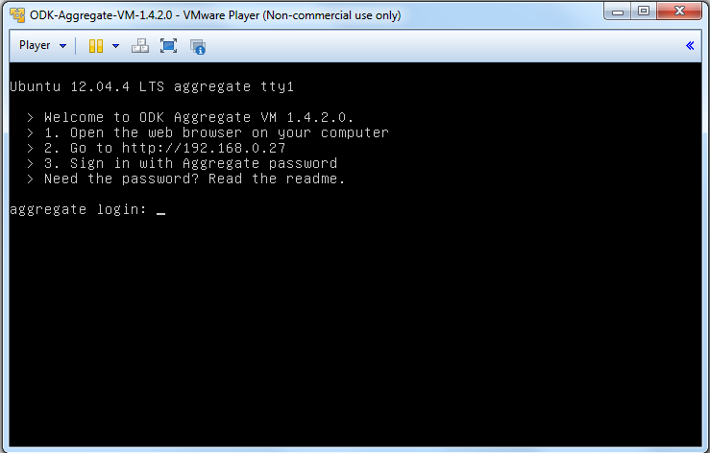
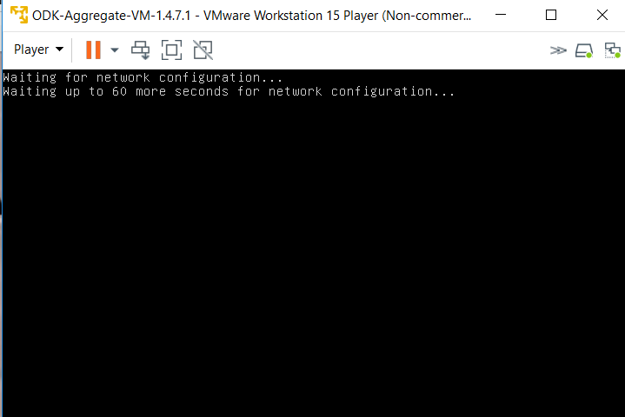

- Do not attempt to directly login in the Virtual Machine window. Open an internet browser and type the URL as showing up on your VM window (in our example highlighted in orange) in the address bar.
- Any time you change the router and hence the network, this url will change. It is not possible to run the VM Server on the same url after you have switched the network, unless this network has been configured exactly the same. Therefore, you should always run the VM on the same network.
- The url shown in the image above can vary depending on how your router has been set up. Please always use the url as shown on your computer.

- An Aggregate Window will show up, requesting you to log in. Use the “Sign In with Aggregate password” option.

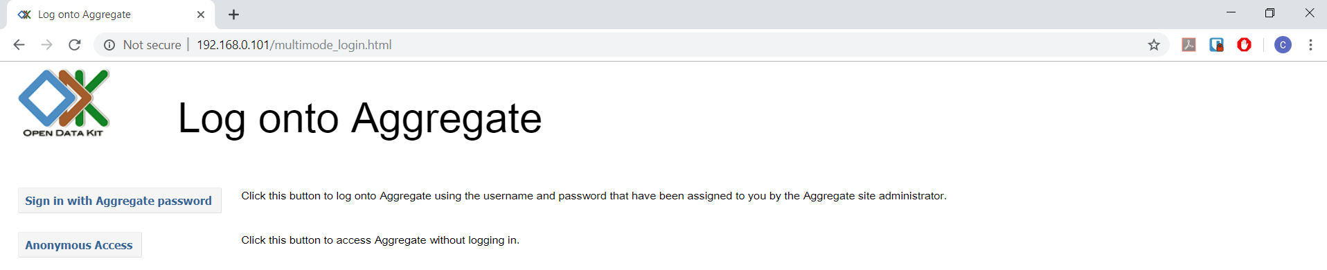

- Another window will open. Use the following identification:
Here is an example below, depending on the VM login might be different.
User: root
Password: aggregate
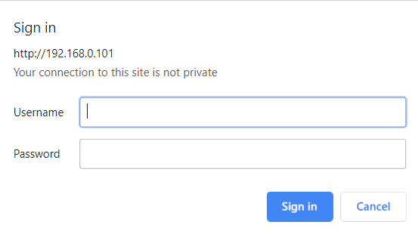
It is advisable to allow anonymous retrieval of the data. You can check if it’s the case on the “Site Admin” tab in Aggregate. Make sure the box “Data collector” is ticked for the User Anonymous:
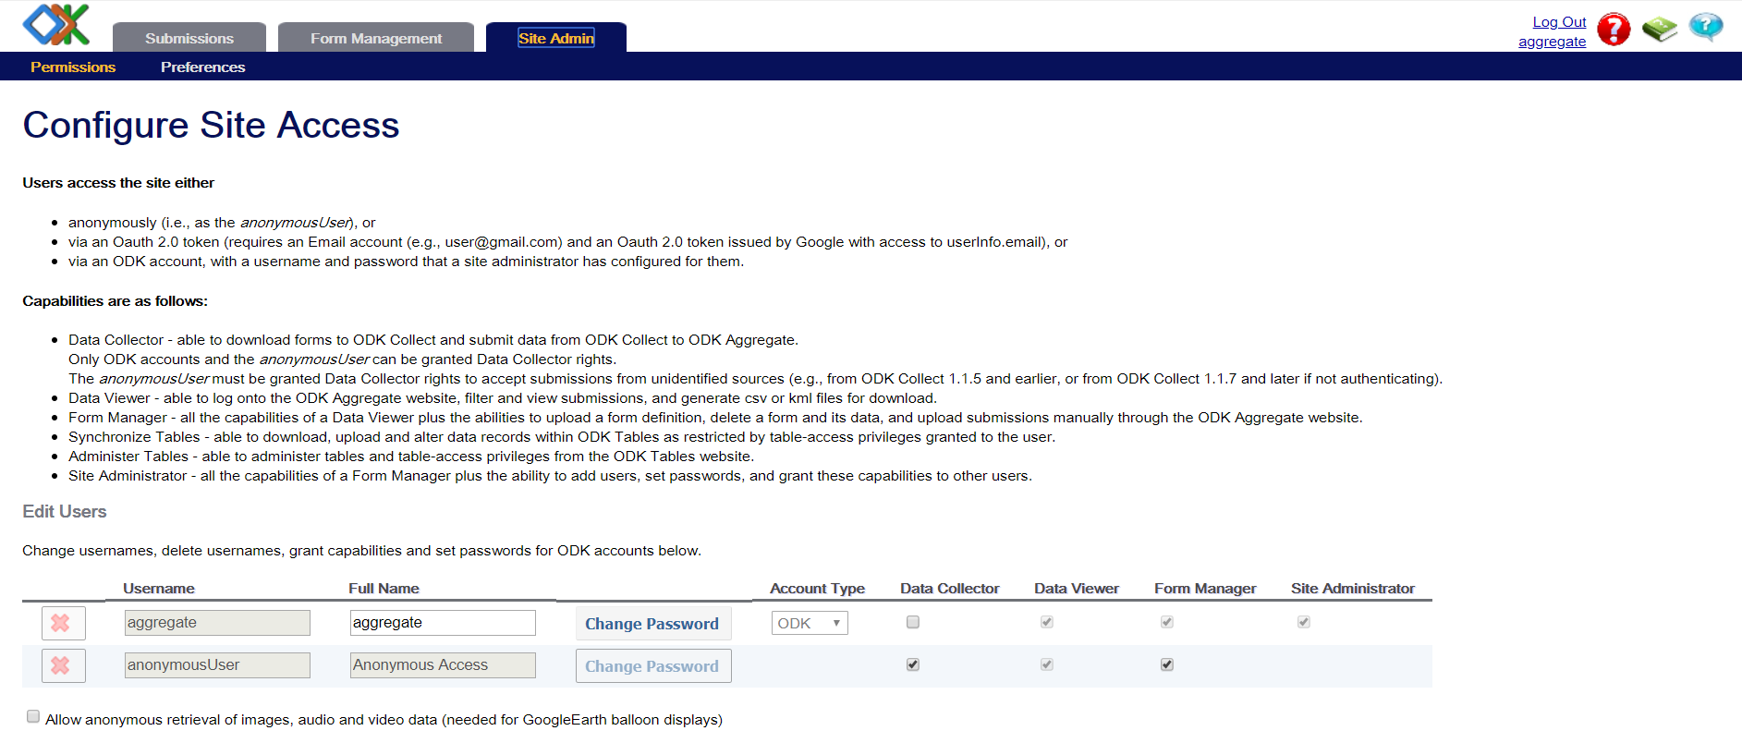

Use your ODK server on the computer
Before the beginning of a survey, erase any old form from the server by clicking on the delete button and confirming you want to delete both forms and data.
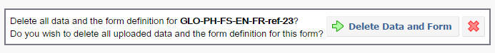
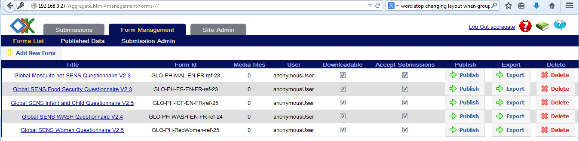

At the beginning of the survey, you have to upload blank forms to the server.
Go to the “Form Management” tab, click on “Add New Form”, select the xml file of your form and upload the form. In case you have been adjusting the global xls SENS forms yourself, you will need to convert the xls form into xml format. You can either use an online converter or an offline converter which you can download and also use in areas where there is no internet. The latest version can be found on Github and an older version which works well with converting all forms can also be downloaded from this Dropbox link. The step of loading the form DOES NOT need to be repeated every evening, just when you want to add a new form to your server.
- To convert an XLSForm into an XML File:
                - Online by using: https://opendatakit.org/xlsform/
                - Offline by using “ODK XLSForm Offline” (find all the available version here: https://github.com/opendatakit/xlsform-offline/releases)
                - Offline by using version on Dropbox:
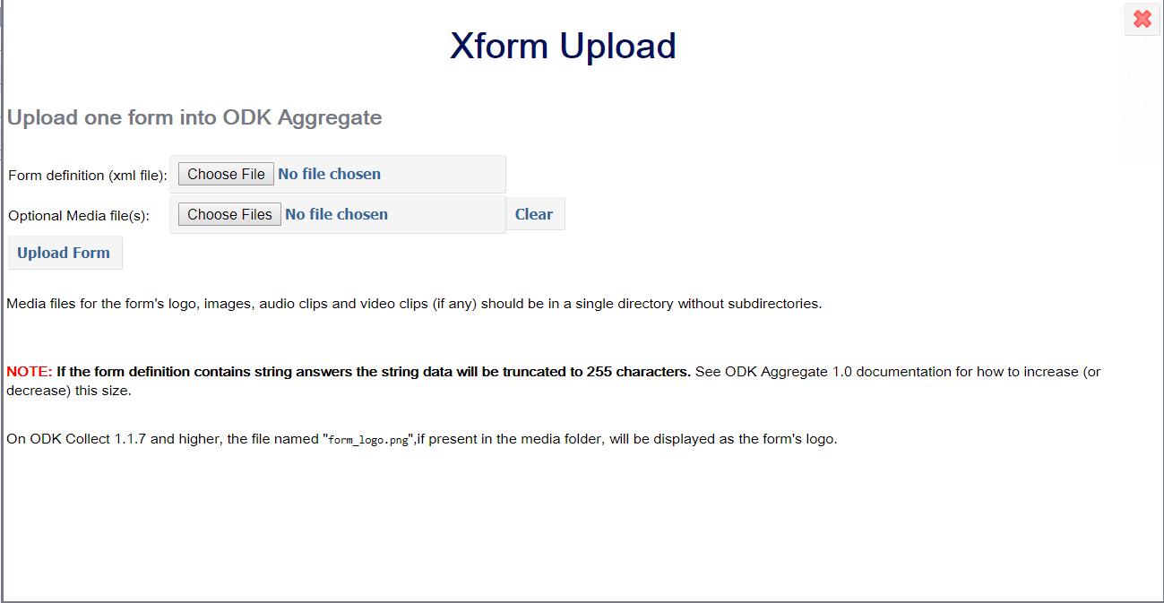
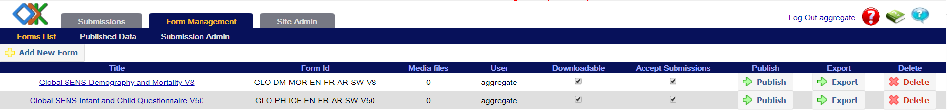

If you click on the Submission tab and you select a form, you can view the data which has been sent so far. In the example below, you can see test data for the Household form.
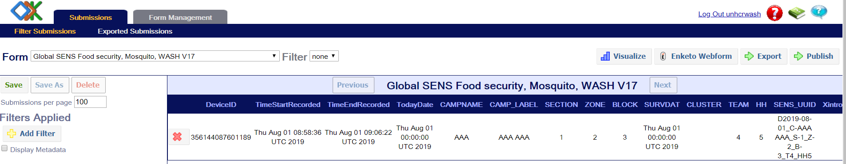

You can also apply a filter to display only some of the records based on criteria of your choice, clicking on the “Add filter” button on the left menu. On the following example, only the records from a specific section are displayed:
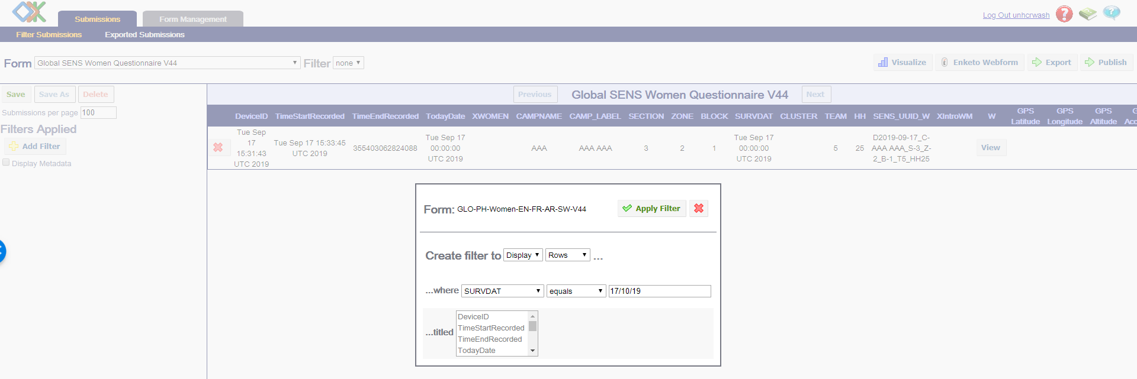
Now you can connect the smartphones to the server.

Using Offline Server: Aggregate VM on Raspberry Pi Mini Server
A new and very user-friendly way to run a SENS survey offline is through configured mini servers which can be connected to your computer. Raspberry Pi is a ready-to-use and easy-to-carry server which has been set-up, it’s the replacement of the UNHCR computer server. The rest steps of connecting phones to the server will be the same as below. Three of these devices are currently available through HQ in Geneva, if you are interested in using them, please get in touch with the nutrition team in HQ by emailing HQPHN@unhcr.org.
The instructions on how to use those mini servers can be found in MDC Tool 16 Connecting Mobile Device to Raspberry Pi Aggregate Server.

Configure your phones to connect them to the server

Connect the phone to the Wi-Fi network
The phones must be in Wi-Fi mode: click on the Wi-Fi icon on the status switch widget, so that the icon is lightened, and the status bar becomes green (1.). If the widget is not visible on your phone home screen, open the Settings menu (2.), then press the “OFF” button on the Wi-Fi line to turn it to “ON” (3.).
If the Wi-Fi network has never been set up on your phone, you will need to enter the log in details:
Network: UNHCRAndroid
Password: UNHCR_Android
To do so, open the Settings menu and press the Wi-Fi line (except on the ON/OFF button) (4.).
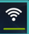
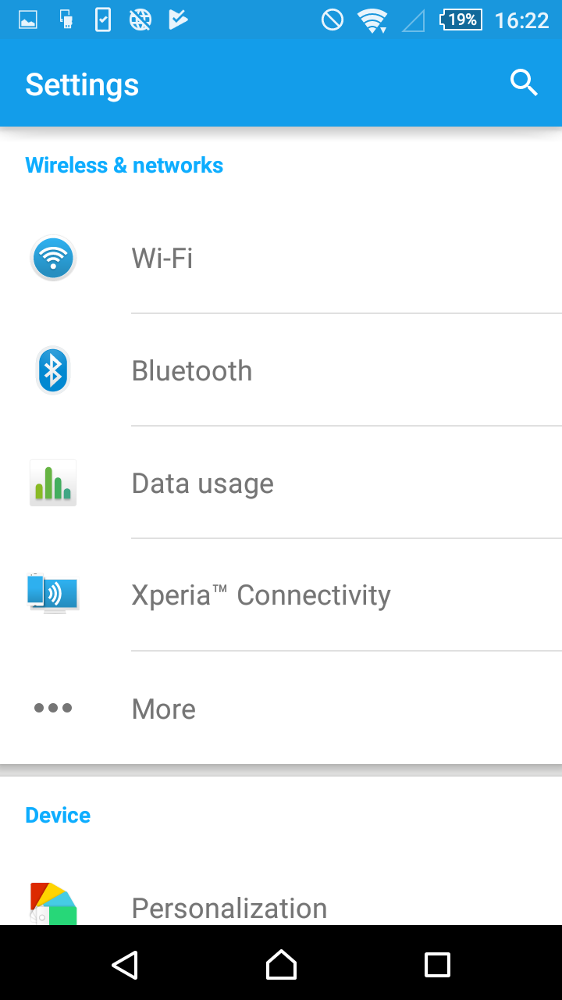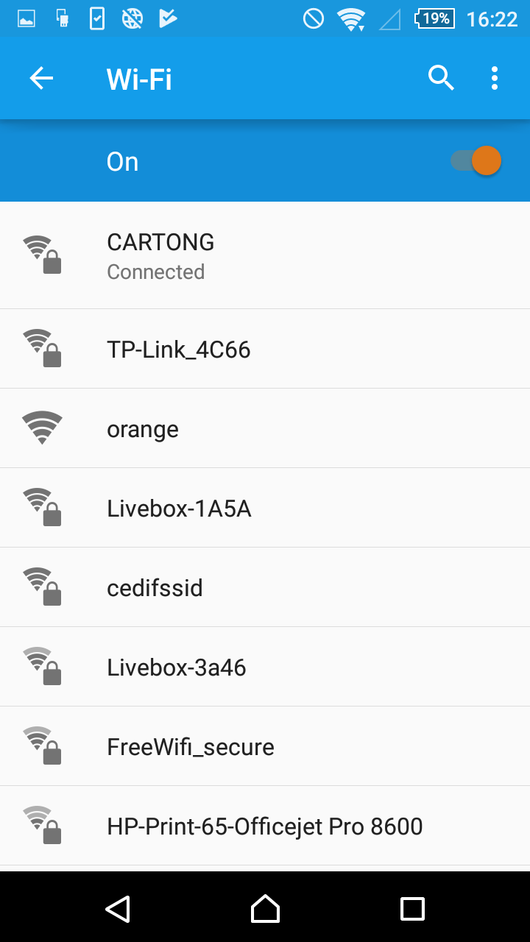
UNHCRAndroid

Press then on the name of the network you want to connect to (should be “UNHCRAndroid”), and enter the password in the pop-up that appears, and click on “Connect”:
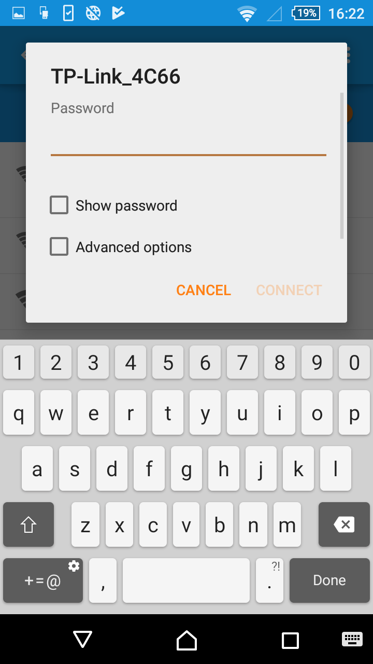
UNHCRAndroid

Configure ODK Collect
Open ODK Collect. Press the three points on the top right screen on the front of the phone (General Settings). Two options will appear, “Admin Settings” and “General Settings”. Press on “General Settings”.
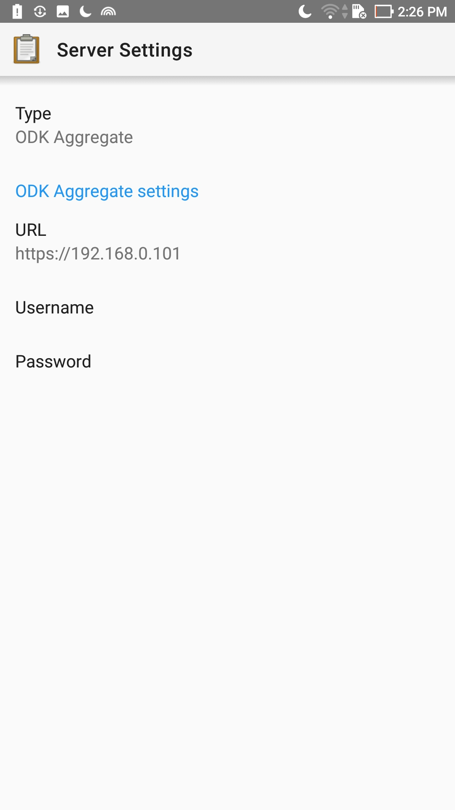 | 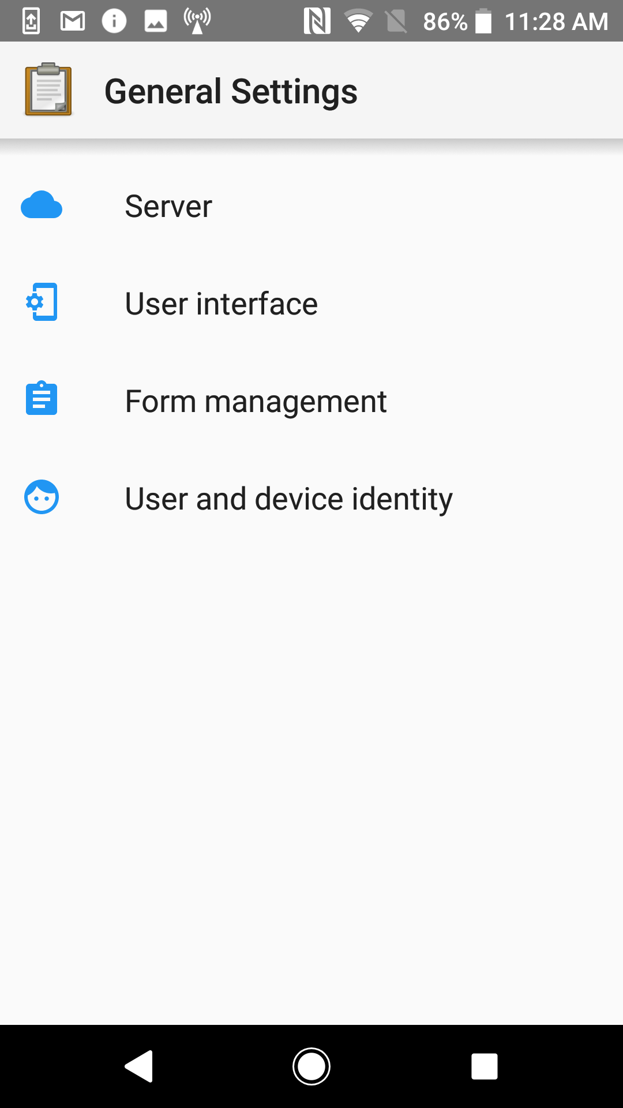 | 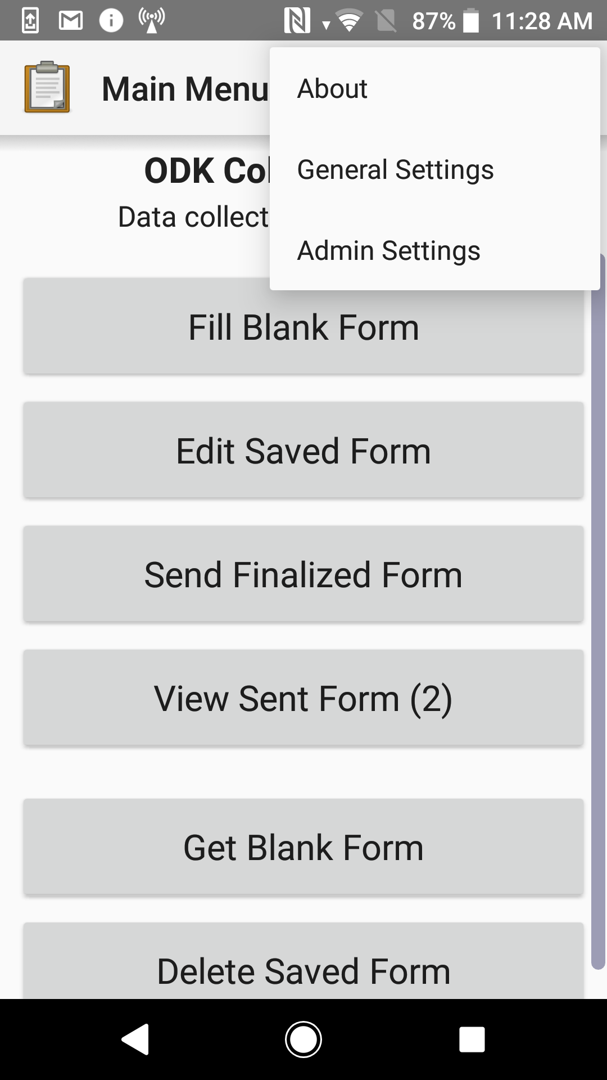

Select “URL” and enter the IP address of your server, in this example it is http://192.168.0.101 (it is the same address we used before while connecting with ODK Aggregate).
No username and password are required.
More information on how you can configure phones and what settings might be useful for your specific context can be found in the MDC Material Powerpoint for Supervisors as well as MDC Tool 15 How to set up a phone.

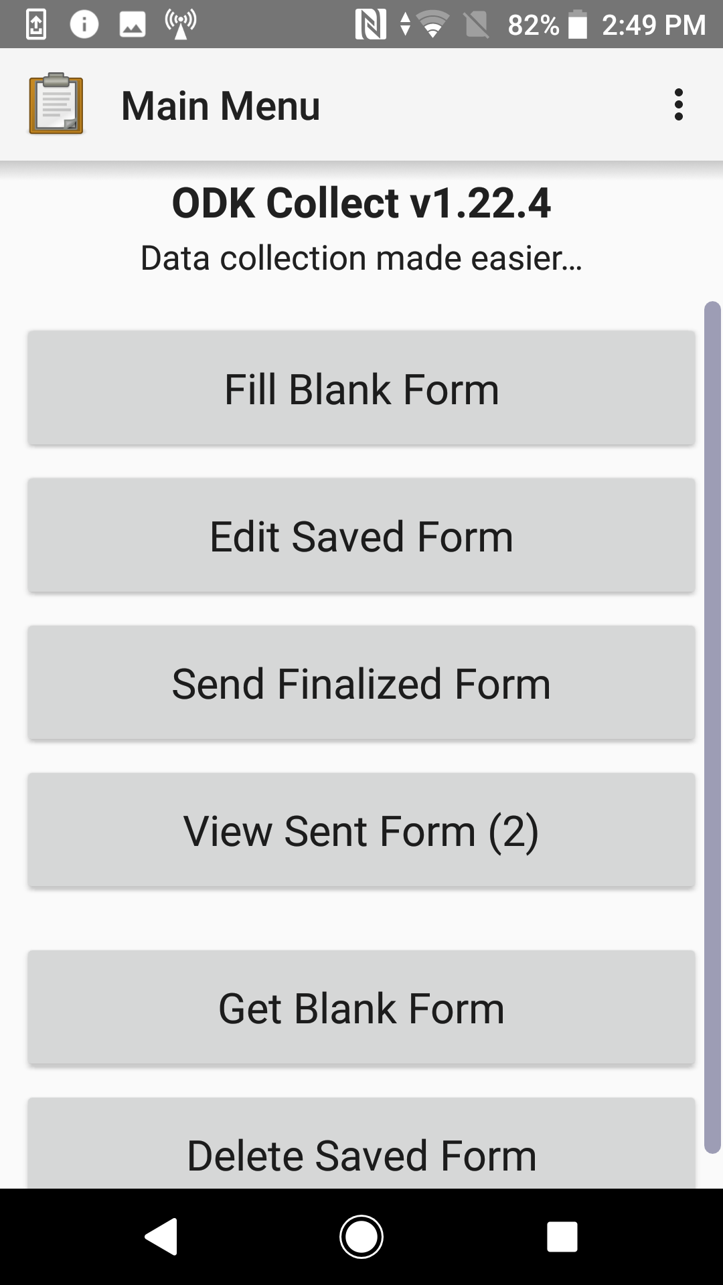
Download new forms from server
Select Get Blank Forms at the bottom and select the forms you want to load on the smartphone (1.).
The forms are now on the phone, ready for the surveys.

Send filled forms to server
Once the survey is completed and you are connected again to the network with the Aggregate server, you can send the completed submissions to the Aggregate server. Select “Send Finalized Form” (2.). Toggle all and send. A summary comes up where it should say “Success” behind all forms. The forms will now be in the server. All forms that have been successfully sent will appear in “View Sent Form”.
2.

- The forms are also in XML format in the ODK folder. So if there has been an issue with synchronization, it is still possible to upload them manually. However, if you delete them from the “Delete Saved Form” folder, they will have been deleted permanently from phone.
1.

Troubleshooting
- Remember that your VM Server needs a network connection, make sure you have first started the router, connected your computer to the network and then launched the VM. Doing those steps in any other orders is incorrect.
- If you are trying to open your ODK Aggregate VM with the desktop icon and an error “browse for VM or remove VM from library” appears, it means Aggregate has been moved on your computer. You need to browse it using the search function of the Start menu.
- If the server does not start correctly, or your ODK Aggregate browser displays “This webpage is not available”, you may have to check whether your router is still working and your computer is connected. If they are not working/not connected, you will need to reset the server by clicking on the pause button and selecting “Reset”. If you have to shut down the computer, you should always “Power Off” your VM Server.
- If your ODK Aggregate browser still displays “This webpage is not available” after trying that, try to temporarily turn down your Firewall and/or Antivirus. As a last resort, try to shut down the VM and restart your computer.
- If your VM still does not work after trying all these solutions, it may be corrupted. Possible causes for that are a switching off WIFI network while the VM is running, wrong extraction, moving the VM’s directory improperly (it does not like drag & drop) or placing it on a FAT32 partition (after several uses, the VM becomes too big). You then need to create a new VM, see tutorial on Installing, Reinstalling the server.
- If a connection to the router fails (resetting the router by switching it off for at least 30 seconds needs to be attempted first!) and there is not an alternative router at hand, you can also run the server and the synchronization through a spare phone. You will need to change the Wifi server settings on all phones including the ODK server settings and the WiFi network will be much less powerful, so only use it as a last resort solution.
- This does not work with all Android phones; the concept has been successfully tested with the Sony Acqua. The phone which is being used as a hotspot CANNOT synchronize, therefore you will need to use a spare phone.

- When using a computer running on Windows 10, the steps as described here might fail depending on what version of VM Player has been installed. Please refer to the IT tutorial “IT Tutorial – Installing a New Server” for further information. The following version of VMWare player has been tested successfully: 7.1.3 build-3206955 with Windows 10. Alternatively, it is also possible to have ODK Aggregate run on VirtualBox http://www.virtualbox.org instead. More information can be found in the IT tutorial as well as in the ODK Aggregate VM ReadMe file.

Follow the steps outlined below:
 | 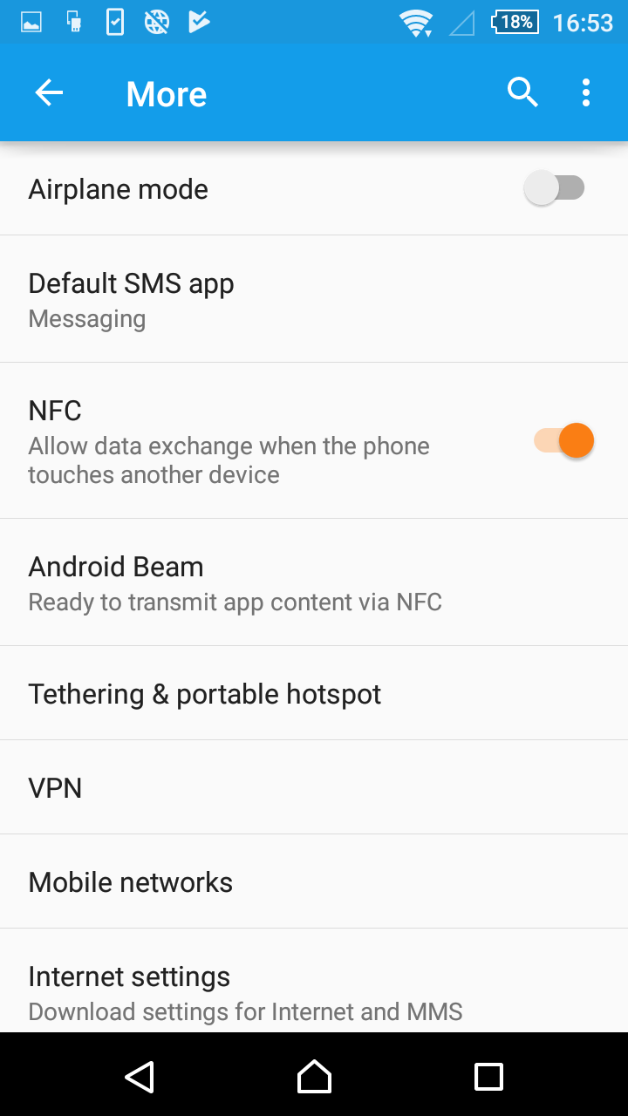 | 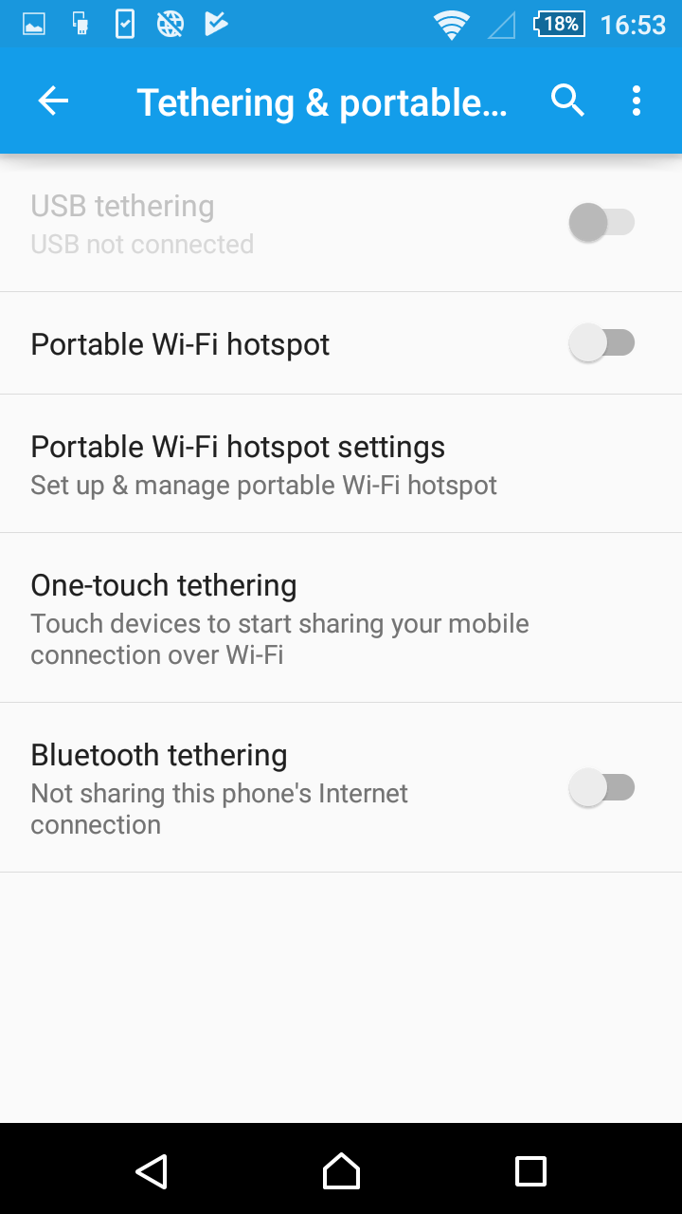 | 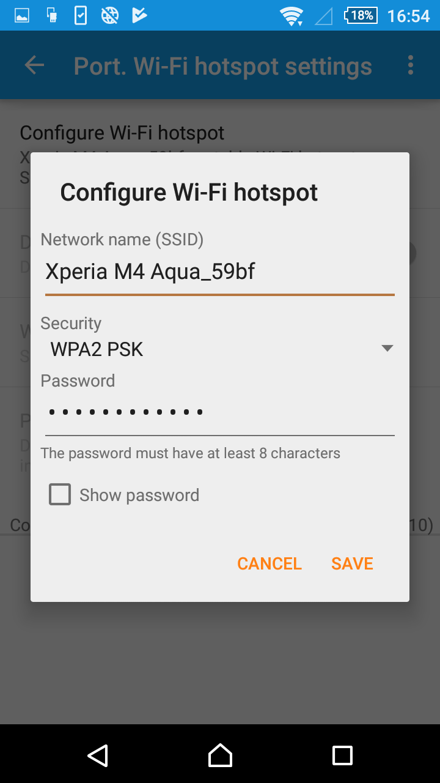
- Select “More”. | - Select “Tethering & portable hotspot” | - Select “Portable Wi-Fi hotspot”. | - Add a name for the hotspot. If you leave “Security” open, no password is required for the computer and the other phones to connect.

Now you can connect your server to the Hotspot (here: network ODK). Restart the server, open your browser for ODK Aggregate interface and connect all your phones to the Hotspot, change the ODK server settings and synchronize them.

VM stands for Virtual Machine.

