**ENA Software set up for UNHCR SENS Surveys on smartphones**

(ENA, Version dated July 9th, 2015)

**TABLE OF CONTENTS**

1. INTRODUCTION TO ENA SOFTWARE (Emergency Nutrition Assessment) 1

2. "ANTHROPOMETRIC DATA ENTRY" SCREEN 2

2.1 UNDERSTANDING THE SCREEN 2

2.2 ANALYSIS OF THE "ENROL" VARIABLE 3

3. "VIEW VARIABLES" SCREEN 4

4. SCREEN "OPTIONS" 5

4.1 ADDING "MEASURE" AND "CLOTHES" COLUMNS 5

4.2 PROTOCOL FOR USING THE "CLOTHES" OPTION 6

4.3 SETTING THE "OPTIONS" SCREEN FOR DATA ENTRY AND/OR ANALYSIS 7

5. UNDERSTANDING FLAGS 8

5.1 DESCRIPTION OF FLAGS 8

5.2 INTERPRETATION OF WHO FLAGS 8

APPENDIX 10

# **INTRODUCTION TO ENA SOFTWARE** (Emergency Nutrition Assessment)

* User-friendly analysis software that assists the SMART methodology.
* The software has automated functions for calculating sample sizes, selecting samples, monitoring the quality of collected data, standardising anthropometric measurements, and generating survey reports that automatically include certain analyses.
* The ENA software facilitates the planning, data collection (verification of collected data plausibility), analysis and writing of the final survey report (some tables and graphs are generated automatically).
* **Check that you are using the latest ENA software (in 2018, the latest version was from July 2015).**

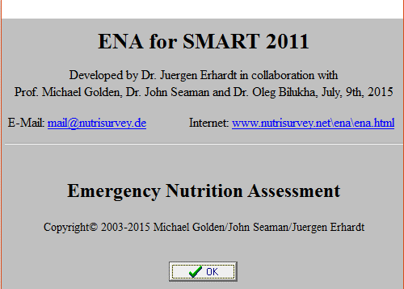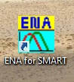

1. ENA launch icon
2. Start the software by clicking on "OK"

# **"ANTHROPOMETRIC DATA ENTRY" SCREEN**

## **UNDERSTANDING THE SCREEN**

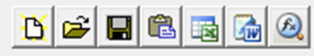

* **Toolbar:**

1. Open a new file (new database);
2. Open an existing file;
3. Save the data;
4. Paste the data (from the computer's "clipboard");
5. Transfer the data to Excel;
6. Transfer the data to Word;
7. Statistical Calculator (for additional data);

* 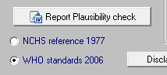**References:** Check that you are using *WHO growth standards 2006*;



* Button to generate the **plausibility check report**

**SMART**

* When daily anthropometric data is transferred to ENA for a plausibility check (or daily data entry if the survey uses paper questionnaires), as well as during the final analysis of the survey data, the screen "Enter Anthropometric Data" must be configured.

## **ANALYSIS OF THE "ENROL" VARIABLE**

* **Adding the "ENROL" variable for the enrolment of children in nutrition programmes (TSFP, OTP/SC):**
  + The "ENROL" variable should be transferred to ENA (from data transferred from smartphones to the survey computer) so that the enrolment rate of acute malnourished children in nutrition programmes can be calculated later using the Epi Info software. This will allow the calculation of z-scores for the weight-for-height (WHZ) index. The number of malnourished children surveyed can be determined using the "WHZ", "MUAC" (Mid-Upper Arm Circumference or brachial perimeter) and "EDEMA" (bilateral oedema) variables, according to the local admission criteria used in the survey area.
  + The "ENROL" column is added using the "Add" button in the "Column/Variable" module of the "Entering Anthropometric Data" screen. Be sure to go to the first cell of the column where you want to add the variable (see figure below).
  + Note that the first 15 columns (from "SURVDAT" (survey date) to "WHZ" (weight-for-height index)) are automatically created by ENA.
  + If the "Show measurement, clothing, and variable weighting columns" option in the ENA "Options" screen is selected, additional columns can only be added after these columns.
  + Refer to Appendix 1 for more information on adding additional / optional columns when implementing a survey using paper questionnaires.
  + To analyse the enrolment rate of acute malnourished children in nutrition programmes using the Epi-Info 7 software, the database derived from the ENA software containing the data for the "ENROL" variable will have to be transferred to Excel. In addition to the data set, the Excel file will then contain the z-scores for the WHZ nutrition index and the flags (unusual data to be excluded on the recommendations of the SMART methodology for the final analysis of results).

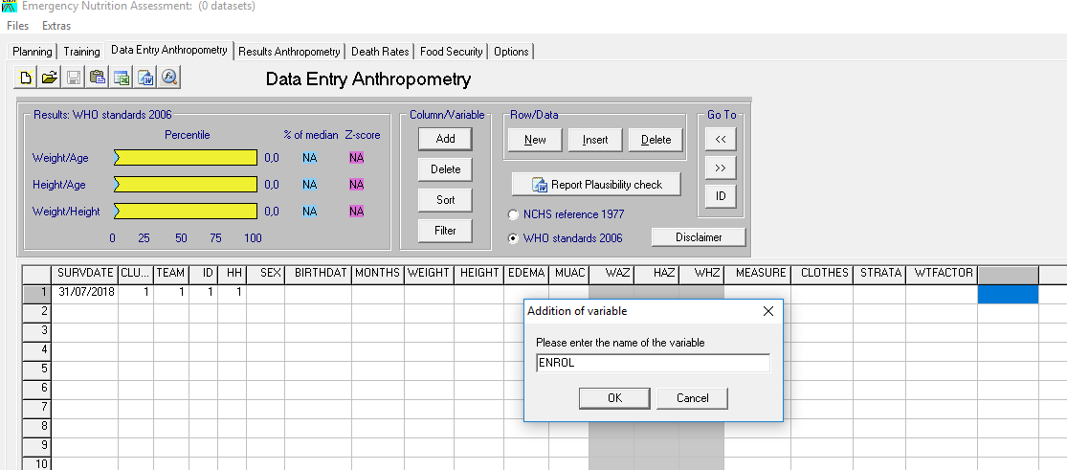

# **"VIEW VARIABLES" SCREEN**

* The "View Variables" screen available from the "Enter Anthropometric Data" screen allows you to view acceptable ranges (or code-response intervals) for the variables collected.
* Some ranges are automatically set by the ENA software (for example, "WEIGHT", "HEIGHT" and "MUAC"), others are adapted to the context (e.g. "CLUSTER", "SURVDAT", "TEAM", "BIRTHDAT"), and some are to be added manually (nutritional indices "WAZ" (or weight-for-age, PAZ),"HAZ" (or height-for-age, TAZ), "WHZ" (or weight-for-size PTZ) and additional variable "ENROL"). See the example below.
* 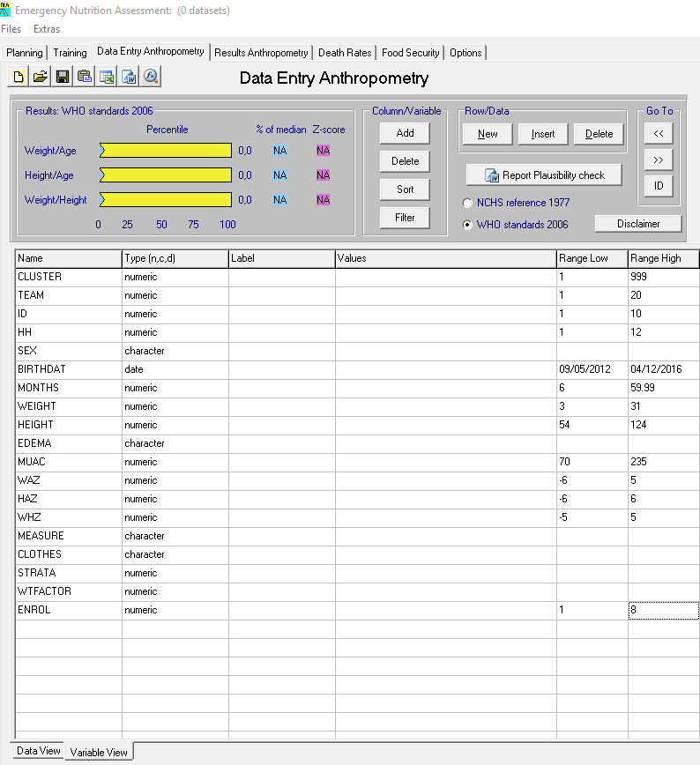If pink flags appear for the nutritional indices "WAZ", "HAZ" or "WHZ", these are WHO flags. These flags are different from SMART flags. See the "Understanding flags" section below, and the SMART documents, for more information about the various flags.

The intervals set for WHZ, WAZ and HAZ are those recommended by WHO when using the 2006 WHO growth standards. The intervals must be added manually.

All values entered in the anthropometry data entry screen (Data View screen) that are outside these ranges will be displayed in pink.

The intervals of certain variables are automatically set by ENA (WEIGHT, HEIGHT, MUAC). Users should manually set the intervals for CLUSTER, TEAM, ID, HH, BIRTHDAT, etc., as well as for additional variables added manually (ENROL).

# **SCREEN "OPTIONS"**

## **ADDING "MEASURE" AND "CLOTHES" COLUMNS**

* **"MEASURE" Variable:**  The person responsible for the child questionnaire records whether the measurement of height is made with the board lying down (child <87.0 cm or <24 months) or with the board standing (child ≥87.0 cm or ≥24 months).

This variable is coded "l" for length (lying height) and "h" for height (standing height).

* **"CLOTHES" Variable:** The person in charge of the child questionnaire records whether the child is weighed completely naked or with clothes.

This variable is coded "y" for "Yes, with garment(s) (or diaper/nappy) and "n" for "No, without garment or only with underwear (panties/underpants)".

* 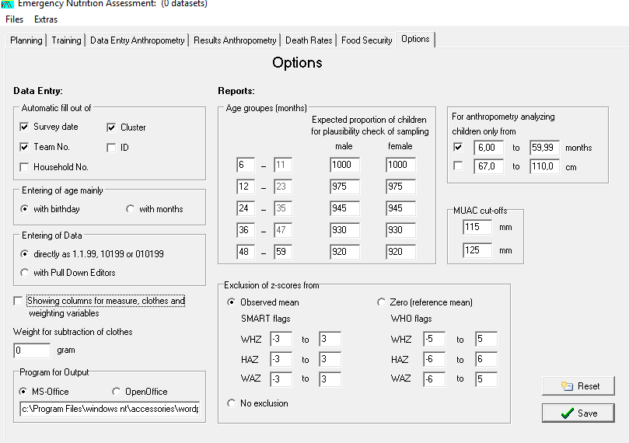Add the "MEASURE" and "CLOTHES" columns in the "Entering Anthropometric Data" screen by checking the "Show measurement, clothing, and weighting of variables" option in the "Options" screen of ENA (see figure below).
* If the "CLOTHES" option is used, the weight of the clothing in grams to be subtracted from the weight of the children weighed with clothing must be entered in the ENA "Options" screen (an automatic subtraction is made by the ENA software). Refer to the protocol below to estimate the average weight of clothing.
  1. **PROTOCOL FOR USING THE "CLOTHES" OPTION**
* In order to estimate the average weight in grams of clothing worn by children surveyed during the weight measurement, and to be subtracted from the weight recorded during the survey, the following protocol must be followed:
* Collect a sample of the clothes most commonly worn by children in the survey area (at least 8 different items of clothing);
* Commercial diapers/nappies are considered clothes;
* Underwear, such as underpants, worn alone are not considered to be clothing;
* Weigh each garment using a *precise scale to the nearest gram* and deduct the average to enter it into the ENA "Options" screen (see figure below);
* Refer to the table below for examples of clothing weights;
* Enter the average in the ENA "Options" screen and save it.

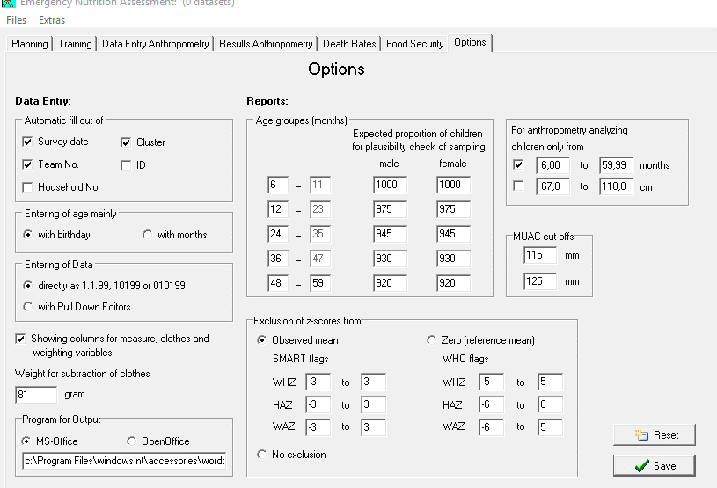

|  |  |
| --- | --- |
| **2-year-old clothing** | **Weight (g)** |
| Clean diaper | 41 |
| Diaper + urine | 114 |
| Pants/Dress | 85 |
| Vest + underwear | 87 |
| Body + diaper | 96 |
| T-shirt/vest | 87 |
| Tights/boxer shorts + t-shirt/vest | 97 |
| Shorts | 40 |
| **Average** | **80.875 rounded up to 81** |

## **SETTING THE "OPTIONS" SCREEN FOR DATA ENTRY AND/OR ANALYSIS**

* The "Options" screen of the ENA software should be set before starting data entry, and before starting an analysis of the children's anthropometric data. Refer to the figure below for the recommended options.

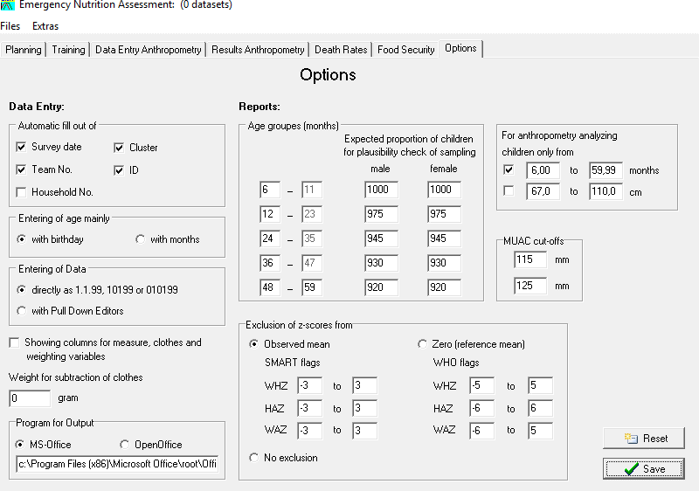

Users should manually uncheck the Household Number box. This is because there may be more than one eligible child per household; and when entering data, it is easier if the household number is not automatically filled in by the software.

Users should manually modify the age groups in months displayed by default in the ENA software in the "Options" screen in order to be able to carry out the various analyses by age group recommended to present in the SENS final report. By default, the ENA software proposes the following age groups: 6-17 months; 18-29 months; 30-41 months; 42-53 months and 54-59 months. The recommended age groups for the analysis of a SENS survey are as follows: 6-11 months; 12-23 months; 24-35 months; 36-47 months and 48-59 months. This is to make the age groups more meaningful in respect to common nutrition target groups in refugee nutrition programmes. Make these changes in the left column.

Make sure to analyse children aged 6-59 months only and to exclude from analysis SMART flags.

# **UNDERSTANDING FLAGS**

## **DESCRIPTION OF FLAGS**

* During the transfer of data to ENA (or data entry if the survey uses paper questionnaires), **pink** **flags** will appear when the values transferred (entered) are outside the defined ranges and entered in the "View Variables" screen.
  + Variables with values outside the acceptable ranges will appear in pink in the "Entering Anthropometric Data" screen. These pink cells are called **flags**.
  + If the pink flags appear at the anthropometric weight-for-height ("WHZ"), height-for-age ("HAZ") and weight-for-age ("PAZ") indices, these are "**WHO flags**".
  + **It is important to note that WHO flags are to be defined daily in the "View Variables" screen to verify the quality of the anthropometric data collected**. Refer to the table below to define the acceptable intervals for each of the nutritional indices.

|  |  |
| --- | --- |
| **Index** | **WHO Flags** |
| **HAZ** | -6 to +6 |
| **WHZ** | -5 to +5 |
| **WAZ** | -6 to +5 |

* The following steps should be followed when a flagis detected:
  + - **Step 1:**
* *Surveys using MDC methods:* Check the "Participants and Measures Control Sheet" containing the data recorded in the household to make sure it is not an entry error in the field phones.
* *Surveys using a paper questionnaire:* Check the original data collection form to make sure it is not a data entry error.
  + - **Step 2:** If it is not an entry error, and if it is a pinkflag for WAZ, HAZ or WHZ ("WHO flag"), the value could be excluded in the final analysis. Note that this can be done automatically in the "Anthropometry Results" screen ("Exclude z-scores with" options).

## **INTERPRETATION OF WHO FLAGS**

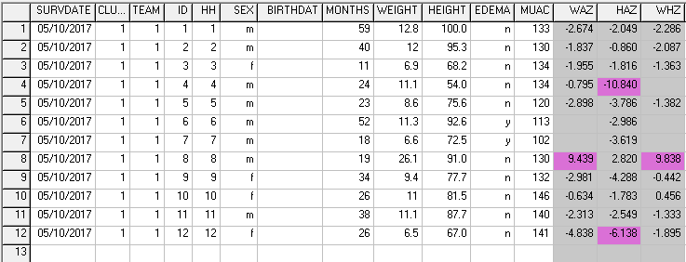

Pink flags for WAZ, HAZ and WHZ values are called ‘WHO flags’ in the Results Anthropometry screen and in the Plausibility Report.

* The pink flags in the nutritional indices columns (WAZ: weight-for-age z-score, HAZ: height-for-age z-score; and WHZ: weight-for-height z-score) can be interpreted as follows:

**Line 4:** There is 1 pink flag in the height-for-age z-score field. This means that there was probably an error with the height measurement of the child. Indeed, the child is 24 months old and measures 54cm (54cm could be the length of a new born baby!). The team should assess whether or not the child can be found the same day or the next day to measure the height. If not, then the child cannot be included in the assessment of wasting (WHZ) or stunting (HAZ). Note that a WHZ was not even calculated by the software because of the extreme height value. The WAZ may still be included in the final analysis because the height variable is not taken into consideration in the calculation of that index.

**Line 8:** There are 2 flags: one in the weight-for-age z-score field and one in the weight-for-height z-score field. This means that there was probably an error in the weight measurement of the child. Indeed, the child is 19 months old and weighs 26.1kg. The team should assess whether or not the child can be found the same day or the next day to measure the weight. If not, then the child will need to be excluded from final analysis for the variables including weight.

**Line 12:** There is one flag in the height-for-age field. In this case, age was probably incorrect. Indeed, the child is 26 months old and only measures 67 cm and weighs 6.5 kg (height and weight of a 6-7 months old child). The team should assess whether or not the child can be found the same day or the next day to take new anthropometric measurements. If not, then the child will need to be excluded from analysis for the HAZ variable.

# **APPENDIX**

* **Appendix 1: Adding columns for additional/optional survey data using the paper questionnaire**
  + If the survey uses paper questionnaires, any additional/optional variables must be entered in ENA. These include variables related to:
    - * Enrolling children in selective feeding programs (CRENAM, CRENAS/CRENI) 🡪 "ENROL" variable
      * Enrolling children in the BSFP (optional indicator) 🡪 "BSFP" variable
      * Measles vaccination and vitamin A supplements 🡪 "MEASLES" and "VITA" variables
      * Deworming over the last 6 months (optional indicator) 🡪 "DEWORM" variable
      * Diarrhoea in the last 2 weeks 🡪 "DIAR" variable
      * The haemoglobin level of children 🡪 "CHHB" variable
  + Extra columns can be added using the "Add" button in the "Column/Variable" module of the "Entering Anthropometric Data" screen. Be sure to go to the first cell of the column where you want to add the variable (see figure below).
  + Note that the first 15 columns (from "SURVDATE" (survey date) to "WHZ" (weight-for-height index)) are automatically created by ENA.
  + If the "Show measurement, clothing, and variable weighting columns" option in the ENA "Options" screen is selected, additional columns can only be added after these columns.

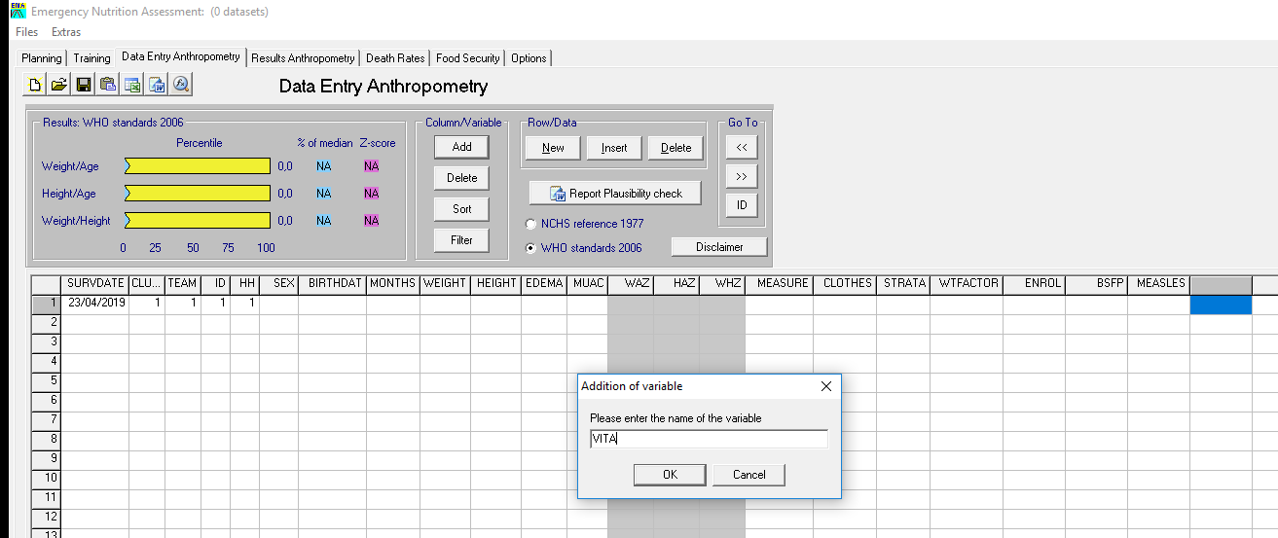

* + The "View Variables" screen available from the "Enter Anthropometric Data" screen allows you to view acceptable ranges (or code-response intervals) for the variables collected.
  + Some ranges are automatically set by the ENA software (for example, "WEIGHT", "HEIGHT" and "MUAC"), others are adapted to the context (e.g. "CLUSTER", "SURVDAT", "TEAM", "BIRTHDAT"), and some are to be added manually (additional "ENROL" variable). See the example below.

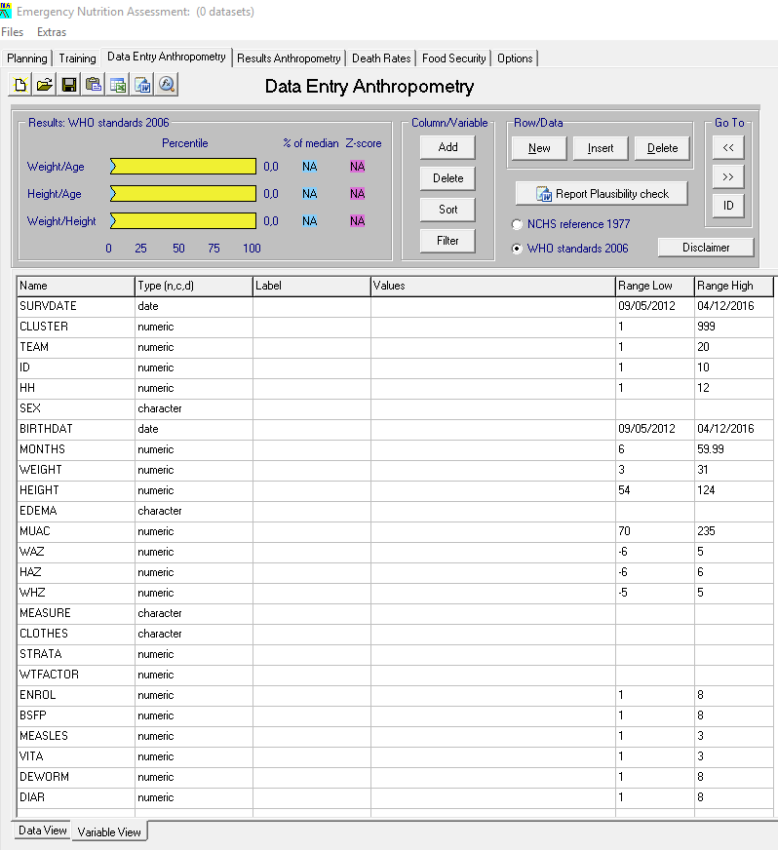

The intervals set for WHZ, WAZ and HAZ are those recommended by WHO when using the 2006 WHO growth standards. The intervals must be added manually.

The intervals of some variables are automatically set by ENA. All values ​​entered in the anthropometry data entry screen (Data View screen) that are outside these ranges will be displayed in pink.

Users should manually set the intervals for CLUSTER, TEAM, BIRTHDAT, etc. variables, as well as for additional variables added manually (ENROL, MEASLES, VITA, etc.).