Anthropometry quality assurance logsheet

Team #: _____

Date  (dd/mm) | Scale  # | Weight  (0.0 kg) | Height  Board  # | Length  (000.0) (cm) | Child MUAC Tape # | Circum-  ference  (000) (mm) | Woman MUAC Tape # | Circum-  ference  (000) (mm) | Remarks on equipment condition
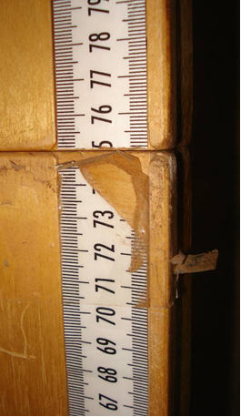
STANDARDIZATION OF ANTHROPOMETRIC EQUIPMENT
Watch out for bad quality tapes on wooden height boards preventing accurate reading!

- Ensure all anthropometric equipment is functioning and not damaged. If any equipment
is damaged and needs to be replaced, record the details in the column “Remarks on
equipment condition”.

Before the anthropometric standardization test, label each piece of equipment with a
distinct number:
- Scales from 1 to n
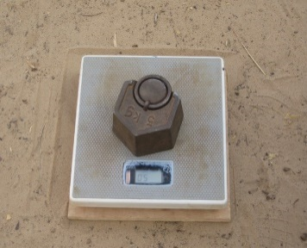
- Height boards from 1 to n
A wooden board to stabilise electronic scale on the ground should be used.
- MUAC tapes from 1 to n

- Measure each scale twice with a standard weight (min. 5 kg).

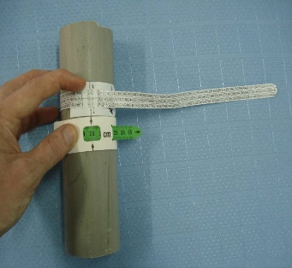
- Measure each height board with a wooden stick of 110.0 cm
and the MUAC tapes with a plastic pipe.

- Supervisors should always plan for spare equipment in case of problems.
- If any equipment is found to be not functioning during data collection, call the supervisor and request to exchange it immediately.

