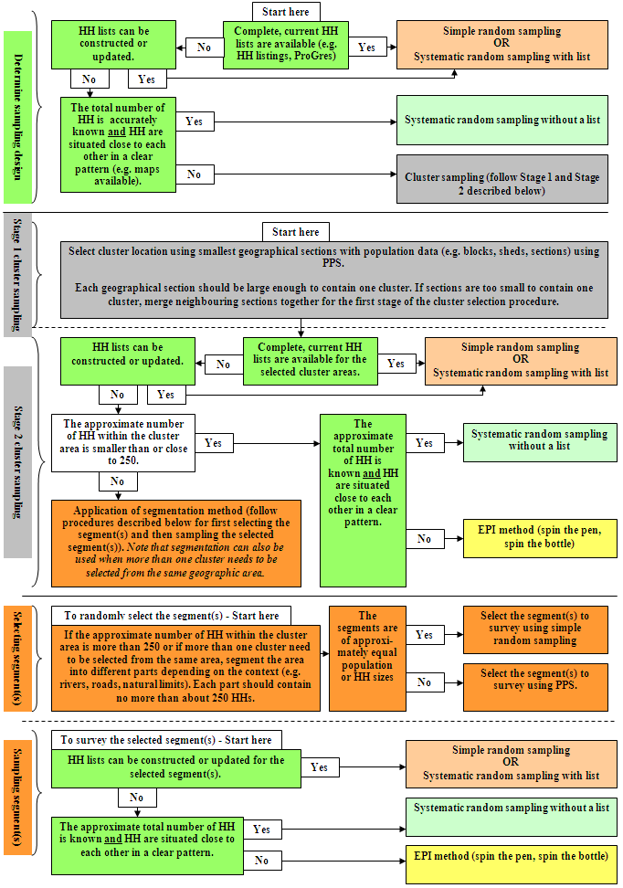

**No**

**A sample should be selected for the survey. Follow SENS Sampling Decision Tree for next steps.**

**Yes**

**No sampling is necessary. An exhaustive (census) survey can be conducted.**

**Start here**

The total size of the population is below approximately 2,500 people (or approximately <600 households).

or slow on et?

**Modified EPI Method (spin the pen/bottle)**

**Modified EPI Method (spin the pen/bottle)**