**Standard Operating Procedures**

**for SENS Survey Data Management using**

**mobile data collection (MDC methods)**

**TABLE OF CONTENTS**

INTRODUCTION 1

1. DAILY VERIFICATION OF QUESTIONNAIRES FOR CONSISTENCY, COMPLETENESS AND MISSING DATA 2

a. Checking in phones (ODK Application) 2

b. Verification in Excel database 6

2. TRANSFER DATA COLLECTED FROM CELL PHONES TO THE SURVEY COMPUTER 7

a. Obtain data files for analysis 7

b. Convert CSV files to Excel format 8

3. TRANSFER ANTHROPOMETRIC DATA FROM EXCEL TO ENA 10

4. FINAL ANALYSES 13

5. MANAGEMENT OF FINAL DATABASES FROM SENS SURVEYS 17

# **INTRODUCTION**

* The collection of data via the use of mobile phones or smartphones (MDC methods), is now used in many countries to conduct SENS surveys.
* Mobile data collection:
  + allows for more accurate results (i.e. better quality);
  + allows for faster data entry while minimizing data entry errors;
  + allows for faster verification of questionnaires for consistency, completeness and missing data;
  + facilitates analysis;
  + and avoids a separate data entry phase.
* Despite the cost and fragility of smartphones, this method is highly recommended for the implementation of SENS surveys.
* The application generally used for mobile data collection is the ODK Collect application (Open Data Kit). This application works under the Android system.

# **DAILY VERIFICATION OF QUESTIONNAIRES FOR CONSISTENCY, COMPLETENESS AND MISSING DATA**

* At the end of each fieldwork day, the survey manager and/or supervisors should review the completed forms in the phones via the ODK application for each team, and also review the different databases in CSV or XLS format from the phone data transfer.

***Note:***

* Data transferred from the phones to the survey laptop will be in CSV format if the survey manager uses a router for data transfer, or in XLS format if the survey manager use the UNHCR Kobo server for data transfer. Use of the UNHCR Kobo server requires a stable internet connection.
* **These checks are mandatory** to ensure high quality data collection. Missing and/or aberrant data should be detected before final analysis of data. Teams also learn from their "mistakes", ensuring better work as data collection progresses.
* The number of missing and/or aberrant data should be relatively small if the interviewers responsible for filling the questionnaires using the phones, check the completeness of the questionnaires of the surveyed household before leaving the household.
* It is also recommended that the interviewers responsible for filling in the questionnaires read the summary messages after completing the Demography questionnaire (number of children under 5 years of age, number of women 15-49 years and number of pregnant), the Mosquito Net Coverage questionnaire (total number of household members, total number of children under 5 years of age and of pregnant women in the household) and the WASH questionnaire (summary).

## **Checking in phones (ODK Application)**

* When verifying questionnaires in the phones, all forms must be reviewed i.e. the demography questionnaire, the food security, mosquito net coverage and WASH questionnaire, the child questionnaire and the woman questionnaire (not just the child questionnaire).
* Verification of the questionnaires can be done in the field during data collection and/or at the end of each collection day. Plan a debriefing session every evening (or every morning) with the teams on the errors/omissions found in phones to ensure continuous improvement of the quality of data collected.
* **Procedure to be followed for the investigator and/or the supervisor(s):**
  + Browse all completed questionnaires in each of the surveyed households by going to the "Edit Saved Form" menu of ODK.

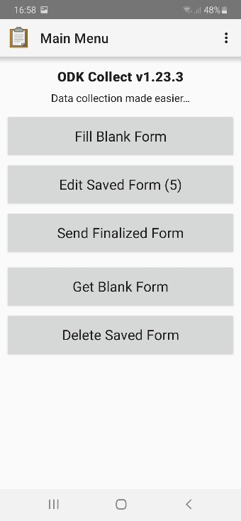

* + We find all the questionnaires completed for the survey day in the menu "Edit Saved Form". The questionnaires are then "Saved". They will be marked as "Finalized" once each is reviewed by the survey manager and/or supervisor(s).

In this example, the phone contains 4 saved questionnaires for household #1 (HH1): one Child questionnaire (Children 0-59 months), one Demography questionnaire, one Food Security, Mosquito Net Coverage and WASH questionnaire (FS-Net-WS), and one Woman questionnaire (Women 15-49 years). The phone also contains one Demography questionnaire for household #2 (HH2).

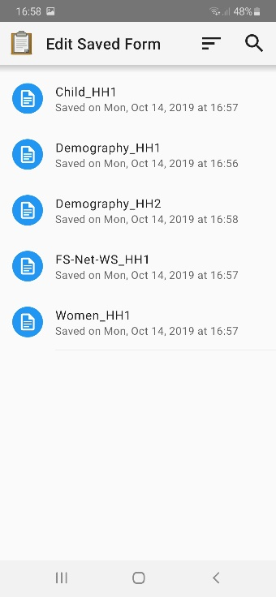

* + Check that there is an answer to each question, and that there is no missing data, by scrolling through the questionnaires on the phone screen.
  + Check identification variables such as camp name, zone/block/section number, cluster number, team number, etc.
  + If a non-mandatory data (i.e. that one might "skip" by mistake in the phone) is missing, put in the code "8" "Don’t know" if this is proposed, or leave the answer empty. Refer to the "Daily questionnaire check" sections within the "Data Review" sections of each of the SENS modules for further information on these verifications and missing data.
* Don't forget to check each "group" within the questionnaires (1 group = 1 individual surveyed or one observed mosquito net or one container used to collect or store water):
  + Review information for each household member within the “Demography” questionnaire and “Mosquito Net Coverage” questionnaire.
  + Review information for each observed moquito net within the “Mosquito Net Coverage” questionnaire.
  + Review information for each container used by the household to collect water within the “WASH” questionnaire.
  + Review information for each child under 5 years of age within the “Child” questionnaire.
  + Review information for each woman aged 15-49 years within the “Woman” questionnaire.

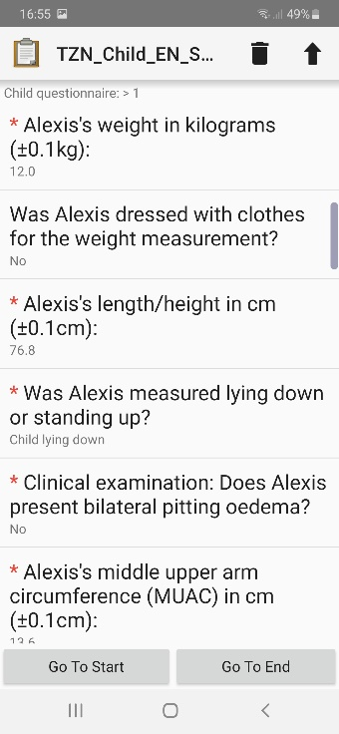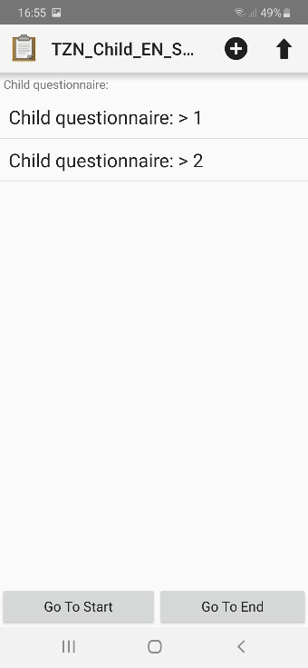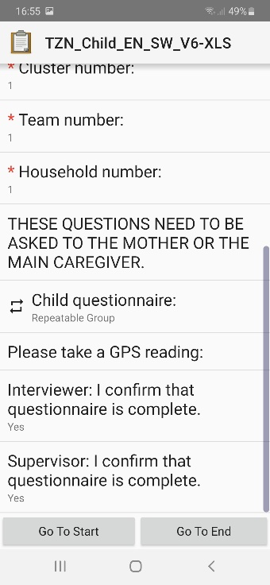

In this example, the questionnaire "Child 0-59 months" contains two groups or two children.



Once the identification variables have been revised (team number, cluster number, household number, etc.), review the answers for child #1 then for child #2.



* + Once the questionnaire has been reviewed, the survey manager and/or supervisor confirms that the questionnaire is complete and marks the questionnaire as "Finalized" and saves it.

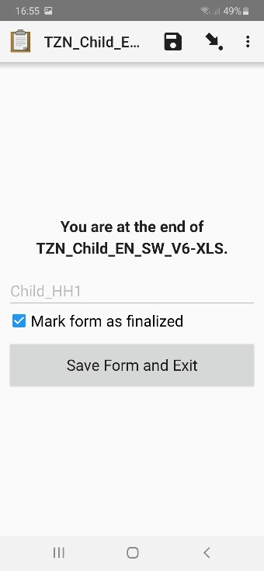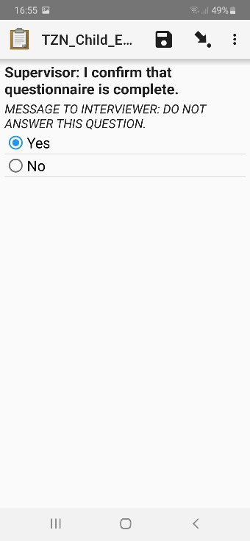

* + **Be sure to check the consistency of responses among questionnaires for the same household**. For example, the number of pregnant women in the Mosquito net questionnaire should normally be the same as in the Women questionnaire and in the Demography questionnaire.
  + The finalized questionnaires are then found in the menu "Send Finalized Form"; they are ready to be sent/transferred to the computer.

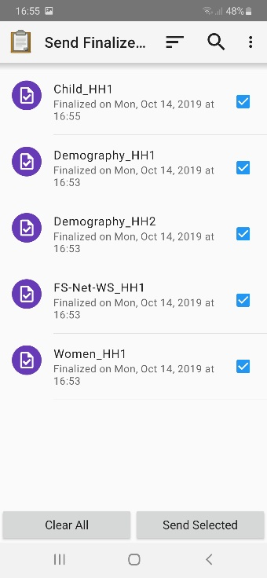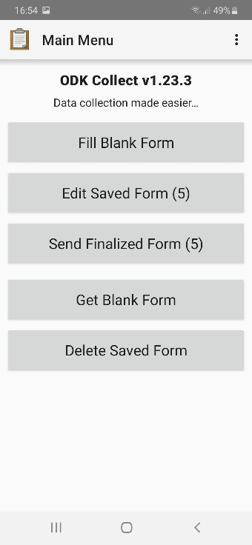

## **Verification in Excel database**

* Once all of the questionnaires have been verified, marked as finalized and transferred to the survey laptop, the collected data appears in various files in CSV or XLS format:
  + A “Demography” (**DM**) file for the Demography questionnaire;
  + A “FS, Mosquito, WASH” (**FS_NET_WS**) file for the Food Security, Mosquito Net Coverage and WASH questionnaire;
  + A ‘’Child’’ file for the child questionnaire (children 0-59 months of age) gathering data on Anthropometry and Health, Anaemia and IYCF practices;
  + A "Women" file for the woman questionnaire (women 15-49 years of age) gathering data on Anthropometry and Health and Anaemia.
* The data for each survey day is automatically compiled into the same CSV/XLS file as data collection progresses. **Be sure to select only children from the relevant camp/survey area within the Excel file if multiple camps/areas are being surveyed.** In addition, the ENA software does not allow quality/data analysis at the camp/area level based on data from multiple camps/areas.
* It is recommended to create a folder tree for the daily transfer of survey data into the computer (refer to the diagram below). This allows for a daily backup of all data.

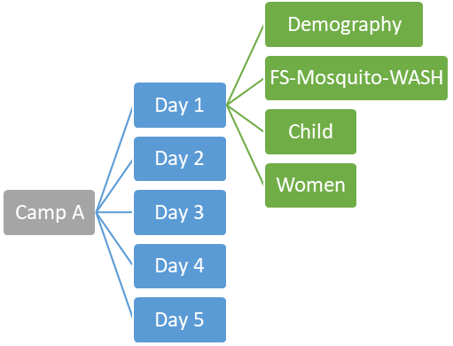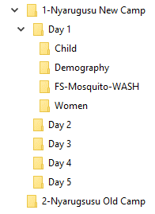

* **Procedure to be followed by the survey manager:**
  + Download data files in XLS or CSV format. Convert all CSV files to Excel using the procedure described below in section 2.
  + Check all variables, except those transferred to the ENA software, that is, anthropometric data for children aged 6-59 months (see Section 3 below for more information on this procedure).
  + Refer to the "Daily Questionnaire Check" sections within the "Data Review" sections of each of the SENS modules for further information on these verifications.

# **TRANSFER DATA COLLECTED FROM CELL PHONES TO THE SURVEY COMPUTER**

## **Obtain data files for analysis**

* See the mobile data collection tools for more information on transferring data from phones to the survey computer (<http://sens.unhcr.org/mobile-technology/tools/>).
* Once the transfer is complete, the data is available in CSV and/or XLS format depending on the use of a router or the UNHCR Kobo server. Depending on the questionnaires, we obtain different data files:
  + For the "Child" questionnaire (children from 0 to 59 months) grouping the variables of Anthropometry and Health, Anaemia and IYCF modules, the data is transferred within two different Excel files (use of a router), or within two different tabs, in the same Excel file (use of the UNHCR Kobo server). The file concerned by the check and data analysis is the one with the name ending in “_C” (use of a router). The tab concerned by the check and data analysis is the one named “C” (use of the UNHCR Kobo server).

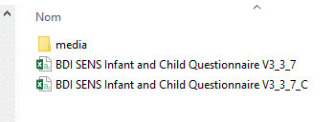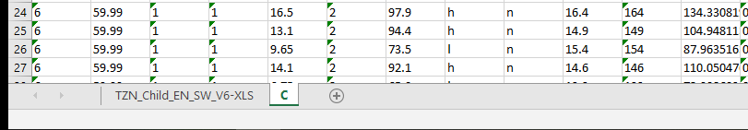

**Router UNHCR Kobo server**

* + For the "Women" questionnaire (women aged from 15 to 49 years) grouping the variables of Anthropometry and Health and Anaemia modules, the data is transferred within two different Excel files (use of a router), or within two different tabs, in the same Excel file (use of the UNHCR Kobo server). The file concerned by the check and data analysis is the one with the name ending in “_W” (use of a router). The tab concerned by the check and data analysis is the one named “W” (use of the UNHCR Kobo server).

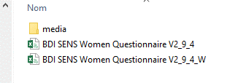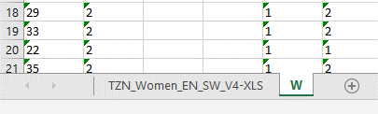

**Router UNHCR Kobo server**

* + For the "DM" questionnaire (Demography), the data is transferred within two different Excel files (use of a router), or within two different tabs, in the same Excel file (use of the UNHCR Kobo server). The file concerned by the check and data analysis is the one named, e.g. “TZN_DM_SW_EN_V5_XLS”.

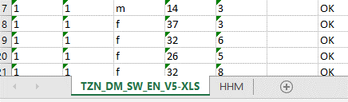

* + For the "FS-NET-WASH" questionnaire (Food Security, Mosquito Net Coverage and WASH), the data is transferred within four different Excel files (use of a router), or within four different tabs, in the same Excel file (use of the UNHCR Kobo server). The file concerned by the check and data analysis is the one named, e.g. “TZN_FS_NET_WS_EN_SW_V7_XLS”.

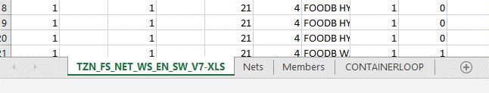

## **Convert CSV files to Excel format**

* **How to convert CSV files to Excel files:**
* Open the CSV format data file;
* Select the entire first column of the database (column A);
* Go to the "Data" menu of Excel, then click on "Convert" to access the Excel conversion wizard;

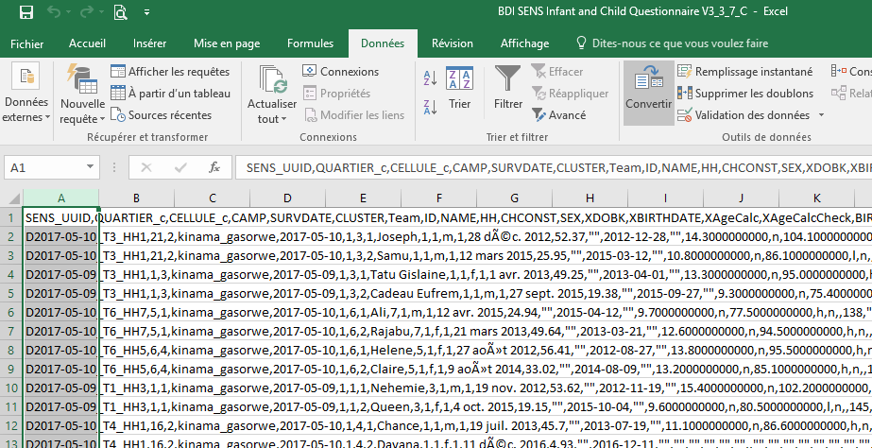

* *Conversion Wizard - Step 1*: Select "Delimited" for the original data type, which means that characters such as commas or tabs separate each field. In our case, data from phones is separated from each other by commas. Click on "Next";
* *Conversion Wizard - Step 2*: select "Comma" for the separator type and uncheck "Tab" which is checked by default. Click on "Next";
* *Conversion Wizard - Step 3*: Select "Standard" to format the data into columns. Click on "Finish".

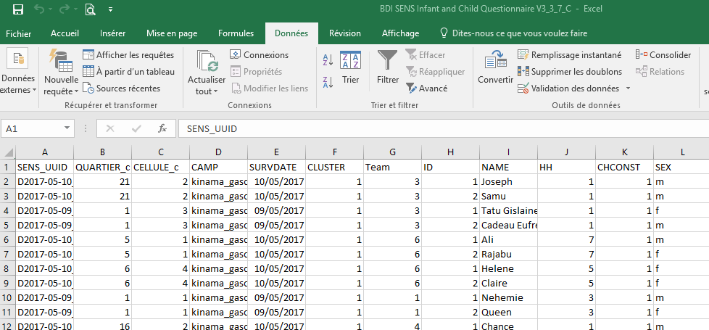

# **TRANSFER ANTHROPOMETRIC DATA FROM EXCEL TO ENA**

* Anthropometric data for children aged 6 to 59 months will need to be transferred to the ENA software daily to verify the quality of the data. Data quality is verified by detecting aberrant / extreme data (WHO flags / pink flags) and generating the SMART plausibility check report.
* The plausibility check report is one of the key tools in SMART for verifying anthropometric data. It assesses the quality of anthropometric data and identifies specific errors, such as digit preference.
* **How to transfer the anthropometric data of children from Excel to the ENA software:**
* Take the "Child" data file in Excel format and do a copy of the data. Name this new tab (or this new file) “ENA_DDMM” for example so that you can select and order the variables to be transferred to the ENA software.
* Filter so as to keep only children between 6 and 59 months old using the variable "MONTHS" (values <6.00) and delete children under six months of age. The database from the phones contains the Anthropometry and Health, Anaemia and IYCF data for all children aged 0 to 59 months:
* When the child's date of birth is known, the age in months is automatically calculated by the phone. In the database, the age in months can be found under the variables ‘’XAgeCalc’’and “MONTHS”.
* When the child's date of birth is unknown and the age is estimated in months using the calendar of local events, the age in months can be found under the variables “XMONTHS” and “MONTHS”.
* During data collection, the phone can identify a child suffering from severe acute malnutrition and/or detect aberrant data (WHO flags/pink flags) when entering the age and/or anthropometric measurements of children aged 6-59 months. New measurements were taken for those children and their age was re-estimated. **The second data/measures will be considered as the final data/measures. The new data/measures that are in the columns “BIRTHDAT_2” or “XMONTHS_2”, “MONTHS_2”, “WEIGHT_2”, “HEIGHT_2”, “MEASURE_2” and “MUAC_2” have to be copied/pasted in the columns “BIRTHDAT” or “XMONTHS”, “MONTHS”, “WEIGHT”, “HEIGHT”, “MEASURE” and “MUAC”.**
* The variables to be transferred to ENA are: "SURVDAT_C", "CLUSTER_C", "TEAM_C", "HH-C", "ID", "SEX", "BIRTHDAT", "MONTHS", "WEIGHT", "CLOTHES", "HEIGHT", "MEASURE", "EDEMA", "MUAC", and "ENROL".
* Delete all variables that will not be transferred to ENA (for example, "SENS_UUID", "CAMPNAME_C", "CAMPLABEL_C", "CHCONST", "CHNAME", "XDOBK", "XMONTHS", etc.).
* Order the variables/columns to follow the same order as the « Data Entry Anthropometry » screen in the ENA software, and thus be able to easily copy/paste the data.

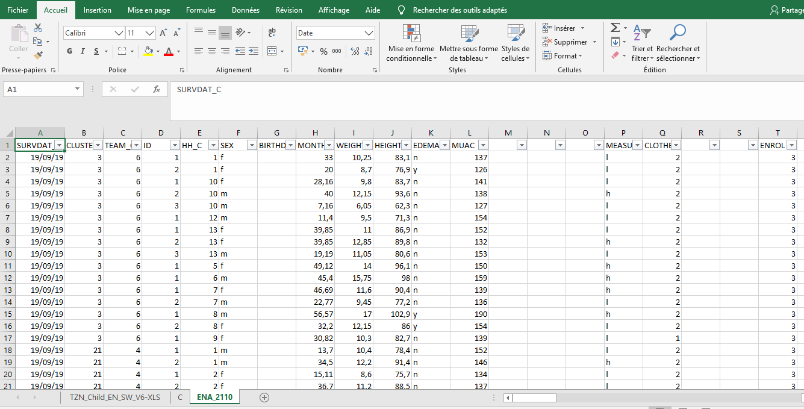

* Copy/paste the data into the ENA software and check for the presence of WHO flags/pink flags by setting the "Variables View" tab in the "Data Entry Anthropometry" screen.
* Generate the SMART plausibility check report for data quality control.

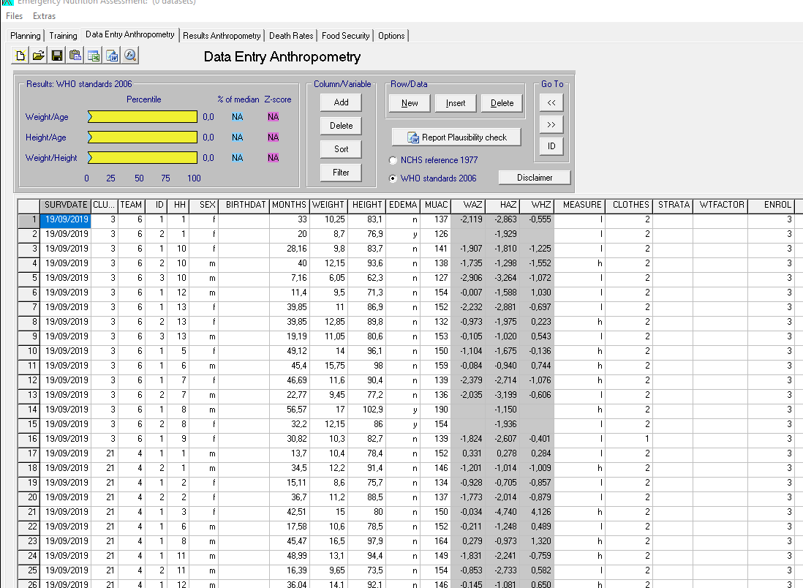

***Note:***

* The "ENROL" variable can only be transferred in the ENA software during the final analysis of the survey data, rather than daily.
* See Tool 2 of the SENS Anthropometry and Health Module [**Tool 2:** ENA Software Setup for SMART for UNHCR SENS Surveys] for further information on adding "MEASURE" and "CLOTHES" columns on the "Data Entry Anthropometry" screen, adding an additional column ("ENROL" variable), configuration of the “Visualization View” screen for detection of WHO flags/pink flags, as well as the analysis of WHO flags.

1. **FINAL ANALYSES**

* Retrieve the CSV or XLS files from the last data collection day, and verify the data using the procedures described above.
* Perform any "last minute corrections" in the Excel files before starting the final analysis. Once the completed questionnaires from the phones have been sent to the survey computer, it is no longer possible to modify a response and /or correct a missing piece of data in the phones. However, interviewers/supervisors may correct and/or collect data/information once the questionnaires have been transferred to the survey computer, or the investigator may need to correct a false response code. (e.g. response code error for the principal source of drinking water for a team on the first survey day).
* Check for missing/aberrant data by using the "Sort" and "Filter" options in Excel.
* Before starting data analysis, you should also ensure that there are no duplicates in the women database as well as in the database at the household level. All duplicates for the child questionnaire are automatically identified by the ENA software within the plausibility check report. Check for the presence of duplicates in the database with the Epi Info Software by following the steps described below:
* Open the Epi Info software and click on the menu « Visual Dashboard ».

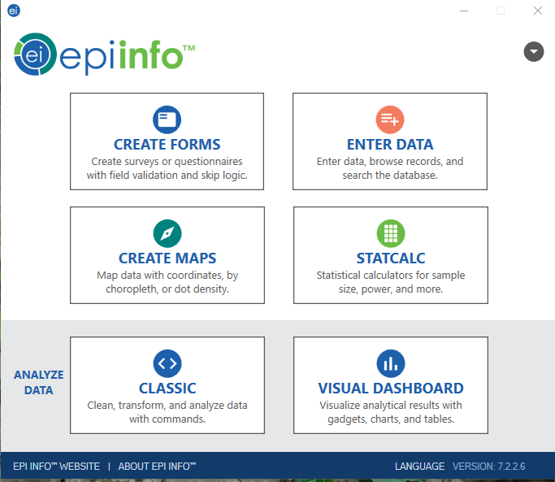

* Click on the arrow in the text box « Epi Info 7 Dashboard » to select a data source.

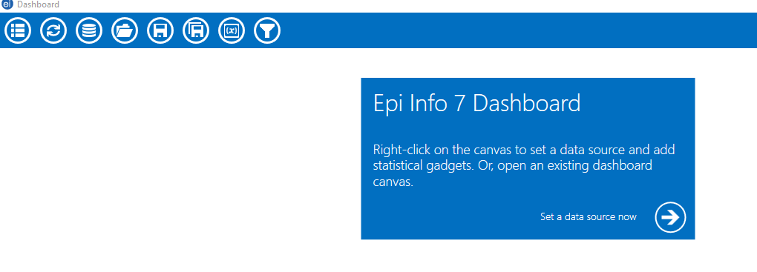

* Select the data source for which you want to check the presence of duplicates. Select the type of database, then select the data source, and if needed, select the tab to be verified within the file. Click on “OK”.

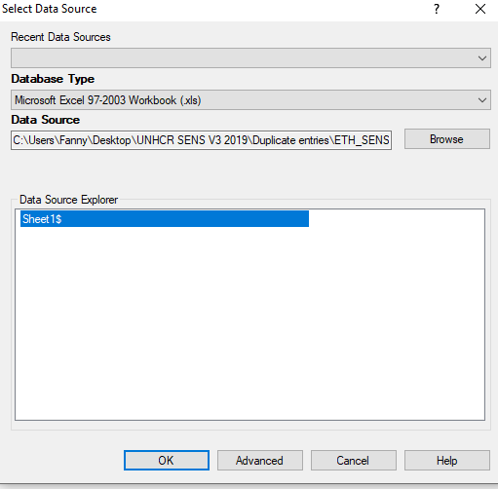

* Do a right click on the main screen and select « Add Analysis gadget », then « Duplicates List ».

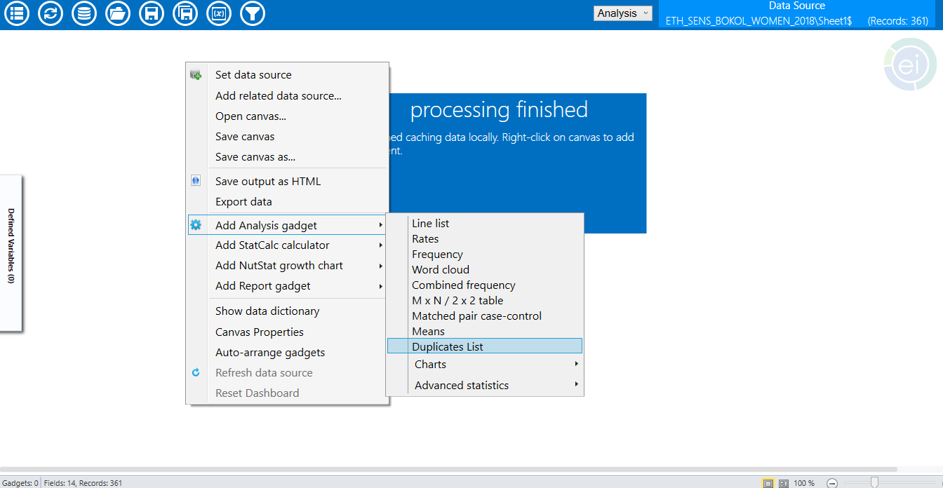

* Select the variables from the questionnaire to verify the presence of duplicates using the « Ctrl » and/or « Shift » button of your keyboard and your mouse. In the example below, the variables « _parent_index » and « SYSTEMDATE » were not selected as they are not part of the variables of the questionnaire. Click on « OK ».

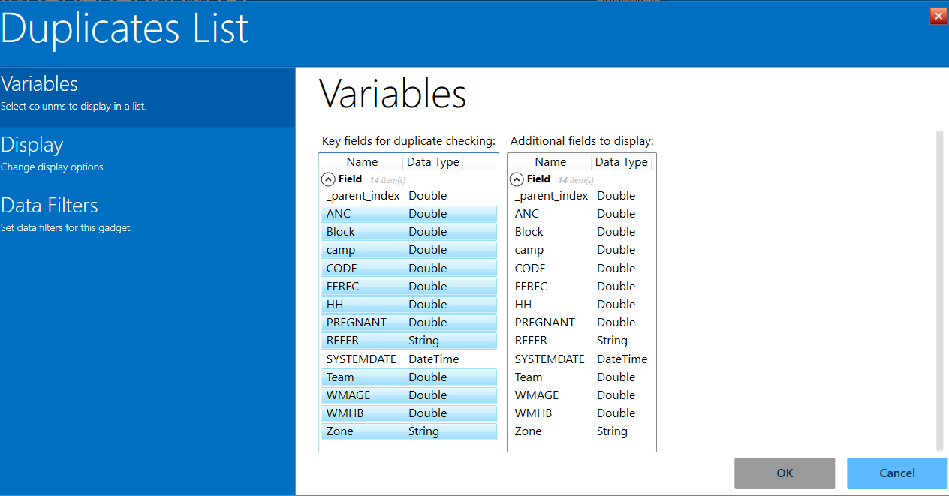

* The duplicates list appears in a table. In the example shown below there are two duplicates. The duplicated data should be deleted from the original database before to start the analysis.

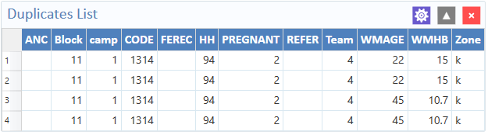

* *Final* anthropometric data for children aged 6 to 59 months should be transferred to the ENA software to obtain malnutrition prevalence, as well as to obtain the final plausibility check report to be included in the annexes of the SENS final report.
* Then, transfer the anthropometric data from ENA to Excel to continue the analysis of the other indicators of the Anthropometry and Health Module (enrolment in selective feeding programmes and possibly the prevalence of overweight[1]) using the Epi Info 7 software;
* See tool 2 of the SENS Anthropometry and Health Module [**Tool 2:** ENA Software Setup for SMART for UNHCR SENS Surveys] for further information on adding "MEASURE" and "CLOTHES" columns in the "Data Entry Anthropometry" screen, adding an additional column ("ENROL" variable), configuration of the “Visualization View” screen for detection of WHO flags/pink flags, as well as the analysis of WHO flags.

***Note:***

* It is recommended to use the "MONTHS" variable from the ENA to Excel data transfer for all analyses including the age of children for the 0-59 months group.

1. **MANAGEMENT OF FINAL DATABASES FROM SENS SURVEYS**

* Databases that are **final** and used to **analyse** the **final** results of the SENS survey must be shared and sent:
  + to the UNHCR country office;
  + to the Nutrition and Food Security Unit of the UNHCR Regional Office;
  + to the Public Health section of UNHCR headquarters.
* **The final databases should be sent in Excel format.** Shared databases must include standard SENS variables as defined in the phones. If other variables were added to the survey, the variable must be described in an individual tab; the following information is mandatory: name of the added variable, variable code, answer codes and definition(s).
* **The final database must not include the names of the participants.** The columns “NAME” in the “Demography” and “Food Security, Mosquito Net and WASH” database, “CHNAME” in the “Child” database, and “WMNAME” in the “Women” database should be deleted before sharing with other parties.
* It is recommended that you do not group the databases into a single Excel file (i.e. one database per tab). Keep the databases **separated** according to the questionnaires used, as when transferring phones to the survey computer (i.e. a database for children, a database for women, a demography database, etc.).
* The final results of the survey should also be entered online in the SENS database.

1. The ENA software version of July 9, 2015 does not always allow for obtaining overweight prevalence results.