UNHCR

STANDARDISED EXPANDED

NUTRITION SURVEY (SENS) GUIDELINES

FOR REFUGEE POPULATIONS

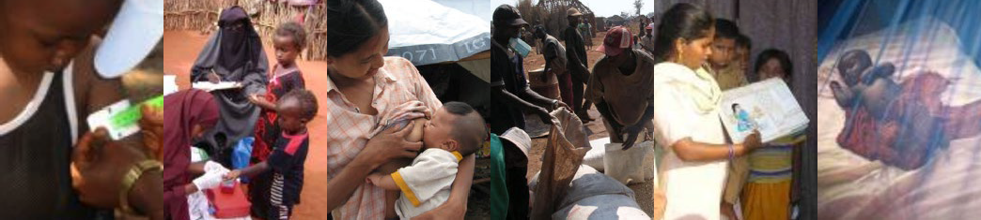

**PRE-MODULE: SURVEY STEPS AND SAMPLING**

## Module 1: Demography

## Module 2: Anthropometry and Health

## Module 3: Anaemia

## Module 4: Infant and Young Child Feeding (IYCF)

## Module 5: Food Security

## Module 6: Mosquito Net Coverage

## Module 7: Water, Sanitation and Hygiene (WASH)

## A PRACTICAL STEP-BY-STEP GUIDE

###### VERSION 3 (2018)

**PRE-MODULE: SURVEY STEPS AND SAMPLING**

## Module 1: Demography

## Module 2: Anthropometry and Health

## Module 3: Anaemia

## Module 4: Infant and Young Child Feeding (IYCF)

## Module 5: Food Security

## Module 6: Mosquito Net Coverage

## Module 7: Water, Sanitation and Hygiene (WASH)

## A PRACTICAL STEP-BY-STEP GUIDE

###### VERSION 3 (2018)

**Preface**

Nutritional outcomes continue to be of concern in most refugee contexts. UNHCR recommends the measurement of demography, anthropometric status, anaemia and other associated indicators (including infant and young child feeding, food security, WASH and mosquito net coverage) on an annual basis in order to monitor the situation, react in a timely manner to nutritional problems, and complement the already existing assessments, monitoring or surveillance data.

This is a guidance document for UNHCR public health and/or nutrition and food security officers, survey manager consultants and partners, which aims to standardise the way annual nutrition surveys are conducted. A 2009 review of UNHCR nutrition surveys worldwide highlighted a lack of standardisation in data collection methods, the type of information collected, and in the ways it was analysed and presented. In order to measure trends over time, surveys need to be replicable and the same definitions, geographic boundaries and methodologies need to be used from year to year. To help overcome these challenges, UNHCR encourages the adoption of the internationally recognised SMART (Standardised Monitoring and Assessment of Relief and Transitions) methods for survey design and anthropometric assessments. In refugee contexts, there are often very limited opportunities to conduct household surveys other than nutrition surveys. Hence the nutrition survey is an opportunity to collect other types of key data needed for programme planning and improvement. Refugee settings, especially in camps, differ from ‘normal’ settings in a number of ways, including the provision of food assistance (in-kind, or cash-based), free primary health care services, proximity to health centres, proximity to water collection points, and free distribution of mosquito bed nets, but also often limited livelihood opportunities as well as limited access to a wide variety of food sources.

The guidelines are designed to cover most emergencies and all stable, protracted situations. Some adaptation may be needed for use in certain emergencies, surrounding villages, and urban settings. In the future, these guidelines will be further updated and improved as lessons continue to be learnt on their application and usefulness, and the field of survey methodology evolves.

These guidelines are divided into eight components: one pre-module entitled *Survey Steps and Sampling* and seven individual survey modules namely: *Demography; Anthropometry and Health; Anaemia; Infant and Young Child Feeding (IYCF); Food Security; Mosquito Net Coverage; and Water Sanitation Hygiene (WASH*). The pre-module is a quick reference guide and focuses on the practical steps for conducting UNHCR Standardised Expanded Nutrition Survey (SENS). The pre-module is not meant to replace already existing survey manuals. To avoid duplication, the user is referred to pre-existing material on certain aspects of survey design and implementation. The individual survey modules provide information for training, data collection, data entry, data analysis, interpretation, drafting recommendations and reporting.

Some countries may have national guidelines or minimum reporting standards for conducting nutrition surveys that slightly differ from the ones proposed here. The user of these guidelines should adapt them, where appropriate, to ensure local standards are met. Moreover, in recent years, electronic data collection on the field (as opposed to paper-based data collection) using mobile phones is being pursued to ease the process of data collection, data quality checks and data entry. UNHCR is moving towards fully integrating the use of mobile phones for data collection and entry as part of the SENS guidelines. Separate guidance material is available for this.

**Comments, feedback and requests for further guidance should be directed to:** [**HQPHN@unhcr.org**](mailto:HQPHN@unhcr.org)

**For more details on the SENS guidelines, its associated tools and reference material on mobile data collection, refer to:**

[**http://sens.unhcr.org/**](http://sens.unhcr.org/)

**Photographs contributed by**: N Berry, S Hoibak, IAR Kassim, M Lung’aho, C Perlongo, A Seal, M Tondeur, World Vision, the WASH Visual Aids Library.

**Table of Contents**

## Survey Steps and Sampling

The following is intended to provide practical guidance for undertaking a SENS survey in a refugee context. The steps may not always be conducted in the order presented below but all of them should be considered during planning and implementation.

STEP 1: DECIDE ON THE NEED FOR A SURVEY 8

STEP 2: GATHER BACKGROUND INFORMATION 11

STEP 3: DEFINE THE SURVEY OBJECTIVES 12

STEP 4: DEFINE GEOGRAPHIC AREA AND POPULATION GROUP TO INCLUDE 21

STEP 5: COMMUNICATE WITH STAKEHOLDERS 23

STEP 6: DECIDE ON TIMING 25

STEP 7: DECIDE ON WHAT MEASUREMENTS TO MAKE AND DATA TO COLLECT 28

STEP 8: DESIGN THE SURVEY 31

STEP 9: OBTAIN EQUIPMENT AND SUPPLIES 44

STEP 10: DESIGN QUESTIONNAIRE 46

STEP 11: SELECT AND TRAIN TEAMS 49

STEP 12: FIELD TEST QUESTIONNAIRE AND PROCEDURES 53

STEP 13: CONDUCT AND SUPERVISE FIELD WORK 55

STEP 14: ENTER AND CLEAN DATA 61

STEP 15: CHECK DATA QUALITY AND ANALYSE 65

STEP 16: WRITE AND DISSEMINATE REPORT 70

WHERE CAN THE SMART INITIATIVE DOCUMENTATION BE FOUND? 76

ANNEX 1 - SAMPLE SIZE CALCULATION AND SAMPLING EXAMPLE 82

ANNEX 2 - CORRECTION FOR SMALL POPULATION SIZE 89

ANNEX 3 - DATA COLLECTION CONTROL SHEET 91

ANNEX 4 - GUIDANCE ON KEY EPI INFO COMMANDS 93

ANNEX 5 - ASSESSING TRENDS AND CHANGES 99

ANNEX 6 - STATISTICAL COMPARISONS BETWEEN TWO SURVEYS 102

## Survey Modules

**Module 1:** Demography

**Module 2:** Anthropometry and Health

**Module 3**: Anaemia

**Module 4:** Infant and Young Child Feeding (IYCF)

**Module 5:** Food Security

**Module 6:** Mosquito Net Coverage

**Module 7:** Water, Sanitation and Hygiene (WASH)

###### A number of tools are available to assist at each step of the survey process and are indicated in the text by the following icon:

###### All the tools and guideline documents can be downloaded from: <http://sens.unhcr.org/>

**List of acronyms**

AGDM Age Gender and Diversity Mainstreaming

ANC Antenatal Care

BSFP Blanket Supplementary Feeding Programme

CDC Centres for Disease Control and Prevention

CI Confidence Interval

DSA Daily Subsistence Allowance

ENA Emergency Nutrition Assessment

ENA for SMART Name of the SMART nutrition survey software EPI Expanded Programme on Immunisation

Epi Info Name of CDC software for epidemiological investigations including nutrition surveys FAO Food and Agriculture Organisation

GAM Global Acute Malnutrition

Hb Haemoglobin

HH Household

HIS Health Information System

HQ Headquarters

IYCF Infant and Young Child Feeding Practices

JAM Joint Assessment Mission

KAP Knowledge, Attitudes and Practices

LLIN Long-lasting Insecticidal Net

MDC Mobile Data Collection

MDD-W Minimum Dietary Diversity for Women

MICS Multiple Indicator Cluster Survey

MSG Multi-Storey Garden

MUAC Mid-Upper Arm Circumference

NGO Non-Governmental Organization

ODK Open Data Kit

OTP Outpatient Therapeutic Programme

PPS Probability Proportional to Size

ProGres Registration database for refugee population data

PSU Primary Sampling Unit

RC Replacement or reserve cluster

SAM Severe acute malnutrition

SC Stabilisation Centre

SENS Standardised Expanded Nutrition Survey

SMART Standardised Monitoring and Assessment of Relief and Transitions

TSFP Targeted Supplementary Feeding Programme

TOR Terms of Reference

U5 Children under 5 years old

UNHCR United Nations High Commissioner for Refugees

UNICEF United Nations Children’s Fund

WASH Water, Sanitation and Hygiene

WFP World Food Programme

WHO World Health Organisation

# Step 1: Decide on the need for a survey

1. **Why should a SENS survey be conducted?**
2. **What other possible ways are there to assess the nutrition situation?**
3. **What budget is required for a SENS survey?**
4. **What support can UNHCR HQ / Regional Offices provide for a SENS survey?**

## Why should a SENS survey be conducted?

Standardised Expanded Nutrition Survey (SENS) surveys should be considered in order to:

* Establish baseline data and estimate if a nutritional emergency or the risk of a nutritional emergency exists;
* Estimate the severity and geographical extent of the nutritional emergency and possibly the groups most affected or at risk;
* Assess the needs for nutrition interventions and identify the most effective measures to prevent or minimize the nutritional emergency;
* Determine the need to establish or expand existing surveillance, so that the effectiveness of interventions can be monitored over time; and
* Assess the likely evolution and impact of the emergency on health, nutritional and anaemia status, taking into account information on infant and young child feeding (IYCF), food security, WASH, mosquito net coverage, and response to the crisis.

## What other possible ways are there to assess the nutrition situation?

* Nutrition surveys remain the best way to accurately estimate the prevalence of malnutrition at the population level.
* Records of cases of malnutrition at health centres or during routine or rapid screening cannot be considered representative of the population. They can, however, give an indication of trends in the number of cases of malnutrition. This is the same with data of admissions to feeding centres. Any significant increase should trigger further investigation.

## What budget is required for a SENS survey?

* Budgets should cover staff time, logistical and dissemination costs. In order to account for all costs, sample size calculation and sampling must be considered very early on in the survey planning process. For an example of a survey budget, see SENS Pre-Module tool: [**Tool 1**- Survey Budget].
* As a general rule, and depending on the context and the available survey equipment, conducting one SENS survey would cost about 15,000-30,000 USD. Survey manager consultants, if required, are recruited at an additional cost. When more than one survey is conducted, additional budget is needed.
* The budget should reflect salaries and/or daily subsistence allowance (DSA) determined by the number of days and staff outlined in the survey timeframe. Additional costs that should be built into the budget include, but are not limited to:
  + Renting space (training, data entry, dissemination of results, other needs);
  + Printing and photocopying;
  + Office supplies such as pens, notepads, flip chart paper, folders, staplers;
  + Communication including SIM cards for mobile phones, satellite phones, radios, e-mail, local and international calls;
  + Car rental for data collection and for travel between survey sites, and cost of drivers;
  + Car maintenance and fuel costs;
  + Accommodation, if appropriate;
  + Participant incentives or daily subsistence allowance (DSA), if appropriate;
  + Supplies for field staff e.g. caps, vests or T-shirts with agency logos for visibility purposes, folders to carry forms, back-packs / bags, umbrellas to keep off rain / sun, rain boots and raincoats;
  + Name tags or badges to identify survey members and their affiliation to local leaders and survey participants;
  + Meals during training and other activities;
  + Mobile data collection (MDC) equipment (smartphones, router, computer);
  + Survey equipment [more details given in SENS Pre-module **Step 10**].

Things to note:

* At times, external support may be required due to limited availability of qualified personnel and additional funds will be required for this. For an example of a survey consultant TOR, see SENS Pre-Module tool: [**Tool 2**- Survey Consultant TOR]. Ample time will be needed to secure availability of a qualified person

as most of the time there is high demand for such services.

## What support can UNHCR HQ / Regional Offices provide for a SENS survey?

* UNHCR HQ / Regional Offices can provide remote technical guidance on SENS surveys, such as methodology, data analysis, interpretation, advice on equipment, and identification of external resources.
* UNHCR HQ / Regional Offices can provide assistance in sourcing equipment for anaemia testing and for Mobile Data Collection equipment, and remote technical guidance for electronic questionnaire coding.
* Sharing implementation plans including protocols (see SENS Pre-module **Step 8**) and draft reports of survey findings with UNHCR HQ / Regional Offices in time for feedback and validation is required.

# Step 2: Gather background information

**a. What background information should be gathered?**

## a. What background information should be gathered?

Before starting a survey, it is important to find out as much as possible about the population to be surveyed from existing sources (this is often called secondary information). This includes:

* Population characteristics and figures including country of origin of refugees, demographic figures from UNHCR ProGres (average household size, percentage of under-5), population head counts or household listings done by partners, and languages spoken.
* Administrative divisions and structure of camps (e.g. blocks, shelters, clusters, sections, sheds).
* Previous surveys and assessments including SENS surveys, rapid assessments, mass screening, malaria surveys, UNHCR water sanitation and hygiene (WASH) KAP, Age Gender and Diversity Mainstreaming (AGDM), vulnerability/socio-economic assessments and Joint Assessment Mission (JAM) reports.
* Health statistics from UNHCR Health Information Systems (HIS), health centres and selective feeding programmes.
* Food security, agriculture and livelihood programmes in place including Multi-Storey Gardens (MSG), kitchen gardens, fresh food vouchers, cash-transfer, income generating activities etc.
* Situation reports on security and political situation including Country Situation Reports (Sitreps).
* Food basket composition and monitoring data (Post-distribution monitoring reports and food basket monitoring reports).
* Maps.

# Step 3: Define the survey objectives

1. **What are the objectives of UNHCR SENS?**
2. **Why are these objectives recommended to be included in UNHCR SENS?**
3. **When should these recommended objectives be included in UNHCR SENS?**
4. **What additional objectives can be included?**

## What are the objectives of UNHCR SENS?

* UNHCR Standardised Expanded Nutrition Survey (SENS) for refugee settings is comprised of seven modules (Modules 1-7) covering standardised objectives. For the full list of the standardized objectives and indicators, see SENS Pre-Module tools: [**Tool 3**- SENS Objectives] and [**Tool 4**- SENS List of Indicators].
* Three modules are individual-based modules (Modules 2-4) whereas four modules are household-based modules (Modules 1 and 5-7). **Table 1** shows the objectives recommended to be covered, depending on the context.

**TABLE 1** PRIMARY, SECONDARY AND OPTIONAL SENS SURVEY OBJECTIVES PER MODULE

|  |  |  |  |  |
| --- | --- | --- | --- | --- |
| **Module** | **Level of representa- tivity** | **Primary objectives** | **Secondary objectives** | **Optional objectives** |
| **1- Demogra- phy** | Household- based | * To determine the demographic profile of the population; |  |  |
|  |  | * To determine the age dependency ratio. |
| **2- Anthro- pometry and Health** | Individual- based | * To measure the prevalence of acute malnutrition in children aged 6-59 months; | * To determine the enrolment into the targeted supplementary (TSFP)   and therapeutic (OTP/SC) nutrition programmes for children aged 6-59 months;   * To determine the enrolment into the blanket supplementary feeding programme (BSFP) for children aged 6-23/6-35/6- 59 months (if applicable); * To determine the coverage of deworming (soil- transmitted helminth control) with mebendazole or albendazole in the   last six months among young children (include context specific target age group, 12-59m/24-59m) (if applicable);   * To determine the coverage of the blanket supplementary feeding programme (BSFP) for pregnant women and lactating women with an infant less than 6 months aged 15-49 years (if applicable). | * To determine the use of oral rehydration salt   (ORS) and/or zinc during diarrhoea episodes in children aged  6-59 months;   * To determine the prevalence of MUAC malnutrition   in women of reproductive age 15-49 years (include if all,  pregnant and / or lactating women with an infant less than 6 months are measured);   * To determine the time of arrival of the children in the camp /asylum country. |
|  |  | * To measure the prevalence of stunting in children aged 6-59 months; |
|  |  | * To determine the coverage of measles vaccination among children aged 9-59 months (or context- specific target group   e.g. 9-23 months); |
|  |  | * To determine the coverage of vitamin A supplementation in the last 6 months among children aged 6-59 months; |
|  |  | * To determine the two-week period prevalence of diarrhoea among children aged 6- 59 months. |
| **3- Anaemia** | Individual- based | * To measure the prevalence of anaemia in children aged 6-59 months and in women of reproductive age between 15-49 years (non-pregnant). | * To determine enrolment into Antenatal Care clinic and coverage of iron-folic acid supplementation in pregnant women. |  |
| **4- IYCF** | Individual- based | * To investigate IYCF practices among children aged 0-23 months. |  |  |

|  |  |  |  |  |
| --- | --- | --- | --- | --- |
| **Module** | **Level of representa- tivity** | **Primary objectives** | **Secondary objectives** | **Optional objectives** |
| **5- Food Security** | Household- based | * To determine the population’s overall ability to meet their food needs with assistance: * a. To determine the duration of the general in-kind food distribution for recipient households (if applicable); | * To determine the proportion of households in each of the targeting categories (if applicable); * To determine the population’s access to and use of cooking fuel (if applicable). |  |
|  |  | * b. To determine the coverage of cash grants and how recipient households spent the cash (if applicable); |  |
|  |  | * c. To determine the coverage of the food vouchers and how recipient households use the vouchers (if applicable); |  |
|  |  | * To determine the extent to which negative coping strategies are used by households; |  |
|  |  | * To assess household food consumption (quantity and quality). |  |
| **6- Mosquito Net Coverage** | Household- based | * To determine the ownership of mosquito nets (all types and LLINs) in households; | * To determine the household coverage of indoor residual spraying in the past 6 months/12 months (if applicable). |  |
|  |  | * To determine the utilization of mosquito nets (all types and LLINs) by the total population, children 0-59 months and pregnant women. |
| **7- Water, Sanitation and Hygiene** | Household- based | * To determine the population’s access to, and use of water, sanitation and hygiene facilities; |  |  |
|  |  | * To determine the population’s access to soap. |

## Why are these objectives recommended to be included in UNHCR SENS?

Demography (See Module 1)

* A description of the population demographics is useful in refugee contexts to help with programme design such as targeting food assistance to meet food and other basic needs.
* Collecting demography information as part of SENS surveys is important to derive key figures relating to the population and the survey sample such as age dependency ratio, average household size, percentage of children under 5 years old (U5) and non-response rate.

Malnutrition (See Module 2)

* Ensuring adequate nutrition and eliminating malnutrition have long been recognised as integral to fulfilling UNHCR’s protection mandate.
* Maternal nutrition status influences the nutrition status of her infant.
* Children U5 are growing rapidly and are considered to be the most sensitive to nutritional stress and particularly vulnerable to disease and food shortages.
* High prevalence of acute malnutrition in children aged 6-59 months has been associated with high mortality rates in refugee contexts.

Measles vaccination (See Module 2)

* Whenever there are crowded emergency settings, large population displacements and high levels of malnutrition, there is a high risk of a measles outbreak. Measles is one of the most contagious viruses and is associated with high mortality rates.
* Acute malnutrition is often associated with increased mortality from measles, especially among U5’s.
* Because measles has high potential for outbreaks and mortality, mass vaccination of children against the disease is a high priority among disaster-affected populations, especially those who are displaced and/or affected by conflict.

Vitamin A supplementation (See Module 2)

* Vitamin A deficiency among young children results in loss of vision, night-blindness and reduced immunity, with an increased chance of dying from infectious diseases.
* Pre-school children are the most at-risk population group for vitamin A deficiency.
* Universal vitamin A distribution involves the periodic administration of high supplemental doses to all pre- school age children every six months. Supplementation with high dose vitamin A capsules can reduce the number of children who die from infectious diseases and prevent vitamin A deficiency.

Diarrhoea (See Module 2)

* Diarrhoea caused by poor water, sanitation and hygiene accounts for the annual deaths of over half a million children U5.
* Diarrhoea contributes to high infant and child morbidity and mortality by directly affecting children’s nutritional status.
* Diarrhoea is a major cause of admission to stabilisation centres for children with severe malnutrition. Infections compromise the nutritional status of children because of higher nutrient requirements and appetite suppression. Malnourished children are prone to infections because of a compromised immune system.

Deworming (See Module 2)

* WHO is committed to deworming pre-school children.
* The London Declaration on Neglected Tropical Diseases which aims to eliminate or control ten neglected diseases by 2020 includes deworming of soil-transmitted helminths in young children.

Anaemia (See Module 3)

* Anaemia is a serious public health problem among refugee populations especially affecting young children and women due to inadequate iron intake, lack of appropriate complementary foods and high rates of infection like malaria and worm diseases.
* The high prevalence of anaemia in young children (besides increasing mortality risk in its severe form) negatively affects cognitive development and the immune system.
* Interventions targeted to women (especially pregnant and lactating women) as well as young children, can improve health and nutrition outcomes in these groups.

IYCF (See Module 4)

* It is the youngest children, between six months and two years old who tend to be the most affected by acute malnutrition and anaemia, conditions that co-exist in refugee settings.
* There is currently limited systematic IYCF information collected from households in refugee contexts.
* Improving IYCF practices in refugee context is a priority for UNHCR.

Food security (See Module 5)

* Food insecurity is a key underlying cause of malnutrition.
* There is currently limited systematic food security information collected from households in refugee contexts.
* Resources are often not available to carry out routine food security assessments in refugee contexts.

Mosquito net coverage (See Module 6)

* Universal coverage of mosquito nets at the household level is currently being pursued in areas where there is malaria transmission.
* Resources are often not available to carry out routine mosquito net coverage surveys in refugee contexts.
* Malaria is related to anaemia levels and acute malnutrition is often associated with increased mortality from malaria, especially among young children.

WASH (See Module 7)

* UNHCR is increasingly implementing regular WASH camp-level monitoring systems.
* The quality of WASH practices is an important determinant of malnutrition and improvement of WASH indicators is a priority for UNHCR.

## When should these recommended objectives be included in UNHCR SENS?

* UNHCR recommends that all nutrition surveys conducted in refugee contexts are standardised and follow the present SENS guidelines, questionnaires and reporting format.
* The guidelines are designed to cover most emergencies and all stable, protracted situations. Some adaptation may be needed for use in certain emergencies and urban settings. Refer to **UNHCR SENS Addendum for out-of-camp settings (Version 3, 2018)** for guidance on how to conduct a SENS in urban and other out-of-camp settings.
* There may be certain contexts where it is not needed, not applicable or not feasible to include all seven modules in the SENS survey. In contexts where it is not needed, not applicable or not feasible to include all seven modules in the SENS survey, the Demography (**Module 1**) and Anthropometry and Health module (**Module 2**) should always take priority over the other modules.
* **Table 2** below describes varying scenarios where it may not be *needed* to include all modules in the annual SENS survey, and these should be discussed and agreed upon with UNHCR HQ / Regional offices at the survey planning stage.

**TABLE 2** INCLUSION AND EXCLUSION OF STANDARDISED MODULES BASED ON NEEDS

|  |  |  |
| --- | --- | --- |
| **Module** | **Possible reasons for not including standard module in SENS survey** | **Notes** |
| **1: Demography** | None | The indicators from Module 1 comprise the basic reporting requirements that should be included in all UNHCR SENS survey reports. |
| **2: Anthropometry and Health** | None | The indicators from Module 2 comprise the basic reporting requirements that should be included in all UNHCR SENS survey reports. |
| **3: Anaemia** | Prevalence of anaemia in children aged 6-59 months and / or in women of reproductive age below 30% for two consecutive years. | If prevalence is below 30% include anaemia in alternate years only for monitoring purposes. |
| **4: IYCF** | Large scale IYCF assessment or IYCF household survey conducted prior to SENS survey. | - |
| **5: Food Security** | Large scale food security assessment or food security household survey conducted prior to SENS survey. | - |
| **6: Mosquito Net Coverage** | 1. Refugee setting is in a malaria free environment. 2. There has been no mosquito net distribution. 3. Large scale mosquito net coverage household survey conducted prior to SENS survey. | - |
| **7: WASH** | 1. UNHCR WASH KAP or other WASH assessments conducted prior to SENS survey. 2. WASH monitoring system is in place with indicators stable and meeting targets. | - |

## What additional objectives can be included?

Additional objectives may be included where there is a clear need for the information to assist decision making. The following additional data may be collected, where justified:

* Mortality (**SENS recommendation**: refer to SMART initiative documentation for latest guidelines on collecting mortality data in a nutrition survey; contact UNHCR HQ / Regional offices for mobile data collection guidance for SENS);
* Coverage of blanket feeding programmes in age groups other than U5 and pregnant and lactating women with an infant under 6 months (**SENS recommendation**: refer to Module 2-Anthropometry and Health, and adapt U5 blanket supplementary feeding programme question to age group for survey context);
* Anthropometric status in other age groups: 0-5 months old, children 5-9 years, elderly (**SENS recommendation**: Contact UNHCR HQ / Regional offices for guidance on the latest guidelines to follow in these age groups);
* Morbidity other than diarrhoea (**SENS recommendation**: refer to the latest UNICEF MICS child questionnaire);
* Coverage of other vaccinations (**SENS recommendation**: refer to latest guidance from WHO on vaccination coverage surveys);
* Additional IYCF WHO indicators such as minimum acceptable diet (**SENS recommendation**: refer to IYCF WHO guidance);
* Additional food security indicators that will allow improved comparative analysis between refugees and host populations and provide additional evidence for advocacy for integration of refugees into national systems: e.g. Minimum Dietary Diversity for Women or MDD-W (**SENS recommendation**: refer to FAO guidance).

If additional data collection is needed, the objectives of adding more information need to be clearly set out in the SENS protocol and final report. In addition, it must be possible for the information to be quickly and reliably obtained during a short visit to the household. The following questions need to be considered for each additional data that is considered for inclusion in the annual SENS survey:

* Can the data be obtained from other sources e.g. from the compiled secondary background information (see SENS Pre-module **Step 2**), or UNHCR HIS?
* Was the data collected in the last SENS survey? Is it necessary to collect the same data in the current survey?
* If additional data are collected, can the results be used to guide implementation?
* Can analysis of the results impact on overall programme interventions and management?
* Is there a plan for presentation of the data in the final SENS survey report (i.e. table of results, graphs, figures?

Things to watch out for:

* Questions should *not* be added simply because the answers will be interesting.
* Some information collected in isolation will not be very informative.
* Each additional piece of data that is collected will prolong the training and the survey itself, thereby requiring more financial resources and complicating the analysis.
* If too much additional data is added to the survey, it might undermine the quality of the whole survey due to surveyor and respondent fatigue.
* The required sample size and the population to be surveyed may vary for different information.

# Step 4: Define geographic area and population group to include

1. **At what level should a SENS survey be conducted?**
2. **Who is the survey population?**
3. **How to conduct a SENS survey among refugees or mixed populations living in out-of-camp settings?**
4. **What are the target group(s) for each standard module?**

## At what level should a SENS survey be conducted?

* Depending on the objectives and on the context, SENS surveys can be conducted in each camp in a country, or alternatively several camps from the same country can be combined into one representative survey.
* In most refugee contexts (camp-based), one representative sample is usually drawn from each camp. When the surrounding villages are also surveyed, a separate representative sample is usually drawn from the host community.
* In certain contexts, a SENS survey combining several camps into one survey is implemented if camps are in the same area and if there is no indication that the nutritional situation is different between camps. For example, the latter can be shown from previous SENS survey reports or from similar admission trends to selective feeding programmes.
* When conducting a SENS survey combining several camps into one survey, it is necessary to consider the objectives of the SENS survey carefully and whether it would be applicable and meaningful to include the household-based modules on Food Security, WASH and mosquito net coverage. In these particular contexts, a careful analysis of the situation is needed during the survey planning stage because the present household-based SENS modules were designed for conducting a representative survey in a camp where there are moderate differences in context and access to services available in and around the camp. UNHCR HQ / Regional offices should be contacted for expert guidance on setting the objectives of these combined surveys.
  + For example, the following factors need to be investigated: whether the various locations have different access to food assistance and cycles, different types of markets, agricultural activities or livelihoods; whether the various locations have different access to WASH facilities and different water sources; whether the mosquito net distribution modalities or timing differs between the various camps.

## Who is the survey population?

* The population to be assessed when using the present SENS Guidelines are refugees living in camps. All present SENS modules (individual-based and household-based) are mainly applicable to populations living in camps.
* Assessing mobile refugee populations (e.g. emergency situation with high influx and movement of refugees in and around camps) will require expert guidance on planning a SENS survey. Contact UNHCR HQ / Regional offices for advice on where to get guidance.

## How to conduct a SENS among refugees or mixed populations living in out-of-camp settings?

* For assessing populations who live in towns or villages, or mixed populations in out-of-camp situations, the Demography module and all individual-based modules (Modules 2-4) are applicable to these situations whereas the present SENS sampling guidance and the household-based SENS modules (Modules 5-7) may not always be applicable to these situations. UNHCR HQ / Regional offices should be contacted for expert guidance on planning a SENS survey in these various settings.
* Refer to **UNHCR SENS Addendum for out-of-camp settings** for a guidance on how to conduct a SENS among refugees living in urban and other out-of-camp settings.

## What are the target group(s) for each standard module?

* **Module 1 (household-based) - Demography**: all persons of concern (household as a whole).
* **Module 2 (individual-based) - Anthropometry and Health**: children aged 6-59 months and women of reproductive age (15-49 years).
* **Module 3 (individual-based) - Anaemia**: children aged 6-59 months and women of reproductive age (15- 49 years).
* **Module 4 (individual-based) - IYCF**: children aged 0-23 months.
* **Module 5 (household-based) - Food Security**: all persons of concern (household as a whole).
* **Module 6 (household-based) - Mosquito Net Coverage**: all persons of concern (household as a whole).
* **Module 7 (household-based) - WASH**: all persons of concern (household as a whole).

# Step 5: Communicate with stakeholders

1. **Who should be informed about the SENS survey?**
2. **What partners are usually involved in a SENS survey?**
3. **Is it necessary to seek ethics approval to conduct a SENS survey?**

## Who should be informed about the SENS survey?

* To ensure technical quality of the SENS survey and to be able to provide support where needed, UNHCR Regional and HQ nutrition and health focal points should be informed about the planned SENS survey.
* It is essential to communicate with refugees, host populations and government authorities about the purpose of the survey to ensure they understand why the survey is being carried out, how they can assist with planning and implementation and to resolve any timing, access, participation and security issues at the start. Refer to SENS Pre-module tool: [**Tool 5**- SENS information letter] for a model letter to adapt for sensitisation purposes.

Things to watch out for:

* The target survey population may be working, at school, engaged in household tasks, at feeding centres or at the general food distribution site and less likely to be present or able to interrupt their activities when the survey team arrives. It is necessary to determine before data collection begins when the optimal time for reaching participants is, and to keep in mind that these times may be different for the populations residing in different parts of the camps and those in the host communities.

## What partners are usually involved in a SENS survey?

Main partners for planning and implementing SENS surveys are:

* UNHCR Regional or HQ technical focal points;
* Ministry of Health;
* NGO partners in health and nutrition;
* WFP;
* UNICEF;
* Etc.

Other partners are:

* Academic partners;
* Centres for Disease Control and Prevention (CDC, Atlanta), Emergency Response and Recovery Branch, Centre for Global Health.

Things to note:

* An experienced consultant can be appointed to conduct the survey after seeking technical views of UNHCR Regional / HQ focal points (see section on budget and TOR in SENS Pre-module **Step 1**).
* In-country nutrition agencies / universities / national bodies that are used to carrying out surveys might also be approached. Their ability should be checked by reviewing their profile.

## Is it necessary to seek ethics approval to conduct a SENS survey?

* In most settings, there is no need to seek ethics approval for conducting a SENS survey. This is because SENS surveys are part of routine monitoring on an annual basis. Routine monitoring activities do not require special ethics review. Nevertheless, it is important to inform the relevant Ministry (e.g. Ministry of Health or Statistics or UNHCR’s principle line Ministry) or National Nutrition Programme where it exists in advance of the SENS survey. Seeking consent from the survey participants is essential (see below).

# Step 6: Decide on timing

1. **When should a SENS survey be conducted?**
2. **What key issues should be considered in determining the timing of the survey?**
3. **How much time should be allocated to the SENS survey?**

## When should a SENS survey be conducted?

* Once each year in stable situations (annual SENS surveys are done to assist evaluation of the effectiveness of response and recovery).
* Within two months after the start of a new operation/arrival of new refugees.
* In the event of a change in the situation which might affect the nutritional situation (e.g. mass influx, alteration or reduction in food assistance, disease outbreak).

## What key issues should be considered in determining the timing of the survey?

* Annual SENS surveys should be conducted at the same time (similar months) each year, so that direct comparisons can be made. The timing of a yearly SENS survey should not be altered without a clear justification.
  + Ensuring that routine SENS surveys are conducted at the same time each year requires planning well in advance.
* Ideally, SENS surveys should be conducted at periods of the highest nutrition and food security risk, e.g. during the hunger gap.

## How much time should be allocated to the SENS survey?

* Each activity from the planning of the SENS survey to dissemination of the final SENS report should indicate the number of days and number of staff necessary for its completion.
  + For example, a timeframe for the survey field work is provided below with an indicative number of days for some activities. These may vary depending on the context. Refer to SENS Pre-module Tool: [**Tool 6**- SENS survey timeline] for a model timeline to use and adapt in Excel format.
  + Orders for necessary equipment and supplies should be ordered **three months** prior to the survey.

##### EXAMPLE OF SENS SURVEY SCHEDULE

|  |  |
| --- | --- |
| **Activity** |  |
| **Survey preparation** | **Week 1** |
| Finalise draft budget |  |
| Finalise review of secondary information |  |
| Finalise objectives and select SENS modules to be included with all partners and UNHCR HQ / Regional Offices |  |
| Confirm populations and geographic areas |  |
| Communicate with stakeholders and sensitise community |  |
| Develop draft timeframe |  |
| **Survey design** | **Weeks 2 - 3** |
| Determine sampling method, calculate sample size and select cluster if applicable |  |
| Send preliminary survey protocol to UNHCR HQ / Regional Offices for review |  |
| **Survey protocol** | **Weeks 2 - 3** |
| Finalise survey protocol |  |
| Finalise staff numbers |  |
| Finalise budget |  |
| Finalise timeframe |  |
| **Equipment and supplies** | **Weeks 2 - 3** |
| Organise equipment and supplies (ordering should be done **three months** prior to the survey start) |  |

|  |  |
| --- | --- |
| **Questionnaires** | **Weeks 2 - 3** |
| Adapt standardised SENS questionnaires to context |  |
| Circulate questionnaires to all partners involved |  |
| Translate questionnaires |  |
| Field test questionnaires |  |
| Back translate questionnaires |  |
| Finalise and print questionnaires for training |  |
| Finalise mobile data collection system (phones, server, computer, XML forms) |  |
| Finalise all field and training documents |  |
| **Training and field test** | **Weeks 3 - 4** |
| Final recruitment of team members | Prior to training |
| Organise training |  |
| Train field staff | 4-5 days * 20 staff |
| Standardisation tests (anthropometry, anaemia) |  |
| Conduct field test | 1 day * 20 staff |
| Finalise logistics for data collection |  |
| **Data collection** | **Weeks 5 - 6** |
| Fieldwork | 20 staff and 5 drivers * 4-7 days |
| **Data management** | **Weeks 5 - 8** |
| Data validation from smartphones to computer |  |
| Daily data review |  |
| Final data review |  |
| Data analysis |  |
| **Reporting and dissemination of the SENS results** | **Weeks 8 - 14** |
| Preliminary SENS report writing and dissemination | After 2 weeks of survey completion |
| Send preliminary SENS report and raw data (through a secure site) to UNHCR HQ / Regional Offices for review |  |
| Initiate online data entry into the SENS data base |  |
| Final SENS report writing and dissemination | After 2 months of survey completion |
| Complete online data entry of the survey data into the SENS data base |  |

# Step 7: Decide on what measurements to make and data to collect

**a. What data to collect?**

## a. What data to collect?

* **Table 4** shows the data to collect. More detailed information and definitions of indicators are provided in the individual survey modules. These can be downloaded from [**http://sens.unhcr.org/**](http://sens.unhcr.org/)

**TABLE 4** PRIMARY, SECONDARY AND OPTIONAL SENS SURVEY DATA PER MODULE

|  |  |  |  |  |
| --- | --- | --- | --- | --- |
| **Module** | **Target group** | **Primary data** | **Secondary data** | **Optional data** |
| **1- Demography** | All household members | * Consent * Sex * Age in years * Household head sex and age * Total household size | * Household head population group (e.g. host population, internally displaced, refugee/asylum seeker, other) (if applicable) | * Household head country of origin * Time of arrival in the camp / survey area (if applicable) |
| **2- Anthropometry and Health** | Children 6-59 months | * Consent * Sex * Birth date or age in months * Weight * Height / Length * Child measured lying down or standing up * Oedema * MUAC * Measles vaccination * Vitamin A supplementation in last 6 months * Diarrhoea in last 2 weeks | * Child enrolment in targeted supplementary (TSFP) and therapeutic (OTP/ SC) nutrition programme * Child enrolment in blanket supplementary feeding programme (BSFP) (if applicable) | * If weight was measured with clothes * Deworming in last 6 months (if applicable) * Use of ORS during diarrhea episode * Use of zinc tablets or syrup during diarrhea episode * Time of arrival in the camp / survey area (if applicable) |
| Women of reproductive age 15-  49 years |  | * Women enrolment (pregnant women and lactating women with an infant less than 6 months) in BSFP (if applicable) | * Consent * Age in years * Physiological status (pregnancy, lactation) * If lactating a child younger than 6 months * MUAC |
| **3- Anaemia** | Children 6-59 months | * Consent * Sex * Birth date or age in months * Haemoglobin concentration |  |  |
| Women of reproductive age 15-  49 years | * Consent * Age in years * Pregnancy status * Haemoglobin concentration (excluding pregnant women) | * ANC enrolment, and iron and folic acid pills coverage (pregnant women only) |  |

|  |  |  |  |  |
| --- | --- | --- | --- | --- |
| **4- IYCF** | Children 0-23 months | * Consent * Breastfeeding initiation, exclusivity and duration * Feeding practices * Intake of iron-rich or iron-fortified foods * Bottle feeding |  |  |
| **5- Food Security** | All household members | * Consent * Access to and use of food assistance (in-kind, cash grants, food voucher-where applicable) | * Household’s assistance category (if applicable) * Access to and use of cooking fuel (if applicable) |  |
|  |  | * Use of negative coping strategies |  |
|  |  | * Household food consumption |  |
| **6- Mosquito Net Coverage** | All household members | * Consent * Mosquito net ownership (all type and LLINs) | * Indoor residual spraying in last 6 months/12 months (if applicable) |  |
|  |  | * Members of household (all, U5, pregnant) who slept under a mosquito net last night (all type and LLIN) |
| **7- Water, Sanitation and Hygiene** | All household members | * Consent * Access to protected/treated drinking water sources |  |  |
|  |  | * Storage of water |
|  |  | * Quantity of domestic water used per household |
|  |  | * Use of toilets/ latrines |
|  |  | * Access to soap |

# Step 8: Design the survey

1. **Which sampling methods should be used (Sampling Decision Tree)?**
2. **How should a household be defined?**
3. **How is the required sample size calculated?**
4. **If using cluster sampling, how is the number of clusters chosen?**
5. **If using cluster sampling, how are clusters selected?**
6. **How are the households selected?**
7. **How is sub-sampling of households performed for the different modules?**
8. **What should be done if the target sample size or target number of clusters is not achieved?**

**i. What should be included in the SENS survey protocol?**

## Which sampling methods should be used (Sampling Decision Tree)?

* If the total size of the population being surveyed is below approximately 2,500 people (or approximately

<600 households), no sampling is necessary and an **exhaustive (census) survey** can be conducted.

* If the population size is bigger than this, a sample should be selected for the survey.

An exhaustive survey should be conducted when the following conditions are met:

###### Exhaustive survey:

* + the total size of the surveyed population is below approximately 2,500 people (or approximately

<600 households).

* + all households within the survey area (e.g. camp, settlements, or surrounding villages) can be surveyed.

The three sampling methods that can be considered for use in SENS surveys in refugee contexts are:

###### Simple random sampling:

* + used when there is an up-to-date list of all households in the population, with enough information to allow them to be located. This may be available in some camps or settlements from UNHCR ProGres database or from population head counts or household listings from partners.
  + when using population head counts or household listings from partners, ensure that it will be politically acceptable to use in the survey context. The number of refugees can sometimes differ significantly

between these listings and ProGres due to some refugees living outside of the camps for example.

* + when deciding on whether or not to use household lists from ProGres, watch for inaccurate lists where some people i) are registered but do not live in the camp, ii) are registered at a certain ‘address’ in

the camp but actually live at another one or iii) are living in the camp but are not registered at all, thus possibly causing problem during sampling and bias in survey results. When there is hesitation on whether or not to use the ProGres household lists, you can check if registration of household matches ProGres by visiting a few random houses throughout the camp to see if it matches.

* + If the available household lists from ProGres are thought to be inaccurate for sampling, all households in the camps can be labelled /enumerated prior to the survey following a labelling convention and using the definition of the household used in the survey (see next section on household definition). This is usually feasible in relatively small camps with enough staff available who know the different sections of the camp.

###### Systematic random sampling (interval sampling) with a list:

* + used when there is an up-to-date list of all households in the population, with enough information to allow them to be located. This may be available in some camps or settlements from UNHCR ProGres database or from population head counts or household listings from partners (refer to explanation given above for simple random sampling).

###### Systematic random sampling (interval sampling) without a list:

* + used when there is *no* up-to-date list of all households in the population, *but* when the total number of households in the camp or settlements is known and there is an orderly layout of the households that make it possible to go systematically from household to household, without omitting any. This is feasible in camps where households are laid-out in an organised manner or when maps are available and it is possible to easily identify the location of households*.*

###### Cluster sampling:

* + used when there is no up-to-date list of all households in the population and there is no orderly layout of the households, but when the total number of individuals or households in the camp or settlements is known. It requires far less detailed information about the population being sampled. Cluster sampling involves selecting sections (also called geographic areas or enumeration areas) from a camp, settlement or surrounding villages from which clusters of households are then sampled. This is known as a two-stage cluster survey.
  + random allocation of clusters should be done using probability-proportional-to-size (PPS).
  + randomly selecting the households to form each cluster should be done using conventional random methods:
  1. simple random sampling; (2) systematic random sampling; or (3) the modified EPI method. Segmentation may also need to be done in cluster surveys as outlined in the Sampling Decision Tree shown below.

Refer to the SMART Initiative Documentation for more details on how to apply the methods listed above. Things to note:

* In an emergency situation (i.e. influx and poor security), some geographical areas may need to be excluded and conventional sampling methods may need to be adapted. In these situations, external guidance from an expert consultant or agency will be needed in the planning stage, especially when deciding on the sampling methodology.

**FIGURE 1** SAMPLING DECISION TREE

(Also included as a pdf file for printing in SENS Pre-Module tool**:** [**Tool 7**- Sampling Decision Tree])**.**

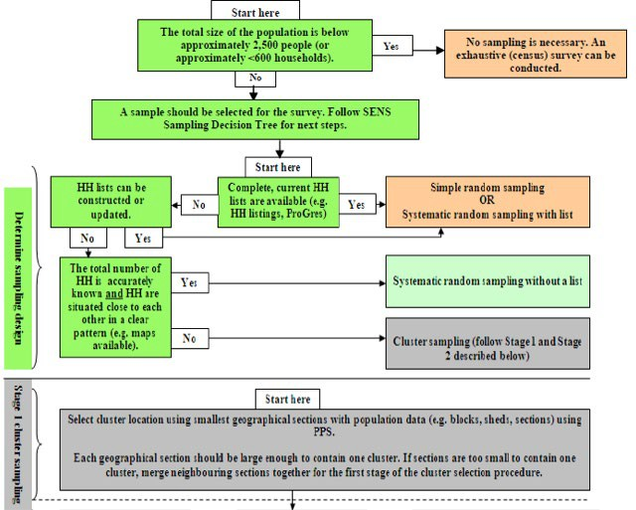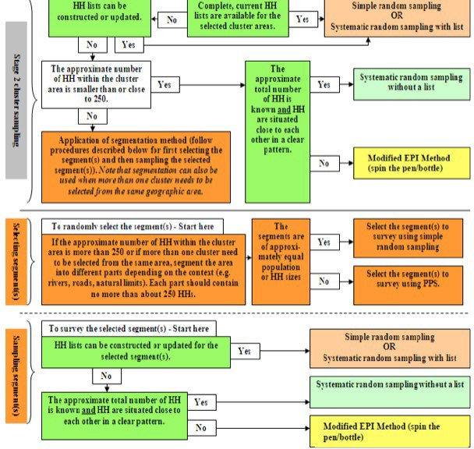

## How should a household be defined?

* There is no universal definition of a household to be used in a nutrition and health survey. However, a classic definition used in nutrition surveys to define a household is: ***a group of people who live together and routinely eat out of same pot.*** For example, if two families share the same pot, they should be assessed as one household.
* ProGres is UNHCR’s registration database for refugee population data. In ProGres v4 (the version at the time of writing SENS version 3), a case and a registration group are defined as follows:
  + **Registration Group**: A Registration Group is one or more individuals who are registered together. For example, a Registration Group could be a family or it could be a household registered together for assistance purposes. An individual must always belong to a Registration Group. An individual can only belong to one Registration Group at any point in time.

**- Case:** A case is used to record and track information about individuals undergoing various processes.

Depending on the process, a case can be composed of one or more individuals. Case membership is independent from Registration Group membership. For example, a resettlement case may contain individuals from different registration groups. A resettlement case can also contain a subset of individuals from the registration group.

* If accurate and updated population lists are available from ProGres for sampling, a household should be defined as it appears in ProGres, i.e. **use the Registration Group as a proxy for household**. From the above definition from ProGres v4, the Registration Group should be the basis for sampling rather than the Case. Case should not be used for sampling.

###### The following procedure should be followed when using ProGres lists for sampling using the Registration Group:

* + - To complete modules 2-4 (the individual-based modules-anthropometry, health, anaemia, IYCF), include only the children and women from the household(s) belonging to Registration Group that was randomly selected from the ProGres list. There might be additional children and women who live together and routinely eat out of the same pot, but belong to a different Registration Group. They should not be included in the survey for modules 2-4.
    - To complete modules 1 and 5-7 (the household-based modules-demography, food security, mosquito net coverage and WASH), include ***all household members who live together and routinely eat out of the same pot***. It is possible that you will need to include people who live together and routinely eat out of the same pot, but who belong to a different Registration Group. They should be included in the survey for modules 1 and 5-7.

###### Why should different definitions for individual and household modules be used?

* + - It is to minimise the risk of major oversampling of children and women in the survey (i.e. excess burden on population, waste of resources, surveyor fatigue). If the definition of ***all members who live together and routinely eat out of the same pot*** is used for the individual modules and thus includes more than one Registration Group this will be very different from the data used to calculate the initial sample size for children and women (higher).
    - Since the household modules rely on information about how people actually live together and share their resources, it is better to use the definition of ***all members who live together and routinely eat out of the same pot***, instead of a Registration Group definition which would not reflect reality.

Things to watch out for:

* It can become very confusing for survey teams if there is no clear definition of the household before the survey starts (especially in polygamous settings).
* Ensure the same procedures are used in the same survey and in surveys from year to year in the same setting. This will allow direct comparisons to be made.

## How is the required sample size calculated?

* UNHCR SENS surveys measure several indicators at the individual-level in different target groups, and several indicators at the household-level.
* To simplify the planning process and to standardise the way surveys are conducted, UNHCR recommends calculating sample size based on GAM *only* using ENA for SMART software and SMART recommendations. The key variables for sample size calculation are: *expected prevalence of GAM*, *desired precision*, *design effect* (if cluster sampling used), *average household size*, *percentage of children under 5 years of age*, *percentage of non-response* and *total population* (when the population of children U5 is less than 10,000; see correction for small population size below).
* A worked out example of a sample size calculation and sampling strategy is provided in **Annex 1**.

The steps for calculating sample size are shown below.

1. Calculate **sample size by number of children** needed to assess the prevalence of acute malnutrition in children aged 6-59 months using the ENA software and the SMART recommendations.

The following information should be entered into the ENA for SMART software to calculate the sample size:

* **The estimated prevalence of acute malnutrition in the survey area**: This can be deduced from for example previous nutrition surveys, number of new admissions to nutrition programmes, or HIS data. If you really do not know the likely prevalence, a ‘safe’ approach is to use the highest prevalence that is anticipated with the widest confidence interval that is acceptable (i.e. the lowest acceptable precision) and the largest design effect that is likely to be encountered (see below information on design effect). E.g.: 20% prevalence, 5% precision and a design effect of 2.
* **The precision you require for your estimate**: The required precision can vary – the more precise you want your estimate to be, the more children you will need to survey. The following table shows the precision recommended at various levels of acute malnutrition prevalence:

**TABLE 5** RECOMMENDED PRECISION AT VARIOUS GLOBAL ACUTE MALNUTRITION (GAM) PREVALENCE LEVELS TO BE ADAPTED TO CONTEXT

|  |  |
| --- | --- |
| **Estimated GAM prevalence (%)** | **Desired precision**  **+/- %** |
| ≤5 | 2.0-2.5 |
| 5-10 | 3.0 |
| 10-15 | 3.0-3.5 |
| ≥15 | 4.0-5.0 |

* **The design effect (if cluster sampling is used):** The design effect is basically a multiplication factor used when calculating sample sizes for cluster surveys, which takes into account the particular issues that arise from using a cluster design. In some settings you can calculate design effects from previous surveys. In others we assume it is between 1.3 and 2, i.e. you have to increase your sample size by ×1.3 to ×2. A review of SENS survey data between 2011-2016 showed that in most stable refugee settings, the design effect for wasting will rarely be above 1.5*.* Never use a design effect below 1.3 in your sample size calculation. The following table gives examples of design effects that can be used depending on the context.

**TABLE 6** EXAMPLE OF DESIGN EFFECTS

|  |  |
| --- | --- |
| **Design effect** | **Context** |
| 1.3 | Population is homogeneous |
| 1.5 | Slight differences seen between clusters |
| 2.0 | Differences seen between clusters |
| >2.0 | High variation between clusters, some clusters are not affected while others are severely affected. |

Things to watch-out for:

* When calculating sample size, precision is the only factor that you can adjust and decide on based on the needs and available resources. The prevalence of GAM and the design effect are based on ‘reality’ and should not be adjusted to modify sample size to suit your needs.

Refer to the SMART Initiative Documentation for further guidance on how to calculate sample size using the ENA software.

1. **Correct for small population size** where needed.

* When the population of *children U5* is **less than 10,000**, it is necessary to use a correction factor in the sample size calculation that will ***decrease*** the survey sample size. The decrease can be significant in certain settings.
* Correction for small population size is usually done in settings where the total population is around 65,000 or below.
* **Ensure to distinguish between the total population and the population of children U5.** Mistakes are often made where survey managers wrongly assume that the 10,000 cut-off is for the **total** population rather than the population of **U5** and forget to correct for small population size in areas where total population size is above 10,000.
* Guidance on how to apply this correction factor using ENA for SMART is shown in **Annex 2.**

1. **Convert the sample size in number of children into number of households** using ENA software. Include a non-response rate of 5-15%, depending on the context. This is the ***total household sample size*** for the survey.

* Two critical population characteristics of the survey area need to be available to make this conversion:
  1. the average household size and (2) the proportion of children U5 in the total population. In addition, a clear definition of a household needs to be used (Refer to SENS Pre-module **Step 7** described above). As described previously, for emergency situations where reliable demographic data cannot be found because of a new influx or newly established camps, external guidance from an expert should be sought in the planning stage.
* The average household size to use will depend on the method of sampling and the definition of the household used in the survey.
  + If simple random sampling or systematic random sampling from ProGres list is used, a household is always defined as it appears on the ProGres list, i.e. ***individual or group of people belonging to the same registration group***. In this case, the average household size from ProGres is used.
  + If simple random sampling or systematic random sampling from household headcounts / household listings done just prior to the survey is used, a household is defined the same way as was done during the listing.
  + If systematic random sampling without a list is used, a household is usually defined as ***a group of people who live together and routinely eat out of same pot***. In this case, the average household size based on this definition known from partners, previous surveys or other assessment needs to be used.
  + If cluster sampling is used, follow the instructions and the definitions mentioned above depending on the method of sampling used to select the households at the second stage.
* The proportion of U5 in the total population is usually always derived from UNHCR ProGres database, as long as ProGres is more or less up-to-date. **This data is not affected by the definition of the household used in the survey.**
* There will often be some degree of uncertainty about the average household size and the proportion of U5 in the population. It is thus recommended to use the lower values of both variables, which would produce larger sample sizes in terms of households. For example, if it is thought that the average household size in a given refugee setting is about 5.5-6, and the proportion of U5 is about 15-18%, it is advisable to take the lower values (5.5 and 15%) for calculation of the sample size. Overestimation of the household size and of the proportion of U5 may result in a situation where the achieved sample size in terms of households will not provide the required number of children for precise GAM results to be obtained.
* The final stage in sample size calculation is adjustment for non-response to account mainly for refusal and absentees. Use a non-response rate of 5-10% if you have quite reliable demographic data and no major problems with refusal, accessibility and absentees are expected. Use a non-response rate of 15% (up to 20%) if you are uncertain about the demographic data or if it is anticipated that there may be issues with refusal, accessibility and absentees.

Refer to the SMART Initiative Documentation for further guidance on how to convert number of children into number of households for sample size calculation.

1. Decide on the ***household sample size* required for collecting the data from the different standard modules**:

* **Module 1: Demography (household as a whole):** With any survey design, assess all sampled households as a whole.
* **Module 2: Anthropometry and Health (children 6-59 months):** With any survey design, all eligible children within all of the sampled households will be assessed.
* **Module 2: Anthropometry and Health (women of reproductive age 15-49 years):** Follow the same sampling method as described below for Module 3 Women Anaemia.
* **Module 3: Children Anaemia (children 6-59 months):** Select one of the scenarios outlined in **Table 7** below based on the survey design and the number of children aged 6-59 months calculated with ENA for SMART software.

**TABLE 7** SAMPLE SIZE REQUIREMENTS FOR SENS ANAEMIA ASSESSMENT IN CHILDREN AGED 6-59 MONTHS

|  |  |  |  |
| --- | --- | --- | --- |
| **Survey design** | **Children anaemia scenario** | **Module 2 (Anthropometry and Health) sample size children 6-59 months** (calculated using ENA for SMART software) | **Module 3 (Anaemia) sample size children 6-59 months** |
|  |  |  | Assess all eligible children |
|  | 1 | ≤600 children | found in all randomly selected households for |
|  |  |  | anaemia. |
| **Cluster sampling** |  |  | Half of the sampled households (sub-sample) |
|  |  |  | should be randomly |
|  | 2 | >600 children | selected and all eligible |
|  |  |  | children found in these |
|  |  |  | households should be |
|  |  |  | assessed for anaemia. |
|  |  |  | Assess all eligible children |
|  | 3 | ≤400 children | found in all randomly selected households for |
|  |  |  | anaemia. |
| **Simple or systematic random sampling** |  |  | Half of the sampled households (sub-sample) should be randomly |
|  | 4 | >400 children | selected and all eligible |
|  |  |  | children found in these |
|  |  |  | households should be |
|  |  |  | assessed for anaemia. |

* **Module 3 - Women Anaemia (women of reproductive age 15-49 years):** The sample size should be selected according to one of the scenarios below.

1. **Women anaemia scenario 1:** *You need to measure the prevalence of anaemia in women of reproductive age (15-49 years) for surveillance purposes but you do not need to assess the impact of an intervention and are not planning to intervene with a direct anaemia intervention (e.g. blanket iron supplementation to all women) in the immediate future*:
   * With any survey design, half of the sampled households (sub-sample) should be randomly selected and all eligible women found in these households should be assessed for anaemia.
2. **Women anaemia scenario 2:** *You are planning to implement/have been implementing a direct intervention (e.g. blanket iron supplementation to all women) to reduce anaemia in women of reproductive age (15-49 years) and you need to assess the baseline prevalence and impact of the intervention*:
   * With any survey design, follow the same sampling scenario used in children for anaemia assessment (see **Table 7** above).

* **Module 4: IYCF (children 0-23 months):** With any survey design, all eligible children within all of the sampled households will be assessed for IYCF practices.
* **Module 5: Food Security (household as a whole):** With any survey design, half of the households (sub- sample) should be randomly sampled for the assessment of food security.
* **Module 6: Mosquito Net Coverage (household as a whole):** With any survey design, half of the households (sub-sample) should be randomly sampled for the assessment of mosquito net coverage.
* **Module 7: WASH (household as a whole):** With any survey design, half of the households (sub-sample) should be randomly sampled for the assessment of WASH.

Things to note:

* With exhaustive surveys, follow the same recommendations for sub-sampling as outlined above.

###### If using cluster sampling, how is the number of clusters chosen?

* If you are using cluster sampling, you will need to decide on the cluster size (i.e. total number of households per cluster) and the total number of clusters. Never sample less than 25 clusters (same as SMART recommendations). Usually the number of clusters should not exceed 45 clusters in one survey unless there is good reason to do differently.
* When following the SMART recommendations, the number of clusters is determined after calculating sample size and after determining the cluster size. The cluster size is determined by estimating the number of households that a team can survey in one day. It makes it much easier in terms of logistics for the teams and for the survey manager if one cluster is surveyed per team each day in order to ensure high quality data collection. For example:
  + If you estimate that it takes a team on average 35 minutes to complete the survey in each household and to walk from one selected household to another, and you know you will be working in the field on average for 7 hours per day (not including breaks and travel to / from the central site), you can estimate that each team could measure 12 households per day (7 hours multiplied by 60 min=420 min; 420min divided by 35min=12 households). If your total sample size requirement is 450 households, you will need to visit 38 clusters (450 households divided by 12 households per day=37.5) to achieve your overall sample size in number of children.

Things to note:

* The planning process in refugee settings will sometimes differ from the planning process in large rural areas because travel times are often shorter. Hence, the planning process described in SMART may need to be adapted.

###### If using cluster sampling, how are clusters selected?

* If cluster sampling is used, you then need to allocate the clusters to the sections of the camp / settlement using PPS and the cluster allocation table in ENA software.
* You will need to have a list of the approximate population sizes of each geographic area (e.g. block / section) in the camp(s) of interest. The smallest available geographic unit is usually chosen, as long as population data are available, the geographic unit has a name/code and the area is large enough to contain one cluster.

###### How are the households selected?

* Refer to the sampling decision tree (**Figure 1**) for general guidance.

###### How is sub-sampling of households performed for the different modules?

* As is described above, depending on the survey design, sub-sampling of households needs to be done for some of the standardised modules included in the SENS survey.
* When using a list, randomly select half of the households originally selected to be sampled.
* If a list is not being used for sampling then sample every other household.

Things to note:

* A worked out example of a sample size calculation and sampling strategy is provided in **Annex 1**.
* A data collection control sheet should be used by survey teams to keep track of surveyed households, see **Annex 3** or see SENS Pre-Module tool: [**Tool 8**- Data Collection Control Sheet]. Note that the information recorded on the data collection control sheet is not entered into the database, is not analysed and is mainly used to aid survey team members and the survey manager in the daily management of data collection for each module.

###### What should be done if the target sample size or target number of clusters is not achieved?

Additional sampling may need to be done when the target sample size has not been reached or when the target number of clusters has not been reached.

###### Procedure to follow when the target sample size has not been reached:

* If less than 80% of the target sample size of children aged 6-59 months was achieved by the end of the survey, the following should be done. Otherwise, no additional sampling is needed:
  + For *simple or systematic random sampling surveys*, another sample of households from the whole population should be taken to boost the sample size of children. This sample should be *25%* of the original sample size.
  + For *cluster sampling surveys*, all of the replacement clusters (RC) automatically selected by ENA for SMART software should be sampled.

###### Procedure to follow when the target number of clusters has not been reached:

* All of the replacement clusters (RCs) automatically selected by ENA for SMART in the planning stage should be sampled if 10% or more of your original clusters were not completed for various reasons (including security, refusal or problems with access). Otherwise, no additional sampling is needed.

*When conducting additional sampling, if the same household is re-selected by chance from the list or within the cluster area, it should be skipped and not surveyed twice. Another one should not be selected in its place. Note that it is possible that a replacement cluster (RC) is sampled from the same area as an original cluster.*

* See **Module 2-Anthropometry and Health** for more details and examples.

###### What should be included in the SENS survey protocol?

* A survey protocol must be written to explain the methods that will be used. The protocol should be shared with UNHCR HQ / Regional Offices and other key stakeholders well ahead of time for them to provide feedback before the survey training begins. Key elements of the survey protocol include.
  + Names of partners involved, affiliations and contact information (technical and financial);
  + Background and rationale;
  + Survey objectives;
  + Definitions of survey populations and inclusion criteria;
  + Geographic boundaries of survey;
  + Population’s demographic data;
  + Sample size calculation;
  + Sampling methodology;
  + Data collection and measurements;
  + Survey team composition;
  + Training plans;
  + Field monitoring and quality control checks;
  + Ethical considerations (informed consent, consent for the use of Mobile Data Collection (MDC methods), consent for the use of GPS, referral of malnourished and anaemia children and women);
  + Questionnaires;
  + Data management and analysis;
  + Preliminary survey schedule;
  + Equipment list (see **Step 9** below).
* For an example of a SENS nutrition survey protocol, see SENS Pre-Module tool: [**Tool 9**- Standard SENS Survey Protocol].

# Step 9: Obtain equipment and supplies

1. **What equipment and supplies are needed?**
2. **What equipment is needed for electronic data collection?**
3. **How much equipment and supplies should be obtained?**
4. **Where can equipment and supplies be ordered?**

## What equipment and supplies are needed?

* The equipment and supplies needed to implement UNHCR SENS are listed in the individual survey module.
* Supplies should be ordered well ahead of time, i.e. **at least three months prior to the survey start** whenever feasible, or be borrowed from various bodies including WFP, UNICEF, local health centres and partners, provided they are in good condition to be used for a survey.
* UNHCR recommends that a ‘survey equipment kit’ containing good quality survey equipment and supplies be kept aside in each branch or field office and be dedicated for the sole purpose of data collection for SENS surveys.

Things to watch out for:

* Often, the procurement of equipment and supplies is not considered early enough during planning for a SENS survey, and this can cause significant delays in the field work.

## What equipment is needed for electronic data collection?

* Electronic data collection (as opposed to paper-based data collection) using mobile phones is recommended to be used wherever feasible to ease the process of data collection, data quality checks and data entry.
* Refer to UNHCR SENS website for guidance material on how to implement a SENS using mobile data collection (MDC).
* The following equipment will be needed to implement a SENS MDC survey:
  + Standard smartphones, usually two per team, with an android platform compatible with Open Data Kit (ODK) applications. ODK is a set of free, open-source applications for creating questionnaires and storing data.
  + One wireless router or Raspberry pi system.
  + One dedicated survey computer.
  + A steady power supply.
  + Extension cords/cables and/or power banks to charge all smartphones on a daily basis and plug in the MDC equipment.

## How much equipment and supplies should be obtained?

* A supplies planning tool is provided to help in calculating the amount of equipment and supplies needed

and to estimate the overall cost. See SENS Pre-Module tool: [**Tool 10**- Survey Supplies Planning Tool]. 

* There should always be extra equipment available to ensure replacement of faulty equipment during the survey (e.g. smartphones, scale, height boards, MUAC tape, HemoCue Machines) or where the survey sample has been underestimated (e.g. HemoCue microcuvettes, safety lancets, alcohol, etc. for anaemia assessment).

Things to watch out for:

* Ensure to factor in a higher number of anaemia supplies for each survey when measuring anaemia in children and in women in case the available demographic data is not up-to-date. It is recommended that you factor in an additional *40%* of anaemia supplies, especially where demographic data are uncertain. This is automatically calculated in the Supplies Planning Tool mentioned above (**Tool 10**).

## Where can equipment and supplies be ordered?

* A list of international suppliers is provided in the individual modules. Up-to-date information on local suppliers from within each country / region may be found on the companies’ websites.

# Step 10: Design questionnaire

1. **Which questionnaire should be used?**
2. **How should answers be coded?**
3. **How should the questionnaire be translated?**
4. **How should the questionnaire be finalised?**

## Which questionnaire should be used?

* The recommended SENS questionnaire should be used without altering or removing questions. Some questions are optional and should be added depending on the context. For the full UNHCR SENS questionnaire, see SENS Pre-Module tool: [**Tool 11**- Full SENS Questionnaire] and [**Tool 12**- Full SENS Questionnaire with Instructions]. Note that the latter questionnaire contains all of the key instructions for survey mangers when planning a SENS.
* It is essential to adapt the SENS questionnaire to the local context. See guidance provided in the individual modules for local adaptation of some of the questions and answer options.

Things to note:

* Many of the questions have been designed to measure trends over time in the same region as well as across regions and populations, and to conform to international reporting requirements.

## How should answers be coded?

* Answers to survey questions will be either a continuous number (e.g. weight recorded in kg, also known as a *continuous variable*), or a categorical response (e.g. Yes / No / Don’t know; also known as a *categorical variable*).
* The answer codes outlined in the UNHCR SENS questionnaire should be used so that SENS survey data sets are harmonised as much as possible and the standard Epi Info analysis guidance provided in each module can be used.
* When implementing a SENS using mobile data collection (MDC) methods, these variables are automatically coded within the standard questionnaires.

## How should the questionnaire be translated?

* The UNHCR SENS questionnaire currently exists in French and English. The SENS website contains more translations in different languages (e.g. Arabic, Somali, Swahili). A beneficial feature of the ODK in MDC SENS surveys is that one can switch between languages during an interview, or the interviewer can fill in the questionnaire using one language and the supervisor or survey manager can check in another.
* The surveyed population should be interviewed in the language they speak most comfortably, though second languages can be used among populations that are truly bilingual.
* It is important to carefully document all languages spoken in the survey area and what proportion of the study population speaks what language. This will not only impact the decision on what languages the questionnaire must be translated into, but also influence the choice of the surveyors.
* When the questionnaire has been satisfactorily translated, it should then be back-translated to its original language by someone other than the person who did the original translation in order to minimise bias. The back-translated questionnaire should then be reviewed against the original tool to make sure that the meaning of each question and terms were not altered during the translation process.
* After a thorough translation has been done, the questionnaire should be piloted among the survey population prior to the training start. Pilot testing should be done before the questionnaire is finalised and before the surveyors are trained.

Things to watch out for:

* Local terms that most clearly explain the question should be used.
* Whenever possible, interviewers should not translate the questionnaire into another language during the interviewing process.
* Translators should not reformat the document during the translation process as this creates confusion and can lead to missed questions and mistakes in skip patterns.

## How should the questionnaire be finalised?

* The standardised SENS questionnaires are readily programmed and available for MDC and can be reused in any setting with adaptation.
* After a thorough translation has been done (if necessary) and the questionnaires from each module have been adapted where appropriate, the XLS forms can be finalised and converted to XML forms (these are necessary when conducting MDC surveys). These resulting XML forms are then uploaded into the smartphones and should be tested for flow, skip patterns, age eligibility etc. with various made-up scenarios. This is the step where potential bugs can be detected.
* Questionnaires (MDC or paper) can then be further reviewed and tested during training. It is common to make further changes after the training taking into consideration the feedback from participants familiar with the survey area (see **Step 11** for more details).
* The next step is to administer the questionnaire to a few selected households before the questionnaire is finalised for good before the survey start (see **Step 12** for further details).

###### The questionnaires can no longer be modified after the survey start.

# Step 11: Select and train teams

1. **How should the survey teams be structured?**
2. **How many teams should be included?**
3. **How should the teams be trained?**
4. **What reference documentation should be provided to teams?**

## How should the survey teams be structured?

* There should be at least one survey manager1 supported by survey supervisors. The survey manager should be experienced in undertaking SENS surveys, training, handling and analysing data, writing reports and managing logistics and people.
* The survey supervisors should be experienced in training, managing logistics and people, and supervising surveyors during data collection. It is required for each supervisor to attend the entire SENS training prior to the survey start in order to ensure high quality data collection and effective supervision.
* Each team should consist of 4-5 people, one of whom is the team leader. The team leader in each team should take responsibility for the quality and reliability of the data collected by the team, records the data from the measurements and/or administers questionnaires. Two people are needed to take the anthropometric measurements, at least one person is required for taking the haemoglobin measurements, and at least one person to help the team leader administer the questionnaires. Depending on the extent of the survey, the team leader can administer the questionnaires and record the data from the measurements, however in many contexts, it is recommended to have one additional person specifically assigned for administering the household questionnaires. For an example of job descriptions for each team member, which should be adapted to each context, see SENS Pre-Module tool: [**Tool 13**- Survey Team Job Descriptions].
* When electronic data collection is used, the smartphones should be handled by one or two team members specifically trained on this. The chosen team members should preferably be familiar with smartphones and mobile technology, or at least have the capability to quickly acquire the needed skills. Normally the team leader will handle one phone with the individual questionnaires (Anthropometry and Health-Module 2, Anaemia-Module 3, IYCF-Module 4), while another team member will handle one phone with the household questionnaires (Demography-Module 1, Food Security-Module 5, Mosquito Net Coverage-Module 6, WASH-Module 7).
* If travel by car is necessary, then drivers need to also be considered. In addition to the data collection staff, data entry clerks can also be recruited for paper-based surveys.

1 Note that survey manager is used throughout these guidelines. Other commonly terms used to describe this position include: survey consultant or survey coordinator.

* The composition of teams needs to be sensitive to the local context in terms of gender, ethnicity and language skills as well as local knowledge of the survey area. It is best practice to include at least one woman in each team. It is also useful to include members in each team who will be able to easily carry the height boards and other equipment.
* Whenever possible, use surveyors who will be considered unbiased by the survey population and other stakeholders.

Things to watch out for:

* The team leader must always oversee the anthropometric and haemoglobin measurements and be responsible for writing down the results. **Ensuring the quality of anthropometric and haemoglobin measurements as well as the overall data quality of the survey team should be the priority focus for the team leader while in the household**.

## How many teams should be included?

* Six teams should ideally be used in a survey depending upon the budget, sample size, time allocated to complete the survey, and the size and accessibility of the area covered.
* It is recommended to limit the number of teams to eight at a maximum.

Things to watch out for:

* Although it is faster with more teams, it is much more difficult to train, supervise, and recruit good reliable team leaders for each team, provide transport and equipment, and organise a large number of teams.
* The more surveyors there are, the harder it is to supervise them adequately and the more risk there is to have poor quality results.

## How should the teams be trained?

* The training for the full UNHCR SENS (i.e. all 7 modules included) using MDC methods is recommended to last at least 5 days, depending on context and team experience (excluding the standardisation tests for anthropometry and haemoglobin measurements, and the pilot test).
* Extra staff should be trained in case someone is unable to perform the field work.
* Recommendations for training and tips are provided in the individual SENS modules for the different levels of responsibility (i.e. team leader, measurer, and interviewer).

*The main topics to cover in training of data collectors (note that team leader may be provided with a more in- depth training than some of the data collectors) are as follows:*

* Reason / objectives for SENS survey
* Composition of survey teams
  + Roles and responsibility
* Sampling procedure
  + Why sample, explained in a way that surveyors can later on explain to community members when asked
  + Rationale and importance of representativeness
* Questionnaire and sheets
  + Introduction to the household and obtaining informed verbal consent
  + Household-level information
  + Child-level information
  + Woman-level information
* Interviews and observations
  + Interview questions and interviewing techniques - go through each question for clarity, answer options, cultural appropriateness, gender sensitivities, avoid suggestive questioning but probe where necessary
* Measurements
  + Age recording and use of local events calendar
  + Measurement techniques (anthropometry and haemoglobin) and practicing with children and/or adults
  + Standardise measurements among team members
* Survey logistics
  + Equipment
  + Mobile phones handling
  + Communication
  + Travel
  + Incentives / salary / allowances
  + Food and drinks
  + Accommodation, etc.

Things to note:

* Training is fundamental for the quality of the survey information collected and preparation for the training and survey will take time, especially the first year the full UNHCR SENS is implemented.

## What reference documentation should be provided to teams?

* The data collection process must be standardised so that teams understand their responsibilities and do not have to improvise in the field.
* In addition to developing a survey protocol prior to data collection, it is also necessary to provide to teams simple instructions / key guidance that explain the step-by-step process of data collection, with a particular emphasis on the roles and responsibilities of each team member. Teams should have copies of this information to reference when they are out in the field.
* Teams should be given the following documents for example: paper questionnaires (important in both MDC and paper-based surveys); job descriptions; images depicting best practice techniques for anthropometric measurements; assignment of clusters; equipment checklist; events calendar; case definitions; referral forms; contact details of survey manager, supervisors and team leaders; camp map.

# Step 12: Field test questionnaire and procedures

1. **How should the field test be conducted?**
2. **How long should the questionnaire take to administer?**
3. **Who should be checking and doing the measurements, and recording the information?**
4. **Who should be conducting the interviews and recording the information?**

## How should the field test be conducted?

* After the training is completed, teams should visit a location in the camp or the surrounding villages that is not part of the real survey but is similar, and should run through all the steps whilst under close supervision.
* At the end of the field test (also known as the pilot test or pre-test), the team members, the survey manager and the survey supervisor(s) should be confident that they can undertake the survey accurately.

The field test includes practicing on the following:

* Working as a team;
* Organising equipment / logistics;
* Sampling procedures for selecting households and individuals;
* Introducing the team and the survey to participants;
* Obtaining consent;
* Conducting interviews and observations;
* Taking and recording measurements;
* Filling out the questionnaire and the different sheets.

## How long should the questionnaire take to administer?

* As a rule of thumb, completion of the full UNHCR SENS questionnaire in a household is expected to take approximately 30-45 minutes on average with an *experienced* survey team: 5-10 minutes for the anthropometric measurements, 5-10 minutes for haemoglobin measurements and 20-25 minutes for the questionnaires on demography, health, IYCF, food security, mosquito nets and WASH.
* However, at the start of the survey, it may take significantly longer for the teams to complete the questionnaires (maybe >1hr). As the teams become familiar with their work, their speed will increase. As a result, the time taken to complete each household (and cluster, where applicable) will decrease as the survey goes on.

## Who should be checking and doing the measurements, and recording the information?

* The team leader should at all times check and supervise the anthropometric and haemoglobin measurements, and record the data.
* The anthropometric measurements should be done by two people trained on anthropometric measurements and having been tested in a standardisation test: one measurer and one assistant measurer. The mother or the team leader can help to position difficult children during these measurements (weight, height / length, MUAC, oedema) but they should not play the role of the assistant measurer.
* The haemoglobin measurements should be done by one person trained on haemoglobin measurements and having been tested in a standardisation test. One of the anthropometric measurer can assist in the process of haemoglobin measurements.

Things to note:

* During data collection in MDC surveys, the anthropometric and haemoglobin measurements in children aged 6-59 months and women should be recorded in the SENS Pre-module SENS tool: [**Tool 14**- Participants and measures control sheet]. This allows surveyors to avoid registration mistakes and/or missing data. This tool also allows survey manager and/or supervisors to verify the recorded data within each questionnaire and possibly correct or complete missing and/or aberrant data.

## Who should be conducting the interviews and recording the information?

* In most full SENS surveys, the team leader should be responsible for handling the individual questionnaires (Anthropometry and Health-Module 2, Anaemia-Module 3, IYCF-Module 4) and another team member should be responsible for handling the household questionnaires (Demography-Module 1, Food Security-Module 5, Mosquito Net Coverage-Module 6, WASH-Module 7). Note that the team leader should closely supervise the team member handling the household questionnaires in all contexts.

**Step 13: Collect data and supervise**

1. **How should field work be scheduled and the community informed?**
2. **How should individual households be approached and informed consent sought?**
3. **What special cases may be encountered in the field and which procedures to follow?**
4. **How is the data entered and transferred to the computer in MDC surveys?**
5. **How should supervision be conducted?**

## How should field work be scheduled and the community informed?

* Prior to going to the field, it is important to develop a detailed data collection schedule taking into consideration the local events (e.g. food distribution days, nutrition programmes days, market days - in most contexts, data collection should not take place during those days).
  + With cluster sampling surveys, this schedule should include the cluster location and name, the assigned cluster number, the date it will be surveyed and the team number assigned to that particular cluster.
  + With simple or systematic random sampling surveys with a list, this schedule should include the team number assigned to specific sections of the camp, the date each section will be surveyed and the number of households to survey per section.
* This data collection schedule should be provided to the refugee leaders, host population leaders (where applicable) and other relevant local authorities in order for them to sensitise the community and inform them to remain near their house on the day of the survey in that specific location (Refer to **Step 5** above).
* The data collection schedule may need to be adjusted once fieldwork begins.

## How should individual households be approached and informed consent sought?

* The teams should be trained on the consent process just as they are on administering the questionnaire.
* When the survey team reaches the selected household, the team leader should introduce him / herself and the study team, clearly explain the objectives of the survey, what the information will be used for, that the survey is anonymous and participants’ confidentiality will be upheld, how long the questionnaire will take, and obtain permission from the head of the household for the measurements and interviews.
* First, the household must choose to participate, then each individual should be given the opportunity to agree or decline him / herself.
* If it is a survey using Mobile Data Collection (MDC methods), consent to participate in the survey includes an authorization to use a smartphone or tablet to record data. If GPS coordinates are recorded (optional data) during the administration of the questionnaires at the individual level (children and women), as well as at the household level (food security, mosquito nets and WASH questionnaires), an authorization for registration of GPS coordinates of the household will be requested at the end of the demography questionnaire.
* After completing the measurements and questionnaire, each person and household should be thanked for providing their time and assistance. The team leader should answer any additional questions that the household might have, including those about the survey itself and should refer the household to available services for questions regarding nutrition and health care.

Informed consent includes the following elements:

* An explanation of the purpose of the survey, how the person was selected to participate and how the results will be used in terms that the survey participant can understand.
* An explanation about the right to refuse to participate: all participants have the right to refuse participation in the SENS survey without giving a reason for her / his decision.
* An explanation of the procedure and risk involved: fears about taking blood need to be addressed prior to testing in order to make the survey participants comfortable and cooperative. The survey workers should be familiar with local beliefs about blood collection before beginning the survey.
* An explanation about confidentiality: in some refugee settings, the community is concerned when personal information is collected about them as they fear that this can affect the services provided to them in the camp. Survey participants should be reassured that the information will be kept confidential.

###### EXAMPLE OF A VOLUNTARY INFORMED CONSENT FORM:

(Read this statement to the head of the household or, if they are absent, another adult member of the house before the interview)

My name is and I work with [organisation/institution].

* We would like to invite your household to participate in a survey that is looking at the nutrition and health status of people living in this [camp / survey area]. UNHCR is sponsoring this nutrition survey.
* Taking part in this survey is totally your choice. You can decide to not participate, or if you do participate you can stop taking part in this survey at any time for any reason.
* If you stop being in this survey, it will not have any negative effects on how you or your household is treated or what assistance you receive.
* If you agree to participate, we will ask you some questions about your family and we will also measure all the children in the household who are older than 6 months and younger than 5 years [and/or women]. In addition to these assessments, we will test a small amount of blood from the finger of the children and women to see if they have anaemia.
* Before we start to ask you any questions or take any measurements, we will ask you to give us your verbal consent. Be assured that any information that you will provide will be kept strictly confidential.
* You can ask me any question that you have about this survey before you decide to participate or not.
* If you do not understand the information or if your questions were not answered to your satisfaction, do not declare your consent on this form. Thank you.

Things to watch out for:

* Survey teams often forget to ask for consent, or the authorization to use the smartphone or tablet (if the survey uses MDC methods), or thank the family after surveying their household. Make sure that teams always ask for consent, authorization to use the smartphone or tablet or GPS and always thank the family for their time.

## What special cases may be encountered in the field and which procedures to follow?

* **Absences:** If an individual or an entire household is absent, the team leader should record this information and determine another time to return on the same day. The team should return to an absent household or revisit an absent individual up to two times, if it is logistically feasible, on the same survey day and/or before leaving the survey area. If they are unsuccessful after this, the individual or household should be recorded as an absence and they should not be replaced with another household or individual.
* **Refusals:** If an individual or an entire household refuse to participate, then it will be considered a refusal and this information should be recorded. The individual or household should be recorded as a refusal and they should not be replaced with another household or individual.
* **Abandoned households:** A household will be considered abandoned if neighbours report that nobody has lived in that household for more than one month (or another context-specific timeline) *or* if the inhabitants have been repatriated. This household should be replaced by another household and it should be considered as abandoned. In populations where there is a great deal of long term travel out of the camp, then the criteria may be altered to include only those people who have been residing in the household in the past two weeks, past month or another context-specific timeline. A note should be made in the final report about the criteria for inclusion used.
* **Household with no children**: If it is determined that a selected household does not have any eligible children, the questionnaires at the household level should still be administered to the household and the woman questionnaire to any eligible women.
* **Child in nutrition / health centre**: It is important to measure the children who are located in nutrition or health centres. The team should go to the centre if it is feasible to do so to take the measurements and information from the child. If it is impossible to visit the centre, the child should be given an ID number and should be considered as absent and not replaced. The fact that the child was in a nutrition / health centre at the time of the survey should be recorded in the SENS Pre-module Tool: [**Tool 8**- Data collection control sheet] in the space provided. This recommendation differs from the standard SMART recommendation, which considers nutrition surveys that are usually conducted in large geographic areas and where it is often not possible to go to the nutrition or health centres for measurement of the admitted children.
* **Disabled child**: If a physical deformity prevents the measurement of child’s weight or height, the child should be given an ID number and the data should be recorded as missing for these variables. The fact that the child was disabled should be recorded in the SENS Pre-module Tool: [**Tool 8**- Data collection control sheet] in the space provided. The child should be included for the assessment of the other indicators (e.g. oedema, measles vaccination, vitamin A supplementation, etc.).
* **Not enough households in the cluster area (cluster surveys *only*)**: If after visiting all the households in a cluster area, it is determined that there are not enough households to complete the cluster, the closest neighbouring section / area should be used to complete the cluster making sure that it is not already part of another cluster. When arriving at the neighbouring area, the same sampling procedure should be repeated for selecting the first household until the cluster is complete.

Things to note:

* If your sample size in number of children aged 6-59 months is significantly reduced due to the above situations, you may need to re-sample. Refer to SENS Pre-module **Step 8**, **Point ‘h’** and **Module 2** for detailed guidance on how to proceed.

## How is the data entered and transferred to the computer in MDC surveys?

* During data collection in MDC surveys, the survey teams record all response directly on the phones. Every day, the survey manager and supervisors review questionnaires for inconsistencies and provide immediate feedback to the survey teams. At the end of the day and once data quality is ensured, the phones are connected to a local network set up specifically for the survey and data from the phones are transferred to an offline server, where multiple data can be stored. The offline server is accessed through a computer connected to the same local network, and downloaded to Excel-readable format ready for analysis (Excel-readable CSV format is converted to XLS format for analysis). There is no need for an active internet or mobile network connection to collect and save data. Refer to SENS Pre-module Tool: [**Tool 15**- Standard Operating Procedure (SOP) for SENS data management] for guidance on how to do these format conversions.
* Another alternative when there is a stable internet connection is to use the Kobo server ([https://kobo. unhcr.org](https://kobo.unhcr.org/)). In that case, at the end of the day the data from the phones are uploaded to the Kobo server. Then the Kobo server is accessed through a computer connected to internet and the data can be downloaded directly in XLS format. See specific guidance on mobile phone data collection for more detailed explanations.
* In paper-based surveys, data entry clerks should enter the data onto the computer on a daily basis, whenever possible.

## How should supervision be conducted?

* There should be daily supervision of survey teams by the survey manager and supervisors throughout the survey. Detailed recommendations, tips and common errors to watch for are provided in the individual survey modules.
* Teams usually need the most support from the survey manager and supervisors at the early stages of the survey, when many of the procedures are new, as well as at the end of the survey as team members tire and tend to rush, and make more mistakes.
* The survey manager and supervisors should always concentrate on providing support to the weakest teams and should remind the teams to take enough time for appropriate rest periods, and have refreshments and food with them.
* There should be a daily debriefing session with each team to discuss any problems that have arisen during the day. This often brings out important points. This debriefing session can happen every evening at the end of data collection or every morning before starting a new survey day.

Survey managers and supervisors should focus on the following elements:

* Correct techniques are used for selecting the households;
* The definition of the household is used appropriately;
* The respondent is selected correctly;
* The team introduces themselves correctly;
* Informed consent is asked at the beginning of the interview process;
* Authorization to use the smartphone (and registration of GPS coordinates) is requested;
* Correct techniques are used for measuring weight, height, MUAC and haemoglobin of children and/or women, and assessing oedema and age;
* Daily testing of measuring equipment is carried out and the equipment is in order (check of anthropometry and anaemia equipment; see **Modules 2-3** for more details on how to record and keep track of these equipment quality checks);
* The vitamin A capsule, iron-folate tablet and deworming tablet (where applicable) is shown to the respondent to help them recall accurately;
* The proper definition of diarrhoea is used;
* Appropriate interviewing and direct observation techniques are used when asking the questions (interviewer speaks clearly, no leading questions are asked that might influence the respondent’s answers, question is read exactly as written, skip patterns followed correctly);
* The data are correctly entered into the phones (or the paper questionnaire) and there are no discrepancies of interrelated questions; and
* Survey respondents and the community are treated with respect at all times.

**Step 14: Manage and review data**

1. **What are the recommended software to use?**
2. **Where can we find software available for analysing SENS surveys?**
3. **How should the databases be organised?**
4. **How should the survey data files be named?**
5. **How and when should questionnaires be checked?**
6. **Why should data be reviewed?**

## What are the recommended software to use?

UNHCR currently recommends the use of ENA for SMART software and Epi Info for Windows (version 7’s) for the following reasons:

* These software allow for both data entry (if paper-based surveys are used) and analysis, and take into account the complex design of cluster surveys for analysis.
* ENA for SMART and Epi Info for Windows software appear to be the most commonly used software in nutrition surveys by different actors, and good guidance material on their use is freely available (see below).
* ENA for SMART and Epi Info for Windows software are freely available from the internet and no license is needed for their use.

## Where can we find software available for analysing SENS surveys?

* As part of the SMART initiative, a software package called Emergency Nutrition Assessment (ENA) was developed.
  + ENA provides a standardised analysis of anthropometry and mortality surveys and contains many of the necessary calculations in one programme. The software has different sheets (planning, training, data entry, results, and options) which follow the steps of a survey. It allows the generation of anthropometric indices using WHO Growth Standards, produces automated analyses of key mortality and nutrition indicators, conducts automated anthropometric data quality checks, and generates reports that include results of these automated analyses.
  + However, ENA for SMART software can only be used for entry and analysis of data from children U5 (and not from women of reproductive age).
  + It can be downloaded freely at: [http://smartmethodology.org/survey-planning-tools/smart-emergency- nutrition-assessment/](http://smartmethodology.org/survey-planning-tools/smart-emergency-nutrition-assessment/)
  + Note that the food security analysis option is not currently recommended for use in UNHCR SENS surveys. Refer to **Module 5** on Food Security for the recommended method to follow in refugee situations.
* Epi Info software can be used to analyse nutrition surveys. Epi Info for Windows is available for free download from CDC at <https://www.cdc.gov/epiinfo/index.html>
  + This software package does not provide automated analysis of nutrition and mortality surveys, but allows for the calculation of 95% confidence intervals taking into account the design of cluster surveys.

## How should the databases be organised?

* When using mobile phones for data collection, the database for each questionnaire (1- Demography, 2- Food security, mosquito net coverage and WASH, 3- Children under-5, 4- Women), will be in CSV format. After data is collected, it is uploaded from the phones to the survey computer via a wireless router. The CSV files are then converted to XLS files in Excel. These Excel files (or XLS) can easily be copied and used in the various analysis software recommended above. If the Kobo server is used, the database for each questionnaire will be automatically in XLS format. See specific guidance on mobile phone data collection for more detailed explanations.
* Refer to SENS Pre-module Tool: [**Tool 15**- Standard Operating Procedure (SOP) for SENS data management] for guidance on how to store the various databases from each module.

## How should the survey data files be named?

* A slightly modified version of the SMART naming convention is recommended to be used to name the survey files as follows:
  + The name of the file should start with a three letter code for the country (e.g. SUD for Sudan, NEP for Nepal, BAN for Bangladesh);
  + Then, the file name should have the date of the survey in YYMM format (e.g. 1804 if the survey was conducted in April of 2018 or 1709 if the survey was conducted in September of 2017);
  + The data file name should indicate the letters corresponding to the type of information collected:
    - Demography data should be described with ‘**DM**’
    - Children anthropometry, health, anaemia and/or IYCF data should be described with **‘CH’**
    - Women anaemia and/or anthropometry data should be described with **‘WM’**
    - Food security, Mosquito et coverage and WASH information should be described respectively with

**‘FS’, ‘TN’** and **‘WS’**

* + The region, type of participant (refugee, host) or the agency involved can be usefully included in the name of all the files.
  + It is good practice to keep all files related to one survey including data files, planning documents, final questionnaire, training documents, survey tools etc. in one unique folder with sub-folders entitled Planning, Training, Survey Tools, Data, and Report containing the corresponding files.

Things to watch out for:

* It is important to be consistent in naming files and directories, and to give all files a name that can be recognised later by anybody looking into the survey documentation.
* Under no circumstances should the survey files be called report.doc, SurveyData.xls etc. with no details in the title of the file.
* Note that it is recommended not to use under-scores in the file name with Epi Info.
* Mistakes are often made while saving, recoding variables or correcting error codes.
* All files should have a version number or date included in their title. Without this errors can easily be made, for example, by copying an older file over a more recent file with the same name!
* Always save and keep backups of your files in different locations regularly, such as on your laptop in the office and on a memory stick that you keep with you.

## How and when should questionnaires be checked?

* Questionnaires should be checked on a daily basis for consistency, and for missing data. Detailed recommendations, tips and common errors to watch for when checking questionnaires are provided in the individual survey modules. Further details are provided in SENS Pre-module Tool: [**Tool 15**- Standard Operating Procedure (SOP) for SENS data management].
* When mobile phones are used for data collection, data should be uploaded to the server and saved on the survey computer every night.
* During data collection in MDC surveys, the anthropometric and haemoglobin measurements in children aged 6-59 months and women should be recorded in the SENS Pre-module SENS tool: [**Tool 14**- Participants and measures control sheet]. This allows surveyors to avoid registration mistakes and/or missing data. This tool also allows survey manager and/or supervisors to verify the recorded data within each questionnaire and possibly correct or complete missing and/or aberrant data.

## Why should data be reviewed?

* Data review aims to identify and correct as many mistakes as possible and to check where there are missing data.
  + Of course, it is never possible to be sure that data is completely free of errors because some errors will not look like mistakes. For example, if we record 3 containers to collect or store water in the house, when in fact it is 4 containers, or if we record a volume of 15.0L, when in fact it is 20.0L, it is quite possible that this will not show up during the checks.
  + This emphasises the need to have well trained teams with strong team leaders / supervisors using good quality equipment that is regularly checked during the survey and regular supervision providing support to the ‘weakest’ teams.
* Any queries should be directed to the concerned team members and addressed to minimise duplication of errors and oversights as the survey is still on-going.
* If any team is getting a large number of error codes or flags, the survey manager should accompany the team to the field to provide support in improving the measuring techniques and press for high quality data collection.

Things to watch out for:

* Under no circumstances should a value be ‘made up’, for example, because other questions suggest a certain value is true.

# Step 15: Check data quality and analyse

1. **How should the data be analysed and checked for quality?**
2. **How should the survey sample be described?**
3. **How is a graph of trends made?**
4. **How to determine if there is a difference between two surveys?**
5. **How should the results from different camps be presented and combined?**

## How should the data be analysed and checked for quality?

* Data analysis should be done after data review process has been completed.
* Before starting data analysis, it should be ensured that there are no duplicate entries in the database from the women questionnaires and the questionnaires at the household level. Further details on how do this in Epi Info are provided in SENS Pre-module Tool: [**Tool 15**- Standard Operating Procedure (SOP) for SENS data management]. Duplicate entries from the children questionnaires are automatically identified by the ENA for SMART software in the plausibility report.
* Results from cross-sectional surveys should be descriptive and presented as proportions (with 95% confidence interval) and/or means for the overall sample and according to specific criteria where applicable (e.g. age group, sex).
* When an exhaustive SENS survey is done, there is no need to report the 95% confidence intervals. If sub- sampling is performed however within an exhaustive survey, confidence intervals should be reported.
* Standard analysis commands using Epi Info 7 for Windows are available in each individual module Annexes. **Annex 4** contains guidance on the main Epi Info commands to use for analysing SENS survey data with some examples of analysis outputs. Free guidance on the use of Epi Info for Windows and training material on Epi Info can be found at the following site: [http://www.cdc.gov/EpiInfo](http://www.cdc.gov/EpiInfo/)
* Refer to the individual survey modules to view the UNHCR recommended tables and graphs to be included in the final SENS report.
  + Whenever possible, use the recommended tables and graphs without altering or removing columns or rows.
  + Many of the tables and graphs have been designed to allow the measurement of trends over time in the same region as well as across regions and populations, one of the core purposes of the surveys, and to conform to international reporting requirements.

Things to watch out for:

* Often people immediately jump directly into their analysis and correct errors as they come across them. Data review should always be done prior to starting analysis.
* Recoding of variables should be done in a separate data file and you should always keep the original raw data file with the original variable names.
* For a description of common errors and tips to follow during the analysis process, see SENS Pre-Module

tool: [**Tool 16**- Data analysis tips]. 

## How should the survey sample be described?

* The final sample size reached for households and children should be equal to or exceed the planned sample size. If this is not the case, you may have results that are less precise than what was hoped for. It may be problematic if results need to be compared with past and future surveys to measure trends or look at differences between surveys.
* The obtained survey sample size in number of children aged 6-59 months should be presented in the final SENS report to see whether the numbers were as expected. If using a cluster design, the obtained number of clusters should also be shown. See **Module 1- Demography** and **Module 2-Anthropometry and Health** for more details.
* The percentage of U5 and average household size should be derived from the results. In addition, the population sampling frame and the observed non-response rate should always be reported. This will help in the planning of future assessments. See **Module 1- Demography** for more details.

## How is a graph of trends made?

* Graphs of trends covering several years for each key indicator should be presented in the final SENS report. To identify a trend, it is advised that prevalence data from *at least three time points* are obtained from nutrition surveys carried out at similar times of the year. See **Annex 5** for guidance and examples on how to interpret changes and trends.
* See the individual survey modules for the recommended graphs of trends to include in the final SENS report. *These include*:
  + Individual-based indicators:
    - Prevalence of GAM and SAM in children aged 6-59 months from year to year.
    - Coverage of measles vaccination and vitamin A supplementation in last six months (by card or recall) in children U5 from year to year.
    - Coverage of deworming in last 6 months in children from year to year.
    - Prevalence of anaemia and mean haemoglobin levels in children aged 6-59 months and women of reproductive aged 15-49 years (non-pregnant) from year to year.
    - Prevalence of Key Reproductive Health Indicators for pregnant women from year to year.
    - Prevalence of key IYCF indicators in children under-2 from year to year.
  + Household-based indicators:
    - Food Security data trend analysis.
    - Mosquito net module trend analysis.
  + For a tool that will automatically generate trend graphs, see SENS Pre-Module tool: [**Tool 17**- Trends and Graphs].

Things to note:

* The prevalence figures (e.g. acute malnutrition, anaemia) or the coverage figures (e.g. measles vaccination, vitamin A coverage) obtained from the survey sample represent an estimate of the overall prevalence or coverage data in the population at a given point in time. Therefore the *month* and *year* of the survey should always be reported. It is not sufficient to know the year of the survey alone when assessing trends.
* The ‘precision’ of the estimate is measured by a statistical term known as the *confidence interval (CI).* This reflects the error introduced by the sampling method and the sample size. Confidence intervals are usually associated with a probability of 95 per cent, which is equivalent to saying that: (1) if the survey is done 100 times the true population value will be within the range of the confidence interval 95 times out of 100; or (2) we are 95% confident that the true population value lies between the lower and upper value of the confidence interval. Confidence intervals are therefore an integral part of the results, should be shown in the trend graphs and be interpreted when assessing trends (see section below).

Things to watch out for:

* Often people disaggregate the results by children’s age, nationality or even cluster to conduct statistical analyses and compare results without considering the limitations of doing so. These analyses need to be interpreted with caution since sample size may not be large enough to detect differences if they exist or differences may be identified when there are none in reality. However, major differences in results between different groups should be looked into and warrant an in-depth investigation following the SENS survey to try to understand if the difference is real and if it is, why there is a difference.

## How to determine if there is a difference between two surveys?

* The simplest way to determine whether two survey results are significantly different is to look at the CIs for each survey. This applies to simple / systematic random surveys and cluster surveys.
  + If the CIs around the prevalence or coverage estimate do not overlap, then it can be concluded that there is a statistically significant difference between the two cross-sectional surveys. However, in some cases, the CIs may overlap slightly and there may still be a statistically significant difference between the two surveys. In these cases, a statistical test needs to be conducted.
  + The CDC IERHB calculator entitled ‘CDC calculator two surveys’ can be used to assess statistical differences between two surveys. For the CDC calculator, see SENS Pre-Module tool: [**Tool 18**- CDC Calculator two surveys]. To know whether there is a statistically significant difference between two survey estimates, a statistical test is conducted and a p-value calculated. If the p-value is >0.05, then there is no statistically significant difference whereas if it is <0.05, then there is a statistically significant difference in the survey results. For a worked out example on how to use the CDC Calculator see **Annex 6**. For detailed instructions on the CDC calculator, see SMART documentation.
* When comparing results from exhaustive surveys, changes do not need to be compared statistically and any changes can be considered real. For example, if anaemia decreased from 34.5% to 30.1%, it can be confirmed that there was a decrease in the prevalence of anaemia between the two surveys without performing a statistical test.

Things to watch out for:

* In refugee camp settings, there can be large population movements in and out of the camps. These should not be ignored when interpreting change (or absence of change) in indicators over time.
  + When the surveyed population is not stable and varies in number and / or composition over time, a lack of change in a specific indicator (e.g. GAM, stunting) is not necessarily due to a lack of effect of the interventions implemented in a refugee camp.
  + Contact UNHCR HQ / Regional offices for support on how to interpret trends.

## How should the results from different camps be presented and combined?

* When presenting the results from several camps with a representative sample drawn from each camp into one report, results can be presented two different ways: i) reporting results for each indicator from each camp separately or ii) combining results from all camps into one table per indicator. See SENS Pre-Module tools: [**Tool 19**- Dolo SENS Report 2017] and [**Tool 20a**- Jordan SENS Report 2016].
* When surveying several camps with a representative sample drawn from each camp, it is not appropriate to simply combine the samples from all camps to calculate the overall prevalence without taking into consideration a weighting factor. Weighting factors should be calculated based on the total population in each camp and in each sample, and taken into consideration during analysis of combined results. For a tool that will automatically generate weighed prevalence and/or mean results, see SENS Pre-Module tool: [**Tool 21**- Weighting Data Tool].

# Step 16: Write and disseminate report

1. **What should be included in the final SENS report?**
2. **How should the data be interpreted and information triangulated?**
3. **How should the results be compared to public health significance classification cut-offs and targets?**
4. **How should SENS recommendations be formulated?**
5. **How should the results of the SENS survey be disseminated?**

## What should be included in the final SENS report?

* After the standard results tables and figures have been completed, the results need to be explained and contextualised in a manner that is beneficial to the end-users and conclusions should be developed with specific recommendations that can be acted upon.
* The results should be presented in a standard way:
  + To allow comparison of different surveys.
  + To ensure that no important information is omitted.
  + To allow the reader who is familiar with this format to quickly find particular information s/he is searching for.
* The following is a summary of important areas to cover in reporting survey results as is recommended by SMART. The SENS report should include all the information necessary to evaluate the quality of the survey:
  + Executive summary;
  + Introduction;
  + Survey objectives;
  + Partners involved;
  + Methodology: sample size, size of clusters (where applicable), sampling procedures, case definitions and inclusion criteria, questionnaire, training, supervision, data review, data analysis, ethical considerations;
  + Results;
  + Limitations;
  + Discussion (comparison with previous surveys and trends, seasonal variation on nutrition status, information from secondary sources, e.g. HIS, rapid assessment, national surveys);
  + Conclusions and recommendations;
  + Annexes: SMART plausibility report summary, assignment of clusters (if applicable), standardisation test results, maps, questionnaire.
* A template preliminary report and template final report are provided to be used as a standard. The final report is based on the SMART automated report generated by the ENA for SMART software. For a copy of the UNHCR preliminary SENS report template, see SENS Pre-Module tool: [**Tool 22**- Preliminary SENS Report Template]. For a copy of the UNHCR SENS full report template, see SENS Pre-Module tool: [**Tool 23**- Full SENS Report Template]. For examples of reports see, SENS Pre-Module tools: [**Tool 24a**- Malawi Preliminary SENS Report 2016] & [**Tool 20a**- Jordan Final SENS Report 2016].



* The SENS Survey checklist should be used as a guide in making sure the report is complete, see SENS Pre-Module tool: [**Tool 25**- SENS Report Checklist].

## How should the data be interpreted and information triangulated?

* Interpreting and using the SENS survey results is a group activity that should involve nutritionists, public health teams, food security teams, WASH teams, malaria teams etc…, and the community members themselves.
* The following factors should be considered in interpretation:
  + Trends and changes;
  + Confidence Intervals (CI);
  + Seasonality;
  + Intervention cut-offs and benchmarks;
  + Aggravating factors or risks e.g. ration cuts, pipeline breaks, epidemic like measles or whooping cough, high incidence of respiratory or diarrheal disease, crude mortality rate>1/10,000/day, new influx;
  + Baseline or “normal” prevalence;
  + Prevalence of other types of malnutrition e.g. multiple micronutrient deficiencies, chronic malnutrition.
* The framework shown below should also be used when interpreting nutrition survey results.

**FIGURE 2** FRAMEWORK FOR ACTIONS TO ACHIEVE OPTIMUM FETAL AND CHILD NUTRITION AND DEVELOPMENT (BLACK ET AL., THE LANCET, 2013)

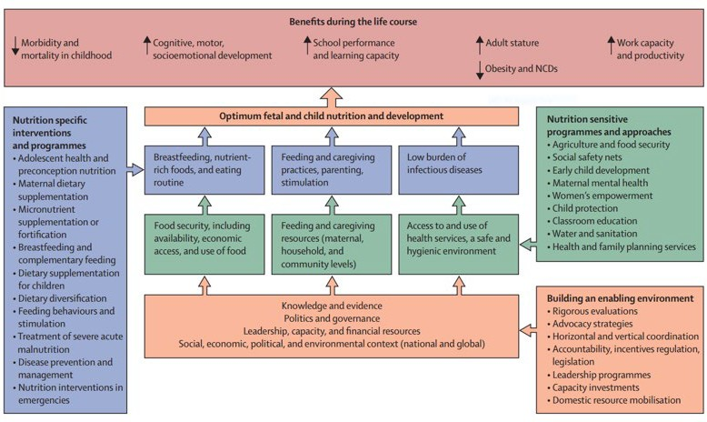

## How should the results be compared to public health significance classification cut-offs and targets?

* Public health significance classification cut-offs and targets exist for some of the SENS indicators and are described in more detail in the SENS individual modules. See **Table 8** shown below for a summary of the currently available classifications and targets.

**TABLE 8** SUMMARY OF PUBLIC HEALTH SIGNIFICANCE CLASSIFICATION CUT-OFFS AND TARGETS FOR KEY SENS INDICATORS

|  |  |  |
| --- | --- | --- |
| **Indicator Name** | **Classification of public health significance** | **Target** |
| **Children 6-59 months** |  |  |
| Global Acute Malnutrition (GAM) | Very high/critical if ≥ 15% (WHO-UNICEF  Classification, 2018) | UNHCR Target of <10% |
| Severe Acute Malnutrition (SAM) |  | UNHCR Target of <2% |
| Total Underweight | Critical if ≥ 30%  (WHO classification) |  |
| Total Stunting | Very high/critical if ≥ 30% (WHO-UNICEF  Classification, 2018) |  |
| Total overweight | Very high/critical if ≥ 15% (WHO-UNICEF  Classification, 2018) |  |
| Measles vaccination (9-59 months) |  | Target of ≥ 95% |
| Vitamin A supplementation within past 6 months |  | Target of ≥ 90% |
| Supplementary feeding programme (TSFP) enrolment |  | Target of ≥ 90% |
| Therapeutic feeding programme (OTP/SC) enrolment |  | Target of ≥ 90% |
| Total Anaemia (Hb <11 g/dl) | High if ≥ 40%  (WHO Classification | UNHCR Target of <20% |
| **Children 0-23 months** | | |
| Timely initiation of breastfeeding |  | UNHCR Target of ≥85% |
| Exclusive breastfeeding under 6 months |  | UNHCR Target of ≥75% |
| Predominant breastfeeding under 6 months |  | UNHCR Target of ≥90% |
| Continued breastfeeding at 1 year |  | UNHCR Target of ≥90% |
| Continued breastfeeding at 2 years |  | UNHCR Target of ≥60% |
| Introduction of solid, semi-solid or soft foods |  | UNHCR Target of ≥60% |
| Consumption of iron-rich or iron-fortified foods |  | UNHCR Target of ≥60% |
| Bottle feeding |  | UNHCR Target of <5% |
| Non-breastfed children under 6 months |  | UNHCR Target <2% |
| Non-breastfed children under 12 months |  | UNHCR Target <5% |

|  |  |  |
| --- | --- | --- |
| **Indicator Name** | **Classification of public health significance** | **Target** |
| **Women 15-49 years** | | |
| Total Anaemia (Hb <12 g/dl) | High if ≥ 40% (WHO Classification) | UNHCR Target of <20% |
| **Total population** | | |
| Proportion of total households owning at least one LLIN |  | Target of >80% |
| Average number of persons per LLIN |  | 2 persons per LLIN |
| Average liters per person per day of domestic water collected from protected/treated sources at household level (average on persons surveyed) |  | Emergency: ≥15 litres |
|  | Post-emergency: ≥20 litres |
| % households with at least 10 L/p potable/ drinking water storage capacity |  | Emergency: ≥70% |
|  | Post-emergency: ≥80% |
| % households collecting drinking/potable water from protected/treated sources |  | Emergency: ≥70% |
|  | Post-emergency: ≥95% |
| % households reporting defecating in a toilet/ latrine |  | Emergency: ≥60% |
|  | Post-emergency: ≥85% |
| % households with access to soap |  | Emergency: ≥70% |
|  | Post-emergency: ≥90% |

## How should SENS recommendations be formulated?

* Recommendations should be:
  + Directly justified and supported by data included in the SENS report.
  + Linked to the objectives of the survey.
  + Classified according to a timeframe, i.e. immediate, medium or longer term.
  + Followed-up on throughout the year following the SENS survey, i.e. status achieved, in-progress or not done.
* Refer to the individual SENS modules for more information on recommendations.

Things to watch out for:

* It is common to see recommendations that are not specific enough and not based directly on the survey results. Recommendations should be worded very carefully, be clear and concise.

## How should the results of the SENS survey be disseminated?

* The preliminary SENS report with key findings should be available *within one to two weeks* after finishing data collection and shared initially with UNHCR counterparts for comments before wider dissemination. Often the preliminary results need to be presented to stakeholders verbally to help get the messages across quickly. It is also important to inform the surveyed population about the results. Typically, a PowerPoint presentation is first made with the key SENS findings and then a preliminary report is written for dissemination. Sharing preliminary results is essential to assist with formulating recommendations to be included in the final report. For the recommended preliminary SENS report format, see SENS Pre- module Tool: [**Tool 22**- Preliminary SENS Report Template]. For an example of a presentation showing preliminary SENS results, see SENS Pre-module tool: [**Tool 26a**- Preliminary SENS Presentation Jordan 2016].
* The full SENS report should be written and disseminated as soon as possible after completion of the survey and no later than two months after the assessment is completed to enable timely intervention where necessary.
* Draft reports of SENS surveys should be shared with Regional Offices and/or UNHCR HQ for comments before finalisation and release.
* The raw data files should be saved and maintained at country level for any future reference, and should also be sent to UNHCR HQ / Regional Offices. Refer to SENS Pre-module Tool: [**Tool 15**- Standard Operating Procedure (SOP) for SENS data management] for guidance on how data should be shared.
* Results of SENS surveys are recorded in a Global SENS Database at UNHCR HQ and are used, along with other information, to report on situations and trends, and to trigger actions.
* If the survey is conducted in collaboration with other agencies, all parties must agree on how the data will be stored and protected according to UNHCR refugee data protection guidelines.
* All related publications or presentations will need to be agreed upon beforehand by all parties involved in the data collection.
* Communications with the media regarding the nutrition situation should be shared with Regional Office / UNHCR HQ focal points before release.
* SENS survey reports and data may be shared via UNHCR HQ with a wider audience for purposes of enhancing knowledge management to contribute to improving understanding of nutrition outcomes.

**Where can the SMART initiative documentation be found?**

## SMART Survey Planning Tools

Components of the Survey Planning Tools:

##### The SMART Methodology Manual

SMART (2006). Measuring Mortality, Nutritional Status, and Food Security in Crisis Situations - SMART Methodology version 1 April 2006

* A manual detailing a basic integrated method for assessing nutritional status and mortality rate in emergency situations. It includes details of how to use the ENA Software for analysing data. The manual is aimed at host government partners and humanitarian organisations as part of the SMART initiative enhancing capacity and draws from core elements of several existing methods and best practice.
* Link: <http://smartmethodology.org/survey-planning-tools/smart-methodology/smart-methodology-manual/>

##### SMART Capacity Building Toolbox

**SMART (2014). *Enumerator Training Package***

* The Enumerator Training Package offers a set of materials specifically designed for Enumerator-level training (individuals who are collecting the data in the field). It is possible to download the whole package or to download only specific modules.
* Package includes:
  + Enumerator Training Manual (PDF).
  + Module 1 - SMART Overview and Survey Teams (PPT, PDF).
  + Module 2 - Questionnaire and Event Calendar (PPT, PDF, online video complement).
  + Module 3 - Anthropometry and Malnutrition (PPT, PDF, online video complements).
  + Module 4 - Quality Checks (PPT, PDF).
  + Module 5 - Sampling Methods (PPT, PDF).
  + Module 6 - Mortality Questionnaire (PPT, PDF, online video complement).
* Availability: Free (various formats), English, French and Spanish (videos in English only).
* Links:
  + EN: <http://smartmethodology.org/survey-planning-tools/smart-capacity-building-toolbox/>
  + FR: <http://smartmethodology.org/survey-planning-tools/kit-de-formation-smart/>
  + SP: <http://smartmethodology.org/survey-planning-tools/herramientas-para-smart/>

**SMART (2014). *Survey Manager Training Package***

* The Survey Manager Training Package offers a set of materials for Survey Manager-level training (individuals who will be planning, supervising, analyzing and report writing of the survey data). It is possible to download the whole package or to download only specific modules/tools.
* Package includes:
  + Survey Manager Training Manual (PDF).
  + Survey Manager Modules and Presentations:
    - Module 1 - Overview of Nutrition and Mortality Surveys (PPT, PDF)
    - Module 2 - Survey Teams (PPT, PDF, online video complement)
    - Module 3 - Sampling (PPT, PDF)
    - Module 4 - Survey Field Procedures (PPT, PDF)
    - Module 5 - Anthropometry (PPT, PDF, online video complements)
    - Module 6 - Standardisation Test (PPT, PDF, online video complement)
    - Module 7 - Plausibility Check for Anthropometry (PPT, PDF)
    - Module 8 - Mortality (PPT, PDF)
    - Module 9 - Interpretation of Results and Reporting (PPT, PDF)
    - Complementary Tools and Resources (include data exercises, software manuals, statistical calculators, required readings, facilitator resources and handouts) (PDF).
  + Annexes including practical resources for each module of the SMART Survey Manager curriculum (PDF).
* Availability: Free (various formats), English, French and Spanish (videos in English only).
* Links:
  + EN: <http://smartmethodology.org/survey-planning-tools/smart-capacity-building-toolbox/>
  + FR: <http://smartmethodology.org/survey-planning-tools/kit-de-formation-smart/>
  + SP: <http://smartmethodology.org/survey-planning-tools/herramientas-para-smart/>

**SMART (2016). *E-Learning Series***

* The four modules based on the Enumerator curriculum include: *Module 1* - Overview of Field Surveys; *Module 2* - Survey Teams; *Module 3* - Questionnaire Design; and *Module 4* - Field Procedures. It is important to note that these e-learning modules are supplementary training material and are not in any way meant to replace the face-to-face platform for delivering the SMART methodology curriculum. The modules target both beginners and refresher participants.
* Availability: Free, access to modules via an individual [www.disasterready.org](http://www.disasterready.org/) account, English.
* Link: <http://smartmethodology.org/survey-planning-tools/smart-capacity-building-toolbox/>

##### ENA Software

SMART (2011). Emergency Nutrition Assessment (ENA) Software version July 9, 2015

* A user-friendly analytical program recommended by SMART. It has automated functions for sample size calculations, sample selection, quality checks, standardization for anthropometry measurements, and report generation with automatic analyses. ENA is highly favoured by field practitioners; it facilitates survey planning, data collection, analysis and reporting with the ability to generate automatic standard tables and graphs for anthropometric indices and plausibility check reports.
* Includes ENA Software Manual (PDF).
* Availability: Free download (various formats), English.
* Link: <http://smartmethodology.org/survey-planning-tools/smart-emergency-nutrition-assessment/>

## SMART Methodology Resources

**SMART (n.d.). *Interpreting SMART Results (CDC Calculator)***

* The CDC Statistical Calculators (in Excel format) are used to help interpret prevalence results from nutritional surveys, which are often expressed as an estimate with a confidence interval.
* Tools and instructions are offered for use with one or two surveys. Each Excel tool includes three sheets: two are for cluster surveys (depending whether design effect is known or not) and one is for simple or systematic random sampling. It is possible to download the whole package or to download only specific resources.
* Includes:
  + CDC Statistical Calculator – One Survey (XLS File)
  + Instructions for Calculator – One Survey (PDF)
  + CDC Statistical Calculator – Two Surveys (XLS File)
  + Instructions for Calculator – Two Surveys (PDF)
* Availability: Free Download (various formats), English and French.
* Link: <http://smartmethodology.org/survey-planning-tools/smart-methodology/>

SMART (2012). Sampling Methods and Sample Size Calculation for the SMART Methodology

* A complement document for individuals involved in nutrition survey sampling to better understand the sampling module of SMART.
* Availability: Free download (PDF), English and French.
* Link: <http://smartmethodology.org/survey-planning-tools/smart-methodology/>

**SMART (2015). *SMART Plausibility Check for Anthropometry***

* The Plausibility Check is a key SMART innovation used to analyse the overall quality of anthropometric survey data. The document provides explanations on the logic behind the statistical tests used to analyse anthropometric data and a step-by-step approach on how to interpret the different sections of the Plausibility Check.
* Availability: Free download (PDF), English.
* Link: <http://smartmethodology.org/survey-planning-tools/smart-methodology/>

UNHCR STANDARDISED EXPANDED NUTRITION SURVEY (SENS) GUIDELINES FOR REFUGEE POPULATIONS

81



**ANNEXES**

## Annex 1 - Sample size calculation and sampling example

###### Step-by-step procedure to follow

##### CLUSTER SAMPLING

###### Step 1: Calculating the sample size

* The sample size by number of children needed is first calculated to assess the prevalence of acute malnutrition in children aged 6-59 months using the ENA for SMART software and the SMART recommendations. Include a non-response rate ranging between 5-15%, depending on the context.
* Fill out **Table 9** shown below with the information from the survey context. An example is provided for illustration purpose. This table can be included in your survey protocol and/or final SENS survey report.

**TABLE 9** SAMPLE SIZE CALCULATION

|  |  |  |
| --- | --- | --- |
| Survey background | | |
| Survey site(s) | *[Include name of refugee camp(s) or area(s) to be surveyed]* | |
| Survey design | Cluster sampling because no complete, current household list is available. | |
| Total population | *[Include numbers and source of information]* e.g. 171,000, UNHCR ProGres. | |
| **Parameters for Anthropometry** | **Value** | **Assumptions based on context** |
| **Estimated Prevalence of GAM (%)** | 7.0% | *[Include justification for chosen figure]* e.g. The GAM prevalence (%) from the previous SENS survey was 7.2% (5.4-9.5 95% CI). It is assumed that the situation will be similar. |
| **± Desired Precision** | 3.0% | *[Include justification for chosen figure]* |
| **Design Effect** | 1.5 | *[Include justification for chosen figure]* |
| **Children to be included** | **454** | This is the number given by the ENA for SMART software |
| **Average Household Size\*** | 6.0 | *[Include source of information with corresponding definition of household]* e.g. The number from the previous SENS survey is used with the following definition: ***a group of people who live together and routinely eat out of the same pot.*** |
| **% of Children Under Five years old** | 18.0% | *[Include source of information]* |
| **% Non-Response Households (usually between 5-15%)** | 15.0% | *[Include justification for chosen figure]* |
| **Households to be included** | **549** | This is the number given by the ENA for SMART software |
| **Clusters to be included** | **32** | *[Include justification for chosen figure]* |

*Include definition of household corresponding to the average HH size figure used.

ENA for SMART software should be filled out as shown in **Figure 3**. **FIGURE 3** ENA FOR SMART SOFTWARE SCREEN-CLUSTER SAMPLING

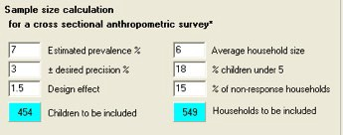

###### Step 2: Choosing the number of clusters to include in the survey

* If you are using cluster sampling, you now need to decide on the cluster size and the total number of clusters. To follow with the example, let’s say that the final survey design is a 3218, meaning that you will survey 32 clusters of 18 households.

###### Step 3: Deciding on the household sample size and sampling procedure for each module

* After calculating the sample size needed in number of households as illustrated above, you need to decide on the household sample size for measuring the indicators in the different modules. In addition, you need to plan how the households will be randomly selected and how the sub-sampling of households will be performed. Refer to the Sampling Decision Tree **(SENS Pre-module Step 8**) for guidance on how to perform second stage sampling.
* SENS Pre-Module **Tool 8** (Data Collection Control Sheet) should be adapted depending on the total number of households to be surveyed per day for each module. See **Annex 3** for the recommended data collection control sheet format.
* Fill out **Table 10** shown below with the information related to your survey (e.g. select which children anaemia scenario is followed for the assessment of anaemia in children; select the most appropriate sampling method). An example is provided for illustration purposes for a **32x18** cluster survey (32 clusters of 18 households). This table can be included in your survey protocol and/or final SENS survey report.

**TABLE 10** HH SAMPLE SIZE AND SAMPLING - CLUSTER SURVEY

|  |  |  |  |  |
| --- | --- | --- | --- | --- |
| **Module** | **Sample size** | | **Cluster size** | **Sampling** |
| **1: Demography** | 576 HHs | | 18 HH  per cluster | All selected households will be assessed for demography indicators as outlined in Module 1. |
| **2: Children Anthropometry and Health** | 576 HHs | | 18 HH  per cluster | All eligible children within all of the sampled HH will be assessed for anthropometry and health indicators as outlined in Module 2. |
| **2: Women Anthropometry and Health** | - | | - | Follow same procedure as women anaemia for women anthropometry and health indicators as outlined in Module 2. See below women anaemia procedure. |
| **3: Children Anaemia** | Children Anaemia Scenario 1 (see **Table 7** for sampling  recommendations): 454 children need to be assessed according to sample size calculation based on GAM (see **Table 9**). | 576  HH | 18 HH  per cluster | All eligible children from all selected HH will be assessed for anaemia indicators as outlined in Module 3. |
|  |
| **3: Women Anaemia** | Women Anaemia Scenario 1: *You need to measure the prevalence of anaemia in women*  *of reproductive age for surveillance purposes but you do not need to assess the impact of an intervention and are not planning to intervene in the immediate term* | 576/2=  288  HH | 18/2=9  HH per cluster | Half of the selected HH (sub-sample) should be randomly assessed for women anaemia and all eligible women found in these HH should be assessed for anaemia indicators as outlined in Module3. |
| Women Anaemia Scenario 2: *You are planning to implement / have*  *been implementing an intervention to reduce anaemia in women of reproductive age and you need to assess the baseline prevalence and impact of the intervention* | 576  HH | 18 HH  per cluster | Follow same procedure as outlined above for children anaemia. |
| **4: IYCF** | 576 HH | | 18 HH  per cluster | All eligible children within all of the sampled HH will be assessed for IYCF indicators as outlined in Module 4. |
| **5: Food Security** | 576/2=288 HH | | 18/2=9  HH per cluster | Half of the HH (sub-sample) should be randomly assessed for food security indicators as outlined in Module 5. |
| **6: Mosquito Net Coverage** | 576/2=288 HH | | 18/2=9  HH per cluster | Half of the HH (sub-sample) should be randomly assessed for mosquito net as outlined in Module 6. |
| **7: WASH** | 576/2=288 HH | | 18/2=9  HH per cluster | Half of the HH (sub-sample) should be randomly assessed for WASH indicators as outlined in Module 7. |

###### Step 4: Deciding on the best method to use to sub-sample the households to survey

* Within each cluster, when using a list, randomly select half of the household originally selected to be sampled.
* If a list is not being used for sampling then sample every other household.

##### SIMPLE OR SYSTEMATIC RANDOM SAMPLING

###### Step 1: Calculating the sample size

* The sample size by number of children needed is first calculated to assess the prevalence of acute malnutrition in children aged 6-59 months using the ENA for SMART software and the SMART recommendations. Include a non-response rate ranging between 5-15%, depending on the context.
* Fill out **Table 11** shown below with the information from the survey context. An example is provided for illustration purpose. This table can be included in your survey protocol and/or final SENS survey report.

**TABLE 11** SAMPLE SIZE CALCULATION

|  |  |  |
| --- | --- | --- |
| **Survey background** | | |
| Survey site(s) | *[Include name of refugee camp(s) or area(s) to be surveyed]* | |
| Survey design | Simple random sampling because a complete, current household list is available. | |
| Total population | *[Include numbers and source of information]* e.g. 171,000, UNHCR ProGres | |
| **Parameters for An- thropometry** | **Value** | **Assumptions based on context** |
| **Estimated Prevalence of GAM (%)** | 7.0% | *[Include justification for chosen figure]* e.g. The GAM prevalence (%) from the previous SENS survey was 7.2% (5.4-9.5 95% CI). It is assumed that the situation will be similar. |
| **± Desired Precision** | 3.0% | *[Include justification for chosen figure]* |
| **Children to be includ- ed** | **278** | This is the number given by the ENA for SMART software |
| **Average Household Size\*** | 6.0 | *[Include source of information with corresponding definition of household]* e.g. The number from the previous SENS survey is used with the following definition: ***a group of people who live together and routinely eat out of the same pot.*** |
| **% of Children Under Five years old** | 18.0% | *[Include source of information]* |
| **% Non-Response Households (usually between 5-15%)** | 15.0% | *[Include justification for chosen figure]* |
| **Households to be in- cluded** | **336** | This is the number given by the ENA for SMART software |

*Include definition of HH corresponding to the average HH size figure used.

ENA for SMART software should be filled out as shown in **Figure 4**

**FIGURE 4** ENA FOR SMART SOFTWARE SCREEN-SIMPLE OR SYSTEMATIC RANDOM SAMPLING

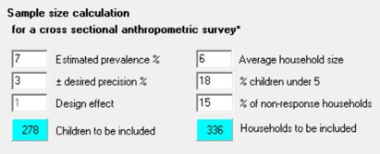

###### Step 2: Deciding on the sample size and sampling procedure for each module

* After calculating the sample size needed in number of households as illustrated above, you need to decide on the household sample size for measuring the indicators in the different modules.
* Fill out **Table 12** shown below with the information related to your survey (e.g. select which scenario is followed for the measurement of anaemia in children). An example is provided for illustration purpose. This table can be included in your survey protocol and/or final SENS survey report.

**TABLE 12** HH SAMPLE SIZE AND SAMPLING - SIMPLE AND SYSTEMATIC RANDOM SAMPLING

|  |  |  |  |
| --- | --- | --- | --- |
| **Module** | **Sample size** | | **Sampling** |
| **1: Demography** | 366 HH | | All selected households will be assessed for demography indicators as outlined in Module 1. |
| **2: Children Anthropometry and Health** | 366 HH | | All eligible children within all of the sampled HH will be assessed for anthropometry and health indicators as outlined in Module 2. |
| **2: Women Anthropometry and Health** | - | | Follow same procedure as women anaemia for women anthropometry and health indicators as outlined in Module 2. See below women anaemia procedure. |
| **3: Children Anaemia** | Children Anaemia Scenario 1 (see **Table 7** for sampling recommendations): 278 children need to be assessed according to sample size calculation based on GAM (see **Table 11**). | 366 HH | All eligible children from all selected HH will be assessed for anaemia indicators as outlined in Module 3. |
| **3: Women Anaemia** | Women Anaemia Scenario 1: *You need to measure the prevalence of anaemia in women of reproductive age for surveillance purposes but you do not need to assess the impact of an intervention and are not planning to intervene in the immediate term* | 366/2=  183 HH | Half of the selected HH (sub-sample) should be randomly assessed for women anaemia and all eligible women found in these HH should be assessed for anaemia indicators as outlined in Module3. |
| Women Anaemia Scenario 2:  *You are planning to implement / have been implementing an intervention to reduce anaemia in women of reproductive age and you need to assess the baseline prevalence and impact of the intervention* | 366 HH | Follow same procedure as outlined above for children anaemia. |
| **4: IYCF** | 366 HH | | All eligible children within all of the sampled HH will be assessed for IYCF indicators as outlined in Module 4. |
| **5: Food Security** | 366/2=183HH | | Half of the HH (sub-sample) should be randomly assessed for food security indicators as outlined in Module 5. |
| **6: Mosquito Net Coverage** | 366/2=183 HH | | Half of the HH (sub-sample) should be assessed for mosquito net as outlined in Module 6. |
| **7: WASH** | 366/2=183 HH | | Half of the HH (sub-sample) should be randomly assessed for WASH indicators as outlined in Module 7. |

###### Step 3: Deciding on the best method to use to sub-sample the households to survey

* When using a list, randomly select half of the households originally selected to be sampled.
* If a list is not being used for sampling then sample every other household.

## Annex 2 - Correction for small population size

When the population of children U5 is less than 10,000, it is necessary to use a correction factor in the sample size calculation that will *decrease* the survey sample size. The ENA for SMART software automatically applies this correction factor if the relevant information is entered onto the Planning screen.

###### Simple random sampling

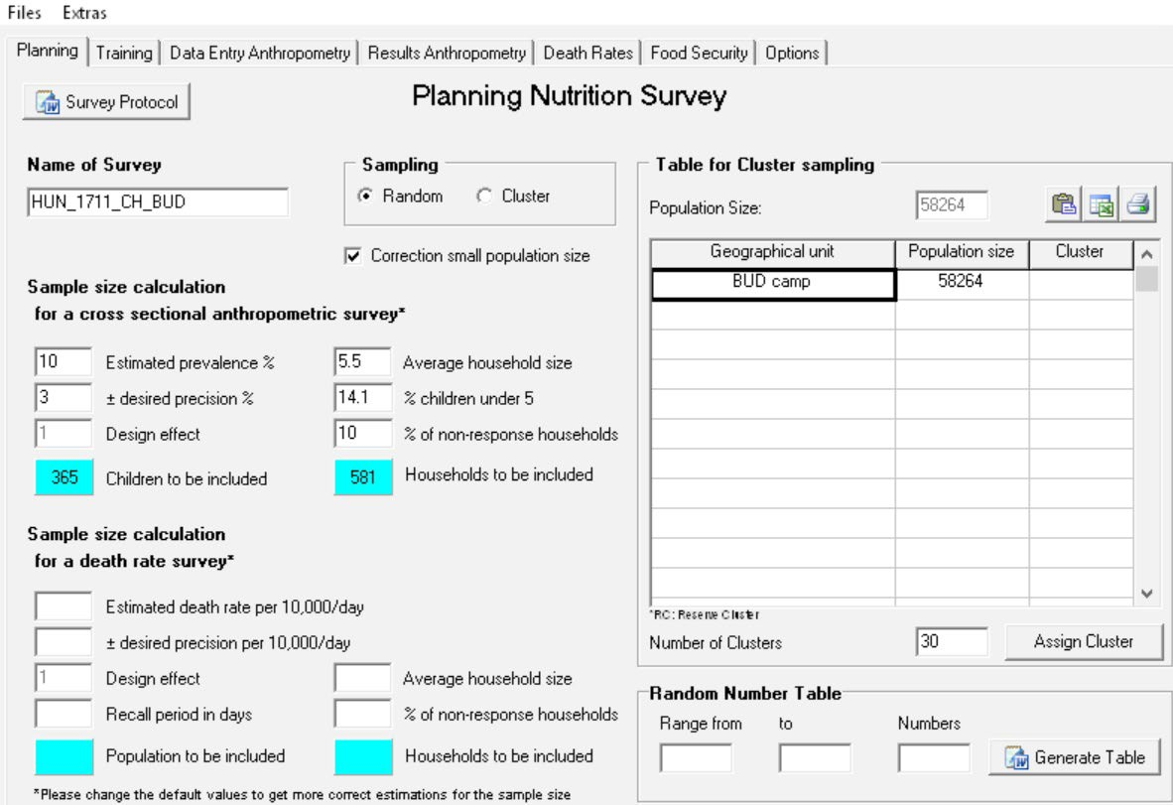

After entering the total population size of the camp / survey area on the first row of the table, the Population Size box automatically shows the same population as the one manually entered. By clicking on ‘Correction small population size’, the ENA for SMART software then automatically applies the correction factor to the sample size calculation by deriving the total number of U5 children. In this example, the total number of

U5 children is: 58,264 x 14.1%≈8,215 U5 which is <10,000. Hence it is necessary to apply the correction factor which will decrease the sample size needed.

Enter the total population of the camp / survey area on the first row of the ‘Table for Cluster sampling’. Use this table for simple random surveys even though it says that it is for cluster sampling.

Fill out the sample size calculator with the relevant information and click on ‘random’ when conducting a simple random survey.

###### Cluster sampling

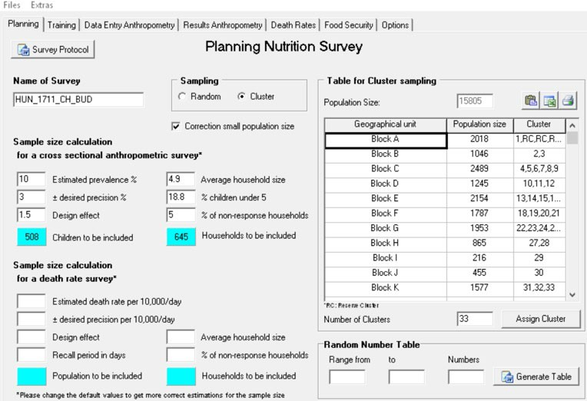

Choose the smallest geographic units in the camp

/ survey area with available population data. In this example, population size per Block was available and entered.

After entering the total population size per geographic unit in the table, the Population Size box automatically shows the total population of

the camp / survey area by adding the population per block that was entered. By clicking on ‘Correction small population size’, the ENA for SMART software then automatically applies the correction factor to the sample size calculation by deriving the total number of U5 children. In this example, the total number of U5 children is: 15,805 x 18.8%≈2,971 U5 which is <10,000. Hence it is necessary to apply the correction factor which will decrease the sample size needed.

Fill out the sample size calculator with the relevant information and click on ‘cluster’ when conducting a cluster survey.

Refer to the SMART Initiative Documentation for further guidance on how to correct for small population size.

## Annex 3 - Data collection control sheet

See SENS Pre-Module tools: [**Tool 8**- Data collection control sheet] 

###### USE 1 SHEET PER DAY PER TEAM/PER CLUSTER. Grey cells mean that those questions and/or measurements should be skipped in that specific HH; it is used to aid survey team members and survey manager in the daily management of data collection for each module.

|  |  |  |  |
| --- | --- | --- | --- |
| **Camp Name** | **Section Code / Number** | **Zone Code / Number** | **Block Code / Number** |
|  |  |  |  |

|  |  |  |  |  |  |  |  |  |
| --- | --- | --- | --- | --- | --- | --- | --- | --- |
| **Survey Date (DD/MM/YYYY)** | | | | | **Cluster Number (if applicable)** | | **Team Number** | |
| | | | |/| | | |/| | | || | | | | | | | | | | | | | |

|  |  |  |  |  |  |  |  |
| --- | --- | --- | --- | --- | --- | --- | --- |
| **HH #** | **Head of HH name** | **Household Questionnaire** | | | | **Household needs to be revisited**  Yes or No | **Household re-visited**  Yes or No |
| **Demography**  1=completed 2=absent* 3=refusal | **Food Security**  1=completed 2=absent* 3=refusal | **Mosquito Net**  1=completed 2=absent* 3=refusal | **WASH**  1=completed 2=absent* 3=refusal |
| 1 |  |  |  |  |  |  |  |
| 2 |  |  |  |  |  |  |  |
| 3 |  |  |  |  |  |  |  |
| 4 |  |  |  |  |  |  |  |
| 5 |  |  |  |  |  |  |  |
| 6 |  |  |  |  |  |  |  |
| 7 |  |  |  |  |  |  |  |
| 8 |  |  |  |  |  |  |  |
| 9 |  |  |  |  |  |  |  |
| 10 |  |  |  |  |  |  |  |

* If eligible child or woman of reproductive age, or the entire household is absent, team should re-revisit the household once before leaving the camp to conduct the interview and/or measure the child/mother.

|  |  |  |  |
| --- | --- | --- | --- |
| **Camp Name** | **Section Code / Number** | **Zone Code / Number** | **Block Code / Number** |
|  |  |  |  |

|  |  |  |  |  |  |  |  |  |
| --- | --- | --- | --- | --- | --- | --- | --- | --- |
| **Survey Date (DD/MM/YYYY)** | | | | | **Cluster Number (if applicable)** | | **Team Number** | |
| | | | |/| | | |/| | | || | | | | | | | | | | | | | |

|  |  |  |  |  |  |  |  |  |  |  |  |  |
| --- | --- | --- | --- | --- | --- | --- | --- | --- | --- | --- | --- | --- |
| **HH #** | **Head of HH name** | **Children Questionnaire\*** | | | | | | **Women Questionnaire\*** | | | **House- hold needs to be revisit- ed**  Yes or No | **House- hold re-vis- ited**  Yes or No |
| **# Chil- dren U5**  (0-59  months) | **# Chil- dren U2**  (0-23  months) | **# Eligible children 6-59**  **months** | **# Eligible children 6-59**  **months measured**  **/assessed for anae- mia** | **# Chil- dren with disabili- ties** | **# Chil- dren in medical/ nutrition center** | **# Eligible women 15-49**  **years** | **# Eligible women 15-49**  **years mea- sured\*\*** | **# Eligible women 15-49**  **years assessed for anae- mia\*\*** |
| 1 |  |  |  |  |  |  |  |  |  |  |  |  |
| 2 |  |  |  |  |  |  |  |  |  |  |  |  |
| 3 |  |  |  |  |  |  |  |  |  |  |  |  |
| 4 |  |  |  |  |  |  |  |  |  |  |  |  |
| 5 |  |  |  |  |  |  |  |  |  |  |  |  |
| 6 |  |  |  |  |  |  |  |  |  |  |  |  |
| 7 |  |  |  |  |  |  |  |  |  |  |  |  |
| 8 |  |  |  |  |  |  |  |  |  |  |  |  |
| 9 |  |  |  |  |  |  |  |  |  |  |  |  |
| 10 |  |  |  |  |  |  |  |  |  |  |  |  |

* If eligible child or woman of reproductive age is absent, team should re-revisit the household once before leaving the camp to conduct the interview and/or measure the child/mother.

** Depending on the scenario chosen for anaemia in women, half of the sampled households (sub-sample), or all of the sampled households should be randomly selected for anaemia and anthropometry (MUAC) in women. All eligible women found in these households should be assessed for anaemia and MUAC measurement (See **SENS Pre-Module Step 8** for more details).

## Annex 4 - Guidance on key Epi Info commands

Free guidance on the use of Epi Info and training material on Epi Info can be found at the following site: <https://www.cdc.gov/epiinfo/index.html>

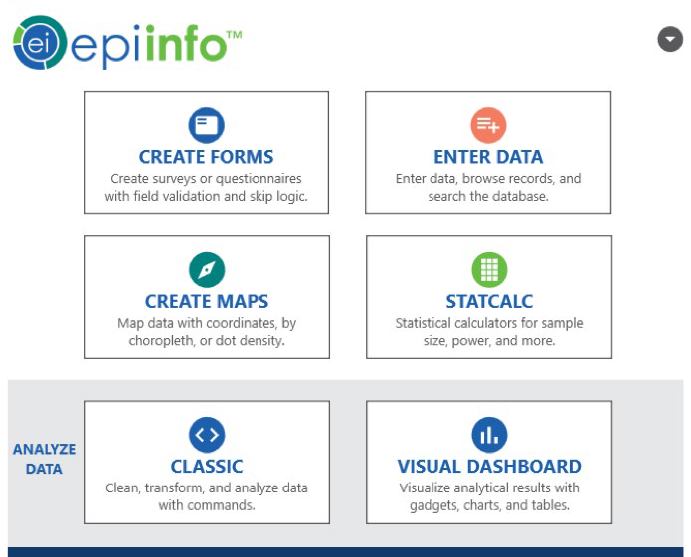

The Analyse Data module in Epi Info is used to analyse the survey data from each SENS module included in the survey. Note that there is standard analysis guidance ready to use for each SENS module. See details in each module.

The following analysis commands are needed to analyse a SENS Survey:

1. Read (Import)
2. Write (Export)
3. Define
4. Assign
5. Recode
6. Select
7. Cancel Select
8. If
9. Frequencies (with simple random sampling surveys)
10. Means (with simple random sampling surveys)
11. Complex Sample Frequencies (with cluster surveys)
12. Complex Sample Means (with cluster surveys)

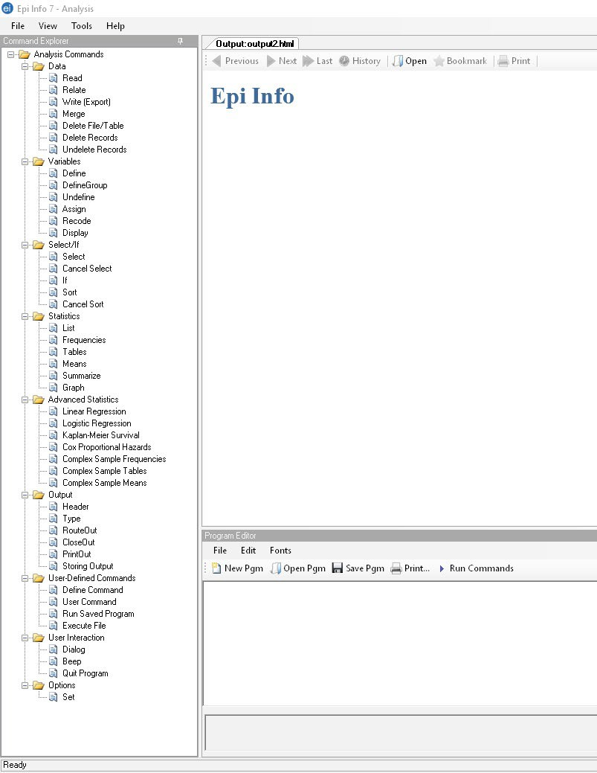

This section of the Analysis module shows the programme codes or PGM syntax to perform each analysis. Note that there are standard Epi Info codes / syntax included in each SENS module. See details in each module.

This section of the Analysis module shows the outputs (results) of the analysis performed. You may cut and paste the outputs in a Word document for future reference as you perform the analysis.

###### Setting the Options for analysis cluster surveys



Click on Set in the Options command.

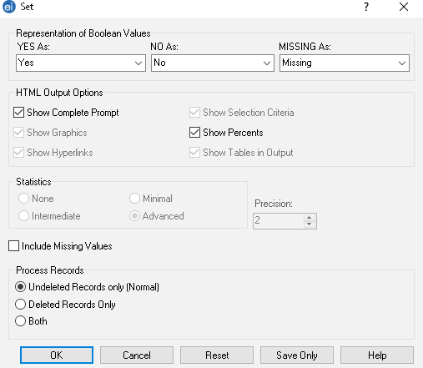

Check that <Advanced> is selected: this will ensure that confidence intervals are shown when using the Complex Sample Frequencies command.

Click Ok.

##### ANALYSING FREQUENCIES AND MEANS FOR DIFFERENT SURVEY DESIGNS

In Epi-Info, frequencies and means are analysed differently for simple / systematic random surveys as compared to cluster surveys. The *Statistic module* of Epi Info Analysis commands is used for simple and systematic random surveys while the *Advanced Statistics module* is used for cluster surveys. The PGM codes and the Epi Info analysis / results outputs will differ. The frequencies and means results will be the exact same no matter what survey design is used, however the confidence intervals will differ.

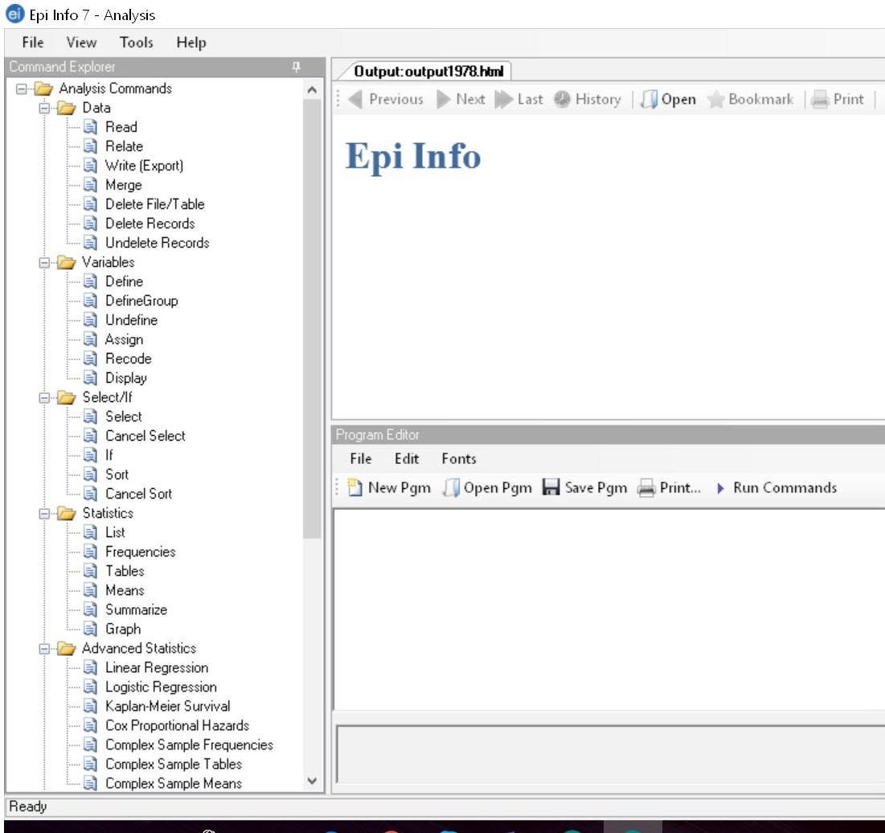

**Advanced statistics module:** to be used to calculate frequencies and means with cluster surveys.

**Statistics module:** to be used to calculate frequencies and means with simple / systematic random surveys.

Examples of PGM codes and Epi info outputs / results when using **simple / systematic random sampling** and the Statistics module.

Main results (proportions) are shown here.

FREQ VITA

|  |  |  |  |  |
| --- | --- | --- | --- | --- |
| **VITA** | **Frequency** | **Percent** | **Cum. Percent** |  |
| 1 | 339 | 41.65% | 41.65% |  |
| 2 | 341 | 41.89% | 83.54% |  |
| 3 | 134 | 16.46% | 100.00% |  |
| Total | 814 | 100.00% | 100.00% |  |
|  |  | | | |

###### Wilson 95% Conf Limits

|  |  |  |  |
| --- | --- | --- | --- |
| 1 | 38.31% | 45.06% |  |
| 2 | 38.55% | 45.31% | Confidence intervals are shown here. |
| 3 | 14.07% | 19.17% |  |

MEANS CHHB

|  |  |  |  |  |  |  |  |
| --- | --- | --- | --- | --- | --- | --- | --- |
| Obs | Total | | Mean | | Variance | | Std Dev |
| 502.0000 | 5635.0000 | | 11.2251 | | 1.7512 | | 1.3233 |
| Minimum | 25% | Median | | 75% | | Maximum | Mode |
| 7.4000 | 10.4000 | 11.3000 | | 12.1000 | | 15.4000 | 11.3000 |

Examples of PGM codes and Epi info outputs / results when using **cluster sampling** and the Advanced Statistics module.

FREQ VITA PSUVAR=CLUSTER

|  |  |
| --- | --- |
| **VITA** | **TOTAL** |
| **1** | 339 |
| Row % | 100.000  Confidence intervals are shown here for each category of results (LCL stands for Lower Confidence Limit and UCL stands for Upper Confidence Limit). Please note that they are wider than shown above when analysing a simple or systematic random survey.  Main results (proportions) are shown here (Col %). Please note that they are the same as shown above when analysing a simple or systematic random survey. |
| Col % | 41.646 |
| SE % | 6.201 |
| LCL % | 29.043 |
| UCL % | 54.249 |
| **2** | 341 |
| Row % | 100.000 |
| Col % | 41.892 |
| SE % | 5.518 |
| LCL % | 30.678 |
| UCL % | 53.106 |
| **3** | 134 |
| Row % | 100.000 |
| Col % | 16.462 |
| SE % | 5.148 |
| LCL % | 5.999 |
| UCL % | 26.925 |
| **TOTAL** | 814 |
| Design Effect | 12.866 |

MEANS CHHB PSUVAR=CLUSTER

|  |  |  |  |  |  |  |  |
| --- | --- | --- | --- | --- | --- | --- | --- |
|  | **CHHB** | | | | | | |
|  | **Count** | **Mean** | **Std Error** | **Confidence Limits** | | **Minimum** | **Maximum** |
| **Lower** | **Upper** |
| **TOTAL** | 502 | 11.225 | 0.062 | 11.098 | 11.352 | 7.400 | 15.400 |

## Annex 5 - Assessing trends and changes

When interpreting trends and changes, the following two questions need to be asked:

**Question 1**: Is the situation stable or persistent, or has the situation improved or deteriorated in comparison to surveys conducted using *similar* methods on the *same* target population?

**FIGURE 5** PREVALENCE TREND CLASSIFICATIONS

**Stable**

*Public Health Threshold*

**Persistent**

*Public Health Threshold*

#### Time (years)

**Improving**

**Deteriorating**

Global Acute Malnutrition Prevalence (%)

**Question 2**: Is the observed change a “significant” change? A significant change is shown by the 95 % CI.

In the following figures, the point prevalence of a survey result is shown and the bars show the upper and lower limit of the CI. When the CIs overlap, this would suggest that there is no statistically “significant” change. However, in some cases, the CIs may overlap slightly and there may still be a statistically significant difference between the two surveys. In these cases, a statistical test needs to be conducted.

Things to watch out for:

* In refugee camp settings, there can be large population movements in and out of the camps. These should not be ignored when interpreting change (or absence of change) in indicators over time.
* When the surveyed population is not stable and varies in number and / or composition over time, a lack of change in a specific indicator (e.g. GAM, stunting) is not necessarily due to a lack of effect of the interventions implemented in a refugee camp.
* Contact UNHCR HQ / Regional offices for support on how to interpret trends.

Examples

Was there a significant improvement in the nutritional situation between November 2010 and November 2011 (Figure 6)?

**FIGURE 6** TREND IN PREVALENCE OF ACUTE MALNUTRITION IN CHILDREN 6-59 MONTHS FROM 2009-2011

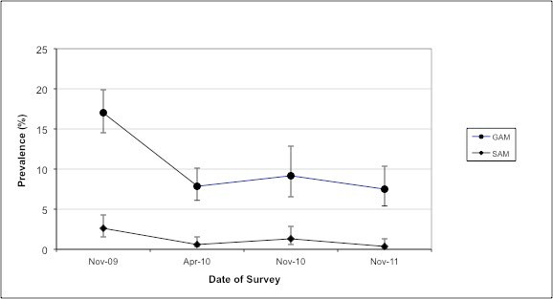

**Answer:** No, the CIs overlap. We can see the situation is similar and has been stable since April 2010 in terms of acute malnutrition.

Is the nutritional situation significantly worse in August 2011 in comparison with August 2010 (Figure 7)?

**FIGURE 7** TREND IN PREVALENCE OF ACUTE MALNUTRITION IN CHILDREN 6-59 MONTHS FROM 2009-2011

**Date of Survey**

Aug-11

Aug-10

Aug-09

25

20

15

10

5

0

**Trend in Prevalence of Acute Malnutrition in Children 6-59m**

GAM (WHO

Standards 2006)

SAM (WHO

Standards 2006)

**Answer:** Yes, the CIs do not overlap. We can see that the situation has deteriorated in terms of acute malnutrition.

**Prevalence (%)**

Was there a significant improvement in the nutritional situation between August 2010 and August 2011 (Figure 8)?

**FIGURE 8** TREND IN PREVALENCE OF ACUTE MALNUTRITION IN CHILDREN 6-59 MONTHS BETWEEN 2009 AND 2011.

**Date of Survey**

Aug-11

Aug-10

Aug-09

18

16

14

12

10

8

6

4

2

0

**Trend in Prevalence of Acute Malnutrition in Children 6-59m**

GAM (WHO

Standards 2006)

SAM (WHO

Standards 2006)

**Answer:** The CI overlap, however it is possible that the change is statistically significant between August 2010 and August 2011. A statistical test needs to be done to see if the change in GAM prevalence is statistically significant (see **Annex 6** for an example on how to use the CDC Calculator). We can see that there has been a decreasing trend in the past three years in the prevalence of acute malnutrition in the surveyed population.

**Prevalence (%)**

Has there been a significant improvement in anaemia prevalence from August 2010 to August 2011 (Figure 9)?

**FIGURE 9** ANAEMIA CATEGORIES IN CHILDREN 6-59 MONTHS FROM 2009-2011

Aug-09 Aug-10 Aug-11

**Date of Survey**

20.2

23.0

21.0

14.6

18.1

18.9

50

45

40

35

30

25

20

15

10

5

0

**Trend in Anaemia Categories in Children 6-59 months Camp/Setting name, Country**

Severe anaemia

Moderate anaemia Mild anaemia

**Prevalence (%)**

**Answer:** The CIs are not shown on the figure and hence we cannot conclude by looking at the Figure alone. A statistical test needs to be done to see if the change in anaemia prevalence is statistically significant (see **Annex 6** for an example on how to use the CDC Calculator).

## Annex 6 - Statistical comparisons between two surveys

|  |  |  |
| --- | --- | --- |
|  | **Survey 1 (33x14)** | **Survey 2 (35x14)** |
| **Anaemia – Children 6-59 months** | **October 2008**  n = 502 | **October 2009**  n =568 |
| **Total Anaemia (Hb<11.0 g/dL)** | 43.6%  (39.3-48.1 95% CI ) | 35.9%  (32.0-40.0 95% CI) |

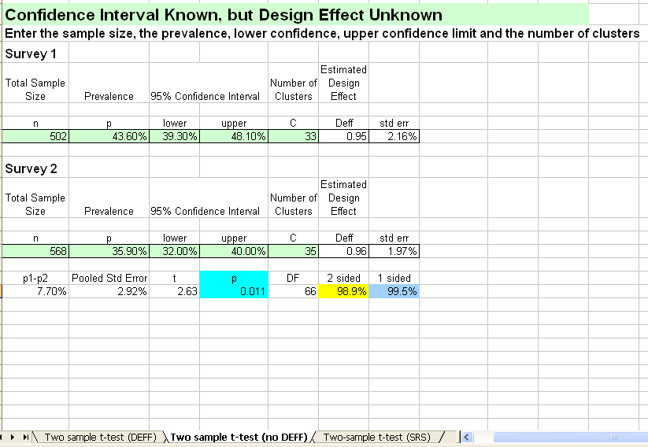

Use this sheet when you are comparing two surveys which used **cluster sampling** and when you

do **not** know the **design effect for anaemia or the indicator being measured**, like in this example.

Use this sheet when you are comparing two surveys which used **cluster sampling** and when you know the **design effect for anaemia, or the indicator being measured**.

Use this sheet when you are comparing two surveys which used **simple random sampling** or

**systematic random sampling** (SRS). There is therefore no design effect.

- If the p-value is >0.05, there is no statistically significant difference between the two surveys. In the survey report, simply report the

p-value as follows: ‘p>0.05’.

- If the p-value is <0.05 (as shown in this example), there is a statistically significant difference between the two surveys. In the survey report, simply report the p-value as follows: ‘p<0.05’.

Fill out the details (green cells) from the two surveys you wish to compare.

UNHCR STANDARDISED EXPANDED NUTRITION SURVEY (SENS) GUIDELINES FOR REFUGEE POPULATIONS

III





UNHCR STANDARDISED EXPANDED NUTRITION SURVEY (SENS) GUIDELINES FOR REFUGEE POPULATIONS

IV



UNHCR

STANDARDISED EXPANDED

NUTRITION SURVEY (SENS) GUIDELINES FOR REFUGEE POPULATIONS

### PRE-MODULE: SURVEY STEPS AND SAMPLING