Tutorial - Using the Offline server ODK Aggregate with Raspberry Server
Tutorial version: 6.0
System used: ODK Aggregate version 2.0.3; ODK Collect version 1.23.3

Overview
To setup your pre-configured RaspberryPi and connect it to a mobile device you will need to follow the steps below:
- Connect the RaspberryPi and mini router
- Configure your phones to connect them to the offline server

The set-up is straightforward and requires no previous knowledge of any of the hardware. This document also contains a section on how to troubleshoot at the end. Downloading data from the server is covered in another tutorial called Tool 2 - Exporting Data for Analysis.

Connect the RaspberryPi and mini router
The below configuration will be used to link the four devices (RaspberryPi, Router, Mobile Device and Laptop). As the RaspberryPi has already been configured, no additional hardware or software is required.

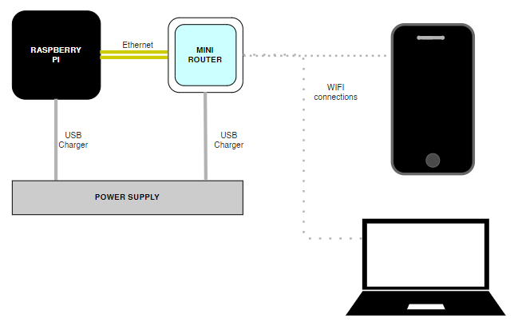

- Connect the RaspberryPi to a power supply using the one of the mini USB charging plugs and do the same with the router. Each should display a light to confirm that it has power (in the case of the RaspberryPi it may be necessary to remove the lid to see the light).  - Connect the RaspberryPi to the mini router using a short Ethernet cable.  - You can check your setup against the image to the right. | 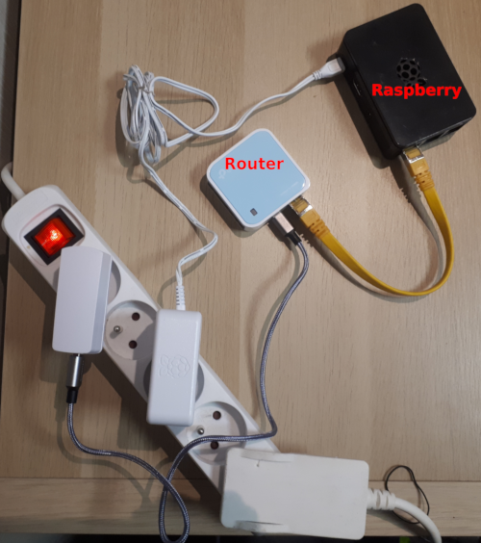
- Note: If you are in an environment with irregular power supply, you can also use an USB power bar to power the devices.

Connect your laptop to the router
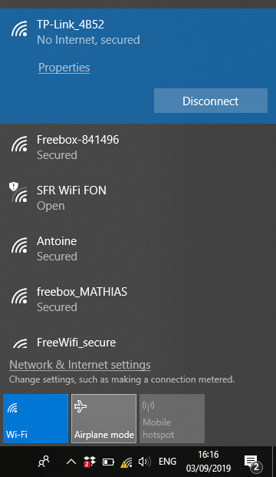
This step needs to be done to access ODK Aggregate. This is only necessary for users who will manage user access, export data or control the publication of new forms. More information on using ODK Aggregate can be found here: https://docs.opendatakit.org/aggregate-use/
To connect your laptop please follow the steps below:
- Connect your laptop to the mini router by clicking the wifi symbol usually at the bottom right-hand corner of the screen (second image below). The precise name of the TPlink router and its password will be supplied with the equipment.

- Access the ODK Aggregate interface by opening your browser and typing the following IP address http://192.168.0.100
  - if the IP address above does not work, try http://192.168.0.101 instead.

- Your screen should now appear like the first image below. If the IP address cannot be found, please ensure that you are still connected to the router and that the laptop has not automatically reverted to another connection with internet access.

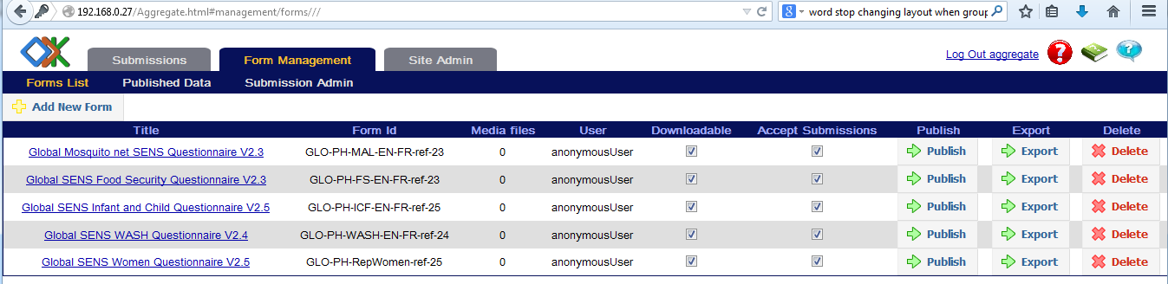
- Please note that unlike tools such as KOBO, forms can be uploaded to ODK aggregate in xml format only. (Further details can be found at https://docs.opendatakit.org/aggregate-use/)

Connect your mobile device to the router
The mobile device is connected in order to download ODK forms and upload data. If you do not already have ODK Collect installed on the mobile device, please first read Tool15 - Tutorial - How to Setup a Phone for a SENS Survey.

Connect the phone to the Wi-Fi network
The phones must be in Wi-Fi mode: click on the Wi-Fi icon on the status switch widget, so that the icon is blue (1.). If the widget is not visible on your phone home screen, open the Settings menu (2.), click “Connections” or “WIFI” depending on the device (3.), then press the button on the Wi-Fi line to turn it blue for “ON” (4.).
If the Wi-Fi network has never been set up on your phone, you will need to enter the log in details:
To do so, open the Settings menu and press the Wi-Fi line (not on the ON/OFF button) (5.).
Press then on the name of the network you want to connect to (6.) The name of the TP-Link router will be supplied with the equipment as well as the password. Enter the password in the pop-up that appears (7.), and click on “Connect”:
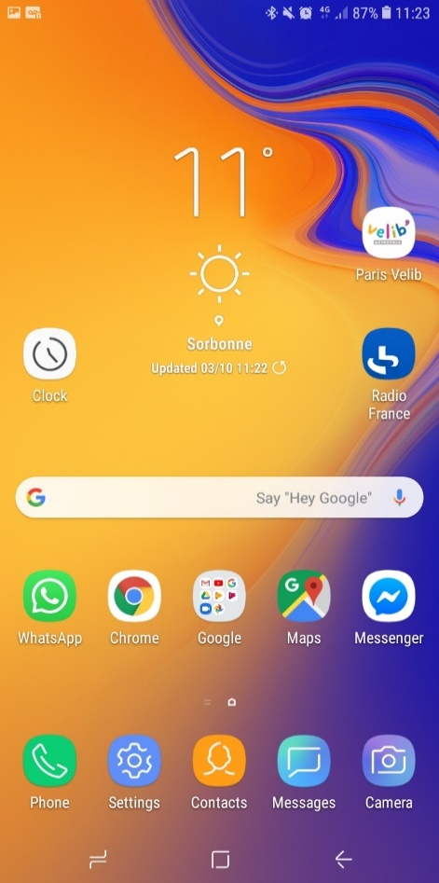
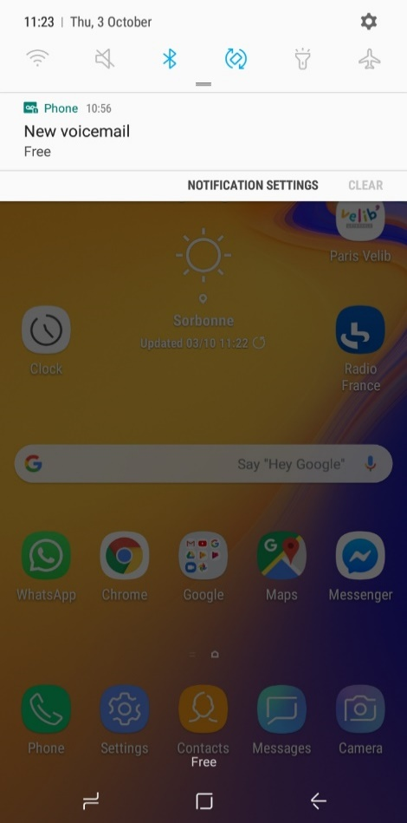
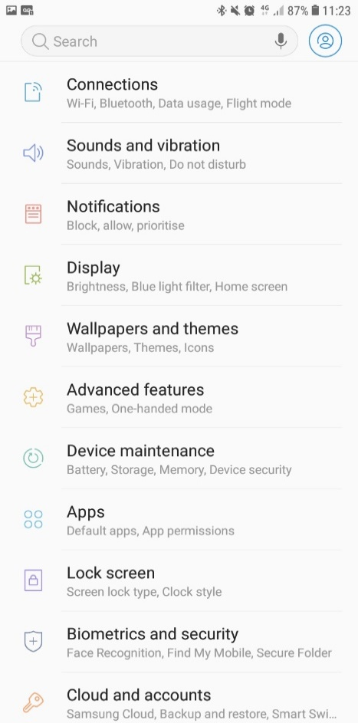
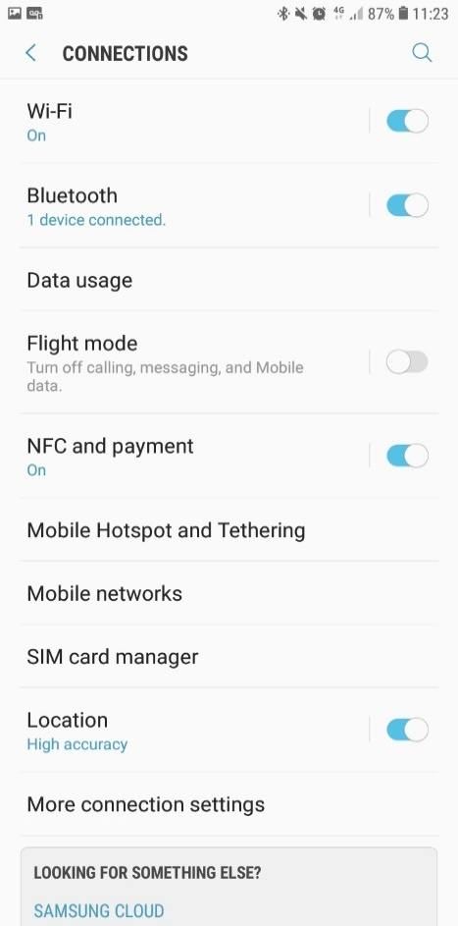
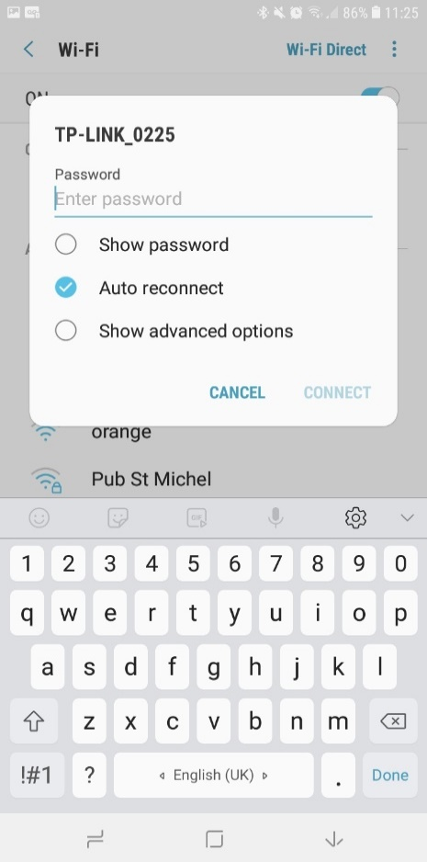
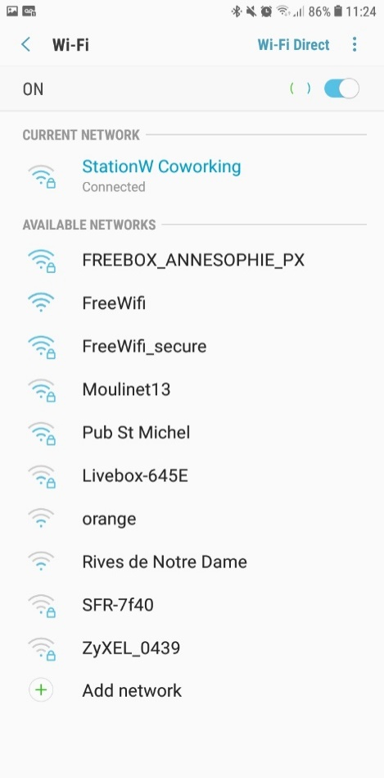
5.

7.

6.

4.

3.

2.

1.

Configure ODK Collect
Open ODK Collect. Press the menu key of the phone: on the Sony Aqua, it is the top right button on with the three dots (1.). Three options will appear, “About”, “Admin Settings” and “General Settings”. Press on “General Settings” (2.).

Select “Server” and “URL. Then enter the IP address of the server, it will be http://192.168.0.100. (if the IP address above does not work, try http://192.168.0.101 instead)
Username and password will also be supplied with the equipment.
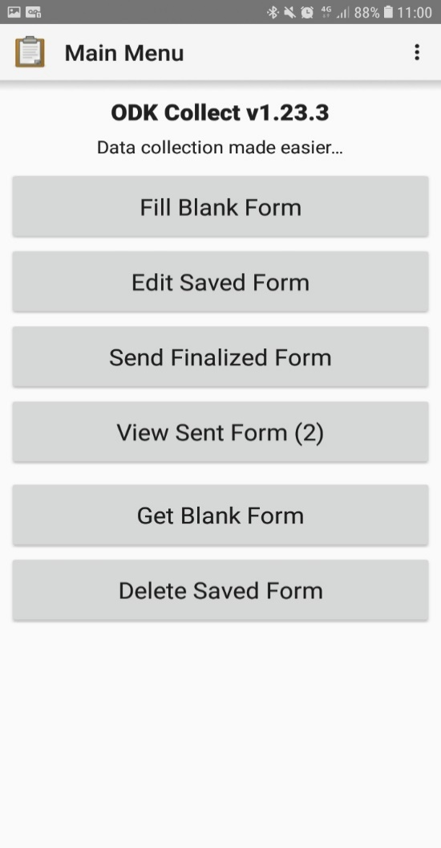
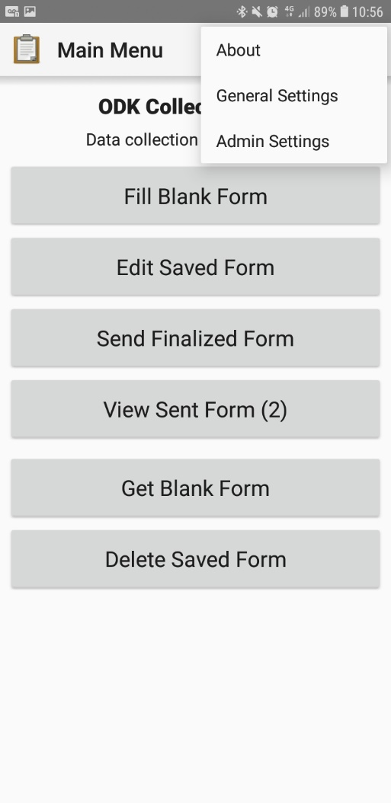
1.

2.

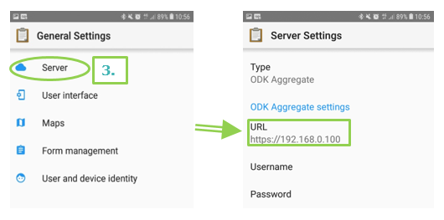

Using ODK Collect
For more detailed information on installing and using ODK Collect on your device please check the following document Tool6 - Training Enumerators (Slide 20).

Troubleshooting
If the IP address http://192.168.0.100 does not work on your browser on your computer in order to connect to ODK Aggregate, try with http://192.168.0.101 instead. The same applies for ODK Collect on your mobile devices.
If your mobile device still does not connect successfully when downloading forms please check the following:
- “http://” precedes the IP address in the ODK collect settings and there should be no text following it. Do not use “https://”.
- Make sure that the telephone is still connected to the router and has not automatically reverted to another network or entered airplane mode.
- Test the connection within close proximity to the router in case the issue is a weak signal due to a large distance between the mobile device and router.

