Model nutrition assessment report

(adapted from the Save the Children Fund emergency nutrition assessment handbook and the SMART methodology for UNHCR SENS Nutrition Surveys)

For a full SENS model report, see**:**

**SENS Pre-module Tool 20a- Jordan Full SENS Report**

# SENS REPORT

(region, camp names, country etc.)

Survey conducted: (month, year)

Report finalised: (month, year)



**UNHCR**

**IN COLLABORATION WITH**

(name and logo of agencies involved)

**See UNHCR SENS Pre-Module (Survey Steps and Sampling) and the individual survey Modules (Modules 1-7) for guidance on reporting. This report is a modified version of the standard report generated by ENA for SMART software (version July 9th 2015).**

Executive summary (4-6 pages only; include summary table as shown below)

· Geographic area surveyed, population type, population number (total and U5)

· Dates of survey

· Objectives

· Methodology used (sampling, sample size, main indicators)

· Summary of results as shown in the table below, as well as other important results

· Brief interpretation of the results

· Recommendations (immediate, medium term, long term)

Table 1 Summary of results

| **Surveyed Area** | **Camp 1** | **Camp 2** | **Camp 3** |  |
| --- | --- | --- | --- | --- |
| **Data collection period** | **Date** | **Date** | **Date** | **Classification of public health significance or target (where applicable)** |
| **CHILDREN 6-59 months % [95% CI]** |  |  |  |  |
| **Acute Malnutrition (WHO 2006 Growth Standards)** |  |  |  |  |
| Global Acute Malnutrition (GAM) |  |  |  | Very high/critical if ≥ 15% (WHO-UNICEF)  UNHCR Target of < 10% |
| Moderate Acute Malnutrition (MAM) |  |  |  |  |
| Severe Acute Malnutrition (SAM) |  |  |  | UNHCR Target of < 2% |
| Oedema |  |  |  |  |
| **Mid Upper Arm Circumference (MUAC)** |  |  |  |  |
| MUAC <125 mm and/or oedema |  |  |  |  |
| MUAC 115-124 mm |  |  |  |  |
| MUAC <115 mm and/or oedema |  |  |  |  |
| **Stunting (WHO 2006 Growth Standards)** |  |  |  |  |
| Total Stunting |  |  |  | Very high/critical if ≥ 30% (WHO-UNICEF) |
| Severe Stunting |  |  |  |  |
| **Programme coverage** |  |  |  |  |
| Measles vaccination with card or recall (9-59 months) |  |  |  | Target of ≥ 95% |
| Vitamin A supplementation within past the 6 months with card or recall |  |  |  | Target of ≥ 90% |
| **Diarrhoea** |  |  |  |  |
| Diarrhoea in the last 2 weeks |  |  |  |  |
| **Anaemia** |  |  |  |  |
| Total Anaemia (Hb < 11 g/dl) |  |  |  | High if ≥ 40%  Target of < 20% |
| Mild (Hb 10-10.9) |  |  |  |  |
| Moderate (Hb 7-9.9) |  |  |  |  |
| Severe (Hb < 7) |  |  |  |  |
| **CHILDREN 0-23 months % [95% CI]** |  |  |  |  |
| **IYCF indicators** |  |  |  |  |
| Timely initiation of breastfeeding |  |  |  | UNHCR Target of ≥ 85% |
| Exclusive breastfeeding under 6 months |  |  |  | UNHCR Target of ≥ 75% |
| Consumption of iron-rich or iron-fortified foods |  |  |  | UNHCR Target of ≥ 60% |
| Bottle feeding |  |  |  | UNHCR Target of < 5% |
| **WOMEN 15-49 years % [95% CI]** |  |  |  |  |
| **Anaemia (non-pregnant)** |  |  |  |  |
| Total Anaemia (Hb <12 g/dl) |  |  |  | High if ≥ 40% (WHO)  UNHCR Target of < 20% |
| Mild (Hb 11-11.9) |  |  |  |  |
| Moderate (Hb 8-10.9) |  |  |  |  |
| Severe (Hb <8) |  |  |  |  |
| **DEMOGRAPHY % [95% CI]** |  |  |  |  |
| **Household size and Composition** |  |  |  |  |
| Average household size (mean, SD / range) |  |  |  |  |
| Percent of children U2 |  |  |  |  |
| Percent of children U5 |  |  |  |  |
| Percent of pregnant women |  |  |  |  |
| **Household Head Profile** |  |  |  |  |
| Female headed households |  |  |  |  |
| Male headed households |  |  |  |  |
| Children headed households |  |  |  |  |
| **Age dependency ratio** |  |  |  |  |
| Average age dependency ratio (mean, SD / range) |  |  |  |  |
| **FOOD SECURITY % [95% CI]** |  |  |  |  |
| Proportion of households receiving a food assistance (in-kind and/or cash grants and/or food vouchers) |  |  |  |  |
| **In-kind food distribution** |  |  |  |  |
| Average number of days general food ration lasts out of [insert cycle] days (mean, SD or range) |  |  |  |  |
| **Cash grants & Food voucher** |  |  |  |  |
| Proportion of households receiving cash grants |  |  |  |  |
| Proportion of households receiving food vouchers to cover basic food needs |  |  |  |  |
| **Cooking fuel** |  |  |  |  |
| Proportion of households receiving cooking fuel assistance |  |  |  |  |
| Average number of days cooking fuel lasts (mean, SD or range) |  |  |  |  |
| **Negative household coping strategies** |  |  |  |  |
| Proportion of households reporting using one or more negative coping strategies over the past 4 weeks |  |  |  |  |
| Proportion of households reporting using the following coping strategies over the past 7 days: |  |  | | |
| Rely on less preferred and/or less expensive foods |  |  |  |  |
| Borrow food, or rely on help from a friend or relative |  |  |  |  |
| Reduce the number of meals eaten in a day |  |  |  |  |
| Limit portion sizes at mealtime |  |  |  |  |
| Reduce consumption by adults so children could eat |  |  |  |  |
| Average rCSI (mean, SD / range) |  |  |  |  |
| **Food Consumption Score (FCS)** |  |  |  |  |
| Average FCS (mean, SD / range) |  |  |  |  |
| FCS profiles: |  |  | | |
| Acceptable |  |  |  |  |
| Borderline |  |  |  |  |
| Poor |  |  |  |  |
| **MOSQUITO NET COVERAGE % [95% CI]** |  |  |  |  |
| **Mosquito net ownership** |  |  |  |  |
| Proportion of households owning at least one LLIN |  |  |  | Target of > 80% |
| Average number of persons per LLIN (mean) |  |  |  | 2 persons per LLIN |
| **Mosquito net utilisation** |  |  |  |  |
| Proportion of household members (all ages) who slept under an LLIN |  |  |  |  |
| Proportion of children 0-59 months who slept under an LLIN |  |  |  |  |
| Proportion of pregnant women who slept under an LLIN |  |  |  |  |
| **Indoor residual spraying** |  |  |  |  |
| Proportion of households covered by IRS |  |  |  |  |
| **WASH % [95% CI]** |  |  |  |  |
| **Water quality** |  |  |  |  |
| Proportion of households collecting drinking water from protected/treated sources |  |  |  | Emergency: ≥ 70%  Post-emergency: ≥ 95% |
| **Water quantity** |  |  |  |  |
| Proportion of households that use domestic water collected from protected/treated sources (with protected containers only): ≥ 20 lpppd |  |  |  |  |
| Proportion of households that use domestic water collected from protected/treated sources (with protected containers only): 15 - <20 lpppd |  |  |  |  |
| Proportion of households that use domestic water collected from protected/treated sources (with protected containers only): <15 lpppd |  |  |  |  |
| **Toilet/Latrine use** |  |  |  |  |
| Proportion of households reporting defecating in a toilet |  |  |  | Emergency: ≥ 60%  Post-emergency: ≥ 85% |
| **Access to soap** |  |  |  |  |
| Proportion of households with access to soap |  |  |  | Emergency: ≥ 70%  Post-emergency: ≥ 90% |

**1. Introduction**

**Geographic description of survey area**

Name of country, province, district, sub-district, etc.

Name of camp(s) or settlement(s)

Type of setting (e.g., rural, urban, camp, etc.)

Year of establishment of camp(s) or settlements(s) if applicable

If available/applicable, the surface area

If applicable, brief description of terrain (e.g., mountains, desert, etc.)

If applicable, brief description of the climate and the season when the survey was conducted.

**Description of the population**

Total number of people living in survey area (total population and U5)

If applicable, type of population (resident, IDPs, refugees, mixed, etc.)

If applicable, length of time the population has resided in the camp(s) or settlements(s)

If applicable, ethnic and/or religious groups

Major livelihoods in the area (e.g., agriculture, pastoralist, traders, etc.).

**Food security situation**

Relief programmes in area

Type of food assistance, description of food basket and number of people on food assistance, etc.

Quality of roads, access to markets, etc.

**Health situation**

Availability of health services

Describe deworming activities for young children e.g. target group, when was the last campaign

Show the following graphs using UNHCR HIS data from the year preceding the survey (i.e. total and U5 mortality rate, top 5 causes of morbidity in U5).

For a tool that will automatically generate these recommended graphs, see:

**SENS Pre-Module Tool 17 (a & b) -Trends and Graphs.**

**FIGURE 1** CRUDE AND UNDER-5 MORTALITY RATES



Figure 2 Top five causes of morbidity in children under-5



**Nutrition situation**

Nutrition services and activities

Admission to therapeutic feeding programmes and targeted supplementary feeding programmes over past 12 months (show following figure)

For a tool that will automatically generate this recommended graph, see:

**SENS Pre-Module Tool 17 (a & b) -Trends and Graphs.**

Nutritional and anaemia status of population

Results from rapid assessments or other types of nutrition assessments

**FIGURE 3** NUMBER OF ADMISSIONS TO TREATMENT PROGRAMMES FOR MAM AND SAM IN CHILDREN 6-59 MONTHS



1. **Survey Objectives**

**Primary objectives:**

1. To determine the demographic profile of the population;
2. To determine the age dependency ratio;
3. To measure the prevalence of acute malnutrition in children aged 6-59 months;
4. To measure the prevalence of stunting in children aged 6-59 months;
5. To determine the coverage of measles vaccination among children aged 9-59 months (or context-specific target group e.g. 9-23 months);
6. To determine the coverage of vitamin A supplementation received during the last 6 months among children aged 6-59 months;
7. To determine the two-week period prevalence of diarrhoea among children aged 6-59 months;
8. To measure the prevalence of anaemia in children aged 6-59 months and in women of reproductive age between 15-49 years (non-pregnant);
9. To investigate IYCF practices among children aged 0-23 months;
10. To determine the populations overall ability to meet their food needs with assistance: i) to determine the coverage of in-kind food assistance and the duration the general in-kind food distribution for recipient households; ii) to determine the coverage of cash grants and how the recipient households spent the cash; iii) to determine the coverage of the food vouchers and how recipient households use the vouchers;
11. To determine the extent to which negative coping strategies are used by households;
12. To assess household food consumption (quantity and quality);
13. To determine the population’s access to, and use of, improved water, sanitation and hygiene facilities*;*
14. To determine the population’s access to soap;
15. To determine the ownership of mosquito nets (all types and LLINs) in households;
16. To determine the utilisation of mosquito nets (all types and LLINs) by the total population, children 0-59 months and pregnant women;

*Include other additional objectives negotiated for the survey*

1. To establish recommendations on actions to be taken to address the situation in *[insert refugee setting]*;

**Secondary objectives:**

1. To determine the enrolment into the targeted supplementary (TSFP) and therapeutic (OTP/SC) nutrition programmes for children 6-59 months;
2. To determine the coverage of the blanket supplementary feeding programme (BSFP) for children aged 6-23/6-36/6-59 months;
3. To determine the coverage of deworming (soil-transmitted helminth control) with mebendazole and/or albendazole in the last six months among young children (include context specific target age group);
4. To determine the coverage of the blanket supplementary feeding programme (BSFP) for pregnant women and lactating women with an infant less than 6 months aged 15-49 years;
5. To determine enrolment into Antenatal Care clinic and coverage of iron-folic acid supplementation in pregnant women;
6. To determine the proportion of households in each of the targeting categories;
7. To determine the population’s access to and use of cooking fuel;
8. To determine the household coverage of indoor residual spraying in the past 6 months/12 months.

**Optional objectives:**

1. To determine the use of oral rehydration salt (ORS) and/or zinc during diarrhoea episodes in children ages 6-59 months;
2. To determine the prevalence of MUAC malnutrition in women of reproductive age 15-49 years (include if all, pregnant and/or lactating women are measured);
3. To determine the time of arrival of the children in the camp/asylum country;
4. **Methodology**

**3.1 Sample size**

For an example on how to report sample size, see:

**SENS Pre-Module Annex 1-Sample size calculation and sampling example.**

What sampling methodology (e.g., systematic random sampling, cluster sampling, etc.) did you chose? Why?

How did you calculate the sample size for anthropometry? (show the sample size calculation, including assumptions for expected prevalence, expected DEFF [if cluster sampling], required precision); if number of children was converted into the number of households, describe how this was done; which software and version was used

How did you calculate the sample size for the other indicators?

Describe whether sample sizes were adjusted for non-response, and if yes, justify the predicted non-response rate

If cluster sampling, how did you decide how many clusters and how many households per cluster?

**3.2 Sampling procedure: selecting clusters (where applicable)**

What population figures did you get and from whom (for example, ProGres, beneficiary lists from partners, household counts etc. village level population figures from district council)? How old was population data?

How did you assign the clusters? (for example, 30 clusters were randomly selected by assigning probability proportional to population size)

Describe any changes to the selection of the clusters during the survey. How many clusters were not visited and why? Were they replaced, and if yes how replacement clusters were identified?

**3.3 Sampling procedure: selecting households and individuals**

How did you choose the households and children within a cluster?

If simple random sampling was used random selection through enumeration or through segmentation with subsequent enumeration was used, describe briefly how this was carried out?

If systematic random sampling was used, describe how the total number of houses in the cluster, the sampling interval and the random start were determined.

If EPI method was used, describe key procedures (how initial direction was determined, how the 1st household was selected, how subsequent households were selected, etc.).

If other methods were used like segmentation, explain why and briefly describe the methods.

If several different selection methods were used depending on the cluster, explain which methods were used, and how many clusters used each method?

Were empty households or households with absent children re-visited? If yes, how?

Were empty or non-responding households replaced? If yes, how?

Were all eligible children in selected households weighted and measured?

Who were survey respondents, and how were they selected within the household?

**3.4 Questionnaire and measurement methods**

**Questionnaire**

For the full UNHCR SENS questionnaire, see:

**UNHCR Pre-module Tool 11- Full SENS Questionnaire.**

Show the final questionnaire in Appendix

In what language was the questionnaire used in the field?

In what language(s) were the interviews in the field conducted?

If applicable, was the questionnaire translated and back-translated by a different translator before the survey?

Was the questionnaire pre-tested (piloted) before the survey?

Are the copies of the questionnaire in English and in local language included in the Appendices?

Who performed the interviews and handled the questionnaires (e.g. team leader)?

Were interviews conducted with a translator in the field?

**Measurement methods**

1. For a description of survey methods to be used for each SENS module, see the relevant section in each individual module.

2. For a summary of all measurement methods used in a SENS nutrition survey, see: **SENS Pre-Module Tool 20a- Jordan Full SENS Report 2016 (pages 18-20).**

How was the data collected for each indicator? (See SENS Guidelines)

**3.5 Case definitions, inclusion criteria and calculations**

1. For a description of case definitions, inclusion criteria and calculation to be used for each SENS module, see the relevant section in each individual SENS module.

2. For a 4-page summary of case definitions, inclusion criteria and calculations to be used in a SENS survey, see: **SENS Pre-Module Tool 19- Dolo SENS Report 2017 (pages 34-37).**

What was your definition of the household?

What was the age range of the children included in anthropometry survey? What was the age range for other individual modules?

If age was unknown, how did you decide whether or not to include children?

What was your cut-off for deciding whether the height of the child should be measured standing up or lying down?

What was your case definition for GAM and SAM? Did you ascertain bilateral oedema? If yes, how?

What well-known event did you use to explain to survey responders the date of the start of recall period?

If other indicators (e.g. anaemia, measles vaccination, diarrhoea, IYCF) were measured, provide case definitions, the way they were assessed (e.g., using HemoCue, or using child’s immunization card), the way there were calculated and state who the respondents for these questions were (e.g. household head, mother, father, etc.).

**3.6 Classification of public health problems and targets**

1. For a description of classification of public health problems and targets to be used in a SENS survey, see the relevant section in each individual SENS module.

2. For a 2-page summary of classification of public health problems and targets to be used in a SENS survey, see: **SENS Pre-Module Tool 19-Dolo SENS Report 2017 (pages 37-38).**

Include the available cut-offs for the classification of public health problems and the targets for the key indicators measured.

**3.7 Training, coordination and supervision**

**Survey teams and supervision**

What was the composition of the survey team?

How many teams were trained, and how many participated in the survey?

What were the qualifications (education, experience) of the survey workers?

How many team supervisors participated in the survey?

What were the qualifications (education, experience) of the team supervisors?

Were teams supervised at all times, or were supervisors shared by several teams?

**Training**

Who conducted the training for survey teams?

What did the training cover (e.g. general survey objectives, overview of survey design, household selection procedures, anthropometric measurements, signs and symptoms of malnutrition, data collection and interview skills, mortality interview)?

Were the anthropometry and/or haemoglobin standardisation exercises conducted as part of the training? If yes, how many children were measured by the teams?

What was the duration of the training?

Was the field test conducted? If yes, how many children/households included in the pre-test?

**3.8 Data collection**

**Data collection**

How long did data collection last?

How did the team introduce themselves and the survey to the selected households?

How did the team ask for consent? Refer the consent form in Appendix.

**Android phones (If smartphones are used for data collection)**

What phone operation system was used?

What data collection software was used?

Was paper data collection also used?

How were the questionnaires developed?

Was there any external expert assistance provided?

How many phones did each team use?

**3.9 Data analysis**

By whom, where and when was data entered?

What type of computer programmes did you use?

What quality control procedures (e.g. double data entry, random checks on a certain percentage of entered records, etc.) were used?

Were outliers in anthropometry data excluded from the analysis? If yes, how were the boundaries for exclusion defined (e.g. +/- 3 SD of WHZ from the observed WHZ mean)?

Was the cleaned raw data shared with UNHCR Branch Office and HQ?

1. Results

**4.1 Demography indicators**

**Sample size and clusters**

Table 2 SAMPLING INFORMAtioN by camp

|  |  |  |  |  |  |
| --- | --- | --- | --- | --- | --- |
| **Survey Area** | **Sampling Information** | **Total planned** | **Total surveyed** | **% of target** | **Non-response rate (%)** |
| **Camp 1** | **Number of clusters (where applicable)** |  |  |  | n/a |
| **Number of households** |  |  |  |  |
| **Number of children 6-59 months** |  |  |  |  |
| **Camp 2** | **Number of clusters (where applicable)** |  |  |  | n/a |
| **Number of households** |  |  |  |  |
| **Number of children 6-59 months** |  |  |  |  |
| **Camp 3** | **Number of clusters (where applicable)** |  |  |  | n/a |
| **Number of households** |  |  |  |  |
| **Number of children 6-59 months** |  |  |  |  |

**Household size and composition**

**Table 3** HOUSEHOLD SIZE AND COMPOSITION, by camp

| **Household size and composition** | | **Camp 1** | **Camp 2** | **Camp 3** |
| --- | --- | --- | --- | --- |
| **Population size – Total persons** | | *[Total population in survey area]* | *[Total population in survey area]* | *[Total population in survey area]* |
| **Total population surveyed – Total persons (all ages)** | | *[Total population surveyed]* | *[Total population surveyed]* | *[Total population surveyed]* |
| **Total U2 surveyed** | | *[Total U2]* | *[Total U2]* | *[Total U2]* |
| **Total U5 surveyed** | | *[Total U5]* | *[Total U5]* | *[Total U5]* |
| **Average household size** | | *[Mean]* | *[Mean]* | *[Mean]* |
| **Household size categories** | 1-4 person(s) | *%* | *%* | *%* |
| 5-6 persons | *%* | *%* | *%* |
| 7-9 persons | *%* | *%* | *%* |
| ≥ 10 persons | *%* | *%* | *%* |
| **Household composition** | Children under two | *[Mean]* | *[Mean]* | *[Mean]* |
| Children under five | *[Mean]* | *[Mean]* | *[Mean]* |
| Children aged 5-14 years | *[Mean]* | *[Mean]* | *[Mean]* |
| Members aged 15-64 years | *[Mean]* | *[Mean]* | *[Mean]* |
| Members aged 65 years and above | *[Mean]* | *[Mean]* | *[Mean]* |
| **Percent of children U2** | | *%* | *%* | *%* |
| **Percent of children U5** | | *%* | *%* | *%* |
| **Percent pregnant women (15-49 years)** | | *%* | *%* | *%* |
| **Percent of elders (65 years and above)** | | *%* | *%* | *%* |
| **Sex ratio** | | *Male/Female* | *Male/Female* | *Male/Female* |

* Population pyramid (show following figure)

For a tool that will automatically generate this recommended graph, see:

**SENS Pre-Module Tool 17 (a & b) -Trends and Graphs.**

**FIGURE 4** POPULATION PYRAMID **IN CAMP 1**

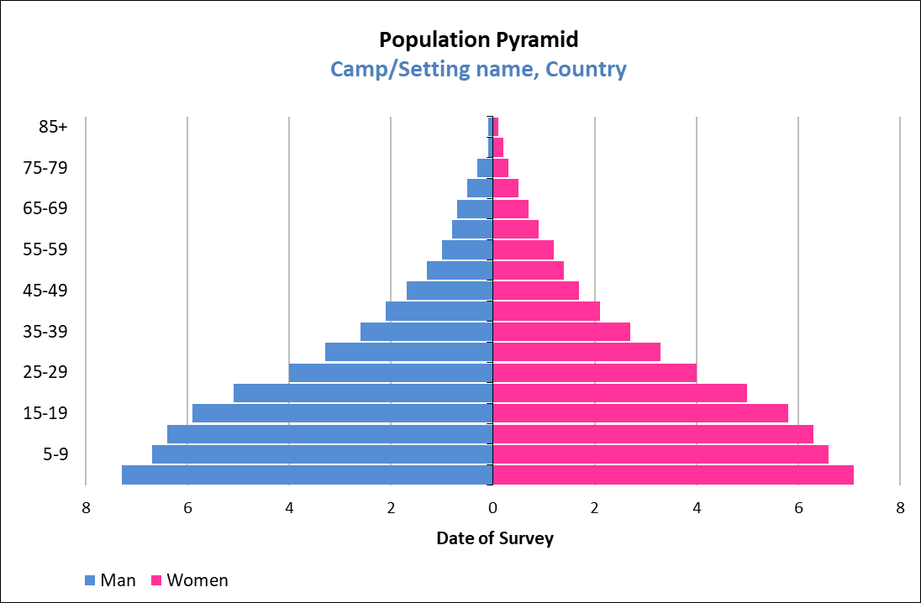

**Time of arrival (optional/if applicable)**

**Table 4** ARRIVAL PROFILE by camp (OPTIONAL/IF APPLICABLE) (ADAPT THE ARRIVAL PROFILE CATEGORIES SO THAT IT MAKES THE MOST SENSE FOR THE LOCAL SETTING)

|  |  |  |  |  |  |  |  |  |  |
| --- | --- | --- | --- | --- | --- | --- | --- | --- | --- |
| **Survey Area** | **N** | **Camp 1** | | **N** | **Camp 2** | | **N** | **Camp 3** | |
| **n** | **%**  **(95% CI)** | **n** | **%**  **(95% CI)** | **n** | **%**  **(95% CI)** |
| **Arrival profile** | | | | | | | | | |
| **Proportion of households where all members arrived to [camp name / country of asylum] at the same time** |  |  |  |  |  |  |  |  |  |
| **Household arrival dates** | | | | | | | | | |
| **1-3 months** |  |  |  |  |  |  |  |  |  |
| **4-6 months** |  |  |  |  |  |  |  |  |  |
| **7-9 months** |  |  |  |  |  |  |  |  |  |
| **9-12 months** |  |  |  |  |  |  |  |  |  |
| **1-2 years** |  |  |  |  |  |  |  |  |  |
| **2-3 years** |  |  |  |  |  |  |  |  |  |
| **> 3 years** |  |  |  |  |  |  |  |  |  |

**Household Head Profile**

**Table 5** HOUSEHOLD HEAD PROFILE, by cAMP

|  |  |  |  |  |  |  |  |  |  |
| --- | --- | --- | --- | --- | --- | --- | --- | --- | --- |
| **Survey Area** | **N** | **Camp 1** | | **N** | **Camp 2** | | **N** | **Camp 3** | |
| **n** | **%**  **(95% CI)** | **n** | **%**  **(95% CI)** | **n** | **%**  **(95% CI)** |
| **Female headed households**  (working age 15-64 years) |  |  |  |  |  |  |  |  |  |
| **Male headed households**  (working age 15-64 years) |  |  |  |  |  |  |  |  |  |
| **Children headed households**  (under 15 years) |  |  |  |  |  |  |  |  |  |
| **Elderly headed households**  (65 years and above) |  |  |  |  |  |  |  |  |  |
| **Mean age of household head in years** |  | *Mean*  *[min, max]* | |  | *Mean*  *[min, max]* | |  | *Mean*  *[min, max]* | |

**Table 6** HOUSEHOLD HEAD COUNTRY OF ORIGIN, by camp (OPTIONAL) - ADAPT THE COUNTRY NAMES TO THE SETTING

|  |  |  |  |  |  |  |  |  |  |
| --- | --- | --- | --- | --- | --- | --- | --- | --- | --- |
| **Proportion of households where household head was from following country of origin:** | **N** | **Camp 1** | | **N** | **Camp 2** | | **N** | **Camp 3** | |
| **n** | **%**  **(95% CI)** | **n** | **%**  **(95% CI)** | **n** | **%**  **(95% CI)** |
| **Country A** |  |  |  |  |  |  |  |  |  |
| **Country B** |  |  |  |  |  |  |  |  |  |
| **Country C** |  |  |  |  |  |  |  |  |  |
| **Country D** |  |  |  |  |  |  |  |  |  |
| **Country E** |  |  |  |  |  |  |  |  |  |
| **Other** |  |  |  |  |  |  |  |  |  |

Mixed populations SENS (out-of-camp) (if applicable)

**Table 7** HOUSEHOLD HEAD Population group, by camp

|  |  |  |  |  |  |  |  |  |  |
| --- | --- | --- | --- | --- | --- | --- | --- | --- | --- |
| **Proportion of households where household head was:** | **N** | **Camp 1** | | **N** | **Camp 2** | | **N** | **Camp 3** | |
| **n** | **%**  **(95% CI)** | **n** | **%**  **(95% CI)** | **n** | **%**  **(95% CI)** |
| **Host community** |  |  |  |  |  |  |  |  |  |
| **Internally displaced** |  |  |  |  |  |  |  |  |  |
| **Refugees/asylum seekers** |  |  |  |  |  |  |  |  |  |
| **Other** |  |  |  |  |  |  |  |  |  |

Age dependency ratio

**Table 8** age DEPENDENCY RATIO*, by camp

|  |  |  |  |  |
| --- | --- | --- | --- | --- |
| **Age dependency ratio** | | **Camp 1**  N = | **Camp 2**  N= | **Camp 3**  N= |
| **Mean**  **(SD)**  **[range]** | **SRS design\*\*** | Ratio  (SD)  [min, max] | Ratio  (SD)  [min, max] | Ratio  (SD)  [min, max] |
| **Mean**  **(95% CI)**  **[range]** | **Cluster design\*\*** | Ratio  (95% CI)  [min, max] | Ratio  (95% CI)  [min, max] | Ratio  (95% CI)  [min, max] |

\***Age dependency ratio** = Number of people aged 0 -14 years and those aged ≥65 years

Number of people aged 15 – 64 years

**When using the Means commands in Epi Info, it will provide the standard deviation (SD) when using the Statistics module and the 95% Confidence Interval when using the Advanced Statistics module.

**Table 9** AGE DEPENDENCY RATIO CATEGORIES BY HOUSEHOLD, by camp

| **Survey Area** | **Age dependency categories** | | **Age dependency ratio** | **Number / Total** | **%**  **(95% CI)** |
| --- | --- | --- | --- | --- | --- |
| **Camp 1** | **Category**  **I** | **1 dependent or less per non-dependent member** | ≤ 1 |  |  |
| **Category**  **II** | **Up to 3 dependents per 2 non-dependent members** | 1.1-1.5 |  |  |
| **Category**  **III** | **Up to 2 dependents per non-dependent members** | 1.6-2.0 |  |  |
| **Category**  **IV** | **More than 2 dependents per non-dependent members** | ≥2.1 |  |  |
| **Camp 2** | **Category**  **I** | **1 dependent or less per non-dependent member** | ≤ 1 |  |  |
| **Category**  **II** | **Up to 3 dependents per 2 non-dependent members** | 1.1-1.5 |  |  |
| **Category**  **III** | **Up to 2 dependents per non-dependent members** | 1.6-2.0 |  |  |
| **Category**  **IV** | **More than 2 dependents per non-dependent members** | ≥2.1 |  |  |
| **Camp 3** | **Category**  **I** | **1 dependent or less per non-dependent member** | ≤ 1 |  |  |
| **Category**  **II** | **Up to 3 dependents per 2 non-dependent members** | 1.1-1.5 |  |  |
| **Category**  **III** | **Up to 2 dependents per non-dependent members** | 1.6-2.0 |  |  |
| **Category**  **IV** | **More than 2 dependents per non-dependent members** | ≥2.1 |  |  |

**4.2 Children 6-59 months**

Age and Sex Distribution

Table 10 Children 6-59 months - Distribution of age and sex of sample in CAMP 1 (*this table is automatically generated by ENA for SMART software, MAKE SURE TO CHANGE THE smart-recommended age Breakdown to the one recommend by sens as shown below*)

|  |  |  |  |  |  |  |  |
| --- | --- | --- | --- | --- | --- | --- | --- |
|  | **Boys** | | **Girls** | | **Total** | | **Ratio** |
| **Age (mo)** | **no.** | **%** | **no.** | **%** | **no.** | **%** | **Boy:Girl** |
| **6-11 months** |  |  |  |  |  |  |  |
| **12-23 months** |  |  |  |  |  |  |  |
| **24-35 months** |  |  |  |  |  |  |  |
| **36-47 months** |  |  |  |  |  |  |  |
| **48-59 months** |  |  |  |  |  |  |  |
| **Total** |  |  |  |  |  |  |  |

Table 11 Children 6-59 months - Distribution of age and sex of sample in CAMP 2 (*this table is automatically generated by ENA for SMART software, MAKE SURE TO CHANGE THE smart-recommended age Breakdown to the one recommend by sens as shown below*)

|  |  |  |  |  |  |  |  |
| --- | --- | --- | --- | --- | --- | --- | --- |
|  | **Boys** | | **Girls** | | **Total** | | **Ratio** |
| **Age (mo)** | **no.** | **%** | **no.** | **%** | **no.** | **%** | **Boy:Girl** |
| **6-11 months** |  |  |  |  |  |  |  |
| **12-23 months** |  |  |  |  |  |  |  |
| **24-35 months** |  |  |  |  |  |  |  |
| **36-47 months** |  |  |  |  |  |  |  |
| **48-59 months** |  |  |  |  |  |  |  |
| **Total** |  |  |  |  |  |  |  |

Table 12 Children 6-59 months - Distribution of age and sex of sample in CAMP 3 (*this table is automatically generated by ENA for SMART software, MAKE SURE TO CHANGE THE smart-recommended age Breakdown to the one recommend by sens as shown below*)

|  |  |  |  |  |  |  |  |
| --- | --- | --- | --- | --- | --- | --- | --- |
|  | **Boys** | | **Girls** | | **Total** | | **Ratio** |
| **Age (mo)** | **no.** | **%** | **no.** | **%** | **no.** | **%** | **Boy:Girl** |
| **6-11 months** |  |  |  |  |  |  |  |
| **12-23 months** |  |  |  |  |  |  |  |
| **24-35 months** |  |  |  |  |  |  |  |
| **36-47 months** |  |  |  |  |  |  |  |
| **48-59 months** |  |  |  |  |  |  |  |
| **Total** |  |  |  |  |  |  |  |

***Things to note:***

* The proportion of children with no exact birthdate that is provided in the Plausibility report of ENA for SMART software should be reported at the bottom of **Tables 10-12** in the final report. This is useful for example to interpret the reliability of stunting and underweight data (both indicators use age).
* The percentage of children recruited on the basis of height (where applicable) should also be reported in the final survey report at the bottom of **Tables 10-12.**

**Time of arrival (optional/if applicable)**

**Table 13** CHILDREN’S ARRIVAL PROFILe by camp (OPTIONAL/IF APPLICABLE) *(ADAPT THE ARRIVAL PROFILE CATEGORIES SO THAT IT MAKES THE MOST SENSE FOR THE LOCAL SETTING)*

|  |  |  |  |  |  |
| --- | --- | --- | --- | --- | --- |
| **Survey Area** | **N** | **Living in the camp/asylum country before** [ADAPT TO THE LOCAL SETTING THE EVENTS THAT PROVOKED THE INFLUX] | | **New arrival in the camp/asylum country after** [ADAPT TO THE LOCAL SETTING THE EVENTS THAT PROVOKED THE INFLUX] | |
| **n** | **% (95% CI)** | **n** | **% (95% CI)** |
| **Camp 1** |  |  |  |  |  |
| **Camp 2** |  |  |  |  |  |
| **Camp 3** |  |  |  |  |  |

***Things to note:***

* GAM results should usually not be disaggregated by time of arrival unless it is planned during sample size calculation (i.e. stratification). However, it is sometimes justifiable to present GAM by time of arrival (typically 2 categories: new arrivals vs older stayers). Seek guidance from UNHCR HQ / Regional Offices if other results need to be disaggregated by time of arrival.

**Anthropometric results (based on WHO Growth Standards 2006)**

Exclude z-scores from Observed mean or SMART flags: WHZ -3 to 3; HAZ -3 to 3; WAZ -3 to 3.

Table 14 Prevalence of acute malnutrition based on weight-for-height z-scores (and/or oedema) and by sex, BY CAMP (*thEsE RESULTS ARE automatically generated by ENA for SMART software AND SHOULD BE MANUALLY TRANSPOSED INTO THE FOLLOWING TABLE FORMAT)*

|  |  |  |  |  |  |  |  |  |  |  |  |
| --- | --- | --- | --- | --- | --- | --- | --- | --- | --- | --- | --- |
| **Survey Area** | **N** | **Global Acute Malnutrition**  (WHZ <-2 z-score and/or oedema) | | | | | | **Moderate Acute Malnutrition**  (WHZ <-2 z-score and ≥-3 z-score) | | **Severe Acute Malnutrition**  (WHZ <-3 z-score and/or oedema) | |
| **All** | | **Boys** | | **Girls** | | **All** | | **All** | |
| **n** | **%**  **(95% CI)** | **n** | **%**  **(95% CI)** | **n** | **%**  **(95% CI)** | **n** | **%**  **(95% CI)** | **n** | **%**  **(95% CI)** |
| **Camp 1** | N | n | %  (95% CI) | n | %  (95% CI) | n | %  (95% CI) | n | %  (95% CI) | n | %  (95% CI) |
| **Camp 2** | N | n | %  (95% CI) | n | %  (95% CI) | n | %  (95% CI) | n | %  (95% CI) | n | %  (95% CI) |
| **Camp 3** | N | n | %  (95% CI) | n | %  (95% CI) | n | %  (95% CI) | n | %  (95% CI) | n | %  (95% CI) |

The prevalence of oedema is %

***Things to watch out for:***

* Often people disaggregate the main survey results by children’s age, nationality, resident status or even cluster to conduct statistical analyses and compare results without considering the limitations of doing so. These analyses need to be interpreted with caution since sample size may not be large enough to detect differences if they exist or differences may be identified when there are none in reality. However, major differences in results between different groups should be looked into and warrant an in depth investigation following the nutrition survey to try to understand if the difference is real and if it is, why there is a difference.
* GAM and SAM prevalence results from year to year should be presented as shown in the example figure below.

Figure 5 prevalence of global and severe acute malnutrition based on WHO Growth Standards in children 6-59 months from 2015-2018, by camp. Note that a trend can only be identified when there are at least three time points. It is advised that prevalence data BE obtained from SENS surveys carried out at similar times of the year *(this FIGURE CAN BE automatically GENERATED BY USING sENS PRE-MODULE TOOL 17b- TRENDS AND GRAPHS)*

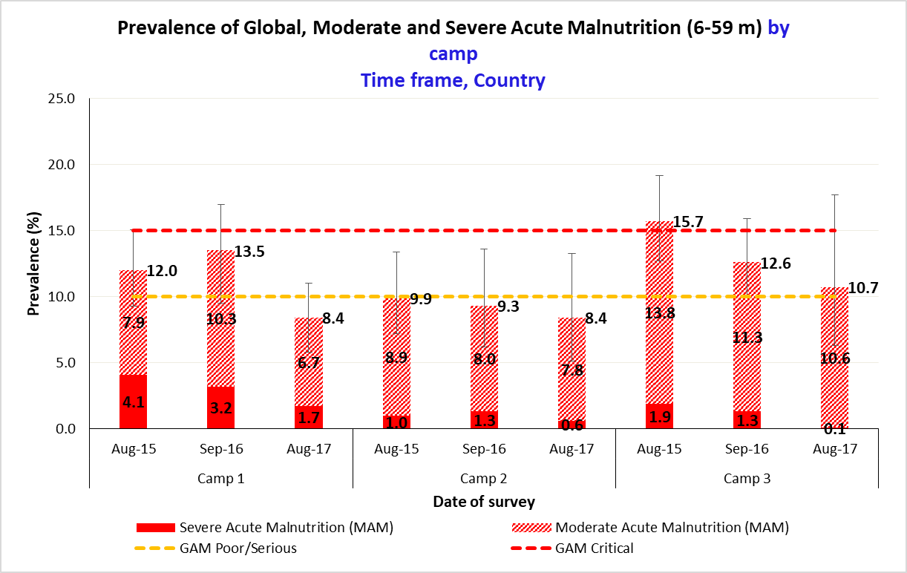

Table 15 Prevalence of acute malnutrition by age, based on weight-for-height z-scores and/or oedema, IN CAMP 1 (*this table is automatically generated by ENA for SMART software)*

|  |  |  |  |  |  |  |  |  |  |
| --- | --- | --- | --- | --- | --- | --- | --- | --- | --- |
|  |  | **Severe wasting**  **(<-3 z-score)** | | **Moderate wasting**  **(≥ -3 and <-2 z-score)** | | **Normal**  **(≥ -2 z score)** | | **Oedema** | |
| **Age (mo)** | **Total no.** | **No.** | **%** | **No.** | **%** | **No.** | **%** | **No.** | **%** |
| **6-11** |  |  |  |  |  |  |  |  |  |
| **12-23** |  |  |  |  |  |  |  |  |  |
| **24-35** |  |  |  |  |  |  |  |  |  |
| **36-47** |  |  |  |  |  |  |  |  |  |
| **48-59** |  |  |  |  |  |  |  |  |  |
| **Total** |  |  |  |  |  |  |  |  |  |

Table 16 Prevalence of acute malnutrition by age, based on weight-for-height z-scores and/or oedema, IN CAMP 2 (*this table is automatically generated by ENA for SMART software)*

|  |  |  |  |  |  |  |  |  |  |
| --- | --- | --- | --- | --- | --- | --- | --- | --- | --- |
|  |  | **Severe wasting**  **(<-3 z-score)** | | **Moderate wasting**  **(≥ -3 and <-2 z-score)** | | **Normal**  **(≥ -2 z score)** | | **Oedema** | |
| **Age (mo)** | **Total no.** | **No.** | **%** | **No.** | **%** | **No.** | **%** | **No.** | **%** |
| **6-11** |  |  |  |  |  |  |  |  |  |
| **12-23** |  |  |  |  |  |  |  |  |  |
| **24-35** |  |  |  |  |  |  |  |  |  |
| **36-47** |  |  |  |  |  |  |  |  |  |
| **48-59** |  |  |  |  |  |  |  |  |  |
| **Total** |  |  |  |  |  |  |  |  |  |

Table 17 Prevalence of acute malnutrition by age, based on weight-for-height z-scores and/or oedema, IN CAMP 3 (*this table is automatically generated by ENA for SMART software)*

|  |  |  |  |  |  |  |  |  |  |
| --- | --- | --- | --- | --- | --- | --- | --- | --- | --- |
|  |  | **Severe wasting**  **(<-3 z-score)** | | **Moderate wasting**  **(≥ -3 and <-2 z-score)** | | **Normal**  **(≥ -2 z score)** | | **Oedema** | |
| **Age (mo)** | **Total no.** | **No.** | **%** | **No.** | **%** | **No.** | **%** | **No.** | **%** |
| **6-11** |  |  |  |  |  |  |  |  |  |
| **12-23** |  |  |  |  |  |  |  |  |  |
| **24-35** |  |  |  |  |  |  |  |  |  |
| **36-47** |  |  |  |  |  |  |  |  |  |
| **48-59** |  |  |  |  |  |  |  |  |  |
| **Total** |  |  |  |  |  |  |  |  |  |

* Wasting prevalence trend by age shown in **Tables 15-17** should also be presented in a graph as shown in the example figure below.

Figure 6 prevalence of wasting by age in children 6-59 months in CAMP 1 *(this FIGURE CAN BE automatically GENERATED BY USING sENS PRE-MODULE TOOL 17- TRENDS AND GRAPHS)*

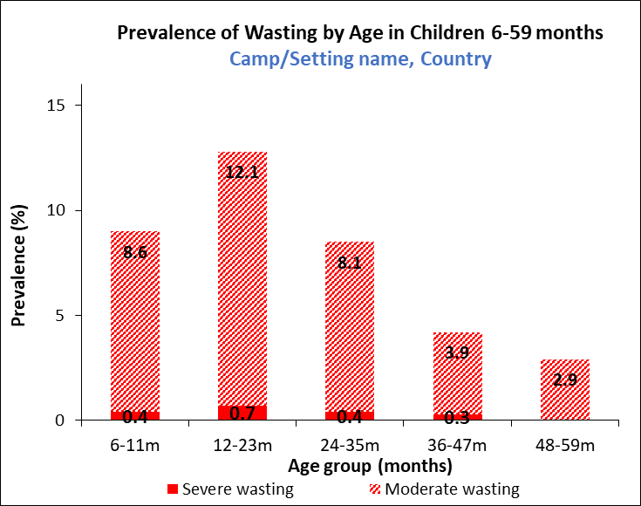

Figure 7 Distribution of weight-for-height z-scores (based on WHO Growth Standards; the reference population is shown in green and the surveyed population is shown in red) of survey population in CAMP 1, CAMP 2 and CAMP 3 compared to reference population (*this FIGURE is automatically generated by ENA for SMART software)*

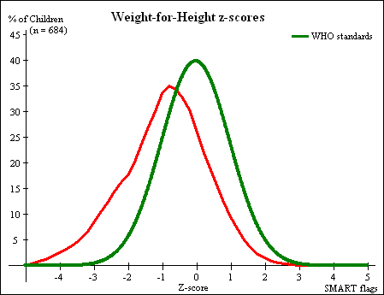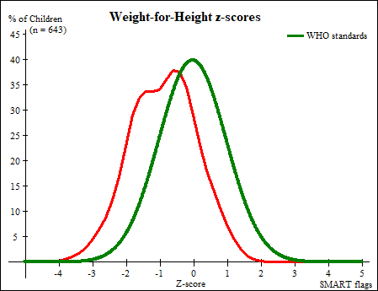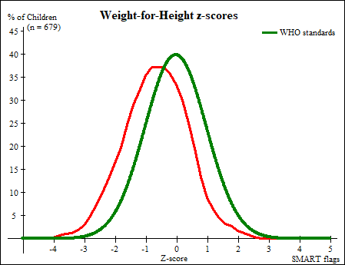

Table 18 Prevalence of MUAC MALNUTRITION, by CAMP (*thESE RESULTS ARE automatically generated by ENA for SMART software HOWEVER YOU NEED TO CHANGE THE TEXT DESCRIPTIONS ACCORDING TO uNHCR’S DEFINITIONS AS SHOWN BELOW)*

|  |  |  |  |  |  |  |  |  |  |  |  |
| --- | --- | --- | --- | --- | --- | --- | --- | --- | --- | --- | --- |
| **Survey Area** | **N** | **Prevalence of MUAC < 125 mm and/or oedema** | | | | | | **Prevalence of MUAC < 125 mm and >= 115 mm, no oedema** | | **Prevalence MUAC < 115 mm and/or oedema** | |
| **All** | | **Boys** | | **Girls** | | **All** | | **All** | |
| **n** | **%**  **(95% CI)** | **n** | **%**  **(95% CI)** | **n** | **%**  **(95% CI)** | **n** | **%**  **(95% CI)** | **n** | **%**  **(95% CI)** |
| **Camp 1** | N | n | %  (95% CI) | n | %  (95% CI) | n | %  (95% CI) | n | %  (95% CI) | n | %  (95% CI) |
| **Camp 2** | N | n | %  (95% CI) | n | %  (95% CI) | n | %  (95% CI) | n | %  (95% CI) | n | %  (95% CI) |
| **Camp 3** | N | n | %  (95% CI) | n | %  (95% CI) | n | %  (95% CI) | n | %  (95% CI) | n | %  (95% CI) |

Table 19 PREVALENCE OF MUAC MALNUTRITION by age, based on MUAC cut off's and/or oedema, in CAMP 1 (*thESE RESULTS ARE automatically generated by ENA for SMART software HOWEVER YOU NEED TO CHANGE THE TEXT DESCRIPTIONS ACCORDING TO uNHCR’S DEFINITIONS AS SHOWN BELOW)*

|  |  |  |  |  |  |  |  |  |  |
| --- | --- | --- | --- | --- | --- | --- | --- | --- | --- |
|  |  | **MUAC < 115 mm** | | **MUAC >= 115 mm and < 125 mm** | | **MUAC > = 125 mm** | | **Oedema** | |
| **Age (mo)** | **Total no.** | **No.** | **%** | **No.** | **%** | **No.** | **%** | **No.** | **%** |
| **6-11** |  |  |  |  |  |  |  |  |  |
| **12-23** |  |  |  |  |  |  |  |  |  |
| **24-35** |  |  |  |  |  |  |  |  |  |
| **36-47** |  |  |  |  |  |  |  |  |  |
| **48-59** |  |  |  |  |  |  |  |  |  |
| **Total** |  |  |  |  |  |  |  |  |  |

Table 20 PREVALENCE OF MUAC MALNUTRITION by age, based on MUAC cut off's and/or oedema, in CAMP 2 (*thESE RESULTS ARE automatically generated by ENA for SMART software HOWEVER YOU NEED TO CHANGE THE TEXT DESCRIPTIONS ACCORDING TO uNHCR’S DEFINITIONS AS SHOWN BELOW)*

|  |  |  |  |  |  |  |  |  |  |
| --- | --- | --- | --- | --- | --- | --- | --- | --- | --- |
|  |  | **MUAC < 115 mm** | | **MUAC >= 115 mm and < 125 mm** | | **MUAC > = 125 mm** | | **Oedema** | |
| **Age (mo)** | **Total no.** | **No.** | **%** | **No.** | **%** | **No.** | **%** | **No.** | **%** |
| **6-11** |  |  |  |  |  |  |  |  |  |
| **12-23** |  |  |  |  |  |  |  |  |  |
| **24-35** |  |  |  |  |  |  |  |  |  |
| **36-47** |  |  |  |  |  |  |  |  |  |
| **48-59** |  |  |  |  |  |  |  |  |  |
| **Total** |  |  |  |  |  |  |  |  |  |

Table 21 PREVALENCE OF MUAC MALNUTRITION by age, based on MUAC cut off's and/or oedema, in CAMP 3 (*thESE RESULTS ARE automatically generated by ENA for SMART software HOWEVER YOU NEED TO CHANGE THE TEXT DESCRIPTIONS ACCORDING TO uNHCR’S DEFINITIONS AS SHOWN BELOW)*

|  |  |  |  |  |  |  |  |  |  |
| --- | --- | --- | --- | --- | --- | --- | --- | --- | --- |
|  |  | **MUAC < 115 mm** | | **MUAC >= 115 mm and < 125 mm** | | **MUAC > = 125 mm** | | **Oedema** | |
| **Age (mo)** | **Total no.** | **No.** | **%** | **No.** | **%** | **No.** | **%** | **No.** | **%** |
| **6-11** |  |  |  |  |  |  |  |  |  |
| **12-23** |  |  |  |  |  |  |  |  |  |
| **24-35** |  |  |  |  |  |  |  |  |  |
| **36-47** |  |  |  |  |  |  |  |  |  |
| **48-59** |  |  |  |  |  |  |  |  |  |
| **Total** |  |  |  |  |  |  |  |  |  |

**Table 22** Prevalence of underweight based on weight-for-age z-scores AND by sex, BY CAMP (*thEsE RESULTS ARE automatically generated by ENA for SMART software AND SHOULD BE MANUALLY TRANSPOSED INTO THE FOLLOWING TABLE FORMAT)*

|  |  |  |  |  |  |  |  |  |  |  |  |
| --- | --- | --- | --- | --- | --- | --- | --- | --- | --- | --- | --- |
| **Survey Area** | **N** | **Prevalence of underweight**  (<-2 z-score) | | | | | | **Prevalence of moderate underweight**  (<-2 z-score and >=-3 z-score) | | **Prevalence of severe underweight**  (<-3 z-score) | |
| **All** | | **Boys** | | **Girls** | | **All** | | **All** | |
| **n** | **%**  **(95% CI)** | **n** | **%**  **(95% CI)** | **n** | **%**  **(95% CI)** | **n** | **%**  **(95% CI)** | **n** | **%**  **(95% CI)** |
| **Camp 1** | N | n | %  (95% CI) | n | %  (95% CI) | n | %  (95% CI) | n | %  (95% CI) | n | %  (95% CI) |
| **Camp 2** | N | n | %  (95% CI) | n | %  (95% CI) | n | %  (95% CI) | n | %  (95% CI) | n | %  (95% CI) |
| **Camp 3** | N | n | %  (95% CI) | n | %  (95% CI) | n | %  (95% CI) | n | %  (95% CI) | n | %  (95% CI) |

Table 23 Prevalence of UNDERWEIGHT by age based on Weight-for-age z-scores, AND OEDEMA in CAMP 1 (*this table is automatically generated by ENA for SMART software)*

|  |  |  |  |  |  |  |  |  |  |
| --- | --- | --- | --- | --- | --- | --- | --- | --- | --- |
|  |  | **Severe underweight**  **(<-3 z-score)** | | **Moderate underweight**  **(≥ -3 and <-2 z-score)** | | **Normal**  **(≥ -2 z score)** | | **Oedema** | |
| **Age (mo)** | **Total no.** | **No.** | **%** | **No.** | **%** | **No.** | **%** | **No.** | **%** |
| **6-11** |  |  |  |  |  |  |  |  |  |
| **12-23** |  |  |  |  |  |  |  |  |  |
| **24-35** |  |  |  |  |  |  |  |  |  |
| **36-47** |  |  |  |  |  |  |  |  |  |
| **48-59** |  |  |  |  |  |  |  |  |  |
| **Total** |  |  |  |  |  |  |  |  |  |

Table 24 Prevalence of UNDERWEIGHT by age based on Weight-for-age z-scores, AND OEDEMA in CAMP 2 (*this table is automatically generated by ENA for SMART software)*

|  |  |  |  |  |  |  |  |  |  |
| --- | --- | --- | --- | --- | --- | --- | --- | --- | --- |
|  |  | **Severe underweight**  **(<-3 z-score)** | | **Moderate underweight**  **(≥ -3 and <-2 z-score)** | | **Normal**  **(≥ -2 z score)** | | **Oedema** | |
| **Age (mo)** | **Total no.** | **No.** | **%** | **No.** | **%** | **No.** | **%** | **No.** | **%** |
| **6-11** |  |  |  |  |  |  |  |  |  |
| **12-23** |  |  |  |  |  |  |  |  |  |
| **24-35** |  |  |  |  |  |  |  |  |  |
| **36-47** |  |  |  |  |  |  |  |  |  |
| **48-59** |  |  |  |  |  |  |  |  |  |
| **Total** |  |  |  |  |  |  |  |  |  |

Table 25 Prevalence of UNDERWEIGHT by age based on Weight-for-age z-scores, AND OEDEMA in CAMP 3 (*this table is automatically generated by ENA for SMART software)*

|  |  |  |  |  |  |  |  |  |  |
| --- | --- | --- | --- | --- | --- | --- | --- | --- | --- |
|  |  | **Severe underweight**  **(<-3 z-score)** | | **Moderate underweight**  **(≥ -3 and <-2 z-score)** | | **Normal**  **(≥ -2 z score)** | | **Oedema** | |
| **Age (mo)** | **Total no.** | **No.** | **%** | **No.** | **%** | **No.** | **%** | **No.** | **%** |
| **6-11** |  |  |  |  |  |  |  |  |  |
| **12-23** |  |  |  |  |  |  |  |  |  |
| **24-35** |  |  |  |  |  |  |  |  |  |
| **36-47** |  |  |  |  |  |  |  |  |  |
| **48-59** |  |  |  |  |  |  |  |  |  |
| **Total** |  |  |  |  |  |  |  |  |  |

Table 26 Prevalence of stunting based on height-for-age z-scores and by sex, BY CAMP (*thEsE RESULTS ARE automatically generated by ENA for SMART software* *AND SHOULD BE MANUALLY TRANSPOSED INTO THE FOLLOWING TABLE FORMAT)*

|  |  |  |  |  |  |  |  |  |  |  |  |
| --- | --- | --- | --- | --- | --- | --- | --- | --- | --- | --- | --- |
| **Survey Area** | **N** | **Prevalence of stunting**  (<-2 z-score) | | | | | | **Prevalence of moderate stunting**  (<-2 z-score and >=-3 z-score) | | **Prevalence of severe stunting**  (<-3 z-score) | |
| **All** | | **Boys** | | **Girls** | | **All** | | **All** | |
| **n** | **%**  **(95% CI)** | **n** | **%**  **(95% CI)** | **n** | **%**  **(95% CI)** | **n** | **%**  **(95% CI)** | **n** | **%**  **(95% CI)** |
| **Camp 1** | N | n | %  (95% CI) | n | %  (95% CI) | n | %  (95% CI) | n | %  (95% CI) | n | %  (95% CI) |
| **Camp 2** | N | n | %  (95% CI) | n | %  (95% CI) | n | %  (95% CI) | n | %  (95% CI) | n | %  (95% CI) |
| **Camp 3** | N | n | %  (95% CI) | n | %  (95% CI) | n | %  (95% CI) | n | %  (95% CI) | n | %  (95% CI) |

**FIGURE 8** PREVALENCE OF GLOBAL AND SEVERE STUNTING BASED ON WHO GROWTH STANDARDS IN CHILDREN 6-59 MONTHS FROM 2015-2018, by camp. **NOTE THAT A TREND CAN ONLY BE IDENTIFIED WHEN THERE ARE AT LEAST THREE TIME POINTS. IT IS ADVISED THAT PREVALENCE DATA ARE OBTAINED FROM SENS SURVEYS CARRIED OUT AT SIMILAR TIMES OF THE YEAR** (THIS FIGURE CAN BE AUTOMATICALLY GENERATED BY USING SENS PRE-MODULE TOOL 17B- TRENDS AND GRAPHS)

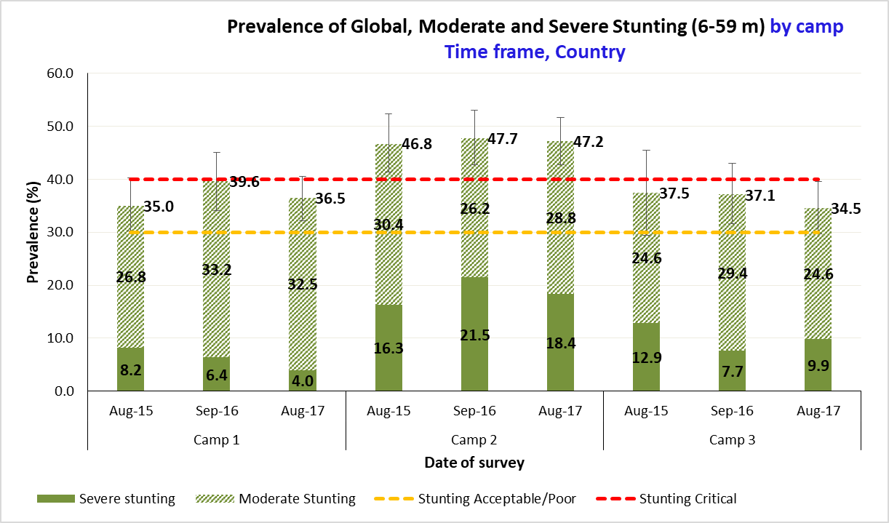

Table 27 Prevalence of stunting by age based on height-for-age z-scores, IN cAMP 1 (*this table is automatically generated by ENA for SMART software)*

|  |  |  |  |  |  |  |  |
| --- | --- | --- | --- | --- | --- | --- | --- |
|  |  | **Severe stunting**  **(<-3 z-score)** | | **Moderate stunting**  **(≥ -3 and <-2 z-score)** | | **Normal**  **(≥ -2 z score)** | |
| **Age (mo)** | **Total no.** | **No.** | **%** | **No.** | **%** | **No.** | **%** |
| **6-11** |  |  |  |  |  |  |  |
| **12-23** |  |  |  |  |  |  |  |
| **24-35** |  |  |  |  |  |  |  |
| **36-47** |  |  |  |  |  |  |  |
| **48-59** |  |  |  |  |  |  |  |
| **Total** |  |  |  |  |  |  |  |

Table 28 Prevalence of stunting by age based on height-for-age z-scores, IN cAMP 2 (*this table is automatically generated by ENA for SMART software)*

|  |  |  |  |  |  |  |  |
| --- | --- | --- | --- | --- | --- | --- | --- |
|  |  | **Severe stunting**  **(<-3 z-score)** | | **Moderate stunting**  **(≥ -3 and <-2 z-score)** | | **Normal**  **(≥ -2 z score)** | |
| **Age (mo)** | **Total no.** | **No.** | **%** | **No.** | **%** | **No.** | **%** |
| **6-11** |  |  |  |  |  |  |  |
| **12-23** |  |  |  |  |  |  |  |
| **24-35** |  |  |  |  |  |  |  |
| **36-47** |  |  |  |  |  |  |  |
| **48-59** |  |  |  |  |  |  |  |
| **Total** |  |  |  |  |  |  |  |

Table 29 Prevalence of stunting by age based on height-for-age z-scores, IN cAMP 3 (*this table is automatically generated by ENA for SMART software)*

|  |  |  |  |  |  |  |  |
| --- | --- | --- | --- | --- | --- | --- | --- |
|  |  | **Severe stunting**  **(<-3 z-score)** | | **Moderate stunting**  **(≥ -3 and <-2 z-score)** | | **Normal**  **(≥ -2 z score)** | |
| **Age (mo)** | **Total no.** | **No.** | **%** | **No.** | **%** | **No.** | **%** |
| **6-11** |  |  |  |  |  |  |  |
| **12-23** |  |  |  |  |  |  |  |
| **24-35** |  |  |  |  |  |  |  |
| **36-47** |  |  |  |  |  |  |  |
| **48-59** |  |  |  |  |  |  |  |
| **Total** |  |  |  |  |  |  |  |

* Stunting prevalence trend by age shown in **Tables 28-30** should also be presented in a graph as shown in the example figure below.

**FIGURE 9** PREVALENCE OF STUNTING BY AGE IN CHILDREN 6-59 MONTHS **in CAMP 1** (THIS FIGURE CAN BE AUTOMATICALLY GENERATED BY USING SENS PRE-MODULE TOOL 17- TRENDS AND GRAPHS)

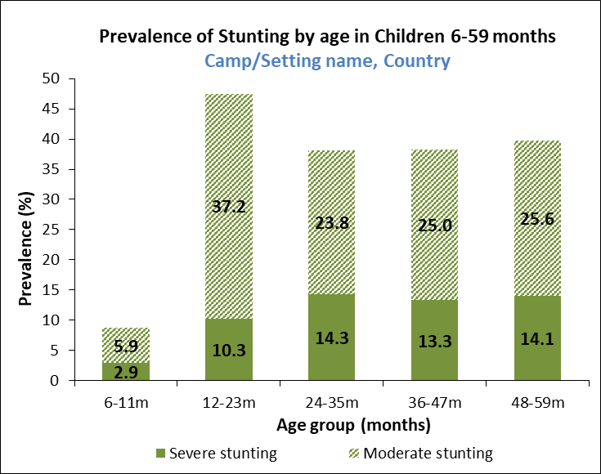

Figure 10 Distribution of height-for-age z-scores (based on WHO Growth Standards; the reference population is shown in green and the surveyed population is shown in red) of survey population in CAMP 1, CAMP 2 and CAMP 3 compared to reference population (*this FIGURE is automatically generated by ENA for SMART software)*

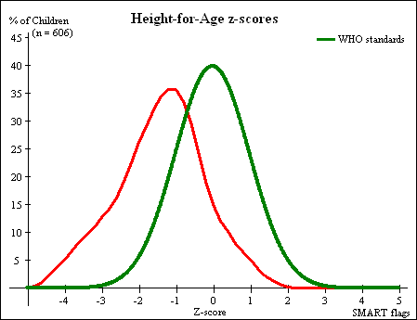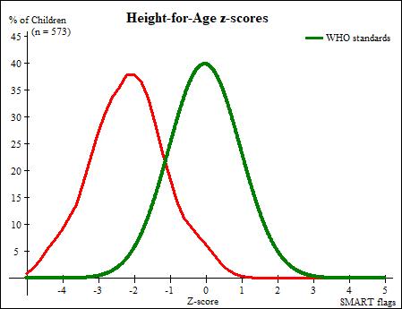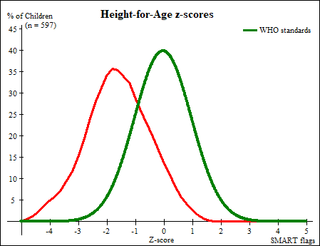

**Table 30** Prevalence of OVerweight based on weight-for-HEIGHT z-scores (no oedema), BY CAMP (*thEsE RESULTS ARE automatically generated by ENA for SMART software AND SHOULD BE MANUALLY TRANSPOSED INTO THE FOLLOWING TABLE FORMAT)*

|  |  |  |  |  |  |
| --- | --- | --- | --- | --- | --- |
| **Survey Area** | **N** | **Prevalence of overweight**  (>2 z-score) | | **Prevalence of severe overweight**  (>3 z-score) | |
| **n** | **%**  **(95% CI)** | **n** | **%**  **(95% CI)** |
| **Camp 1** | N | n | %  (95% CI) | n | %  (95% CI) |
| **Camp 2** | N | n | %  (95% CI) | n | %  (95% CI) |
| **Camp 3** | N | n | %  (95% CI) | n | %  (95% CI) |

Table 31 Prevalence of OVERWEIGHT by age based on Weight-for-HEIGHT z-scores (no oedema), in CAMP 1 (*this table is automatically generated by ENA for SMART software)*

|  |  |  |  |  |  |
| --- | --- | --- | --- | --- | --- |
|  |  | **Prevalence of overweight**  (>2 z-score) | | **Prevalence of severe overweight**  (>3 z-score) | |
| **Age (mo)** | **Total no.** | **No.** | **%** | **No.** | **%** |
| **6-11** |  |  |  |  |  |
| **12-23** |  |  |  |  |  |
| **24-35** |  |  |  |  |  |
| **36-47** |  |  |  |  |  |
| **48-59** |  |  |  |  |  |
| **Total** |  |  |  |  |  |

Table 32 Prevalence of OVERWEIGHT by age based on Weight-for-HEIGHT z-scores (no oedema), in CAMP 2 (*this table is automatically generated by ENA for SMART software)*

|  |  |  |  |  |  |
| --- | --- | --- | --- | --- | --- |
|  |  | **Prevalence of overweight**  (>2 z-score) | | **Prevalence of severe overweight**  (>3 z-score) | |
| **Age (mo)** | **Total no.** | **No.** | **%** | **No.** | **%** |
| **6-11** |  |  |  |  |  |
| **12-23** |  |  |  |  |  |
| **24-35** |  |  |  |  |  |
| **36-47** |  |  |  |  |  |
| **48-59** |  |  |  |  |  |
| **Total** |  |  |  |  |  |

Table 33 Prevalence of OVERWEIGHT by age based on Weight-for-HEIGHT z-scores (no oedema), in CAMP 3 (*this table is automatically generated by ENA for SMART software)*

|  |  |  |  |  |  |
| --- | --- | --- | --- | --- | --- |
|  |  | **Prevalence of overweight**  (>2 z-score) | | **Prevalence of severe overweight**  (>3 z-score) | |
| **Age (mo)** | **Total no.** | **No.** | **%** | **No.** | **%** |
| **6-11** |  |  |  |  |  |
| **12-23** |  |  |  |  |  |
| **24-35** |  |  |  |  |  |
| **36-47** |  |  |  |  |  |
| **48-59** |  |  |  |  |  |
| **Total** |  |  |  |  |  |

Table 34 Mean z-scores, Design Effects and excluded subjects, BY camp (*THESE RESULTS ARE automatically generated by ENA for SMART software* *AND SHOULD BE MANUALLY TRANSPOSED INTO THE FOLLOWING TABLE FORMAT; no design effect should be presented if simple or systematic random sampling wAS used*)

|  |  |  |  |  |  |
| --- | --- | --- | --- | --- | --- |
| **Indicator** | **n** | **Mean z-scores ± SD** | **Design Effect (z-score < -2)** | **z-scores not available\*** | **z-scores out of range** |
| **Camp 1** | | | | | |
| **Weight-for-Height** |  | Mean ± SD of WHZ |  |  |  |
| **Weight-for-Age** |  | Mean ± SD of WAZ |  |  |  |
| **Height-for-Age** |  | Mean ± SD of HAZ |  |  |  |
| **Camp 2** | | | | | |
| **Weight-for-Height** |  | Mean ± SD of WHZ |  |  |  |
| **Weight-for-Age** |  | Mean ± SD of WAZ |  |  |  |
| **Height-for-Age** |  | Mean ± SD of HAZ |  |  |  |
| **Camp 3** | | | | | |
| **Weight-for-Height** |  | Mean ± SD of WHZ |  |  |  |
| **Weight-for-Age** |  | Mean ± SD of WAZ |  |  |  |
| **Height-for-Age** |  | Mean ± SD of HAZ |  |  |  |

* contains for WHZ and WAZ the children with oedema.

* The flagging criteria used for anthropometric indices should be added to analysis section of the final report. (e.g. SMART flags and ranges used like -/+3 from the observed mean).

**Enrolment into nutrition programmes results**

Table 35 Programme ENROLMENT for acutely malnourished children, by CAMP

|  |  |  |  |
| --- | --- | --- | --- |
| **Survey Area** | **Programme** | **Number/total** | **% (95% CI)** |
| **Camp 1** | **Supplementary feeding programme (TSFP) enrolment** |  |  |
| **Therapeutic (OTP/SC) feeding programme enrolment** |  |  |
| **Camp 2** | **Supplementary feeding programme (TSFP) enrolment** |  |  |
| **Therapeutic (OTP/SC) feeding programme enrolment** |  |  |
| **Camp 3** | **Supplementary feeding programme (TSFP) enrolment** |  |  |
| **Therapeutic (OTP/SC) feeding programme enrolment** |  |  |

* It is calculated based on the admission criteria used in the survey setting. Where admission is based on MUAC, WHZ and oedema, you may show two tables of results, one table showing the programme coverage based on MUAC and oedema only, and one table showing the programme coverage based on all three admission criteria.

To see the two recommended tables, see:

SENS **Pre-Module Tool 20a- Jordan Full SENS Report 2016 (pages 32-33).**

* Children with WHZ flags should be excluded from the coverage analysis.

Table 36 coverage OF THE blanket supplementary feeding PROGRAMME, by CAMP (optional indicatOr)

|  |  |  |  |
| --- | --- | --- | --- |
| **Survey Area** | **Programme** | **Number/total** | **% (95% CI)** |
| **Camp 1** | **Blanket supplementary feeding programme (BSFP)** |  |  |
| **Product name** | |______________________| | |
| **Target age group** | |______________________| | |
| **Camp 2** | **Blanket supplementary feeding programme (BSFP)** |  |  |
| **Product name** | |______________________| | |
| **Target age group** | |______________________| | |
| **Camp 3** | **Blanket supplementary feeding programme (BSFP)** |  |  |
| **Product name** | |______________________| | |
| **Target age group** | |______________________| | |

**Measles vaccination coverage results**

Table 37 Measles vaccination coverage for children aged 9-59 months, by camp (*or other context-specific target group*)

|  |  |  |  |  |  |
| --- | --- | --- | --- | --- | --- |
| **Survey Area** | **N** | **Measles vaccination with card** | | **Measles vaccination with card or confirmation from mother** | |
| **n** | **% (95% CI)** | **n** | **% (95% CI)** |
| **Camp 1** |  |  |  |  |  |
| **Camp 2** |  |  |  |  |  |
| **Camp 3** |  |  |  |  |  |

**Vitamin A supplementation coverage results**

Table 38 Vitamin A supplementation coverage for children aged 6-59 months within THE past 6 months, by camp

|  |  |  |  |  |  |
| --- | --- | --- | --- | --- | --- |
| **Survey Area** | **N** | **Vitamin A supplementation in last 6 months with card** | | **Vitamin A supplementation in last 6 months with card or confirmation from mother** | |
| **n** | **% (95% CI)** | **n** | **% (95% CI)** |
| **Camp 1** |  |  |  |  |  |
| **Camp 2** |  |  |  |  |  |
| **Camp 3** |  |  |  |  |  |

**Deworming coverage results (if applicable)**

Table 39 DEWORMING COVERAGE for children aged 12-59/24-59 months within the past 6 months, by camp *(or other context-specific target group)*\*

|  |  |  |  |
| --- | --- | --- | --- |
| **Survey Area** | **N** | **Deworming within the past 6 months** | |
| **n** | **% (95% CI)** |
| **Camp 1** |  |  |  |
| **Camp 2** |  |  |  |
| **Camp 3** |  |  |  |

*Note that this refers to large-scale campaigns done with mebendazole and/or albendazole. To be included only if deworming campaign done alongside a vaccination or vitamin A campaign in the last six months.

* Coverage results for measles, vitamin A supplementation in last 6 months and deworming in last 6 months from year to year should be presented as shown in the example figures below.

Figure 11 coverage of measles vaccination, and vitamin A supplementation IN LAST 6 MONTHS in children 6-59 months from 2015-2018, by camp. Note that a trend can only be identified when there are at least three time points *(this FIGURE CAN BE automatically GENERATED BY USING sENS PRE-MODULE TOOL 17b- TRENDS AND GRAPHS)*

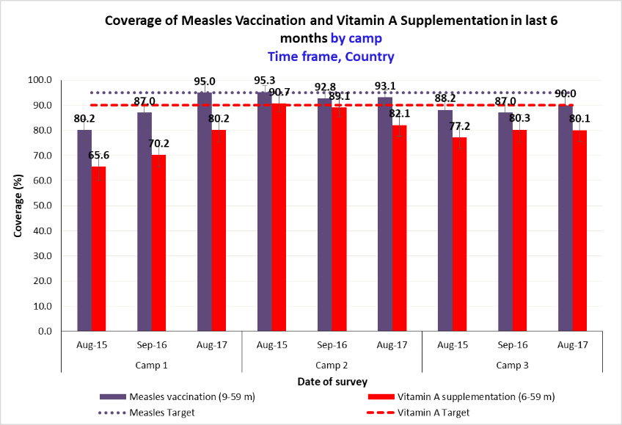

Figure 12 coverage of DEWORMING IN LAST 6 MONTHS in children 12-59/24-59 months from 2015-2018, by camp. Note that a trend can only be identified when there are at least three time points *(this FIGURE CAN BE automatically GENERATED BY USING sENS PRE-MODULE TOOL 17B- TRENDS AND GRAPHS)*

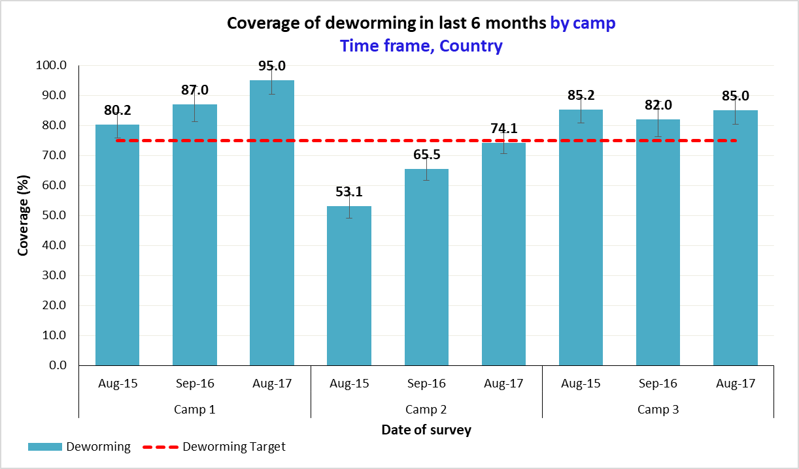

**Diarrhoea results**

Table 40 Period prevalence of diarrhoea, by camp

|  |  |  |  |
| --- | --- | --- | --- |
| **Survey Area** | **N** | **Diarrhoea in the last two weeks** | |
| **n** | **% (95% CI)** |
| **Camp 1** |  |  |  |
| **Camp 2** |  |  |  |
| **Camp 3** |  |  |  |

Table 41 ORS and zinc use during diarroea episode, by camp (optional)

|  |  |  |  |  |  |
| --- | --- | --- | --- | --- | --- |
| **Survey Area** | **N** | **ORS use during diarrhoea episode** | | **Zinc tablet or syrup use during diarrhoea episode** | |
| **n** | **% (95% CI)** | **n** | **% (95% CI)** |
| **Camp 1** |  |  |  |  |  |
| **Camp 2** |  |  |  |  |  |
| **Camp 3** |  |  |  |  |  |

**Anaemia results**

Table 42 Prevalence of TOTAL anaemia, ANAEMIA CATEGORIES, and MEAN haemoglobin concentration in children 6-59 months of age AND BY AGE GROUP, in CAMP 1

|  |  |  |  |  |
| --- | --- | --- | --- | --- |
|  | | **6-59 months**  n = | **6-23 months**  n= | **24-59 months**  n= |
| **Total Anaemia (Hb<11.0 g/dL)** | | (n) %  (95% CI) | (n) %  (95% CI) | (n) %  (95% CI) |
| **Mild Anaemia (Hb 10.0-10.9 g/dL)** | | (n) %  (95% CI) | (n) %  (95% CI) | (n) %  (95% CI) |
| **Moderate Anaemia (7.0-9.9 g/dL)** | | (n) %  (95% CI) | (n) %  (95% CI) | (n) %  (95% CI) |
| **Severe Anaemia (<7.0 g/dL)** | | (n) %  (95% CI) | (n) %  (95% CI) | (n) %  (95% CI) |
| **Mean Hb (g/dL)**  **(SD)**  **[range]** | **SRS design\*** | g/dL  (SD)  [min, max] | g/dL  (SD)  [min, max] | g/dL  (SD)  [min, max] |
| **Mean Hb (g/dL)**  **(95% CI)**  **[range]** | **Cluster design\*** | g/dL  (95% CI)  [min, max] | g/dL  (95% CI)  [min, max] | g/dL  (95% CI)  [min, max] |

*When using the Means commands in Epi Info, it will provide the standard deviation (SD) when using the Statistics module and the 95% Confidence Interval when using the Advanced Statistics module.

Table 43 Prevalence of MODERATE AND SEVERE anaemia in children 6-59 months of age AND BY AGE GROUP, in CAMP 1

|  |  |  |  |
| --- | --- | --- | --- |
|  | **6-59 months**  n = | **6-23 months**  n= | **24-59 months**  n= |
| **Moderate and Severe Anaemia**  **(Hb<10.0 g/dL)** | (n) %  (95% CI) | (n) %  (95% CI) | (n) %  (95% CI) |

Table 44 Prevalence of TOTAL anaemia, ANAEMIA CATEGORIES, and MEAN haemoglobin concentration in children 6-59 months of age AND BY AGE GROUP, in CAMP 2

|  |  |  |  |  |
| --- | --- | --- | --- | --- |
|  | | **6-59 months**  n = | **6-23 months**  n= | **24-59 months**  n= |
| **Total Anaemia (Hb<11.0 g/dL)** | | (n) %  (95% CI) | (n) %  (95% CI) | (n) %  (95% CI) |
| **Mild Anaemia (Hb 10.0-10.9 g/dL)** | | (n) %  (95% CI) | (n) %  (95% CI) | (n) %  (95% CI) |
| **Moderate Anaemia (7.0-9.9 g/dL)** | | (n) %  (95% CI) | (n) %  (95% CI) | (n) %  (95% CI) |
| **Severe Anaemia (<7.0 g/dL)** | | (n) %  (95% CI) | (n) %  (95% CI) | (n) %  (95% CI) |
| **Mean Hb (g/dL)**  **(SD)**  **[range]** | **SRS design\*** | g/dL  (SD)  [min, max] | g/dL  (SD)  [min, max] | g/dL  (SD)  [min, max] |
| **Mean Hb (g/dL)**  **(95% CI)**  **[range]** | **Cluster design\*** | g/dL  (95% CI)  [min, max] | g/dL  (95% CI)  [min, max] | g/dL  (95% CI)  [min, max] |

*When using the Means commands in Epi Info, it will provide the standard deviation (SD) when using the Statistics module and the 95% Confidence Interval when using the Advanced Statistics module.

Table 45 Prevalence of MODERATE AND SEVERE anaemia in children 6-59 months of age AND BY AGE GROUP, in CAMP 2

|  |  |  |  |
| --- | --- | --- | --- |
|  | **6-59 months**  n = | **6-23 months**  n= | **24-59 months**  n= |
| **Moderate and Severe Anaemia**  **(Hb<10.0 g/dL)** | (n) %  (95% CI) | (n) %  (95% CI) | (n) %  (95% CI) |

Table 46 Prevalence of TOTAL anaemia, ANAEMIA CATEGORIES, and MEAN haemoglobin concentration in children 6-59 months of age AND BY AGE GROUP, in CAMP 3

|  |  |  |  |  |
| --- | --- | --- | --- | --- |
|  | | **6-59 months**  n = | **6-23 months**  n= | **24-59 months**  n= |
| **Total Anaemia (Hb<11.0 g/dL)** | | (n) %  (95% CI) | (n) %  (95% CI) | (n) %  (95% CI) |
| **Mild Anaemia (Hb 10.0-10.9 g/dL)** | | (n) %  (95% CI) | (n) %  (95% CI) | (n) %  (95% CI) |
| **Moderate Anaemia (7.0-9.9 g/dL)** | | (n) %  (95% CI) | (n) %  (95% CI) | (n) %  (95% CI) |
| **Severe Anaemia (<7.0 g/dL)** | | (n) %  (95% CI) | (n) %  (95% CI) | (n) %  (95% CI) |
| **Mean Hb (g/dL)**  **(SD)**  **[range]** | **SRS design\*** | g/dL  (SD)  [min, max] | g/dL  (SD)  [min, max] | g/dL  (SD)  [min, max] |
| **Mean Hb (g/dL)**  **(95% CI)**  **[range]** | **Cluster design\*** | g/dL  (95% CI)  [min, max] | g/dL  (95% CI)  [min, max] | g/dL  (95% CI)  [min, max] |

*When using the Means commands in Epi Info, it will provide the standard deviation (SD) when using the Statistics module and the 95% Confidence Interval when using the Advanced Statistics module.

Table 47 Prevalence of MODERATE AND SEVERE anaemia in children 6-59 months of age AND BY AGE GROUP, in CAMP 3

|  |  |  |  |
| --- | --- | --- | --- |
|  | **6-59 months**  n = | **6-23 months**  n= | **24-59 months**  n= |
| **Moderate and Severe Anaemia**  **(Hb<10.0 g/dL)** | (n) %  (95% CI) | (n) %  (95% CI) | (n) %  (95% CI) |

* Anaemia prevalence (mild, moderate and severe) and mean Hb results in children 6-59 should be presented from year to year as shown in the example figures below.

Figure 13 PREVALENCE OF anaemia BY categories in children 6-59 months from 2015-2018, by camp. Note that a trend can only be identified when there are at least three time points. It is advised that prevalence data are obtained from SENS surveys carried out at similar times of the year. *(this FIGURE CAN BE automatically GENERATED BY USING sENS PRE-MODULE TOOL 17b- TRENDS AND GRAPHS)*

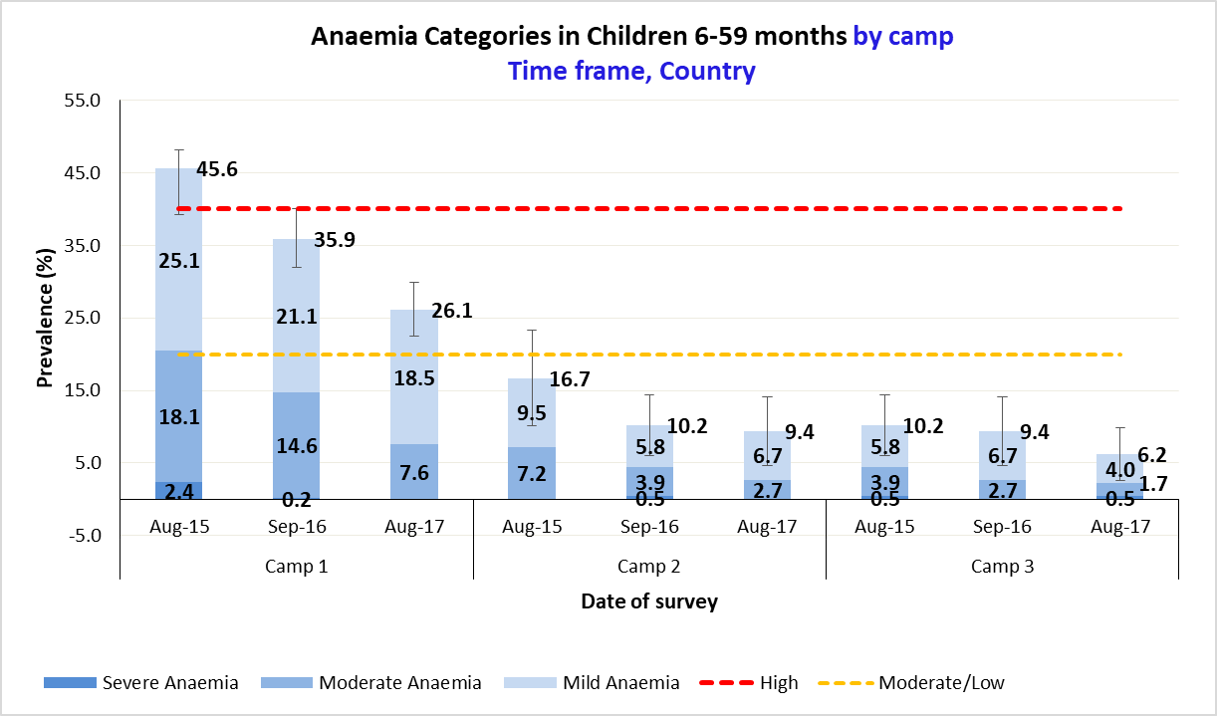

Figure 14 PREVALENCE OF TOTAL ANAEMIA (<11 G/DL), AND MODERATE AND SEVERE ANAEMIA (<10 G/DL) WITH 95% CI IN CHILDREN 6-59 MONTHS FROM 2015-2018, by camp. Note that a trend can only be identified when there are at least three time points. It is advised that data are obtained from SENS surveys carried out at similar times of the year. *(this FIGURE CAN BE automatically GENERATED BY USING sENS PRE-MODULE TOOL 17b- TRENDS AND GRAPHS)*

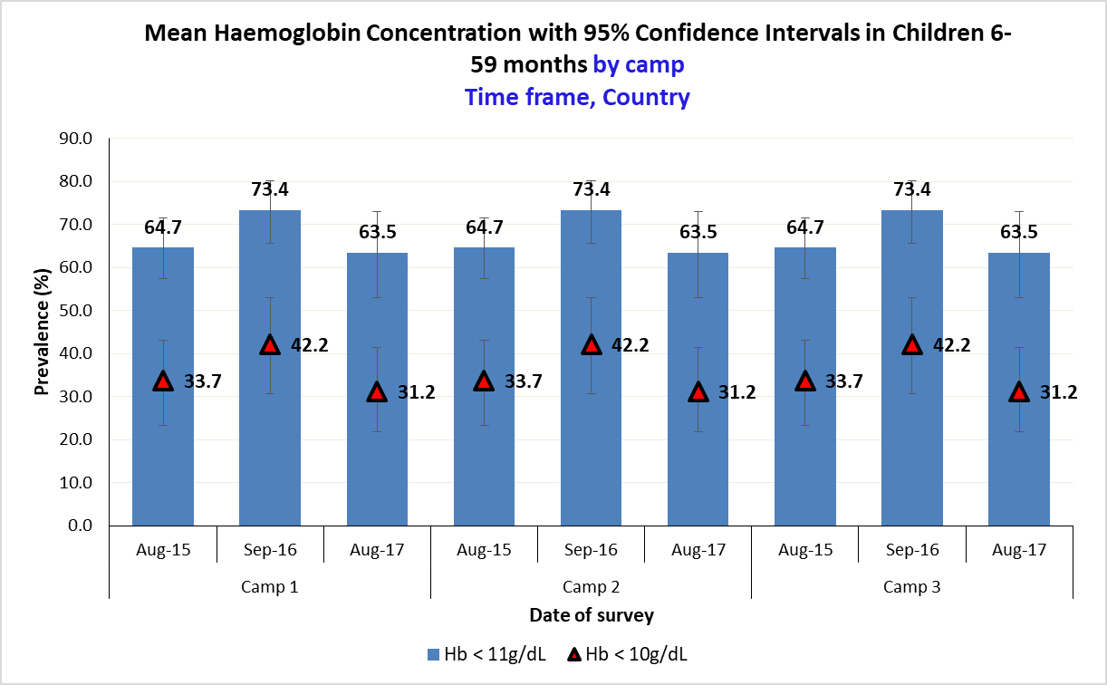

**Figure 15** mean haemoglobin concentration WITH 95% ci in children 6-59 months from 2015-2018, by camp. **Note that a trend can only be identified when there are at least three time points. It is advised that data are obtained from SENS surveys carried out at similar times of the year.***(this FIGURE CAN BE automatically GENERATED BY USING sENS PRE-MODULE TOOL 17B- TRENDS AND GRAPHS)*

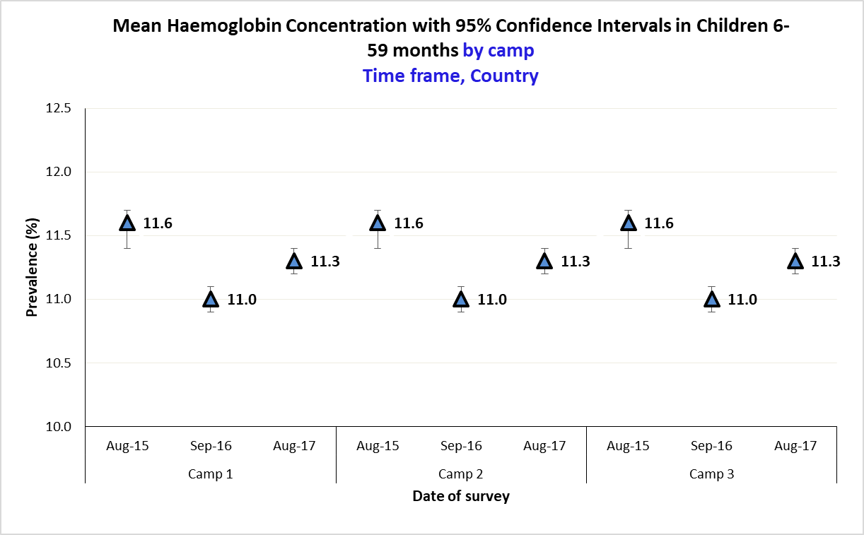

**4.3 Children 0-23 months**

Table 48 Prevalence of Infant and Young Child Feeding Practices Indicators, by CAMP

|  |  |  |  |  |  |  |  |  |  |
| --- | --- | --- | --- | --- | --- | --- | --- | --- | --- |
| **Survey Area** | **N** | **Camp 1** | | **N** | **Camp 2** | | **N** | **Camp 3** | |
| **n** | **%**  **(95% CI)** | **n** | **%**  **(95% CI)** | **n** | **%**  **(95% CI)** |
| **WHO INDICATORS** | | | | | | | | | |
| **Timely initiation of breastfeeding** (0-23 mo) |  |  |  |  |  |  |  |  |  |
| **Exclusive breastfeeding under 6 months** (0-5 mo) |  |  |  |  |  |  |  |  |  |
| **Predominant breastfeeding under 6 months** (0-5 mo) |  |  |  |  |  |  |  |  |  |
| **Continued breastfeeding at 1 year** (12-15 mo) |  |  |  |  |  |  |  |  |  |
| **Continued breastfeeding at 2 years** (20-23 mo) |  |  |  |  |  |  |  |  |  |
| **Introduction of solid, semi-solid or soft foods** (6-8 mo) |  |  |  |  |  |  |  |  |  |
| **Consumption of iron-rich or iron-fortified foods** (6-23 mo) |  |  |  |  |  |  |  |  |  |
| **Bottle feeding** (0-23 mo) |  |  |  |  |  |  |  |  |  |
| **UNHCR INDICATORS** | | | | | | | | | |
| **No breastfeeding under 6 months** (0-5 mo) |  |  |  |  |  |  |  |  |  |
| **No breastfeeding under 12 months** (0-11 mo) |  |  |  |  |  |  |  |  |  |

* The prevalence of a few IYCF indicators should be presented from year to year as shown in the example figure below.
* When IYCF indicators are collected in nutritional surveys based on GAM in children aged 6-59 months, it is not feasible to achieve a large enough sample size for some of the indicators to be estimated as precisely as desired, especially for indicators covering a very narrow age range (e.g. 12-15 months, 6-8 months). Hence, trend analyses need to be interpreted with caution. Nevertheless, trend analyses are useful for assessing the situation and major differences seen from year to year should warrant further investigation.

Figure 16 KEY IYCF indicators from 2015-2017, by camp *(this FIGURE CAN BE automatically GENERATED BY USING sENS pre-module TOOL 17B – TRENDS AND GRAPHS)*

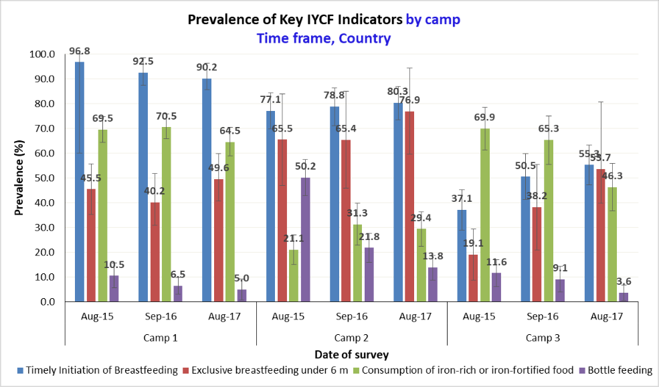

**Prevalence of intake**

**Infant formula**

Table 49 Infant formula intake in children aged 0-23 months, by camp

|  |  |  |  |
| --- | --- | --- | --- |
| **Survey Area** | **N** | **Proportion of children aged 0-23 months who receive infant formula (fortified or non-fortified)** | |
| **n** | **% (95% CI)** |
| **Camp 1** |  |  |  |
| **Camp 2** |  |  |  |
| **Camp 3** |  |  |  |

**Fortified blended foods (if applicable)**

Table 50 FBF intake in children aged 6-23 months, by camp [PRODUCT TO BE ADAPTED: the FBF may be CSB+ for example; DO NOT INCLUDE TABLE IF NO FBF DISTRIBUTED]

|  |  |  |  |
| --- | --- | --- | --- |
| **Survey Area** | **N** | **Proportion of children aged 6-23 months who receive FBF** | |
| **n** | **% (95% CI)** |
| **Camp 1** |  |  |  |
| **Camp 2** |  |  |  |
| **Camp 3** |  |  |  |

Table 51 FBF++ intake in children aged 6-23 months, by CAMP [PRODUCT TO BE ADAPTED: the FBF++ may be CSB++ for example; DO NOT INCLUDE TABLE IF NO FBF++ DISTRIBUTED]

|  |  |  |  |
| --- | --- | --- | --- |
| **Survey Area** | **N** | **Proportion of children aged 6-23 months who receive FBF++** | |
| **n** | **% (95% CI)** |
| **Camp 1** |  |  |  |
| **Camp 2** |  |  |  |
| **Camp 3** |  |  |  |

**Special nutritional products (if applicable)**

Table 52 LNS intake in children aged 6-23 months, by CAMP [PRODUCT TO BE ADAPTED: the LNS product may be Nutributter® or Plumpy’doz® for example; DO NOT INCLUDE TABLE IF NO LNS DISTRIBUTED]

|  |  |  |  |
| --- | --- | --- | --- |
| **Survey Area** | **N** | **Proportion of children aged 6-23 months who receive LNS** | |
| **n** | **% (95% CI)** |
| **Camp 1** |  |  |  |
| **Camp 2** |  |  |  |
| **Camp 3** |  |  |  |

Table 53 MNP intake in children aged 6-23 months, by CAMP [PRODUCT TO BE ADAPTED: the MNP may have a specific name; DO NOT INCLUDE TABLE IF NO MNP DISTRIBUTED]

|  |  |  |  |
| --- | --- | --- | --- |
| **Survey Area** | **N** | **Proportion of children aged 6-23 months who receive MNP** | |
| **n** | **% (95% CI)** |
| **Camp 1** |  |  |  |
| **Camp 2** |  |  |  |
| **Camp 3** |  |  |  |

**4.4 Women 15-49 years**

Table 54 Women physiological status and age, BY CAMP (OPTIONAL)

|  |  |  |  |  |  |  |  |  |  |  |
| --- | --- | --- | --- | --- | --- | --- | --- | --- | --- | --- |
| **Survey Area** | **N** | **Non-pregnant, non-lactating** | | **Pregnant** | | **Lactating with an infant less than 6 months** | | **Lactating with an infant greater than 6 months** | | **Mean age in years** |
| **n** | **% (95% CI)** | **n** | **% (95% CI)** | **n** | **% (95% CI)** | **n** | **% (95% CI)** | **[min, max]** |
| **Camp 1** |  |  |  |  |  |  |  |  |  |  |
| **Camp 2** |  |  |  |  |  |  |  |  |  |  |
| **Camp 3** |  |  |  |  |  |  |  |  |  |  |

**MUAC in women (optional)**

**TABLE 55** PREVALENCE OF MUAC MALNUTRITION IN NON-PREGNANT, NON-LACTATING WOMEN, BY CAMP (*ADAPT THE CUT-OFFS TO THE CONTEXT)*

|  |  |  |  |
| --- | --- | --- | --- |
| **Survey Area** | **N** | **Prevalence of MUAC < [INSERT VALUE] mm** | |
| **n** | **% (95% CI)** |
| **Camp 1** |  |  |  |
| **Camp 2** |  |  |  |
| **Camp 3** |  |  |  |

**TABLE 56** PREVALENCE OF MUAC MALNUTRITION IN PREGNANT AND LACTATING WOMEN WITH AN INFANT LESS THAN 6 MONTHS, BY CAMP (*ADAPT THE CUT-OFFS TO THE CONTEXT)*

|  |  |  |  |
| --- | --- | --- | --- |
| **Survey Area** | **N** | **Prevalence of MUAC < [INSERT VALUE] mm** | |
| **n** | **% (95% CI)** |
| **Camp 1** |  |  |  |
| **Camp 2** |  |  |  |
| **Camp 3** |  |  |  |

**BSFP enrolment (if applicable)**

Table 57 COVERAGE OF THE BLANKET SUPPLEMENTARY FEEDING PROGRAMME, by camp (IF APPLICABLE)

|  |  |  |  |
| --- | --- | --- | --- |
| **Survey Area** | **Programme** | **Number/total** | **% (95% CI)** |
| **Camp 1** | **Blanket feeding programme enrolment** |  |  |
| **Product name** | |______________________| | |
| **Target age group** | |______________________| | |
| **Camp 2** | **Blanket feeding programme enrolment** |  |  |
| **Product name** | |______________________| | |
| **Target age group** | |______________________| | |
| **Camp 3** | **Blanket feeding programme enrolment** |  |  |
| **Product name** | |______________________| | |
| **Target age group** | |______________________| | |

**Anaemia**

Table 58 Prevalence of TOTAL anaemia, ANAEMIA CATEGORIES, and MEAN haemoglobin concentration in non-pregnant women of reproductive age (15-49 years), by camp

|  |  |  |  |  |
| --- | --- | --- | --- | --- |
|  | | **Camp 1**  N = | **Camp 2**  N= | **Camp 3**  N= |
| **Total Anaemia (Hb<12.0 g/dL)** | | (n) %  (95% CI) | (n) %  (95% CI) | (n) %  (95% CI) |
| **Mild Anaemia (Hb 11.0-11.9 g/dL)** | | (n) %  (95% CI) | (n) %  (95% CI) | (n) %  (95% CI) |
| **Moderate Anaemia (8.0-10.9 g/dL)** | | (n) %  (95% CI) | (n) %  (95% CI) | (n) %  (95% CI) |
| **Severe Anaemia (<8.0 g/dL)** | | (n) %  (95% CI) | (n) %  (95% CI) | (n) %  (95% CI) |
| **Mean Hb (g/dL)**  **(SD)**  **[range]** | **SRS design\*** | g/dL  (SD)  [min, max] | g/dL  (SD)  [min, max] | g/dL  (SD)  [min, max] |
| **Mean Hb (g/dL)**  **(95% CI)**  **[range]** | **Cluster design\*** | g/dL  (95% CI)  [min, max] | g/dL  (95% CI)  [min, max] | g/dL  (95% CI)  [min, max] |

*When using the Means commands in Epi Info, it will provide the standard deviation (SD) when using the Statistics module and the 95% Confidence Interval when using the Advanced Statistics module.

* + Anaemia prevalence (mild, moderate and severe) and mean Hb results in women of reproductive age (non-pregnant) should be presented from year to year as shown in the example figures below.

Figure 17 PREVALENCE OF anaemia BY categories in women of reproductive age (non-pregnant) from 2015-2018, by camp. Note that a trend can only be identified when there are at least three time points. It is advised that prevalence data are obtained from SENS surveys carried out at similar times of the year. *(this FIGURE CAN BE automatically GENERATED BY USING sENS PRE-MODULE TOOL 17b- TRENDS AND GRAPHS)*

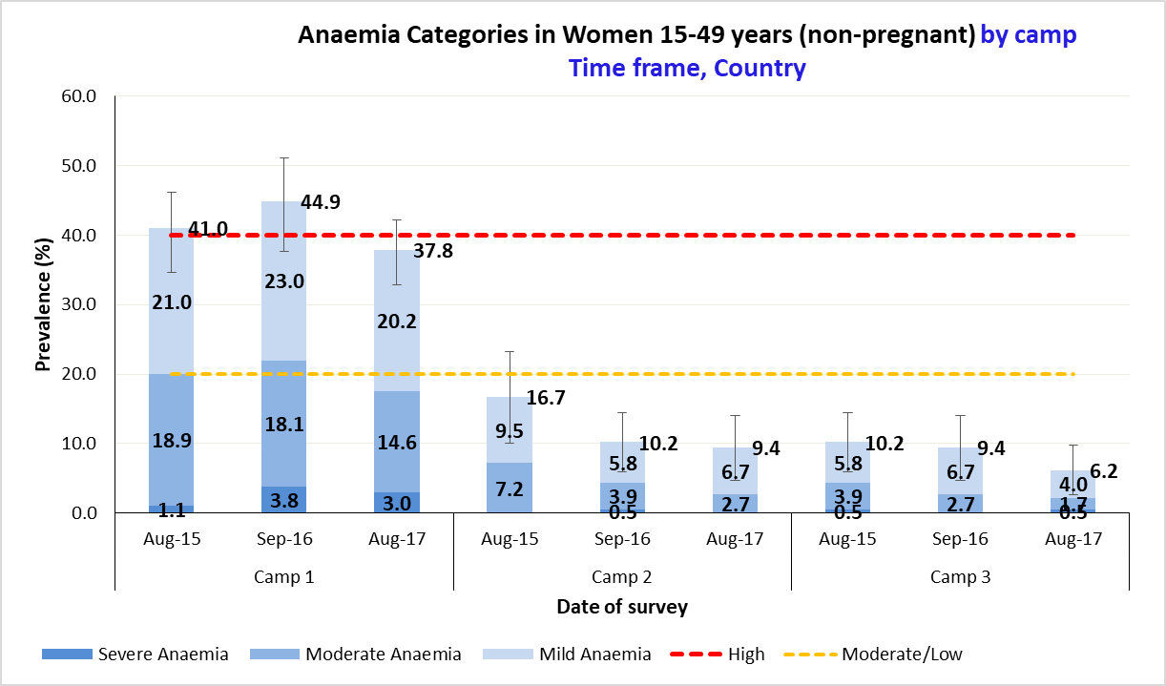

Figure 18 mean haemoglobin concentration with 95% CI in women of reproductive age (non-pregnant) from 2015-2018, by camp. Note that a trend can only be identified when there are at least three time points. It is advised that data are obtained from SENS surveys carried out at similar times of the year. *(this FIGURE CAN BE automatically GENERATED BY USING sENS PRE-MODULE TOOL 17b- TRENDS AND GRAPHS)*

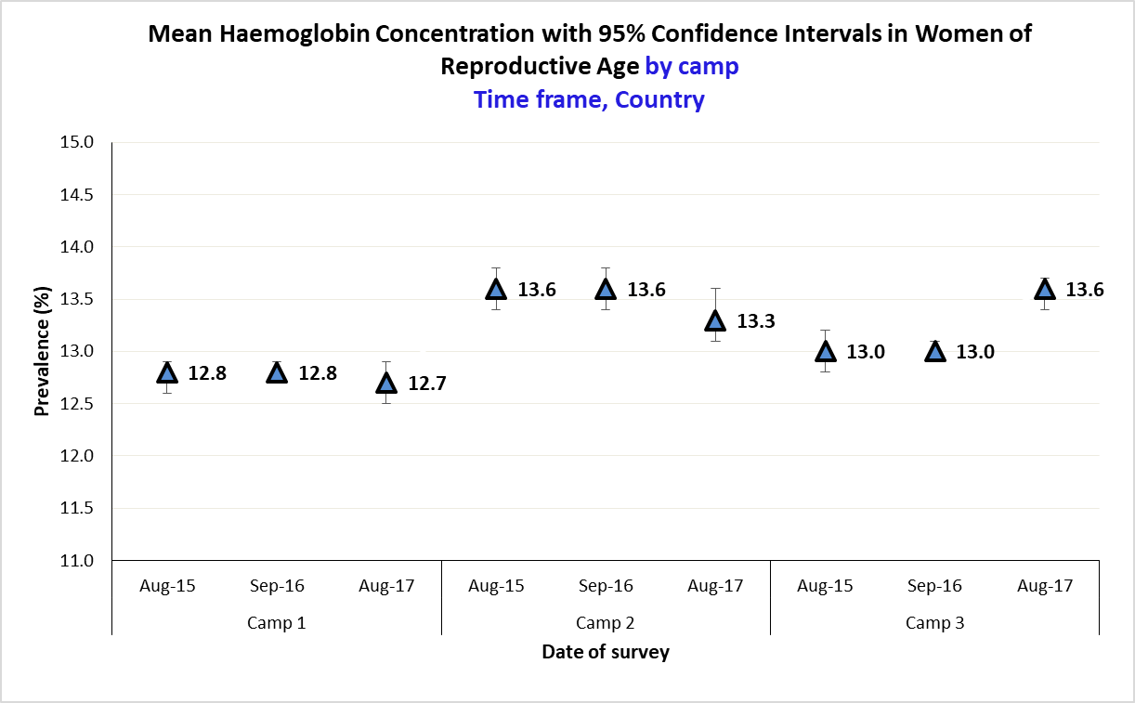

Table 59 ANC ENROLMENT AND IRON-FOLIC ACID PILLS COVERAGE AMONG PREGNANT WOMEN (15-49 YEARS), by camp

|  |  |  |  |  |  |
| --- | --- | --- | --- | --- | --- |
| **Survey Area** | **N** | **Currently enrolled in ANC programme** | | **Currently receiving iron-folic acid pills** | |
| **n** | **% (95% CI)** | **n** | **% (95% CI)** |
| **Camp 1** |  |  |  |  |  |
| **Camp 2** |  |  |  |  |  |
| **Camp 3** |  |  |  |  |  |

Figure 19 ANC ENROLMENT AND coverage of IRON-ACID FOLIC supplementation in PREGNANT WOMEN 15-49 YEARS from 2015-2017, by camp. Note that a trend can only be identified when there are at least three time points *(this FIGURE CAN BE automatically GENERATED BY USING sENS PRE-MODULE TOOL 17b- TRENDS AND GRAPHS)*

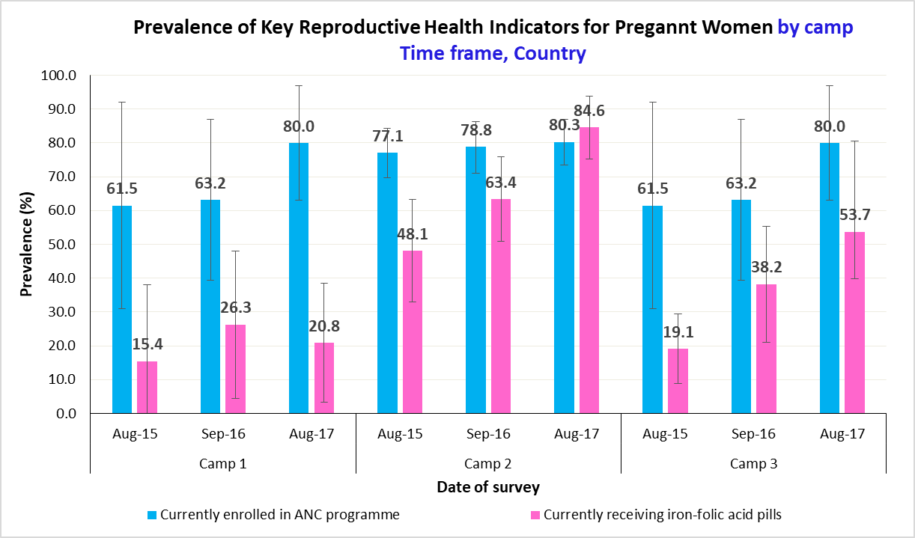

**4.5 Food security**

Table 60 FOOD SECURITY SAMPLING INFORMATION, by camp

|  |  |  |  |
| --- | --- | --- | --- |
| **Total households surveyed for Food Security** | **Planned** | **Actual** | **% of target** |
| **Camp 1** |  | *[only include households with data; exclude absent households and refusals]* |  |
| **Camp 2** |  | *[only include households with data; exclude absent households and refusals]* |  |
| **Camp 3** |  | *[only include households with data; exclude absent households and refusals]* |  |

**Access to food assistance**

Table 61 FOOD ASSISTANCE TYPE, AMOUNT AND DISTRIBUTION SCHEDULE for the last distribution in camp 1*

|  |  |  |  |  |
| --- | --- | --- | --- | --- |
| **Type** | **Distribution schedule**  **(days)** | **Commodities/products distributed** | **Amount per person per day**  **(g/day)** | **Kcal per person per day** |
| **In-kind** |  | Cereals |  |  |
|  | Legumes |  |  |
|  | Oil |  |  |
|  | Sugar |  |  |
|  | Salt |  |  |
|  | Fortified blended food |  |  |
|  | [OTHER] |  |  |
| **Cash grants** | **Targeting category\*\*** | **Distribution schedule** | **Transfer value** | **To cover what percentage of food requirements** |
| Category A |  |  |  |
| Category B |  |  |  |
| Category C |  |  |  |
| Category D |  |  |  |
| **Vouchers** | **Targeting category\*\*** | **Distribution schedule** | **Value of voucher** | **To cover what percentage of food requirements** |
| Category A |  |  |  |
| Category B |  |  |  |
| Category C |  |  |  |
| Category D |  |  |  |

*Note that this data is not collected during a SENS survey in the household questionnaire. Every effort should be made to gather this data prior to the survey start and present it in the final report as outlined above.

**Do not fill this column if cash grant /voucher is provided to all, equally (not targeted to a sub-set of the population). Replace the categories with the terms used locally starting from the most vulnerable to least vulnerable, e.g. very poor, poor, medium, well off.

Table 62 FOOD ASSISTANCE TYPE, AMOUNT AND DISTRIBUTION SCHEDULE for the last distribution in camp 2*

|  |  |  |  |  |
| --- | --- | --- | --- | --- |
| **Type** | **Distribution schedule**  **(days)** | **Commodities/products distributed** | **Amount per person per day**  **(g/day)** | **Kcal per person per day** |
| **In-kind** |  | Cereals |  |  |
|  | Legumes |  |  |
|  | Oil |  |  |
|  | Sugar |  |  |
|  | Salt |  |  |
|  | Fortified blended food |  |  |
|  | [OTHER] |  |  |
| **Cash grants** | **Targeting category\*\*** | **Distribution schedule** | **Transfer value** | **To cover what percentage of food requirements** |
| Category A |  |  |  |
| Category B |  |  |  |
| Category C |  |  |  |
| Category D |  |  |  |
| **Vouchers** | **Targeting category\*\*** | **Distribution schedule** | **Value of voucher** | **To cover what percentage of food requirements** |
| Category A |  |  |  |
| Category B |  |  |  |
| Category C |  |  |  |
| Category D |  |  |  |

*Note that this data is not collected during a SENS survey in the household questionnaire. Every effort should be made to gather this data prior to the survey start and present it in the final report as outlined above.

**Do not fill this column if cash grant /voucher is provided to all, equally (not targeted to a sub-set of the population). Replace the categories with the terms used locally starting from the most vulnerable to least vulnerable, e.g. very poor, poor, medium, well off.

Table 63 FOOD ASSISTANCE TYPE, AMOUNT AND DISTRIBUTION SCHEDULE for the last distribution in camp 3*

|  |  |  |  |  |
| --- | --- | --- | --- | --- |
| **Type** | **Distribution schedule**  **(days)** | **Commodities/products distributed** | **Amount per person per day**  **(g/day)** | **Kcal per person per day** |
| **In-kind** |  | Cereals |  |  |
|  | Legumes |  |  |
|  | Oil |  |  |
|  | Sugar |  |  |
|  | Salt |  |  |
|  | Fortified blended food |  |  |
|  | [OTHER] |  |  |
| **Cash grants** | **Targeting category\*\*** | **Distribution schedule** | **Transfer value** | **To cover what percentage of food requirements** |
| Category A |  |  |  |
| Category B |  |  |  |
| Category C |  |  |  |
| Category D |  |  |  |
| **Vouchers** | **Targeting category\*\*** | **Distribution schedule** | **Value of voucher** | **To cover what percentage of food requirements** |
| Category A |  |  |  |
| Category B |  |  |  |
| Category C |  |  |  |
| Category D |  |  |  |

*Note that this data is not collected during a SENS survey in the household questionnaire. Every effort should be made to gather this data prior to the survey start and present it in the final report as outlined above.

**Do not fill this column if cash grant /voucher is provided to all, equally (not targeted to a sub-set of the population). Replace the categories with the terms used locally starting from the most vulnerable to least vulnerable, e.g. very poor, poor, medium, well off.

Table 64 HOUSEHOLDS BY TARGETING CATEGORIES, by camp *(IF APPLICABLE - REPLACE THE CATEGORIES WITH THE TERMS USED LOCALLY)*

|  |  |  |  |
| --- | --- | --- | --- |
| **Survey Area** | **Household targeting category** | **Number/total** | **% (95% CI)** |
| **Camp 1** | Category A |  |  |
| Category B |  |  |
| Category C |  |  |
| Category D |  |  |
| **Camp 2** | Category A |  |  |
| Category B |  |  |
| Category C |  |  |
| Category D |  |  |
| **Camp 3** | Category A |  |  |
| Category B |  |  |
| Category C |  |  |
| Category D |  |  |

Table 65 Food assistance coverage

|  |  |  |  |
| --- | --- | --- | --- |
| **Survey Area** | **N** | **Proportion of households receiving a food assistance including in-kind and/or cash grants and/or food vouchers** | |
| **n** | **% (95% CI)** |
| **Camp 1** |  |  |  |
| **Camp 2** |  |  |  |
| **Camp 3** |  |  |  |

Out of the households reporting not to have access to food assistance, add the following text description when relevant:

[INSERT PROPORTION] said it was because they were not given a ration card and/or cash grant and/or food voucher, even if they were included in the targeting criteria; [insert proportion] said it was because they were not registered; [insert proportion] said it was because they were registered but determined not eligible; and [insert proportion] gave other reasons.

**In-kind food distribution (if applicable)**

Table 66 Reported duration of general food DISTRIBUTION, by camp

|  |  |  |  |  |
| --- | --- | --- | --- | --- |
| **Average number of days the general food distribution lasts** | | **Camp 1**  N = | **Camp 2**  N= | **Camp 3**  N= |
| **Mean (Days)**  **(SD)**  **[range]** | **SRS design\*** | Days  (SD)  [min, max] | Days  (SD)  [min, max] | Days  (SD)  [min, max] |
| **Mean (Days)**  **(95% CI)**  **[range]** | **Cluster design\*** | Days  (95% CI)  [min, max] | Days  (95% CI)  [min, max] | Days  (95% CI)  [min, max] |

*When using the Means commands in Epi Info, it will provide the standard deviation (SD) when using the Statistics module and the 95% Confidence Interval when using the Advanced Statistics module.

Table 67 REPORTED DURATION OF GENERAL FOOD DISTRIBUTION BY targeting categories, by camp (IF APPLICABLE - REPLACE THE CATEGORIES WITH THE TERMS USED LOCALLY)

|  |  |  |  |  |
| --- | --- | --- | --- | --- |
| **Survey Area** | **Household targeting category** | **Number/total** | **Mean (days)**  **(SD)** | **Mean (days)**  **(95% CI)** |
| **SRS design\*** | **Cluster design\*** |
| **Camp 1** | Category A |  |  |  |
| Category B |  |  |  |
| Category C |  |  |  |
| Category D |  |  |  |
| **Camp 2** | Category A |  |  |  |
| Category B |  |  |  |
| Category C |  |  |  |
| Category D |  |  |  |
| **Camp 3** | Category A |  |  |  |
| Category B |  |  |  |
| Category C |  |  |  |
| Category D |  |  |  |

*When using the Means commands in Epi Info, it will provide the standard deviation (SD) when using the Statistics module and the 95% Confidence Interval when using the Advanced Statistics module.

**Cash grants (if applicable)**

Table 68 cash grants coverage, BY CAMP

|  |  |  |  |
| --- | --- | --- | --- |
| **Survey Area** | **N** | **Proportion of households receiving cash grants** | |
| **n** | **% (95% CI)** |
| **Camp 1** |  |  |  |
| **Camp 2** |  |  |  |
| **Camp 3** |  |  |  |

Table 69 DESCRIPTION OF utilisation of cash grants in camp 1

|  |  |  |
| --- | --- | --- |
| **Proportion of households that use cash grants for:** | **Number/total** | **% (95% CI)** |
| Food |  |  |
| Water |  |  |
| Hygiene items, clothes, shoes |  |  |
| Health costs (including medicines) |  |  |
| Rent, shelter repair, household items (e.g. mattress, blankets, jerrycan), utilities and bills (e.g. electricity, water bills, phone calling credit) |  |  |
| Firewood / fuel for cooking or heating |  |  |
| Assets for a livelihood activity (e.g. seeds, tools, farming, fishing, petty trade, etc.) |  |  |
| Debts repayment |  |  |
| Saved some money, gave some to other family members, relatives, friends |  |  |
| Education (e.g. school fees, uniform, books) |  |  |
| Other |  |  |

Table 70 DESCRIPTION OF utilisation of cash grants in camp 2

|  |  |  |
| --- | --- | --- |
| **Proportion of households that use cash grants for:** | **Number/total** | **% (95% CI)** |
| Food |  |  |
| Water |  |  |
| Hygiene items, clothes, shoes |  |  |
| Health costs (including medicines) |  |  |
| Rent, shelter repair, household items (e.g. mattress, blankets, jerrycan), utilities and bills (e.g. electricity, water bills, phone calling credit) |  |  |
| Firewood / fuel for cooking or heating |  |  |
| Assets for a livelihood activity (e.g. seeds, tools, farming, fishing, petty trade, etc.) |  |  |
| Debts repayment |  |  |
| Saved some money, gave some to other family members, relatives, friends |  |  |
| Education (e.g. school fees, uniform, books) |  |  |
| Other |  |  |

Table 71 DESCRIPTION OF utilisation of cash grants in camp 3

|  |  |  |
| --- | --- | --- |
| **Proportion of households that use cash grants for:** | **Number/total** | **% (95% CI)** |
| Food |  |  |
| Water |  |  |
| Hygiene items, clothes, shoes |  |  |
| Health costs (including medicines) |  |  |
| Rent, shelter repair, household items (e.g. mattress, blankets, jerrycan), utilities and bills (e.g. electricity, water bills, phone calling credit) |  |  |
| Firewood / fuel for cooking or heating |  |  |
| Assets for a livelihood activity (e.g. seeds, tools, farming, fishing, petty trade, etc.) |  |  |
| Debts repayment |  |  |
| Saved some money, gave some to other family members, relatives, friends |  |  |
| Education (e.g. school fees, uniform, books) |  |  |
| Other |  |  |

**Food voucher (if applicable)**

Table 72 food voucher coverage, BY CAMP

|  |  |  |  |
| --- | --- | --- | --- |
| **Survey Area** | **N** | **Proportion of households receiving food vouchers to cover basic food needs** | |
| **n** | **% (95% CI)** |
| **Camp 1** |  |  |  |
| **Camp 2** |  |  |  |
| **Camp 3** |  |  |  |

Table 73 food voucher use, BY CAMP

|  |  |  |  |
| --- | --- | --- | --- |
| **Survey Area** | **N** | **Proportion of households selling food vouchers or products accessed with food vouchers to access other goods and/or services** | |
| **n** | **% (95% CI)** |
| **Camp 1** |  |  |  |
| **Camp 2** |  |  |  |
| **Camp 3** |  |  |  |

**Coverage of basic needs**

Table 74 DESCRIPTION OF BASIC NEEDS NOT MET BY THE HOUSEHOLDS, in camp 1

|  |  |  |
| --- | --- | --- |
| **Basic needs not met by the households:** | **Number/total** | **% (95% CI)** |
| Food |  |  |
| Water |  |  |
| Hygiene items, clothes, shoes |  |  |
| Health costs (including medicines) |  |  |
| Rent, shelter repair, household items (e.g. mattress, blankets, jerrycan), utilities and bills (e.g. electricity, water bills, phone calling credit) |  |  |
| Firewood / fuel for cooking or heating |  |  |
| Assets for a livelihood activity (e.g. seeds, tools, farming, fishing, petty trade, etc.) |  |  |
| Debts repayment |  |  |
| Saved some money, support other family members, relatives, friends |  |  |
| Education (e.g. school fees, uniform, books) |  |  |
| Other |  |  |

Table 75 DESCRIPTION OF BASIC NEEDS NOT MET BY THE HOUSEHOLDS, in camp 2

|  |  |  |
| --- | --- | --- |
| **Basic needs not met by the households:** | **Number/total** | **% (95% CI)** |
| Food |  |  |
| Water |  |  |
| Hygiene items, clothes, shoes |  |  |
| Health costs (including medicines) |  |  |
| Rent, shelter repair, household items (e.g. mattress, blankets, jerrycan), utilities and bills (e.g. electricity, water bills, phone calling credit) |  |  |
| Firewood / fuel for cooking or heating |  |  |
| Assets for a livelihood activity (e.g. seeds, tools, farming, fishing, petty trade, etc.) |  |  |
| Debts repayment |  |  |
| Saved some money, support other family members, relatives, friends |  |  |
| Education (e.g. school fees, uniform, books) |  |  |
| Other |  |  |

Table 76 DESCRIPTION OF BASIC NEEDS NOT MET BY THE HOUSEHOLDS, in camp 3

|  |  |  |
| --- | --- | --- |
| **Basic needs not met by the households:** | **Number/total** | **% (95% CI)** |
| Food |  |  |
| Water |  |  |
| Hygiene items, clothes, shoes |  |  |
| Health costs (including medicines) |  |  |
| Rent, shelter repair, household items (e.g. mattress, blankets, jerrycan), utilities and bills (e.g. electricity, water bills, phone calling credit) |  |  |
| Firewood / fuel for cooking or heating |  |  |
| Assets for a livelihood activity (e.g. seeds, tools, farming, fishing, petty trade, etc.) |  |  |
| Debts repayment |  |  |
| Saved some money, support other family members, relatives, friends |  |  |
| Education (e.g. school fees, uniform, books) |  |  |
| Other |  |  |

Table 77 HOUSEHOLDS BY CATEGORIES OF COVERAGE OF BASIC NEEDS, by camp

|  |  |  |  |
| --- | --- | --- | --- |
| **Survey Area** | **Proportion of households in each category of coverage of basic needs** | **Number/total** | **% (95% CI)** |
| **Camp 1** | All basic needs are met (100%) |  |  |
| More half basic needs are met (>50%) |  |  |
| Few basic needs are met (<50%) |  |  |
| Basic needs are not met (0%) |  |  |
| **Camp 2** | All basic needs are met (100%) |  |  |
| More half basic needs are met (>50%) |  |  |
| Few basic needs are met (<50%) |  |  |
| Basic needs are not met (0%) |  |  |
| **Camp 3** | All basic needs are met (100%) |  |  |
| More half basic needs are met (>50%) |  |  |
| Few basic needs are met (<50%) |  |  |
| Basic needs are not met (0%) |  |  |

**Access to cooking fuel (if applicable)**

Table 78 COOKING FUEL USE in camp 1 (ADAPT LIST TO COOKING FUEL SOURCES AVAILABLE IN THE LOCAL SETTING)

|  |  |  |
| --- | --- | --- |
| **Proportion of households using the following cooking fuel:** | **Number/total** | **% (95% CI)** |
| Wood |  |  |
| Charcoal |  |  |
| Kerosene |  |  |
| Biogas |  |  |
| Liquid petroleum gas (LPG) |  |  |
| Ethanol |  |  |
| Briquettes |  |  |
| Other |  |  |

Table 79 COOKING FUEL USE in camp 2 (ADAPT LIST TO COOKING FUEL SOURCES AVAILABLE IN THE LOCAL SETTING)

|  |  |  |
| --- | --- | --- |
| **Proportion of households using the following cooking fuel:** | **Number/total** | **% (95% CI)** |
| Wood |  |  |
| Charcoal |  |  |
| Kerosene |  |  |
| Biogas |  |  |
| Liquid petroleum gas (LPG) |  |  |
| Ethanol |  |  |
| Briquettes |  |  |
| Other |  |  |

Table 80 COOKING FUEL USE in camp 3 (ADAPT LIST TO COOKING FUEL SOURCES AVAILABLE IN THE LOCAL SETTING)

|  |  |  |
| --- | --- | --- |
| **Proportion of households using the following cooking fuel:** | **Number/total** | **% (95% CI)** |
| Wood |  |  |
| Charcoal |  |  |
| Kerosene |  |  |
| Biogas |  |  |
| Liquid petroleum gas (LPG) |  |  |
| Ethanol |  |  |
| Briquettes |  |  |
| Other |  |  |

Table 81 cooking fuel assistance coverage, by camp (if applicable)

|  |  |  |  |
| --- | --- | --- | --- |
| **Survey Area** | **N** | **Proportion of households receiving cooking fuel assistance** | |
| **n** | **% (95% CI)** |
| **Camp 1** |  |  |  |
| **Camp 2** |  |  |  |
| **Camp 3** |  |  |  |

Table 82 Reported duration of cooking fuel assistance, by camp

|  |  |  |  |  |
| --- | --- | --- | --- | --- |
| **Average number of days the cooking fuel assistance lasts** | | **Camp 1**  N = | **Camp 2**  N= | **Camp 3**  N= |
| **Mean (days)**  **(SD)**  **[range]** | **SRS design\*** | Days  (SD)  [min, max] | Days  (SD)  [min, max] | Days  (SD)  [min, max] |
| **Mean (days)**  **(95% CI)**  **[range]** | **Cluster design\*** | Days  (95% CI)  [min, max] | Days  (95% CI)  [min, max] | Days  (95% CI)  [min, max] |

*When using the Means commands in Epi Info, it will provide the standard deviation (SD) when using the Statistics module and the 95% Confidence Interval when using the Advanced Statistics module.

**Negative coping strategies results**

Table 83 NEGATIVE Coping strategies used by the surveyed population in camp 1 over the past 4 WEEKS

|  |  |  |
| --- | --- | --- |
| **Proportion of households reporting using the following negative coping strategies over the past 4 weeks*:** | **Number/total** | **% (95% CI)** |
| Stop a child from attending school |  |  |
| Sold any assets that would not have normally sold |  |  |
| Ask for money from strangers (begging) |  |  |
| Move to a poorer quality shelter |  |  |
| Send household members under the age of 16 to work |  |  |
| Send a member of the household to work far away |  |  |
| Engage in potentially risky or harmful activities |  |  |
| Skip paying rent /debt repayments to meet other needs |  |  |
| Take out new loans or borrowed money |  |  |
| Reduce expenditure on hygiene items, water, baby items, health or education in order to meet household food needs |  |  |
| **Proportion of households reporting using one or more negative coping strategies over the past 4 weeks** |  |  |

**\*** The total will be over 100% as households may use several negative coping strategies.

Table 84 NEGATIVE Coping strategies used by the surveyed population in camp 2 over the past 4 WEEKS

|  |  |  |
| --- | --- | --- |
| **Proportion of households reporting using the following negative coping strategies over the past 4 weeks*:** | **Number/total** | **% (95% CI)** |
| Stop a child from attending school |  |  |
| Sold any assets that would not have normally sold |  |  |
| Ask for money from strangers (begging) |  |  |
| Move to a poorer quality shelter |  |  |
| Send household members under the age of 16 to work |  |  |
| Send a member of the household to work far away |  |  |
| Engage in potentially risky or harmful activities |  |  |
| Skip paying rent /debt repayments to meet other needs |  |  |
| Take out new loans or borrowed money |  |  |
| Reduce expenditure on hygiene items, water, baby items, health or education in order to meet household food needs |  |  |
| **Proportion of households reporting using one or more negative coping strategies over the past 4 weeks** |  |  |

**\*** The total will be over 100% as households may use several negative coping strategies.

Table 85 NEGATIVE Coping strategies used by the surveyed population in camp 3 over the past 4 WEEKS

|  |  |  |
| --- | --- | --- |
| **Proportion of households reporting using the following negative coping strategies over the past 4 weeks*:** | **Number/total** | **% (95% CI)** |
| Stop a child from attending school |  |  |
| Sold any assets that would not have normally sold |  |  |
| Ask for money from strangers (begging) |  |  |
| Move to a poorer quality shelter |  |  |
| Send household members under the age of 16 to work |  |  |
| Send a member of the household to work far away |  |  |
| Engage in potentially risky or harmful activities |  |  |
| Skip paying rent /debt repayments to meet other needs |  |  |
| Take out new loans or borrowed money |  |  |
| Reduce expenditure hygiene on items, water, baby items, health or education in order to meet household food needs |  |  |
| **Proportion of households reporting using one or more negative coping strategies over the past 4 weeks** |  |  |

**\*** The total will be over 100% as households may use several negative coping strategies.

Table 86 NEGATIVE Coping strategies used by the surveyed population in camp 1 over the past 7 days

|  |  |  |
| --- | --- | --- |
| **Proportion of households reporting using the following negative coping strategies over the past 7 days*:** | **Number/total** | **% (95% CI)** |
| Rely on less preferred and/or less expensive foods |  |  |
| Borrow food, or rely on help from a friend or relative |  |  |
| Reduce the number of meals eaten in a day |  |  |
| Limit portion sizes at mealtime |  |  |
| Reduce consumption by adults so children could eat |  |  |

**\*** The total will be over 100% as households may use several negative coping strategies.

Table 87 NEGATIVE Coping strategies used by the surveyed population in camp 2 over the past 7 days

|  |  |  |
| --- | --- | --- |
| **Proportion of households reporting using the following negative coping strategies over the past 7 days*:** | **Number/total** | **% (95% CI)** |
| Rely on less preferred and/or less expensive foods |  |  |
| Borrow food, or rely on help from a friend or relative |  |  |
| Reduce the number of meals eaten in a day |  |  |
| Limit portion sizes at mealtime |  |  |
| Reduce consumption by adults so children could eat |  |  |

**\*** The total will be over 100% as households may use several negative coping strategies.

Table 88 NEGATIVE Coping strategies used by the surveyed population in camp 3 over the past 7 days

|  |  |  |
| --- | --- | --- |
| **Proportion of households reporting using the following negative coping strategies over the past 7 days*:** | **Number/total** | **% (95% CI)** |
| Rely on less preferred and/or less expensive foods |  |  |
| Borrow food, or rely on help from a friend or relative |  |  |
| Reduce the number of meals eaten in a day |  |  |
| Limit portion sizes at mealtime |  |  |
| Reduce consumption by adults so children could eat |  |  |

**\*** The total will be over 100% as households may use several negative coping strategies.

Table 89 average rcsi*, by camp

|  |  |  |  |  |
| --- | --- | --- | --- | --- |
| **Average rCSI** | | **Camp 1**  N = | **Camp 2**  N= | **Camp 3**  N= |
| **Mean**  **(SD)**  **[range]** | **SRS design\*\*** | rCSI  (SD)  [min, max] | rCSI  (SD)  [min, max] | rCSI  (SD)  [min, max] |
| **Mean**  **(95% CI)**  **[range]** | **Cluster design\*\*** | rCSI  (95% CI)  [min, max] | rCSI  (95% CI)  [min, max] | rCSI  (95% CI)  [min, max] |

*Maximum rCSI is 56.

**When using the Means commands in Epi Info, it will provide the standard deviation (SD) when using the Statistics module and the 95% Confidence Interval when using the Advanced Statistics module.

**Food Consumption Score (FCS) and FSC-Nutrition (FCS-N) results**

The following information needs to be added as text in the results:

“The last general food distribution ended [insert number] days prior to the start of the survey data collection. Or cash grants and/or food vouchers were last provided on [insert DATE] [i.e. [insert number] days prior to the start of the survey data collection”

The general food distribution usually lasts more than one day and may be organised by family size, particularly if in-kind food assistance is used, hence the surveyed households will be at different times of the cycle which may have an impact on the FCS and FCS-N results and this needs to be considered in interpreting the data.

You should also provide an explanation on the season when the survey was conducted and its impact on the overall food availability. For example: “The survey was conducted during the annual lean season, during which the overall food availability is limited. It is hence likely that the household dietary diversity score is lower than it would be e.g. after the harvest.” Note also any extraordinary event that may have affected household dietary intake, such a drought or a festivity. Use of in-kind food items, cash grants or vouchers is also likely to have an impact on the FCS and this should be discussed in the report.

Table 90 Average FCS* by camp

|  |  |  |  |  |
| --- | --- | --- | --- | --- |
| **Average FCS** | | | | |
|  | | **Camp 1** | **Camp 2** | **Camp 3** |
| **Mean**  **(SD)**  **[range]** | **SRS design\*\*** | FCS  (SD)  [min, max] | FCS  (SD)  [min, max] | FCS  (SD)  [min, max] |
| **Mean**  **(95% CI)**  **[range]** | **Cluster design\*\*** | FCS  (95% CI)  [min, max] | FCS  (95% CI)  [min, max] | FCS  (95% CI)  [min, max] |

*Maximum FCS is 112 (129.5 if specialized nutritious foods are included).

**When using the Means commands in Epi Info, it will provide the standard deviation (SD) when using the Statistics module and the 95% Confidence Interval when using the Advanced Statistics module.

Table 91 FOOD CONSUMPTION SCORE BY CATEGORY, by camp

|  |  |  |  |
| --- | --- | --- | --- |
| **Survey Area** | **FCS profiles\*** | **Number/total** | **% (95% CI)** |
| **Camp 1** | Acceptable  FCS > 35 |  |  |
| Borderline  21.5≤FCS≤35 |  |  |
| Poor  FCS≤21 |  |  |
| **Camp 2** | Acceptable  FCS > 35 |  |  |
| Borderline  21.5≤FCS≤35 |  |  |
| Poor  FCS≤21 |  |  |
| **Camp 3** | Acceptable  FCS > 35 |  |  |
| Borderline  21.5≤FCS≤35 |  |  |
| Poor  FCS≤21 |  |  |

*In countries where households have a high sugar and oil consumption (oil and sugar eaten on a daily basis - ~7 days per week), cut-off points of 28 (poor/borderline) and 42 (borderline/acceptable) are usually recommended.

Table 92 FCS BY TARGETING CATEGORIES, by CAMp (IF APPLICABLE - REPLACE THE CATEGORIES WITH THE TERMS USED LOCALLY)

|  |  |  |  |  |
| --- | --- | --- | --- | --- |
| **Survey Area** | **Household targeting category** | **Number/total** | **Mean (FCS)**  **(SD)** | **Mean (FCS)**  **(95% CI)** |
| **SRS design\*** | **Cluster design\*** |
| **Camp 1** | Category A |  |  |  |
| Category B |  |  |  |
| Category C |  |  |  |
| Category D |  |  |  |
| **Camp 2** | Category A |  |  |  |
| Category B |  |  |  |
| Category C |  |  |  |
| Category D |  |  |  |
| **Camp 3** | Category A |  |  |  |
| Category B |  |  |  |
| Category C |  |  |  |
| Category D |  |  |  |

*When using the Means commands in Epi Info, it will provide the standard deviation (SD) when using the Statistics module and the 95% Confidence Interval when using the Advanced Statistics module.

Table 93 consumption frequency categories of each nutrient rich food groups (FCS-N) in camp 1

|  |  |  |  |
| --- | --- | --- | --- |
| **Nutrient rich food groups** | **Consumption frequency categories** | **Number/total** | **% (95% CI)** |
| **Vitamin A rich foods** | Never |  |  |
| Sometimes |  |  |
| At least daily |  |  |
| **Protein rich foods** | Never |  |  |
| Sometimes |  |  |
| At least daily |  |  |
| **Haem iron rich foods** | Never |  |  |
| Sometimes |  |  |
| At least daily |  |  |

Table 94 consumption frequency categories of each nutrient rich food groups (FCS-N) in camp 2

|  |  |  |  |
| --- | --- | --- | --- |
| **Nutrient rich food groups** | **Consumption frequency categories** | **Number/total** | **% (95% CI)** |
| **Vitamin A rich foods** | Never |  |  |
| Sometimes |  |  |
| At least daily |  |  |
| **Protein rich foods** | Never |  |  |
| Sometimes |  |  |
| At least daily |  |  |
| **Haem iron rich foods** | Never |  |  |
| Sometimes |  |  |
| At least daily |  |  |

Table 95 consumption frequency categories of each nutrient rich food groups (FCS-N) in camp 3

|  |  |  |  |
| --- | --- | --- | --- |
| **Nutrient rich food groups** | **Consumption frequency categories** | **Number/total** | **% (95% CI)** |
| **Vitamin A rich foods** | Never |  |  |
| Sometimes |  |  |
| At least daily |  |  |
| **Protein rich foods** | Never |  |  |
| Sometimes |  |  |
| At least daily |  |  |
| **Haem iron rich foods** | Never |  |  |
| Sometimes |  |  |
| At least daily |  |  |

Table 96 FOOD acquisition sources, by camp

|  |  |  |  |
| --- | --- | --- | --- |
| **Survey Area** | **Food acquisition sources** | **Number/total** | **% (95% CI)** |
| **Camp 1** | Purchase (using cash grants and/or with their own cash) |  |  |
| Own production (crops, livestock, fishing/hunting, gathering) |  |  |
| Traded goods/services, barter |  |  |
| Borrowed (loan/credit from traders) |  |  |
| Received as gift (from family relatives or friends/neighbour) |  |  |
| In-kind or voucher based food assistance |  |  |
| Other |  |  |
| **Camp 2** | Purchase (using cash grants and/or with their own cash) |  |  |
| Own production (crops, livestock, fishing/hunting, gathering) |  |  |
| Traded goods/services, barter |  |  |
| Borrowed (loan/credit from traders) |  |  |
| Received as gift (from family relatives or friends/neighbour) |  |  |
| In-kind or voucher based food assistance |  |  |
| Other |  |  |
| **Camp 3** | Purchase (using cash grants and/or with their own cash) |  |  |
| Own production (crops, livestock, fishing/hunting, gathering) |  |  |
| Traded goods/services, barter |  |  |
| Borrowed (loan/credit from traders) |  |  |
| Received as gift (from family relatives or friends/neighbour) |  |  |
| In-kind or voucher based food assistance |  |  |
| Other |  |  |

Figure 20 TRENDS OF FOOD CONSUMPTION PROFILES and rcsi FROM 2017 TO 2018, by camp *(THIS FIGURE CAN BE AUTOMATICALLY GENERATED BY USING SENS PRE-MODULE TOOL 17B – TRENDS AND GRAPHS)*

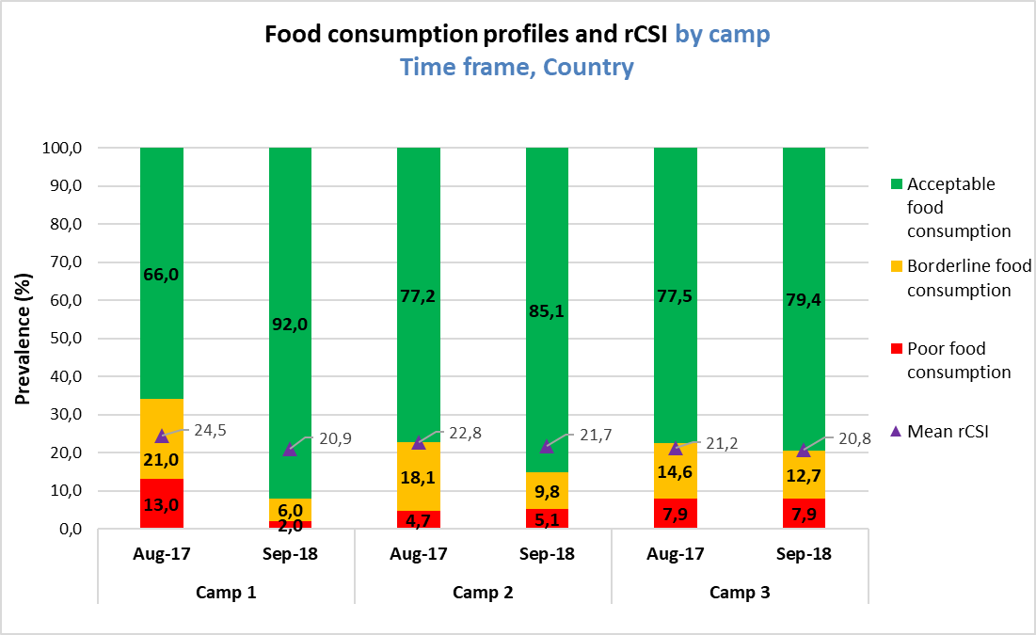

**Figure 21** TRENDS OF FREQUENCY CONSUMPTION OF PROTEIN, VITAMIN a AND HaEM IRON RICH FOODS FROM 2017 TO 2018, **in camp 1** *(this FIGURE CAN BE automatically GENERATED BY USING sENS PRE-MODULE TOOL 17b – TRENDS AND GRAPHS*

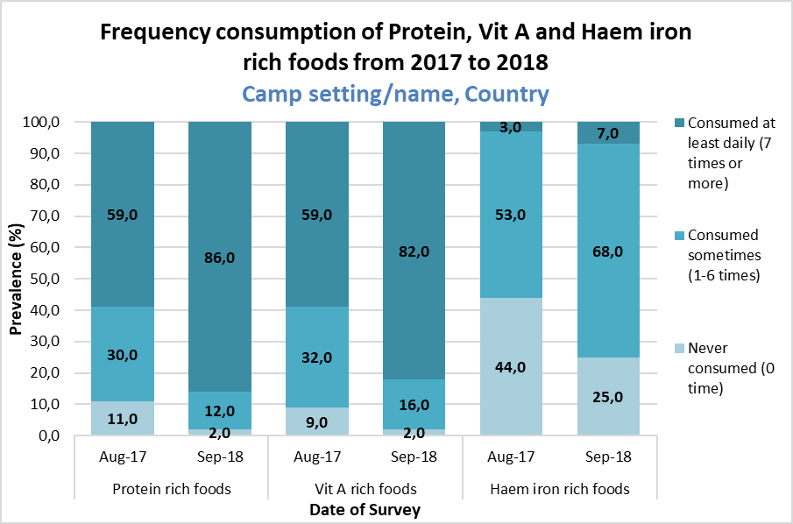

4.6 Mosquito Net Coverage

Table 97 MOSQUITO NET coverage SAMPLING INFORMATION by camp

|  |  |  |  |
| --- | --- | --- | --- |
| **Total households surveyed for Mosquito net coverage** | **Planned** | **Actual** | **% of target** |
| **Camp 1** |  | *[only include households with data; exclude absent households and refusals]* |  |
| **Camp 2** |  | *[only include households with data; exclude absent households and refusals]* |  |
| **Camp 3** |  | *[only include households with data; exclude absent households and refusals]* |  |

Table 98 LIST OF MOSQUITO NET BRAND NAME OBSERVED DURING ASSESSMENT by camp

|  |  |  |  |
| --- | --- | --- | --- |
|  | **Camp 1** | **Camp 2** | **Camp 3** |
| LLIN mosquito net brands observed during the survey | *[insert brandname]*  *[insert brandname]*  *[insert brandname]*  *…* | *[insert brandname]*  *[insert brandname]*  *[insert brandname]*  *…* | *[insert brandname]*  *[insert brandname]*  *[insert brandname]*  *…* |
| Non-LLIN mosquito net brands observed during the survey | *[insert brandname]*  *[insert brandname]*  *[insert brandname]*  *…* | *[insert brandname]*  *[insert brandname]*  *[insert brandname]*  *…* | *[insert brandname]*  *[insert brandname]*  *[insert brandname]*  *…* |

Table 99 Household Mosquito net ownership by camp

|  |  |  |  |  |  |
| --- | --- | --- | --- | --- | --- |
| **Survey Area** | **N** | **Proportion of total households owning at least one mosquito net of any type** | | **Proportion of total households owning at least one LLIN** | |
| **n** | **% (95% CI)** | **n** | **% (95% CI)** |
| **Camp 1** |  |  |  |  |  |
| **Camp 2** |  |  |  |  |  |
| **Camp 3** |  |  |  |  |  |

Figure 22 Household ownership of at least one LLIN from 2015 to 2017, by camp *(this FIGURE CAN BE automatically GENERATED BY USING sENS PRE-MODULE TOOL 17B – TRENDS AND GRAPHS)*

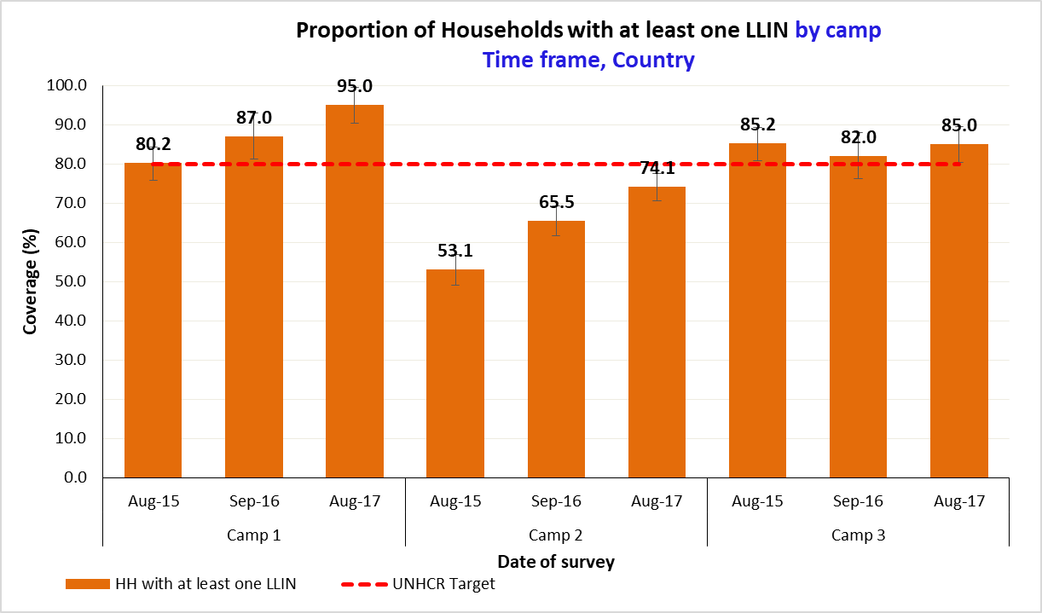

Table 100 NUMBER OF NETS by camp

|  |  |  |  |
| --- | --- | --- | --- |
| **Survey Area** | **N** | **Average number of LLINs per household** | **Average number of persons per LLIN** |
| **Mean** | **Mean** |
| **Camp 1** |  |  |  |
| **Camp 2** |  |  |  |
| **Camp 3** |  |  |  |

Table 101 Mosquito net Utilisation by camp. note that it is not required to include confidence intervals for these indicators as they are complex to calculate

|  |  |  |  |  |  |  |  |
| --- | --- | --- | --- | --- | --- | --- | --- |
|  | **Camp** | **Proportion of total population**  **(all ages)** | | **Proportion of 0-59 months** | | **Proportion of pregnant women** | |
| **N** | **%** | **N** | **%** | **N** | **%** |
| **Slept under net of any type** | Camp 1 | n | **%** | n | **%** | n | **%** |
| **Slept under LLIN** | n | **%** | n | **%** | n | **%** |
|  |  | **N** | **%** | **N** | **%** | **N** | **%** |
| **Slept under net of any type** | Camp 2 | n | **%** | n | **%** | n | **%** |
| **Slept under LLIN** | n | **%** | n | **%** | n | **%** |
|  |  | **N** | **%** | **N** | **%** | **N** | **%** |
| **Slept under net of any type** | Camp 3 | n | **%** | n | **%** | n | **%** |
| **Slept under LLIN** | n | **%** | n | **%** | n | **%** |

Figure 23 Mosquito Net Utilisation by sub-group, by camp *(this FIGURE CAN BE automatically GENERATED BY USING sENS PRE-MODULE TOOL 17b – TRENDS AND GRAPHS)*

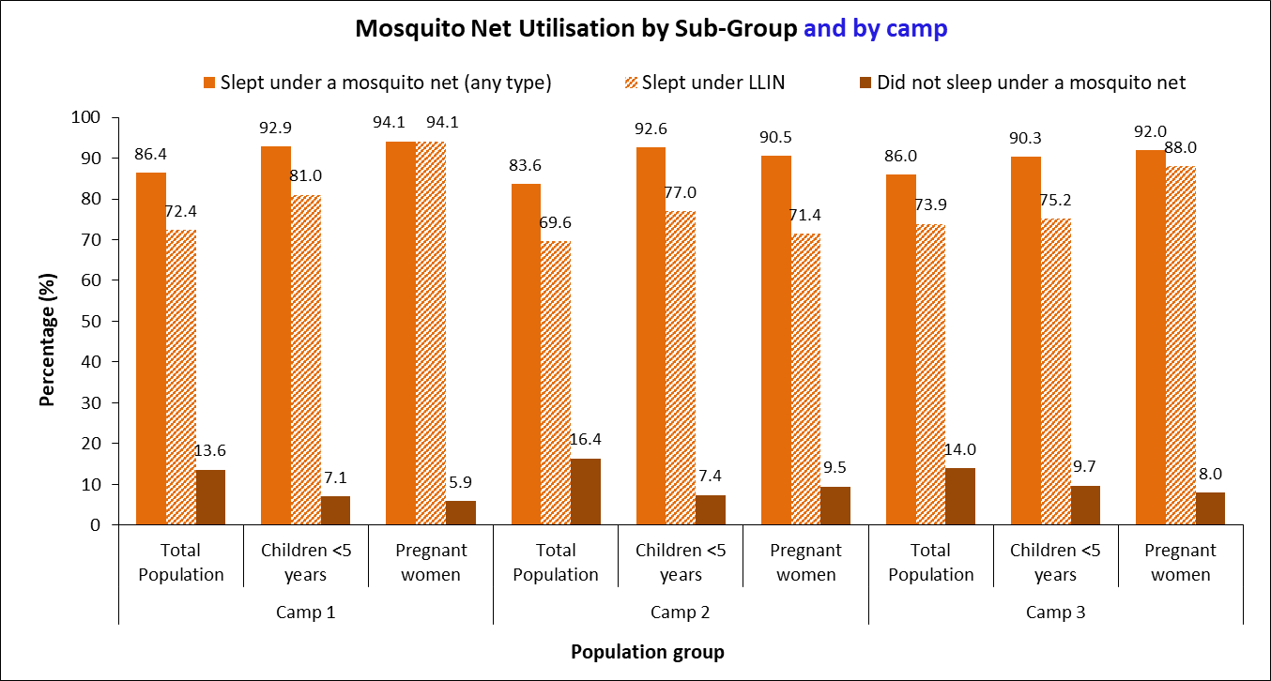

Table 102 Indoor Residual Spraying Household Coverage in the last 6 months, by camp (OPTIONAL – Adapt the frequency of the spraying cycle i.e annualor bi-annual)

|  |  |  |  |
| --- | --- | --- | --- |
| **Survey Area** | **N** | **Proportion of households covered by IRS in the last 6 months/12 months** | |
| **n** | **% (95% CI)** |
| **Camp 1** |  |  |  |
| **Camp 2** |  |  |  |
| **Camp 3** |  |  |  |

**4.7 WASH**

Table 103 WASH SAMPLING INFORMATION by camp

|  |  |  |  |
| --- | --- | --- | --- |
| **Total households surveyed for WASH** | **Planned** | **Actual** | **% of target** |
| **Camp 1** |  | *[only include households with data; exclude absent households and refusals]* |  |
| **Camp 2** |  | *[only include households with data; exclude absent households and refusals]* |  |
| **Camp 3** |  | *[only include households with data; exclude absent households and refusals]* |  |

Table 104 Water Quality by camp

|  |  |  |  |  |  |
| --- | --- | --- | --- | --- | --- |
| **Survey Area** | **N** | **Proportion of households collecting drinking water from protected/treated sources** | | **Proportion of households with at least 10 litres/person drinking water storage** | |
| **n** | **% (95% CI)** | **n** | **% (95% CI)** |
| **Camp 1** |  |  |  |  |  |
| **Camp 2** |  |  |  |  |  |
| **Camp 3** |  |  |  |  |  |

Table 105 Water QUANTITY 1: AMOUNT OF LITRES OF WATER USED PER PERSON PER DAY, by camp

|  |  |  |  |
| --- | --- | --- | --- |
| **Survey Area** | **N** | **Average # L/p/d of domestic water collected at household level, from protected/treated sources with containers of any type** | **Average # L/p/d of domestic water collected at household level, from protected/treated sources with protected containers only** |
| **Mean**  **(SD, or 95% CI)** | **Mean**  **(SD, or 95% CI)** |
| **Camp 1** |  |  |  |
| **Camp 2** |  |  |  |
| **Camp 3** |  |  |  |

Table 106 Water QUANTITY 2: AMOUNT OF LITRES OF WATER USED PER PERSON PER DAY by category, by camp

|  |  |  |  |  |
| --- | --- | --- | --- | --- |
| **Survey Area** | **N** | **Proportion of households that use domestic water collected from protected/treated sources with protected containers only:**  **≥ 20 lpppd** | **Proportion of households that use domestic water collected from protected/treated sources with protected containers only:**  **15-<20 lpppd** | **Proportion of households that use domestic water collected from protected/treated sources with protected containers only:**  **<15 lpppd** |
| **Mean**  **(SD, or 95% CI)** | **Mean**  **(SD, or 95% CI)** | **Mean**  **(SD, or 95% CI)** |
| **Camp 1** |  |  |  |  |
| **Camp 2** |  |  |  |  |
| **Camp 3** |  |  |  |  |

Add the average water usage in lppd for each camp at the bottom of **Table 104** in the final report.

Table 107 ACCESS TO SOAP by CAMP

|  |  |  |  |
| --- | --- | --- | --- |
| **Survey Area** | **N** | **Proportion of households with access to soap** | |
| **n** | **% (95% CI)** |
| **Camp 1** |  |  |  |
| **Camp 2** |  |  |  |
| **Camp 3** |  |  |  |

Table 108 toilet/latrine use by camp

|  |  |  |  |
| --- | --- | --- | --- |
| **Survey Area** | **N** | **Proportion of households reporting defecating in a toilet** | |
| **n** | **% (95% CI)** |
| **Camp 1** |  |  |  |
| **Camp 2** |  |  |  |
| **Camp 3** |  |  |  |

**4.8 Other results**

Include other results and figures.

**4.9 Limitations**

Include limitations of survey, e.g.: poor quality of age data impacting on the reliability of the stunting and underweight results; unreliable population data for cluster selection; quality of training; limited supervision due to security reasons; overall quality of anthropometric data from SMART plausibility check.

5. Discussion

**5.1 Nutritional status of children (and women)**

Discuss sample sex ratio — any bias? If so, explain why you think there is bias

Prevalence of acute malnutrition

If previous survey results are available, how do these results compare to before, or to other areas nearby (e.g. the local population surrounding the camp(s) or settlement(s)?

How does the prevalence compare to national benchmarks of malnutrition?

Is the prevalence of malnutrition typical or not?

What are the major acute causes of malnutrition if known or suspected (taking into account causes already addressed by other interventions)? Consider immediate, underlying and basic causes.

What are the prospects for the coming months? Will the situation get better or worse (refer to seasonal changes etc.)

Who is worst affected?

What are the chronic causes of malnutrition?

What does the community recommend?

Does the story fit together? If not what are the unanswered questions?

A diagram to show the causal framework of malnutrition may be useful.

**5.2 Programme coverage**

Coverage for measles vaccination, vitamin A supplementation within last 6 months, any SFP/TFC/BSFP programmes, ANC and iron-folic acid supplementation.

If previous survey results are available, how do these results compare to before?

How does the prevalence compare to targets for programme coverage?

Explanation for coverage (good/bad/why)

**5.3 Anaemia in young children and women**

Prevalence of anaemia

If previous survey results are available, how do these results compare to before, or to other areas nearby?

How does the prevalence compare to benchmarks of anaemia?

Is the prevalence of anaemia typical or not?

What are the major causes of anaemia if known or suspected (taking into account

causes already addressed by other interventions)?

Who is worst affected?

What does the community recommend?

Does the story fit together? If not what are the unanswered questions

**5.4 IYCF indicators**

Results from key indicators

If previous survey results are available, how do these results compare to before, or to other areas nearby?

What does the community recommend?

Does the story fit together? If not what are the unanswered questions

**5.5 Food security**

Results from key indicators

If previous survey results are available, how do these results compare to before, or to other areas nearby?

What is the state of the pipeline?

Has there been any recent change in food assistance?

What does the community recommend?

Does the story fit together? If not what are the unanswered questions

**5.6 Mosquito net coverage**

Mosquito net ownership and utilisation results by net type, total population and vulnerable population groups (i.e. children U5 and pregnant women).

If previous survey results are available, how do these results compare to before, or to other areas nearby?

How does the results compare to benchmarks for coverage of mosquito nets?

What does the community recommend?

Does the story fit together? If not what are the unanswered questions

**5.7 WASH**

Results from key indicators

If previous survey results are available, how do these results compare to before, or to other areas nearby?

How do the results compare to benchmarks for WASH indicators?

What does the community recommend?

Does the story fit together? If not what are the unanswered questions

**5.8 Other collected information/data**

Include interpretation of results

6. Conclusions

Overall conclusions on the severity of the situation and the urgency of the response required

7. Recommendations and priorities

Remember to prioritise recommendations and try to give a time when action would be appropriate (e.g. immediate, medium term or longer term).

For a tool that will help writing useful recommendations, see:

**SENS Pre-Module Tool 28 -SENS Recommendations.**

Future nutrition monitoring

Is it necessary to carry out another nutrition survey in this area in the near future? Who should do it? Should there be any changes to the survey methodology? When should the survey take place?

8. References

List all secondary sources to which you have referred in the text.

9. Acknowledgements

1. List all government departments, International agencies, International NGOs, National NGOs and other organisations that supported or participated in the survey. (All involved in planning the survey and those organisations or individuals who have provided staff, vehicles, equipment, logistics).

2. List donors and other sources of funds

3. List the individuals involved in the survey

Supervisor/Manager:

Consultants/ Trainers/ Advisors/ analysts:

Logistics/administration:

Team members:

Translators:

Drivers:

Others

4. (Optional) List those who gave permission/ authorisation and otherwise supported the survey in a non-participatory way.

10. Appendices

**Appendix 1**

***SMART Plausibility Check (PC) Report***

**Instructions for presentation of the PC report are as follows:**

* If PC < 20%, only show the overall data quality summary table.
* If PC> 20%, carefully examine the anthropometric data for all teams and by teams; and show the details of the problematic areas in the Appendix along with a short interpretation. UNHCR HQ should be contacted for assistance in analysing problematic scores from the SMART PC reports.

**Appendix 2**

***Assignment of Clusters***

Geographical unit Population size Assigned cluster

**Appendix 3**

***Evaluation of Enumerators (results from anthropometric standardisation test)***

**Appendix 4**

Maps of area

**Appendix 5**

Questionnaires

**Appendix 6**

Local event calendar used during the survey to estimate age of young children

**Appendix 7**

Follow-up table for SENS recommendations

For an example of follow-up table for SENS recommendations, see:

**SENS Pre-Module Tool 28 -SENS Recommendations.**