UNHCR

STANDARDISED EXPANDED
NUTRITION SURVEY (SENS) GUIDELINES
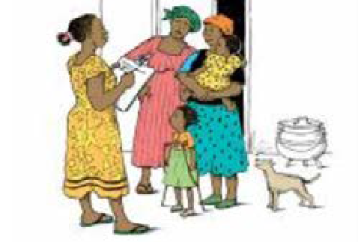
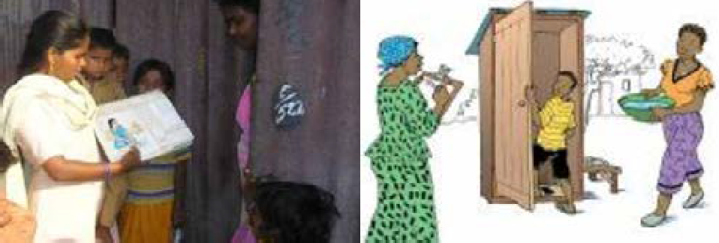
FOR REFUGEE POPULATIONS

MODULE 7:

WATER, SANITATION AND HYGIENE (WASH)

A PRACTICAL STEP-BY-STEP GUIDE
VERSION 3 (2018)

MODULE 7:

WATER, SANITATION AND HYGIENE
(WASH)

A PRACTICAL STEP-BY-STEP GUIDE
VERSION 3 (2018)

Table of Contents

KEY MESSAGES | 4
DEFINITION OF SOME KEY TERMS | 5
OBJECTIVES | 7
DATA COLLECTION | 8
MEASUREMENT METHODS | 8
MATERIAL NEEDED | 8
ETHICAL CONSIDERATIONS | 8
STANDARD PROCEDURE AND QUALITY ASSURANCE | 9
TRAINING | 10
THEORETICAL COMPONENT | 10
PRACTICAL COMPONENT | 12
QUESTIONNAIRE AND INSTRUCTIONS | 13
DATA REVIEW | 17
DAILY QUESTIONNAIRE CHECK AND OVERSEEING INTERVIEWS | 17
DATABASE CHECK | 17
PRESENTATION OF RESULTS | 18
RESULTS TABLES AND FIGURES | 18
DATA ANALYSIS | 20
ANALYSIS PROCEDURES | 20
COMMON ERRORS AND CHALLENGES IN DATA ANALYSIS | 23

USE OF RESULTS | 24
CLASSIFICATION OF PUBLIC HEALTH PROBLEM AND TARGETS | 24
RECOMMENDATIONS | 25
REFERENCES | 26
ANNEX 1 - WATER SOURCE AND SANITATION FACILITY DEFINITIONS | 28
ANNEX 2 - WATER CONTAINERS | 33
ANNEX 3 - SENS WASH QUESTIONNAIRE | 35
ANNEX 4 - TRAINING IDEAS | 37
ANNEX 5 - EPI INFO DATA ANALYSIS | 40

Key messages

- The inclusion of the basic WASH module in the SENS survey will provide key information for planning interventions to address public health concerns and to ensure that basic rights are upheld.

- Poor water, sanitation and hygiene have serious consequences for the health and nutrition status of persons of concern to UNHCR.

- The SENS WASH module provides only a few of the core indicators for monitoring WASH programmes at the household level and should be used in conjunction with the standard UNHCR WASH KAP undertaken WASH specialists.

- All of the questions for the household SENS survey are taken from the UNHCR WASH KAP to harmonise the surveys undertaken in refugee operations.

- On the standardised SENS WASH questionnaire, the questions on water source and sanitation facilities offer a detailed choice of technologies to choose from but it is only necessary to list the options applicable for the specific context that is being assessed (the wording of the actual questions should not be changed).

Definitions of some key terms

WASH: The main objective of water and sanitation interventions is to improve hygiene and health, and this entails ensuring that people are involved in decisions about the programme and that they make the best use of the facilities provided.The term WASH is preferred to water and sanitation or ‘watsan’ to emphasise the importance of a holistic approach to service delivery that focuses on health outcomes and encourages the involvement of communities.

Protected/treated sources of drinking water

- The type of drinking water source used by the household serves to indicate whether their drinking water is of a suitable quality or not. The following protected/treated water sources are assumed to be of a suitable quality: tap stands, handpumps/boreholes, water seller/kiosks, piped connection to house, protected spring, bottled water, water sachets, tanker trucks.

- The following water sources are likely to be contaminated and should not be considered as protected/ treated sources: an unprotected hand-dug well, surface water (lake, pond, dam, river), unprotected spring, rain water collection.

Latrines / toilets

- Household latrine: latrine used by one household only.

- Communal latrine: latrine used by multiple households.

Table 1 provides an overview of the definitions of drinking water and sanitation (toilet) facilities.

TABLE 1 DEFINITIONS

Drinking water | Protected/treated source | Un-protected/un-treated source
 | Public tap/standpipe | Unprotected hand-dug well
 | Handpumps/Boreholes | Surface water (lake, pond, dam, river)
 | Water seller/Kiosks | Unprotected spring
 | Piped connection to house (or neighbour’s) | Rain water collection
 | Protected spring | Other
 | Bottled water, water sachets
 | Tanker trucks
Latrines / toilets | Considered a toilet | Not considered a toilet
 | Household latrine | Open defecation
 | Communal latrine | Plastic bag
 |  | Bucket toilet
 |  | Other

Things to note:

- More detailed explanations with pictures of specific water sources are provided in Annex 1. Help in deciding which types of water source are available in a specific refugee context can be sought from WASH specialists working in the survey area.

Objectives

The SENS WASH survey questions aim to measure the following indicators at household level:

- Access to a protected/treated drinking water source;

- Use of an adequate quantity of water;

- Use of toilets/latrines;

- Access to soap.

The objective should be worded as follows in the survey protocol and report:

- To determine the population’s access to, and use of, water, sanitation and hygiene facilities.

- To determine the population’s access to soap.

The specific objectives of the SENS WASH survey are to determine:

- The proportion of households collecting drinking water from protected/treated sources.
- The proportion of households with at least 10 litres/person potable water storage capacity.
- The average # L/p/d of domestic water collected at household level.
- The proportion of households reporting defecating in a toilet.
- The proportion of households with access to soap.

Data collection

Measurement methods
- WASH variables are assessed using interviews with mothers or the main caretaker of young children and specific observations.

- In order for the measurement methods to be reliable, it is vital that the questions are asked exactly as they are written and that any modification is agreed with all the surveyors so that the methodology is as standardised as possible.

- The capacity (in litres) of common water storage containers used in the specific context must be investigated prior to training the surveyors in order for the surveyors to make an accurate assessment of this variable. Annex 2 shows common water containers used. Pictures should be taken in each context to be shown during training of surveyors.

Material needed
- WASH survey questionnaires: 1 per household surveyed.

- Technical forms for MDC surveys. Paper questionnaire for paper-based surveys (always carry extra copies).
- The SENS WASH questionnaire is shown in Annex 3 or see SENS Pre-Module tools: [Tool 11- Full SENS Questionnaire] and [Tool 12- Full SENS Questionnaire with Instructions].

- WASH pictorial guide for identifying different types of water sources and size of water containers to be used during training.

Ethical considerations
- A standard WASH questionnaire will be administered with the consent of the householder. Refer to SENS Pre-Module Step 13 for guidance on approaching households and seeking informed consent.

Standard procedure and quality assurance
- A standard WASH questionnaire will be administered on a sample of households (refer to SENS Pre- Module Step 8 for guidance).

- A questionnaire is administered to the household even if there are no eligible children for the SENS survey.

- The same definition of the household (appropriate to the context1) should be used by all survey teams and in all subsequent surveys.

- The respondent should be the main carer of any children in the household or a responsible adult (preferably over the age of 18 years) who is able to answer the questions accurately.

- In refugee settings, a household is typically defined as a group of people who live together and routinely eat out of the same pot.

Training

- The training needs to contain a mix of theory, practical exercises (especially role plays) as well as a written or verbal test. Annex 4 provides some training ideas.

- It is crucial that the survey manager(s) refresh their skills before beginning the training and read all of the background material provided.

- The training on the SENS WASH questionnaire will require at least half a day.

- The questionnaire should be adapted prior to the training by selecting the categories that apply to the specific context for the water sources. Minor changes to wording / phrases or the use of explanations for questions can be agreed upon with the whole team during the training.

Theoretical component

The theoretical component on the WASH module should include:

- Overview of module, questionnaire and procedure to be followed.

- The rationale for asking specific questions.

- Information on specific WASH terms.

- Information to help surveyors distinguish different water and sanitation technologies specific to their area.

- A short written or verbal test.

Things to watch out for:

- Table 2 describes the most common errors experienced by survey workers in WASH data collection. These should be emphasised during the training and the survey managers(s) and supervisor(s) should focus on these when assessing the teams’ performance during supervision throughout the survey.

TABLE 2 COMMON ERRORS AND CHALLENGES IN DATA COLLECTION

Common errors | Examples | Solution
Respondents feel embarrassed to answer the questions | Women may not feel comfortable answering questions if the enumerator is male. | Investigate the likelihood of this being a problem prior to the survey and ensure that there are female interviewers.
Questionnaire categories do not capture the responses most commonly given | High percentage of ‘other’ category checked. | Adequate preparation prior to the survey is vital. Make sure that the questionnaire selects the context specific categories and that the surveyors understand these categories.
Respondents do not understand the questions or the information is too difficult to report | High percentage of ‘don’t know’ categories. | Review questions and translation. Ensure that the respondent is ‘knowledgeable’ about the topic, i.e. that they know where family members usually go to defecate.
Question is not read exactly as it is written | The surveyor asks about any water source rather than drinking water source specifically. | The training needs to highlight the common pitfalls.  During supervision, close attention must be paid to these pitfalls.
Surveyor does not understand the question well enough | The surveyor asks about the water that was collected the day of the survey. | The training needs to ensure that surveyors are well prepared so that they can explain the questions to the respondents in a standardised fashion.
The amount of water is not accurately assessed | Surveyors are not confident in determining capacity of containers and guess. | Ensure good preparation to identify likely containers used. Test surveyors during training. Ensure that they know when to contact the supervisor for help.

Practical component
- The practical component should form the main part of the training and should employ role-play to ensure that surveyors are following standard procedures and that they communicate effectively and respectfully with respondents.

Guidance for survey managers

- Tables 3-4 provide instructions on the questionnaire for adaptation to the local context and instructions to be given to the surveyors.

- Discuss with WASH specialists on the types of technology used in the area. Delete any unnecessary options that do not apply to your area of investigation.

- Obtain photographs where possible and compile a quick pictorial guide of the different types of water sources and water container sizes that surveyors are likely to come across.

- Invite a WASH partner involved to support facilitation where possible.

- Prepare / translate and back translate the questionnaire: do not change the wording of the questions.

- Sanitation may be a sensitive topic in some situations and this should be assessed prior to the survey so that acceptable ways of asking the household about their toilet facility can be determined. It may be necessary to have female surveyors interviewing female respondents.

- Some participants will learn more quickly than others and they should be paired with the less able surveyors both in the training and in the field.

Basic instructions for survey teams

- Survey teams need to be trained on interview techniques: introduction, consent, confidentiality etc.

- It is very important that surveyors ask each question exactly as it is written on the questionnaire.

- In addition to the questions, there are statements that appear in capital letters, indicating that they are surveyor instructions and should not be read aloud to the respondent.

- The question may need to be repeated again but the wording should not be changed too quickly as it may be that the respondent did not hear properly or was not concentrating.

- When a question is unclear, it should be asked again or with slightly different wording but care must be taken not to change the meaning or lead the respondent into giving a specific response.

Questionnaire and instructions

- The WASH SENS questionnaire is shown in Annex 3. See SENS Pre-Module tools: [Tool 11- Full SENS questionnaire] and [Tool 12- Full SENS Questionnaire with Instructions].

- The tables 3-4 below provide instructions on the questionnaire for adaptation to the local context, explain the rationale of each question and highlight special instructions to be given to the surveyors.

TABLE 3 WASH MODULE: EXPLANTATIONS OF WASH INTERVIEW QUESTIONS (SECTION WS1)

Question number/ Section WS1 | Variable name | Question | Rationale | Special Instructions
 |  |  |  | These questions need to be asked to the head of the household or, if they are absent, another adult member of the household.
WS1 | WS- CONST | Was consent given for conducting the interview? |  | Ensure that you have introduced the team and informed them about the interview.
 |  | 1= Yes  2= No  3= Absent |  | If a household is absent, the team leader should record this information and determine another time to return on the same day and/or before to leave the survey area. The team should revisit an absent household up to two times, if it is logistically feasible, on the same survey day. If they are unsuccessful after this, the household should be recorded as an absence and they should not be replaced with another household.
 |  |  |  | Refer to SENS Pre-module tool: [Tool 8- Data collection control sheet] for a model tool to help track the absent households.
 |  |  |  | If answer is « 2 » (No) or « 3 » (Absent), stop here for the WASH questionnaire.
WS2 | HHSIZE | What is the total number of household members? |  | Record number.

WS3 | SOURCE | What is the principal source of drinking water for members of your household?  01=Public tap/ Standpipe; 02=Handpumps/ boreholes; 03=Water seller/ kiosks; 04=Piped connection to house (or neighbour’s  house); 05=Protected spring; 06= Bottled water, water sachets; 07=Tanker trucks; 08=Unprotected hand-dug well; 09=Surface  water (lake, pond, dam, river); 10=Unprotected  spring; 11=Rain water collection; 96=Other; 98=Don’t know | The assumption is made that if households use a protected/ treated drinking water source, they are more likely to be drinking clean water. It is not yet possible to test all household water quickly and cheaply in a large-scale survey. | Ask about drinking water sources only, not other water sources.  Do not read the answers. Select one option but do not prompt with responses.  Modify responses for your context. E.g. if that type of source does not exist, do not keep it. If it is rare, consider omitting it as it will be captured under other. Delete options as needed. A visual aid showing different types of water sources may be useful for training purposes.  When deleting options, keep the original answer codes and do not change.
WS4 | TOILET | Where do you and your household members (excluding children under  5) usually go to defecate?  1= Household latrine;  2= Communal latrine;  3= Open defecation;  4= Plastic bag; 5=  Bucket toilet; 6= Other; 8= Don’t know | The aim of this question is to assess if the household uses a toilet. | A household latrine is a latrine used by one household only. A communal latrine is a latrine used by multiple households.  Do not read the answers. Select one option only.

TABLE 4 WASH MODULE: EXPLANTATIONS OF WASH OBSERVATION QUESTIONS (SECTION WS2)

Question number/ Section WS2 | Variable name | Question | Rationale | Special Instructions
These observations are done after the initial questions to ensure the flow of the interview is not broken.

Explain to the respondent that these questions relate to water used for domestic purposes. This includes: drinking, cooking/ food preparation, bathing, and personal hygiene plus laundry and other household cleaning. Excluded from this are animal use, brickmaking or other industry, or agriculture/gardening (non-domestic).
WS5 | SOAP | Please show me the soap you have in the household.  1= Presented within one minute  2= Not presented within one minute/no soap |  | Soap includes bar soap, liquid soap, powder detergent, and soapy water but does not include ash, soil, sand or other handwashing agents.
WS6 | CON- TAINER | How many containers do you have to collect or store water for domestic purposes for your house?  Please show me all of them one by one  Lower limit= 0 Upper limit=25 | Hygiene and health are compromised by a lack of water.  The UNHCR standard is 20 litres per person per day (SPHERE is 15 litres). | Record one by one. Check for all of the containers. Do not include broken, leaking, or non- functional containers.  This question asks you to consider ALL of the water containers that are used to collect water for domestic purposes (not just drinking water).  If the surveyed household did not collect water yesterday or borrowed water containers to collect water yesterday and the containers are not in the households at the time of the survey, that household should be skipped and not replaced. Leave answer blank.
 |  |  |  | These questions need to be completed for each container reported by the respondent and observed.

WS7 | TYPE | What is the type of container?  01=Jerrycan; 02=Bucket; 03=Basin; 04=Bottle; 05=Saucepan; 06=Drums; 96=Other
WS8 | LITER | What is the volume of the container?  Lower limit= 0.5L Upper limit= 300.0L |  | It is often difficult to assess accurately the amount of water used in the household. Prior to the survey, surveyors should know how to determine the capacity of the likely water containers used by a household.  Enter the amount of litres to the nearest 0.5L.
WS9 | PRO- TECT | Is the container covered?  1=Yes 2=No  8=Don’t know | A container that is covered is considered to be protected. Open containers with no lid are more likely to be contaminated. This question serves as a proxy or substitute for contaminated drinking water. Questions that ask how clean a container is are more subjective and are not used.
 |  |  | This question attempts to determine if households are drinking clean water but does not take into account the fact that water can become contaminated at the household level if e.g. unwashed hands come into contact with the drinking water or if the drinking water container is not covered. Where containers are covered, contamination can still occur when removing water from the container.
WS10 | NUM- TRIPS | Number of journeys made with container for the collection of water for domestic purposes yesterday? |  | Please enter ‘0’ if household did not fill it yesterday.
 |  | This includes all water collected morning, afternoon and evening.
 |  | Lower limit=0 Upper limit=10

Data review

- Refer to SENS Pre-module Tool: [Tool 15- Standard Operating Procedure (SOP) for SENS data management] for guidance on how to conduct these checks.

Daily questionnaire check and overseeing interviews - for consistency, completeness and missing data
- The survey manager and supervisors will not have the chance to observe every interview conducted but they are responsible for reviewing every questionnaire for errors. Reviewing questionnaires should be done in the field, if possible, so that any problem can be resolved immediately and if not then at the end of each day.

- While in the field or at the end of each field work day, look at the filled forms on the smartphones (or the questionnaires if a paper-based survey was conducted) from each team and follow the procedure described below:

  - Check that consent was given for the interview (variable: WSCONST). If consent was not given, ask the surveyors if they know the reasons. If there are many refusals, understanding why will help clarify any misunderstandings, concerns or misconceptions with the community being surveyed.

  - Check for missing data and ‘don’t know’ answers (these should always be minimal) If there are missing values, the survey teams should be told the next day to be more careful and not miss any question. If there is a significant number of ‘don’t know’ answers for certain teams, the survey manager or supervisor(s) should accompany the teams the next day to the field to check on the way they conduct the interviews.

Database check
- Brief guidance on the data review process is provided in Annex 5 using Epi Info 7 and in the SENS Pre- module Tool: [Tool 15- Standard Operating Procedure (SOP) for SENS data management].

- Free guidance on the use of Epi Info for Windows and training material on Epi Info can be found at the following site: http://www.cdc.gov/EpiInfo

Presentation of results

- WASH results should be descriptive and presented as proportions (with 95% confidence interval) and means where applicable.

- When presenting the results from several camps with a representative sample drawn from each camp into one report, results can be presented two different ways: i) reporting results for each indicator from each camp separately or ii) combining results from all camps into one table per indicator. See SENS Pre-Module tools: [Tool 19- Dolo SENS Report 2017] and [Tool 20a- Jordan SENS Report 2016].

- When several camps are surveyed with a representative sample drawn from each camp, it is sometimes necessary and important to report combined results. Weighting the data will need to be done if you have conducted surveys in a number of different camps or areas, and need to combine the results for reporting or planning purposes. It is not required to report the combined results for all indicators or to report the confidence intervals for the combined estimates. See the SENS Pre-Module tool that will automatically generate weighed prevalence results for proportions and means: [Tool 21-Weighting Data Tool].

- All survey reports should present results following the tables and figures shown below.

- Where an exhaustive (census) survey is conducted, confidence intervals should not be presented. If sub- sampling was done for the WASH module in an exhaustive survey, then confidence intervals should be presented.

Results tables and figures

TABLE 5 WASH SAMPLING INFORMATION

Household data | Planned | Actual | % of target
Total households surveyed for WASH |  | [only include households with data; exclude absent households and refusals]

TABLE 6 WATER QUALITY

 | Number/total | % (95% CI)
Proportion of households collecting drinking water from protected/treated sources
Proportion of households with at least 10 litres/person drinking water storage capacity

TABLE 7 WATER QUANTITY 1: AMOUNT OF LITRES OF WATER USED PER PERSON PER DAY

Mean (SD, or 95% CI)
Average # L/p/d of domestic water collected at household level, from protected/treated sources with containers of any type
Average # L/p/d of domestic water collected at household level, from protected/treated sources with protected containers only

TABLE 8 WATER QUANTITY 2: AMOUNT OF LITRES OF WATER USED PER PERSON PER DAY BY CATEGORY

Proportion of households that use domestic water collected from protected/treated sources with protected containers only: | Number/total | % (95% CI)
≥ 20 lpppd
15-<20 lpppd
<15 lpppd

TABLE 9 ACCESS TO SOAP

 | Number/total | % (95% CI)
Proportion of households with access to soap

TABLE 10 TOILET / LATRINE USE

 | Number/total | % (95% CI)
Proportion of households reporting defecating in a toilet

Data analysis

Analysis procedures
- The first step in the data analysis process is to classify the categories into more easily manageable variables that relate to the indicators you are trying to measure. This involves recoding some of the responses into ‘new’ variables. Table 11 provides some guidance on calculating the indicators and on using Epi Info software.

- Make sure that the data has been verified before starting the analysis process.

- Brief guidance on using Epi Info software for analysis is provided below. Refer to Annex 5 for standard analysis commands using Epi Info 7. Free guidance on the use of Epi Info for Windows and training material on Epi Info can be found at the following site:.http://www.cdc.gov/EpiInfo

TABLE 11 RECODING INSTRUCTIONS (WHERE APPLICABLE)

QUESTION / OBSERVATION | REPORTED RESULTS (ORGINIAL VARIABLE NAME) | ACTION
WS3. What is the principal source of drinking water for members of your household? | Proportion of households collecting drinking water from protected/treated sources | Exclude from analysis households with answer 98 (this is automatically done with the analysis instructions suggested below)
01= Public tap/Standpipe; 02=  Handpumps/boreholes; 03= Water seller/kiosks; 04= Piped connection to house (or neighbour’s house); 05= Protected spring; 06= Bottled water, water sachets; 07= Tanker trucks; 08= Unprotected hand-dug well; 09= Surface water (lake, pond, dam, river); 10= Unprotected spring; 11=  Rain water collection; 96= Other; 98= Don’t know | (SOURCE) | Define a new variable for categorising the main drinking water source (SOURCE_c). Recode SOURCE to SOURCE_c using the ‘Recode’ command: (1) protected or (2) unprotected.  - Protected [answers 01-07 of the standard SENS WASH questionnaire]  - Unprotected [answers 08-11, and 96 of the standard SENS WASH questionnaire]
Use the ‘Frequencies’ or ‘Complex Sample Frequencies’ command
to analyse SOURCE_c to fill out Table 6. The frequency of answer 1 (‘Protected’) is reported.

QUESTION / OBSERVATION | REPORTED RESULTS (ORGINIAL VARIABLE NAME) | ACTION
WS4. Where do you and your household members (excluding children under 5) usually go to defecate?  1=Household latrine; 2=Communal latrine; 3=Open defecation; 4=Plastic bag; 5=Bucket toilet; 6=Other; 8=Don’t know | Proportion of households reporting defecating in a toilet  (TOILET) | Include in analysis households with answer 8 (this is automatically done with the analysis instructions suggested below).  Define a new variable for a toilet facility definition (TOILET_c). Recode TOILET to TOILET_c using the ‘Recode’ command: (1) toilet or (2) not toilet  - Toilet category [answers 1-2]  - Not toilet category [answers 3-6, 8]  Use the ‘Frequencies’ or ‘Complex Sample Frequencies’ command to analyse TOILET_c to fill out Table 10. The frequency of answer 1 (‘Toilet’) is reported.
WS5. Please show me the soap you have in the household.  1=Presented within one minute 2=Not presented within one minute/ No soap | Proportion of households with access to soap  (SOAP) | No recoding needed.  Use the ‘Frequencies’/‘Complex Sample Frequencies’ command to analyse SOAP to fill out Table 9. The frequency of answer 1 (‘Presented within one minute’) is reported.
WS6. How many containers do you have to collect or store water for domestic purposes for your house? Please show me all of them one by one | (CONTAINER)  Lower limit=0  Upper limit=25
WS7. What is the type of container?  01=Jerrycan; 02=Bucket; 03=Basin; 04=Bottle; 05=Saucepan; 06=Drums; 96=Other | (TYPE)
WS8. What is the volume of container? | (LITER)  Lower limit=0.5L Upper limit=300.0L
WS9. Is the container covered?  1=Yes; 2=No; 8=Don’t know | (PROTECT)
WS10. Number of journeys made with container for the collection of water for domestic purposes yesterday?  This include all water collected morning, afternoon and evening, | (NUMTRIPS)  Lower limit=0  Upper limit=10

QUESTION / OBSERVATION | REPORTED RESULTS (ORGINIAL VARIABLE NAME) | ACTION
 | Proportion of households with at least 10 litres/person drinking water storage capacity  (CONTAINER, LITER, PROTECT, HHSIZE)  (STORAGE) | Define a new variable for categorising households with at least 10 litres/ person drinking water storage capacity (STORAGE_c).  Recode STORAGE to STORAGE_c using the ‘Recode’ command:  - 10 or over 10 litres (≥10)  - 9.99 litres or less (<10)  Use the ‘Frequencies’/‘Complex Sample Frequencies’ command to analyse STORAGE_c to fill out Table 6. The frequency of answer 1 is reported.
 | Average # L/p/d of domestic water collected at household level, from protected/treated sources (with containers of any type)  (SOURCE, CONTAINER, LITER, NUMTRIPS, HHSIZE)  (POTABLE) | Run the ‘Means’ / ’Complex Sample Means’ command on the variable termed POTABLE to calculate the mean and fill out Table 7.
 | Average # L/p/d of domestic water collected at household level, from protected/treated sources (with protected containers only)  (SOURCE, CONTAINER, LITER, PROTECT, NUMTRIPS, HHSIZE)  (POTAPROT) | Run the ‘Means’ / ’Complex Sample Means’ command on the variable termed POTAPROT to calculate the mean and fill out Table 7.
 | Proportion of households that use domestic water collected from protected/treated sources (with protected containers only):  ≥20 litres per person per day  15-<20 litres per person per day  <15 litres per person per day  (SOURCE, CONTAINER, LITER, PROTECT, NUMTRIPS, HHSIZE)  (POTAPROT) | Define a new variable for categorising the amount of water used per person per day per household (LPPPD_c).  Recode POTAPROT to LPPPD_c using the ‘Recode’ command:  (1) 20 or over 20 litres (≥20) (2) 15- 19.99 litres (15-<20)  (3) 14.99 litres or less (<15)  Use the ‘Frequencies’/‘Complex Sample Frequencies’ command to analyse LPPPD_c to fill out Table 8. The frequency of each answer (1-3) is reported.

Common errors and challenges in data analysis
- Table 12 describes the most common errors experienced by survey managers/ supervisors when conducting the final data analysis.

TABLE 12 COMMON ERRORS AND CHALLENGES IN DATA ANALYSIS

Common errors | Examples | Solution
Not taking into consideration a weighting factor when combining results from several camps | When surveying several camps with a representative sample drawn from each camp, combining the samples from all camps to calculate the overall results without taking into consideration a weighting factor. | For a tool that will automatically generate weighed results, see SENS Pre-Module tool: [Tool 21-  Weighting Data Tool].
Reporting WASH results according to certain aggregates of clusters | Reporting the WASH results per group of clusters. | Do not disaggregate cluster surveys according to clusters in the presentation of results. All clusters merged together from all section / blocks of the camp are representative of the camp as a whole and should not be disaggregated.
Reporting a change in the WASH situation without any evaluation of whether the observed change is statistically significant or real | Using the point estimate results of two surveys (e.g. 36% vs. 39%) and concluding that there has been a change in e.g. use of drinking water from protected/treated sources, without looking at the confidence intervals or conducting a statistical test. | Assess whether the confidence intervals overlap and conduct a statistical test using the CDC IERHB calculator. See SENS Pre-  Module tool: [Tool 18-CDC Calculator two surveys].

Use of results

Classification of public health problem and targets
- According to UNICEF, diarrhoea is a leading killer of children accounting for approximately 8 per cent of all deaths among children under age 5 worldwide in 2016. Over 300,000 children under five died from diarrhoeal diseases linked to limited access to safe water, sanitation and hygiene in 2015. Diarrhoea also contributes to high infant and child morbidity and mortality by directly affecting children’s nutritional status. Refugee populations are often more vulnerable to public health risks and reduced funding can mean that long term refugee camps often struggle to ensure the provision of essential services, such as water, sanitation and hygiene. The problem of access to basic WASH facilities is also growing in urban areas as populations increase.

- Hygienic conditions and adequate access to safe water and sanitation services is a matter of ensuring human dignity and is recognised as a fundamental human right.

International and Organizational Targets

- The Sustainable Development Goal (SDG) directly related to water, sanitation, and hygiene is Goal 6: “Ensure availability and sustainable management of water and sanitation for all” which has six targets of which 6.1 “By 2030, achieve universal and equitable access to safe and affordable drinking water for all” and 6.2 “By 2030, to achieve access to adequate and equitable sanitation and hygiene for all and end open defecation, paying special attention to the needs of women and girls and those in vulnerable situations.”

- These WASH targets are linked to a number of other SDG targets including universal access to basic services (1.4), the disease burden from inadequate WASH (3.9), and basic WASH in schools (4a)2.

- School attendance will be affected by WASH related disease as will children’s ability to concentrate once they get to school. Research has also shown that many girl children especially do not attend school because of the absence of sanitation facilities.

UNHCR STANDARD

The following standard applies to UNHCR WASH programmes:

TABLE 13 UNHCR WASH PROGRAMME STANDARD

UNHCR Standard |  | Indicator target
Average liters per person per day of domestic water collected at household level from protected/treated sources (with protected containers only) | Emergency standard | ≥15 liters
 | Post emergency standard | ≥20 liters
% households with at least 10 L/p drinking water storage capacity | Emergency standard | ≥70%
 | Post emergency standard | ≥80%
% households collecting drinking water from protected/ treated sources | Emergency standard | ≥70%
 | Post emergency standard | ≥95%
% households reporting defecating in a toilet/latrine | Emergency standard | ≥60%
 | Post emergency standard | ≥85%
% households with access to soap | Emergency standard | ≥70%
 | Post emergency standard | ≥90%

Recommendations
- The SENS WASH results should be used in conjunction with qualitative assessments and monitoring data to help UNHCR and its partners plan and prioritise public health and WASH interventions. For example, the results can:

  - Provide a quantitative baseline for subsequent monitoring and evaluation of programme progress and effectiveness;
  - Help to show if hygiene promotion has been successful or if the strategy used needs to be changed;
  - Help to develop or adapt WASH monitoring plans;
  - Identify areas of concern with regard to hygiene that require further in depth discussion with communities;
  - Highlight where additional physical or human resources need to be deployed;
  - Help to inform advocacy efforts to improve funding and /or the deployment of resources;
  - Recommendations can also be made to ensure that the survey results are followed up and that the in- formation is shared with key stakeholders, including the affected community. Discussing the results with communities can help to mobilise future action on health issues;
  - Further in depth investigation of key variables may also be indicated from the results of the survey; for example, conducting a standard UNHCR WASH KAP.

References

UNHCR WASH KAP website and resources http://wash.unhcr.org/

MODULE 7: WATER, SANITATION AND HYGIENE (WASH)

27

ANNEXES

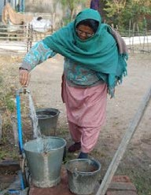
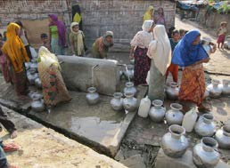

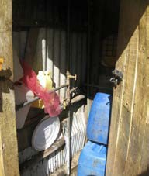
Annex 1 - Water source and sanitation facility definitions3

Protected/treated water source
Piped Water | This includes the two categories below and refers to water piped to the premises:
Piped water into house | Also called a household connection, is defined as a water service pipe connected with in-house plumbing to one or more taps (e.g. in the kitchen and bathroom).
Piped water to the yard/ plot | Also called a yard connection, is defined as a piped water connection to a tap placed in the yard or plot outside the house.
Public tap or standpipe | This is a public water point from which people can collect water. A standpipe is also known as a public fountain or public tap. Public standpipes can have one or more taps and are typically made of brickwork, masonry or concrete.

- Adapted from: WHO and UNICEF (2006) Core Questions on Drinking Water and Sanitation for household surveys; WHO Geneva

Handpump/Borehole | This is a deep hole that has been driven, bored or drilled, with the purpose of reaching groundwater supplies. Boreholes / tube wells are constructed with casing, or pipes, which prevent the small diameter hole from caving in and protect the water source from infiltration by run-off water. Water is delivered from a tube well or borehole through a pump, which may be powered by human, animal, wind, electric, diesel or solar means. Boreholes / tube wells are usually protected by a platform around the well, which leads spilled water away from the borehole and prevents infiltration of run-off water at the well-head.  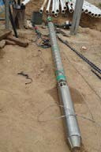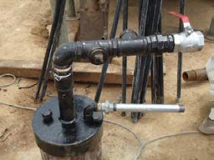  Submersible pump Borehole head  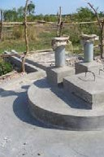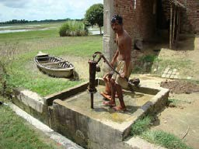  Double hand pump Hand pump
Protected dug well with hand pump | Is a dug well with a hand pump that is protected from runoff water by a well lining or casing that is raised above ground level and a platform that diverts spilled water away from the well. A protected dug well is also covered, so that bird droppings and animals cannot fall into the well.  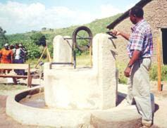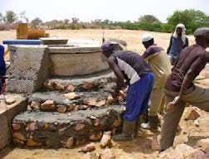  Protected hand dug well with hand pump Protected hand dug well

Protected spring | The spring is typically protected from runoff, bird droppings and animals by a “spring box”, which is constructed of brick, masonry, or concrete and is built around the spring so that water flows directly out of the box into a pipe or cistern, without being exposed to outside pollution.  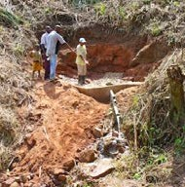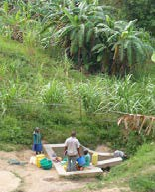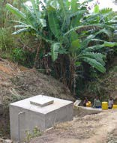  Protection of a spring Protected spring without Protected spring with  reservoir reservoir
Tanker trucks | Refers to chlorinated or treated water distributed using water tankers. The water must be subject to quality control measures.  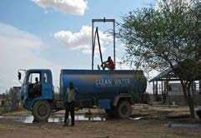
Small water vendor (cart with small tank or drum) | This refers to water sold by a provider who transports water into a community. The types of transportation used include donkey carts, motorized vehicles and other means.  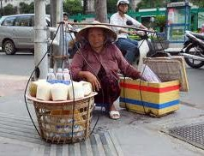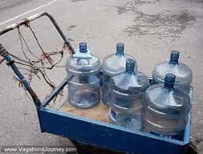

Un-protected / un-treated sources of drinking water
Unprotected spring | This is a spring that is subject to runoff, bird droppings, or the entry of animals. Unprotected springs typically do not have a “spring box”.  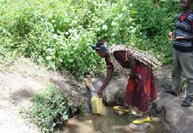
Unprotected hand dug well | This is a dug well for which one of the following conditions is true: 1) the well is not protected from runoff water; or 2) the well is not protected from bird droppings and animals. If at least one of these conditions is true, the well is unprotected.  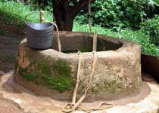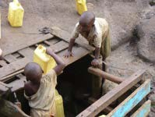
Surface water | Is water located above ground and includes rivers, dams, lakes, ponds, streams, canals, and irrigation channels.  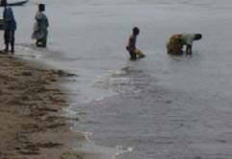

Rainwater collection | Rainwater harvesting from run off is to collect the rain falling on the ground in a pond, dam, reservoir, berkade. The water is usually used by animals and for irrigation.  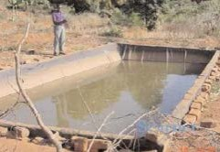  Refers to rain that is collected or harvested from surfaces (by roof or ground catchment) and stored in a container, tank or cistern until used.  Rainwater harvesting systems capture rain from building roofs and other catchment  Areas. They are often installed at the building level, collecting water from houses or public buildings such as schools or hospitals. The water is collected in tanks, drums, buckets, jerry cans until used.  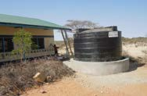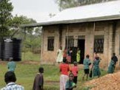  Rainwater harvesting in schools

Annex 2 - Water containers
- Adapt this work sheet with pictures from your own context and ask the surveyors to record the capacity of the containers in litres:

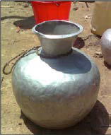  1. Aluminium pot (Large), 16 L, Carrying Water | 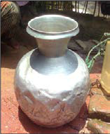  2. Aluminium pot (Medium), 14 L, Carrying Water | 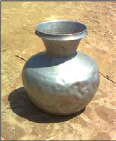  3. Aluminium pot (Small), 8 5 L, Carrying Water | 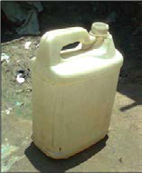  4. Plastic Jar,  5 L, Carrying water
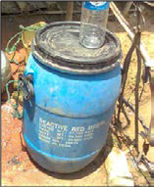  5. Plastic Drum, 50 L, Storing water | 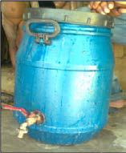  6. Plastic Drum with tap, 42 L, Storing Water | 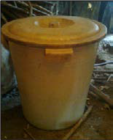  7. Plastic Pot, 42 L, Storing water | 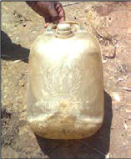  8. UNHCR Jar,  10 L, Carrying water
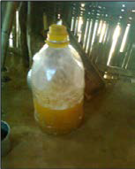  9. Plastic Can, 2 5 L, Domestic Use | 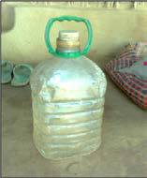  10. Plastic Can, 4 5 L, Domestic Use | 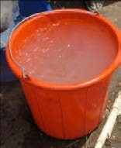  11. 15 L, Storing water | 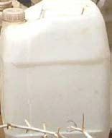  12. 10 L, Carrying water

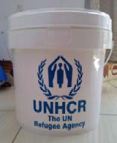
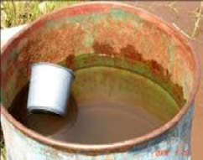
15. 200 L, Storing water

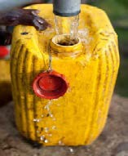

1.7 25 L, Carrying water

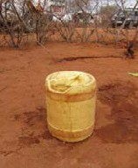
16. 20 L, Carrying water

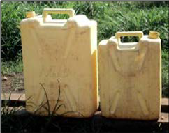
14. Large: 20 L, Carrying water Small: 10 L, Carrying water
13. 14 L, Storing water

Annex 3 - SENS WASH questionnaire

See SENS Pre-Module tools: [Tool 11- Full SENS questionnaire] and [Tool 12- Full SENS Questionnaire with Instructions].

No | QUESTION | ANSWER CODES
SECTION WS1: WASH interview questions
Note | THESE QUESTIONS NEED TO BE ASKED TO THE HEAD OF THE HOUSEHOLD OR, IF THEY ARE ABSENT, ANOTHER ADULT MEMBER OF THE HOUSEHOLD.
WS1 | Was consent given for conducting the interview?  ENSURE THAT YOU HAVE INTRODUCED THE TEAM AND INFORMED THEM ABOUT THE INTERVIEW. | Yes..................................................................................1  No...................................................................................2  Absent............................................................................3 | | | IF ANSWER IS 2 or 3 STOP HERE
 | WSCONST
WS2 | What is the total number of household numbers?  RECORD NUMBER.  HHSIZE |  | | | |
WS3 | What is the principal source of | Public tap/standpipe................................................01
 | drinking water for members of | Handpumps/boreholes.........................................02 | | | |
 | your household? | Water seller/kiosks...............................................03
 |  | Piped connection to house (or neighbour’s
 | SELECT ONE BUT DO NOT | house)...................................................................04
 | PROMPT WITH RESPONSES. | Protected spring...................................................05
 | CONSIDER DRINKING WATER | Bottled water, water sachets...................................06
 | ONLY. | Tanker trucks........................................................07
 |  | Unprotected hand-dug well.....................................08
 |  | Surface water (lake, pond, dam, river)....................09
 |  | Unprotected spring.................................................10
 |  | Rain water collection...................................................11
 |  | Other....................................................................96
 | SOURCE | Don’t know..........................................................98
WS4 | Where do you and your household | Household latrine..........................................................1
 | members (excluding children | Communal latrine......................................................2 | | |
 | under 5) usually go to defecate? | Open defecation....................................................3
 |  | Plastic bag..............................................................4
 | SELECT ONE BUT DO NOT | Bucket toilet...........................................................5
 | PROMPT WITH RESPONSES.  TOILET | Other.........................................................................6  Don’t know...............................................................8
SECTION WS2: WASH observation questions
Note | EXPLAIN TO THE RESPONDENT THAT THESE QUESTIONS RELATE TO WATER USED FOR DOMESTIC PURPOSES. THIS INCLUDES: DRINKING, COOKING/FOOD PREPARATION, BATHING, AND PERSONAL HYGIENE PLUS LAUNDRY AND OTHER HOUSEHOLD CLEANING. EXCLUDED FROM THIS ARE ANIMAL USE, BRICKMAKING OR OTHER INDUSTRY, OR AGRICULTURE/GARDENING (NON-DOMESTIC).
WS5 | Please show me the soap you have in the household.  SOAP | Presented within one minute...............................1  Not presented within one minute/no soap.........2 | | |

WS6 | How many containers do you have to collect or store water for domestic purposes for your house? Please show me all of them one by one  RECORD ONE BY ONE. CHECK FOR ALL OF THE CONTAINERS. DO NOT INCLUDE BROKEN, LEAKING, OR NON-FUNCTIONAL CONTAINERS.  Lower limit=0 Upper limit=25  CONTAINER |  | | | |
WS7 | What is the type of container? | Jerrycan................................................................01  Bucket..................................................................02 | | | |
 |  | Basin....................................................................03
 |  | Bottle...................................................................04
 |  | Saucepan.............................................................05
 |  | Drums..................................................................06
 | TYPE | Other....................................................................96
WS8 | What is the volume of container?  ENTER THE AMOUNT OF LITRES THIS CONTAINER CAN HOLD.  Lower limit=0.5L Upper limit=300.0L  LITER |  | | | | litres
WS9 | Is the container covered?  PROTECT | Yes.........................................................................1  No.........................................................................2  Don’t know...........................................................8 | | |
WS10 | Number of journeys made with container for the collection of water for domestic purposes yesterday? This includes all water collected morning, afternoon and evening.  PLEASE ENTER ‘0’ IF HOUSEHOLD DID NOT FILL IT YESTERDAY.  Lower limit=0 Upper limit=10  NUMTRIPS |  | | | | journeys
 | Interviewer: I confirm that questionnaire is complete: yes/no
Supervisor: I confirm that questionnaire is complete: yes/no

MESSAGE TO INTERVIEWER: DO NOT ANSWER THIS QUESTION.

Annex 4 - Training ideas

EXERCISES

Exercise 1: The questionnaire

- Divide participants into pairs and ask them to go through the questionnaire taking turns to be the respondent and the surveyor.

- Ask them to note any problem they have as they go along. Discuss in plenary.

Exercise 2: Determining the amount of water used

- Obtain samples of commonly used drinking water containers or compile photographs of the containers in a Word document.

- Show each container in turn and ask the participants to guess the capacity of each container, and correct or confirm their responses.

- Ask each person in turn the capacity of a specific container until you have been through them all several times and you think that everyone is confident in assessing the capacity of each container.

- In groups of 2 or 3 provide them with a set of pictures or containers for an imaginary household and ask them to practice filling in the questionnaire. They should invent the number of trips taken.

- The participants do not have to calculate the amount of litres per person per day for the survey but a competent group may want to try to work this out.

ROLE PLAYING

Role Play 1

- Divide the participants into pairs.

- The survey manager takes the role of the respondent and asks each team of two surveyors to use the questionnaire to ask him/her two to three questions.

- The survey manager uses this opportunity to identify the possible pitfalls highlighted in the box below (or identify issues that you think might be a problem in your context).

- After each question review the answer and discuss any problems identified such as poor communication or showing displeasure at a particular response.

- The exercise can be repeated with different participants asking different questions (see Table 14 for an example).

TABLE 14 EXERCISE

Question | Example responses from households | Expected response from surveyor
What is the main source of drinking water for members of your household?  (SELECT ONE) | We use the standpipe and the water from the river. | Make sure it is the drinking water source that is used the most.
Where do you and your household members (excluding children under 5) usually go to defecate?  (SELECT ONE) | My neighbour has a very nice toilet – a latrine in the house.  Sometimes my children use it but I don’t… | Does your household usually use this toilet facility?  Where do you and the other members of your household usually go to the toilet?

Role Play 2

- In groups of 3 ask the participants to invent a short realistic role-play to highlight some of the problems that might be encountered when using the observation questions. For example, showing displeasure when observing the dirty containers.

- Ask the participants to identify the problems in each role-play once it has been performed and clarify the correct procedure.

- Ensure that surveyors know when to ask their supervisor for help e.g. if they don’t know about the capacity of a container.

Role Play 3

- In groups of 4 ask the participants to practice asking the questions taking it in turns to be the respondent and the surveyor.

- Each surveyor should go through all of the questions and observations.

- The other members of the group should take notes and provide constructive feedback to each surveyor.

FIELD PRACTICE

- Interview teams will go to the field in a location where the survey will not be taking place.

- Teams will practice delivering the questionnaire to the household (3 questionnaires)

- Field practice will assist the survey manager and interview teams in identifying any additional difficulties that may present themselves when in the field.

TEST

- The questions in the training test show below can be used as a basis for the written or oral test but can be adapted according to circumstances.

- At least 5 questions should be given to the participants and participants should answer at least 3 out of 5 of the practical questions correctly to pass the test.

- The results of the test can help the survey manager to assess which of the surveyors will need more support in the field. The weaker surveyors can also be paired with stronger ones.

- The questions should be given out with a copy of the finalised questionnaire so that participants can refer to this.

TABLE 15 TRAINING TEST

WASH MODULE
PRACTICE
1. | What does the writing in capital letters on the questionnaire mean?  Answer: These are instructions for the surveyor and should not be read aloud.
2. | How do you observe how much water a household is using per day?  Answer: Ask to see all of the containers that were used to collect water yesterday. Record the container capacity. Record how many journeys were made with each container.
3. | How do you ensure that you do not bias the answers given by the respondent?  Answer: Do not show disgust or pleasure with any answer given but remain respectful and neu- tral. Do not read out the list of answers but wait for the respondent to answer. Read out the ques- tions exactly as they are written.
THEORY
1. | Why are you interested in knowing if people store their drinking water in a covered/protected container?  Answer: Covering water can help to prevent water contamination.

Annex 5 - Epi info Data Analysis

Below are the standard Epi Info codes to use for analysis.

Refer to the fictitious dataset available for practical purposes; Go to SENS WASH: [Tool 1-WS Data], and see the Excel database PIL_0919_WS_PILOT.

The practical Excel database PIL_0919_WS_PILOT is from a survey using cluster sampling.

DATA REVIEW

Run these commands (together or separately; regardless of the survey design) and make sure that the ranges and codes of the variables entered in the database match the standard questionnaire. This step can be omitted when using MDC surveys given that ranges and codes are pre-set, and that values outside of the pre- set ranges and codes cannot be entered during data collection.

FREQ WSCONST

For the below variables, only perform these checks on households having provided consent, i.e. SELECT WSCONST=1

MEANS HHSIZE (note that the range of household size should not exceed 30 in most refugee contexts; you should check that no obvious data entry errors occurred, e.g. entering 100 instead of 10)

FREQ SOURCE
FREQ TOILET
FREQ SOAP
FREQ CONTAINER
FREQ TYPE

MEANS LITER (note that this number can be quite high for some households in some refugee contexts like 200-300 litres, however it is rare; you should check that no obvious data entry errors occurred, e.g. entering 1000 instead of 100)

FREQ PROTECT
FREQ NUMTRIPS

You should check the missing data in your database and double-check that this was not a data entry oversight. The commands below need to be run separately, one by one. After selecting the variable using the code shown below, use the LIST command to view the specific records with missing data and double-check with the original data collection questionnaire. Then cancel the selected variable by typing SELECT and proceed with checking another variable.

SELECT HHSIZE=(.)
SELECT (this will cancel the selected variable)
SELECT SOURCE=(.)

SELECT TOILET=(.)

SELECT SOAP=(.)

SELECT CONTAINER=(.)

SELECT TYPE=(.)

SELECT LITER=(.) (note that data can be missing for households having borrowed containers to collect water or households not having collected water yesterday)

SELECT PROTECT=(.)

SELECT NUMTRIPS=(.)

DATA ANALYSIS

Results from the practical dataset entitled PIL_0919_WS_PILOT (cluster sampling survey) are illustrated below. Refer to the SENS Pre-Module Annex 4 for detailed explanations on how to interpret Epi-info analysis outputs when using different survey designs.

WASH SAMPLING INFORMATION

Household data | Planned | Actual | % of target
Total households surveyed for WASH | 319 | 317 | 99.4%

Actual number of households surveyed and % of target

FREQ WSCONST

WSCONST | Frequency | Percent | Cum. Percent
1 | 317 | 99,37% | 99,38%
3 | 2 | 0,63% | 100,00%
Total | 319 | 100,00% | 100,00%

Wilson 95% Conf Limits

1 | 97,75% | 99,83%
3 | 0,17% | 2,25%

WATER QUALITY ANALYSIS

 | Number/total | % (95% CI)
Proportion of households collecting drinking water from protected/treated sources | 317/317 | 100.0%
Proportion of households with at least 10 litres/person drinking water storage capacity | 128/317 | 40.4% (32.3-48.4)

Drinking water from protected/treated sources

DEFINE SOURCE_c

RECODE SOURCE TO SOURCE_c
1 - 7 = "protected/treated"
8 - 13 = "un-protected/un-treated"
96 = "un-protected/un-treated"
END

SELECT WSCONST=1

FREQ SOURCE_c PSUVAR=CLUSTER

If you are analysing a simple random survey, the code is as follows:

FREQ SOURCE_c

SOURCE_C | TOTAL
protected/ treated | 317
Row % | 100,000
Col % | 100,000
SE % | 0,000
LCL % | 100,000
UCL % | 100,000
TOTAL | 317
Design Effect | -1,00

SELECT (this will cancel the selected variable(s); only to be executed after the analysis is done and the results recorded).

Drinking water storage capacity

DEFINE STORAGE_c

RECODE STORAGE TO STORAGE_c
LOVALUE - 9.9 = "9.9 litres or less"
10.0 - HIVALUE = "10 or over 10 litres"
END

SELECT WSCONST=1

FREQ STORAGE_c PSUVAR=CLUSTER

If you are analysing a simple random survey, the code is as follows:

FREQ STORAGE_c

STORAGE_C | TOTAL
10 or over  10 litres | 128
Row % | 100.000
Col % | 40.379
SE % | 3.997
LCL % | 32.328
UCL % | 48.429
9.9 litres or less | 189
Row % | 100.000
Col % | 59.621
SE % | 3.997
LCL % | 51.571
UCL % | 67.672
TOTAL | 317
Design Effect | 2.097

SELECT (this will cancel the selected variable(s); only to be executed after the analysis is done and the results recorded).

WATER QUANTITY ANALYSIS

WATER QUANTITY 1 : AMOUNT OF LITRES OF WATER USED PER PERSON PER DAY

 | Mean (95% CI)
Average # L/p/d of domestic water collected at household level, | 31.1
from protected/treated sources with containers of any type | (25.5-36.8)
Average # L/p/d of domestic water collected at household level, | 19.7
from protected/treated sources with protected containers only | (15.6-23.8)

Average # L/p/d of domestic water collected at household level, from protected/treated sources with containers of any type

SELECT WSCONST=1

MEANS POTABLE PSUVAR=CLUSTER

If you are analysing a simple random survey, the code is as follows:

MEANS POTABLE

 | POTABLE
 | Count | Mean | Std Error | Confidence Limits |  | Minimum | Maximum
 |  |  |  | Lower | Upper
TOTAL | 317 | 31,140 | 2,795 | 25,512 | 36,769 | 0,000 | 285,000

SELECT (this will cancel the selected variable(s); only to be executed after the analysis is done and the results recorded).

Average # L/p/d of domestic water collected at household level, from protected/treated sources with protected container only

SELECT WSCONST=1

MEANS POTAPROT PSUVAR=CLUSTER

If you are analysing a simple random survey, the code is as follows: MEANS POTAPROT
 | POTAPROT
 | Count | Mean | Std Error | Confidence Limits |  | Minimum | Maximum
 |  |  |  | Lower | Upper
TOTAL | 317 | 19,731 | 2,035 | 15,632 | 23,829 | 0,000 | 285,000

SELECT (this will cancel the selected variable(s); only to be executed after the analysis is done and the results recorded).
45

WATER QUANTITY 2 : AMOUNT OF LITRES OF WATER USED PER PERSON PER DAY BY CATEGORY

Proportion of households that use domestic water col- lected from protected/treated sources with protected containers only: | Number/total | % (95% CI)
≥ 20 lpppd | 103/317 | 32.5% (25.6-39.4)
15-<20 lpppd | 23/317 | 7.3% (4.6-10.0)
<15 lpppd | 191/317 | 60.2% (53.2-67.3)

Water quantity (lpppd)

DEFINE LPPPD_c

RECODE POTAPROT TO LPPPD_c
LOVALUE - 14.99 = "<15"
15 - 19.99 = "15-<20"
20 - HIVALUE = ">=20"
END

SELECT WSCONST=1

FREQ LPPPD_c PSUVAR=CLUSTER

If you are analysing a simple random survey, the code is as follows: FREQ LPPPD_c

LPPPD_C | TOTAL
<15 | 191
Row % | 100.000
Col % | 60.252
SE % | 3.514
LCL % | 53.174
UCL % | 67.330
>=20 | 103
Row % | 100 000
Col % | 32.492
SE % | 3.426
LCL % | 25.592
UCL % | 39.392
15-<20 | 23
Row % | 100.000
Col % | 7.256
SE % | 1.343
LCL % | 4.550
UCL % | 9.961
TOTAL | 317
Design Effect | 1.630

SELECT (this will cancel the selected variable(s); only to be executed after the analysis is done and the results recorded).

ACCESS TO SOAP

 | Number/total | % (95% CI)
Proportion of households with access to soap | 242/317 | 76.3% (68.8-83.9)

SELECT WSCONST=1

FREQ SOAP PSUVAR=CLUSTER

If you are analysing a simple random survey, the code is as follows:

FREQ SOAP
SOAP | TOTAL
1 | 242
Row % | 100,000
Col % | 76,341
SE % | 3,754
LCL % | 68,780
UCL % | 83,901
2 | 75
Row % | 100,000
Col % | 23,659
SE % | 3,754
LCL % | 16,099
UCL % | 31,220
TOTAL | 317
Design Effect | 2,47

SELECT (this will cancel the selected variable(s); only to be executed after the analysis is done and the results recorded).

TOILET / LATRINE USE

 | Number/total | % (95% CI)
Proportion of households reporting defecating in a toilet | 314/317 | 99.1% (98.0-100.0)

DEFINE TOILET_c

RECODE TOILET TO TOILET_c
1 - 2 = "toilet category"
3 - 6 = "not toilet category"
8 = "not toilet category"
END

SELECT WSCONST=1

FREQ TOILET_c PSUVAR=CLUSTER

If you are analysing a simple random survey, the code is as follows:

FREQ TOILET_c
TOILET_C | TOTAL
not toilet category | 3
Row % | 100,000
Col % | 0,946
SE % | 0,535
LCL % | -0,132
UCL % | 2,025
toilet category | 314
Row % | 100,000
Col % | 99,054
SE % | 0,535
LCL % | 97,975
UCL % | 100,132
TOTAL | 317
Design Effect | 0,97

SELECT (this will cancel the selected variable(s); only to be executed after the analysis is done and the results recorded).

MODULE 7: WATER, SANITATION AND HYGIENE (WASH)

53

UNHCR STANDARDISED EXPANDED NUTRITION SURVEY (SENS) GUIDELINES FOR REFUGEE POPULATIONS

54

UNHCR
STANDARDISED EXPANDED
NUTRITION SURVEY (SENS) GUIDELINES FOR REFUGEE POPULATIONS

MODULE 7:
WATER, SANITATION AND HYGIENE (WASH)

