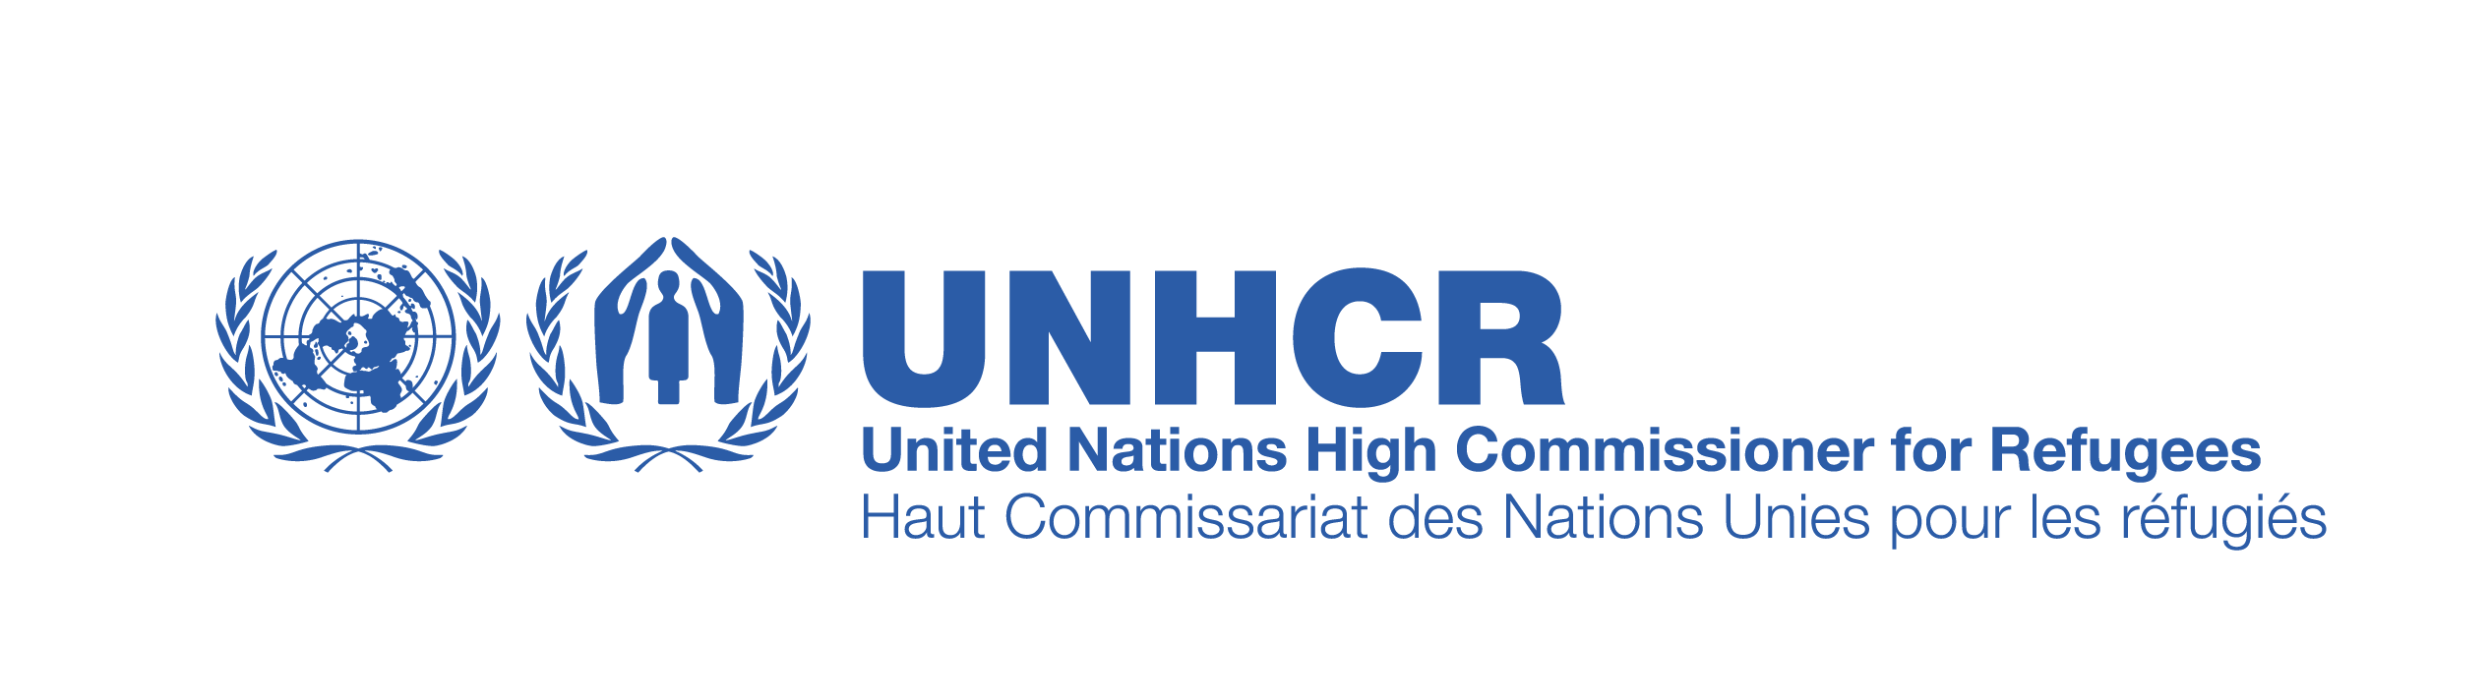
Annex E

Frequently Asked Questions: UNHCR 2020 Call for Expression of Interest

- Why is there a new partner selection and retention policy?
In July 2013, UNHCR launched a new global policy establishing a standard procedure in order to enhance transparency of selection of partners. The objective of UNHCR’s policy on the selection and retention of partners for Partnership Agreements is to ensure that UNHCR identifies the best-fit partners for project implementation in a given operation, in order to provide quality protection and assistance to refugees and other persons of concern. UNHCR Offices, through a multi-functional team approach, are required to undertake adequate due diligence and conduct the process of selection/retention of Implementing Partner(s) in an objective, consistent, transparent and timely manner. Additionally, this policy and procedures incorporates close consultations with partners at the global level, as well as the outcome of piloting in several countries worldwide.

- Is the Call for Expression of Interest (CEOI) open to all organizations?
The CEOI applies to all current/past organizations, national/international non-governmental organizations (INGOs and NGOs). Red Cross and Red Crescent Society or other non-profit entities are eligible to apply to this CEOI. This CEOI does not apply to private companies, Government and/or UN organizations.

- Is registration with the Government of Syria a pre-condition for selection of partners?
Yes. The Government of Syria’s Ministry of Foreign Affairs requires registration of both national and international NGOs. NGOs are responsible for securing government requirements for registration and operation in the country.

- Is registration with UNHCR Headquarters a pre-condition for selection of partners?
Prospective partners that are not registered with UNHCR Headquarters (not having previous experience with UNHCR either in Syria or worldwide) will be required to declare that their organization meets the basic compatibility eligibility criteria for establishing partnership with UNHCR and can open a bank account locally. Only then can the organization be considered for selection for a Partnership Agreement. This can be done by filling the “Partner Declaration” form, available as Annex C to this EOI and by registering on UNHCR’s Partners’ Portal at https://www.unpartnerportal.org/landing/index.html. Since this is a lengthy process, organizations interested in partnering with UNHCR are encouraged to initiate this process at the earliest possible.

- Are all the partners required to complete and sign the Partner Declaration form?
No. The Partner Declaration form is to be submitted only by the new partners who have not worked with UNHCR globally previously.

- What should the Concept Note cover and how is it different from a fully developed project proposal?
The Concept Note is for the organization to express its unique advantage and added value in accomplishing project objectives. The Concept Note is to clearly spell out objectives for undertaking the project, describe the implementation approach, expected outputs, and demonstrate abilities to meet the selection criteria and project requirements, the unique advantage the organization brings to the partnership, and its complementarity with UNHCR. Once accepted, it is important that the selected partner participates in the design and detailed budgeting of the project and in concluding the Project Partnership Agreement. Therefore, the Concept Note should not be a fully developed project proposal, but rather should be concise and contain clear information, not exceeding 5 pages.

- Should organizations strictly follow the format proposed by UNHCR when submitting concept notes?
Yes. All partners are required to submit Concept Notes to the UNHCR Office according to the same standard submission format required by the Office to ensure fair assessment, consistency and objectivity.

- Are current UNHCR implementing partners required to submit a Concept Note if they want to continue working with UNHCR in 2020?

Yes, current implementing partners are also required to present a Concept Note if they want to be considered for a partnership in 2020.

- Who will select/clear the Concept Notes submitted by organizations?
UNHCR has established an Implementing Partnership Management Committee (IPMC), which will review and evaluate all Concept Notes. The IPMC will submit its recommendations to the UNHCR Representative in Damascus for final endorsement.

- What are the IPMC’s selection criteria?
Please refer to the Call for Expression of Interest document (Annex B) which provides the detailed selection criteria. In addition, the IPMC will be assessing each Concept Note against available information including screen and verify the information provided by the applicant partner(s), internal technical and risk assessments (as applicable) for specific sectors conducted by the various units of UNHCR, previous performance/audit reports (if available), reference checks, web search, confirmation of legal status and registrations. If it is deemed necessary to undertake such assessment, visit to the partner’s office is possible to facilitate the selection process.

The IPMC will then consider all factors to identify the partner that most substantially conforms to the requirements and criteria mentioned above.
- When will UNHCR’s decision on selection be communicated?
UNHCR will communicate in writing the outcome of the selection process during the week of 03 September 2019 to all applicant organizations – both the successful as well as the non-successful.

- What is the meaning of selection?

The selection entails that the NGO will be retained as a UNHCR partner in 2020. The selection however, is not a commitment by UNHCR to fund the NGO to the amount submitted by the NGO in the Concept Note. The funding to be received by UNHCR will be subject to receiving a full-fledged project proposal and the related discussions around this submission.

- Once a partner is selected, will the partner have to participate in Calls for Expression of Interest(s) every year?
While the selection of a partner is for a period of two UNHCR program cycles, prior to entering into the second year Project Partnership Agreement, a desk review by UNHCR’s Program Section (or other designated section) is to be conducted to ensure that the operation requires retention and the partner performance is adequate. If the desk review determines that the partner should not be retained, the matter shall be referred to the IPMC. Upon recommendation of the Committee, the Head of Office may decide not to retain the partner. Such decision will be communicated in writing to the partner, in advance. If the desk review concludes that the partner should be retained, the Office can proceed with signing a new Partnership Agreement with the same partner.

- Once partners are selected, what are the next steps?
Once the selection process is completed and decisions communicated to all applicant organizations, all selected partners will be requested to provide detailed project proposals for the 2020 implementation period. These detailed proposals should be discussed with the relevant UNHCR office in Damascus (for partners selected in multiple locations), Aleppo, Qamishly, Homs, Sweida and Tartous to jointly develop and agree on the various aspects of the partnership.

- In instances of queries relating to the Project or the Concept Note, what are the UNHCR contacts?
You can contact the Program Section of UNHCR Damascus at: syrdaxoi@unhcr.org.

