Annex A to RFQ UKRKI / RFQ / 2021-123, procurement of medical equipment and machinery

Attention! The pictures in this specification are provided as examples for explanation of product requirements. UNHCR does not require suppliers of identical goods.

LOT 1 | The required amount
Reinforced wheelchair | 2 pcs
Specifications (Recommended by WHO)
Type: indoor and outdoor
Seat and back material: nylon
Frame material: steel
Seat width (cm): 66
Overall width (cm): 86
Folded width (cm): 32
Seat depth, (cm): 46
Seat height from floor, (cm): 49
Back height, (cm): 45
Backrest adjustment: non-adjustable
Armrests: removable
Footrests: removable-folding
Wheel type: cast
Front tires, (inch): 7
Rear tires, (inch): 24 x 1 3/8
Weight, (kg): 25
Maximum load, (kg): 300
Approximate view:
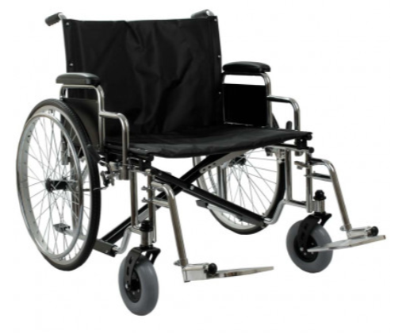

LOT 2 | The required amount
Water storage tank | 1 pcs
Specifications
Volume: 500 l
Type: Vertical
Body Material: Plastic
Diameter: 630 - 710 mm
Height: 1450 - 1760 mm
Sight hole diameter: 300 - 350 mm
The ability to connect to the water supply system from above and below - available
Approximate view:
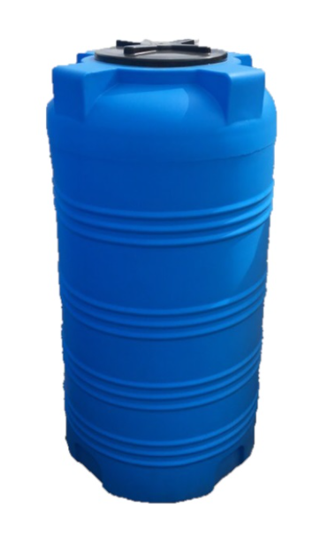
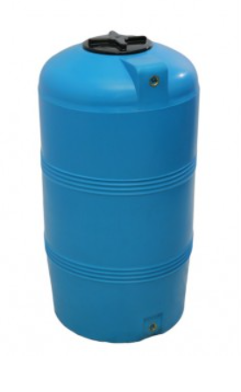

LOT 3 |  |  | The required amount
High pressure washer and watering hoses with quick-release couplings
Specifications
3.1 | High pressure washer | Engine type: electric  Engine power, kW: 2.2 - 2.6  Wheels: Yes  Productivity, l / hour: 420-470  Max. working pressure, bar: 150 - 170  Hose length, m: 6 - 8  Cable length, m: 3 (or more)  Pistol: Yes  Filter: Yes  Built-in detergent tank: Yes  Ability to draw water from barrels: Yes  Hose reel: Yes | 2 pcs
3.2 | Watering hoses with quick-release couplings | Length - 40 - 50 meters Connection type - Quick release (the proposed version of the watering hose with quick-release couplings must be suitable for the proposed high-pressure washing | 2 pcs
Approximate view:
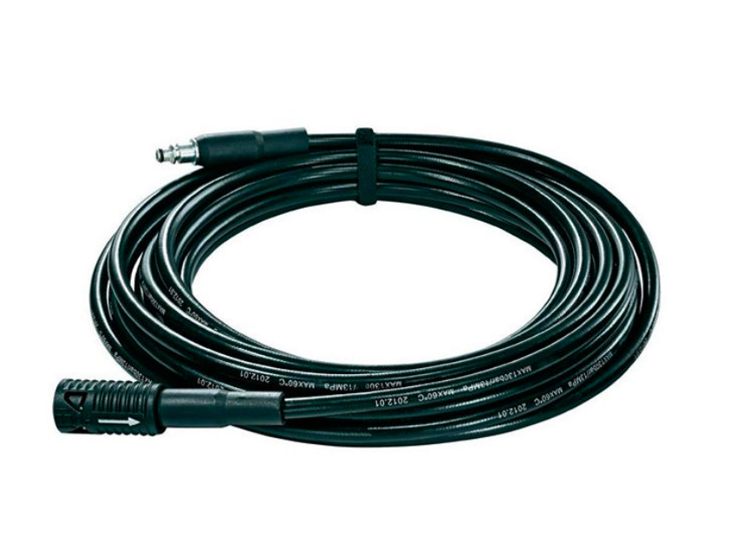
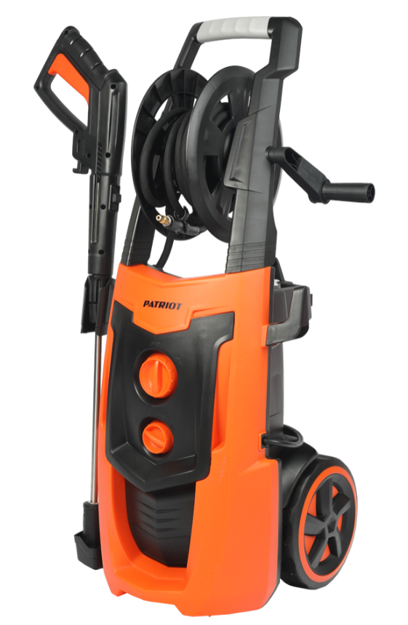

LOT 4 |  |  | The required amount
First aid kit
Specifications
4 | First aid kit «HoReCa» -Variant №2 | The first-aid kit for "HoReCa" Option No. 2 includes:  - The tire is flexible to the sample  - SAM Splint 90 cm (China) 1 pcs  - Film-valve for CPR "Paramedic" 3 pcs  - Hydrogel anti-burn Burnshield 125 ml 1 pcs  - Plastospray - liquid adhesive plaster 1 pcs  - Respiratory mask type CPR 1 pcs  - Spray cold (freezing) 400 ml 1 pcs  - Non-sterile gauze bandage 7m x 14cm 5 pcs  - Sterile gauze bandage 7m x 14cm 5 pcs  - Non-sterile gauze bandage 5 mx 10 cm 5 pcs  - Sterile gauze bandage 5 mx 10 cm 5 pcs  - Elastic bandage 2 pcs  - Triangular gusset plate 2 pcs  - Harness Esmarch 2 pcs  - Antiseptic napkin "Paramedic" 10 pcs  - Medical paramedic gloves, size L 5 pcs  - Sterile gauze napkin in packing 16x14 cm 1 pcs  - Medical plaster 2 cm x 500 cm 5 pcs  - Bactericidal plaster 2.5 x 7.6  - Paramedic scissors 1 pcs  - Hydrogen peroxide spray 50 ml 1 pcs  - Pharmacy bag KEMP Royal Responder Bag 1 pcs | 3 pcs
Approximate view:
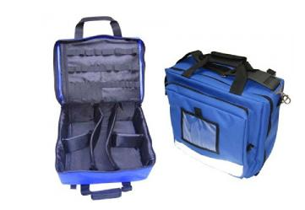

LOT 5 |  |  | The required amount | Approximate view:
Portable pulse oximeter, Automated tonometer, Glucometer,Test strips - Gmate Life, Finger lancing device (scarifier)
Specifications (Recommended by WHO)
5.1 | Portable pulse oximeter | 1) Saturation measurement level: 70% - 99%.  2) Heart rate measurement error: 1% or less 3) Pulse rate detection to include the range: 30–240 bpm.  4) Pulse rate resolution: 1 bpm or less. | 3 pcs
5.2 | Automated tonometer | Pressure measurement range: 0-299 mmHg, pulse rate: 40-180 beats / min.  Limit measurement error pressure: no more than 3 mm Hg, pulse rate: no more than 5%  Clinically Proven: Yes, IP  Cuff included: New generation universal compression cuff for arms with an upper arm circumference of 22 to 42 cm.  The ability to use a large cuff (32-42 cm): Yes  Possibility of using a children's cuff (17-22 cm): Yes  Air blowing: automatic by electric air compressor  Air release: automatic | 3 pcs
5.3 | Glucometer | software compensation of the patient's hematocrit level;  multi-pulse system for monitoring the reaction of the enzyme solution;  automatic linearity correction;  automatic correction of "oxygen" corrections.  automatic encoding;  underfilling blood detector;  time to get the result - no more than 5 seconds;  no chip, coding or calibration required; | 3 pcs
5.4 | Test strips | Measurement method - Electrochemical  Measurement time - from 3 to 5 sec.  Sample volume - up to 0.4 μl  Measurement range 0.6 - 33.3 mmol / l  The analyzed indicator is glucose | 6 sets
5.5 | Finger lancing device (scarifier) | Type: spear;  Material: stainless steel;  Sterile, pyrogen-free, non-toxic;  Designed for single use;  Individual packing; | 300 pcs | 