Annex A
Leased Areas and Internal Parking Spaces

Layout of the premise on 2nd floor
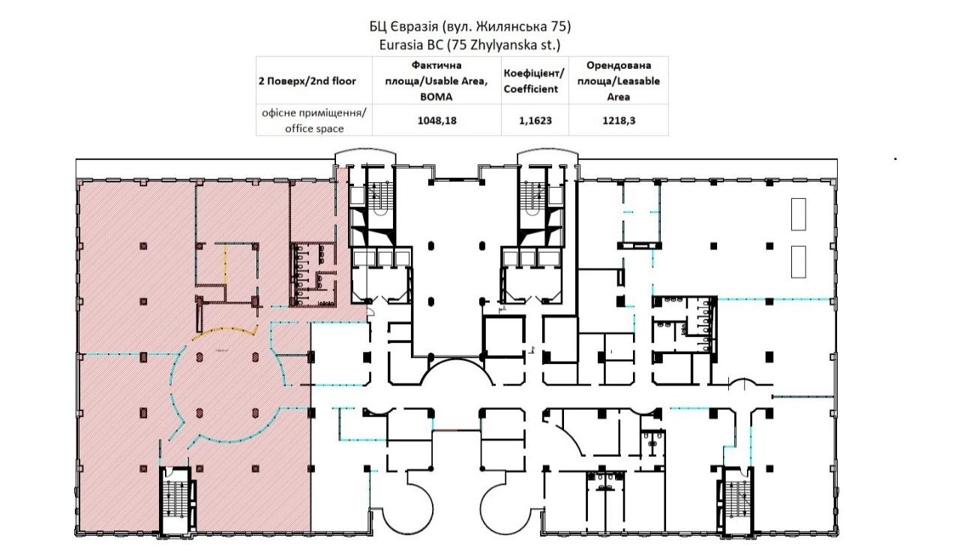
Layout of the premise on 3rd floor
