UKRDN/RFQ 2023-137

ANNEX A1 – Technical Specifications

QUANTITY OF PRODUCTS

SN # | MATERIAL Description | Measurement Unit | *Total Quantity
1 | Reflective insulation screen (550…600 x 5000 mm) | pcs | 6 000
2 | Polyethylene membrane for construction (4000 x 5000 mm) | pcs | 3 000
3 | Double-sided adhesive tape | pcs | 6 000
4 | Construction tape | pcs | 3 000
5 | Masking tape | pcs | 3 000
6 | Polyurethane foam stripes | pcs | 60 000
7 | Bag | pcs | 3 000

*The total quantity stated in the above table is 3,000 kits.

UNHCR requests to submit quality certificates for each item requested.

UNHCR will only accept items with the exact same specifications as stated below.
If an awarded bidder in their bid confirms that they would deliver the items as per the below specifications, but during the implementation of the frame agreement, they cannot deliver the awarded items with the exact same specifications as stated below, such deliveries will be rejected without any financial compensation to the awarded bidder; if the awarded bidder repeatedly (3 times) fails to deliver the awarded items with the exact same specifications as stated below, the frame agreement will be terminated.

SPECIFICATIONS

Reflective insulation screen
Size: 550…600mm x 5000mm;  Reflective material: Aluminum foil;  Base material: PPE;  Type: foiling on one side;  Roll height: 550…600mm;  Thickness: not less than 3…4 mm; | 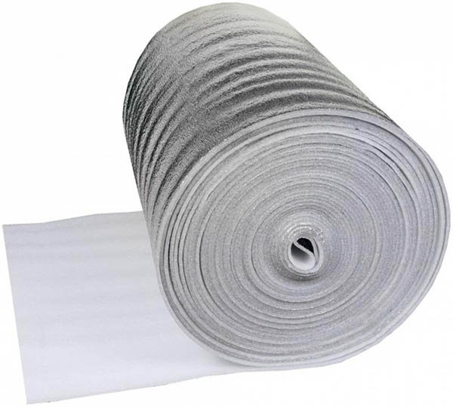  Example image

Polyethylene membrane for construction
Size: 4,000mm x 5,000mm  Material: Polyethylene;  Type: Protective, single-layer;  Color: Transperent;  Density: Not less than 48 microns; | 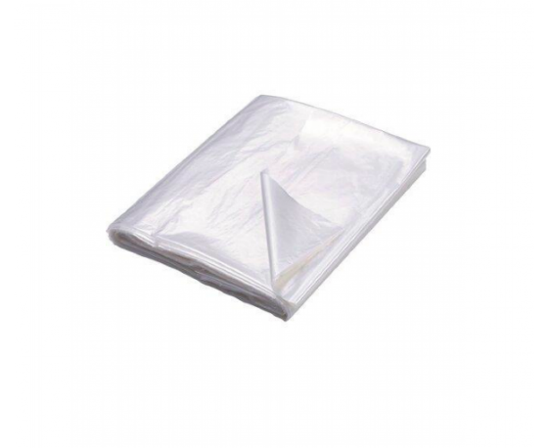  Example image

Double-sided adhesive tape
Size per piece: Width - not less than 15mm;  Length – not less than 10m;  Material: Foamed base;  Type: Double-sided adhesive backing; | 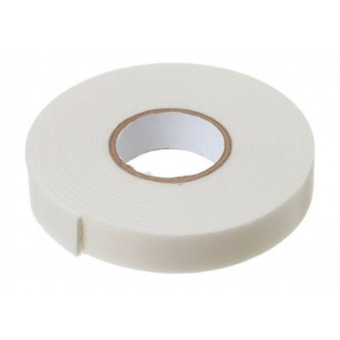  Example image

Construction tape
Size: Not less than 40mm x 50,000mm  Material: Aluminum foil;  Application temperature: From +10 to +40 °C;  Operating temperature: From -40 to +200 °C; | 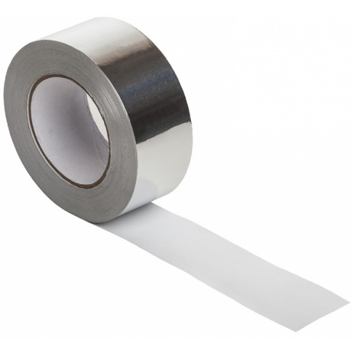  Example image

Masking tape
Size: Not less than 40mm x 40,000mm  Type: Masking tape; | 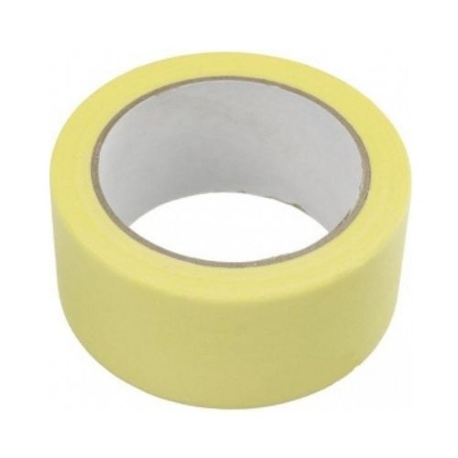  Example image

Polyurethane foam stripes
Size: Not less than 20mm x 20mm x 2m  Type: Polyurethane foam stripes;  Density - not less than 20 kg/cubic | 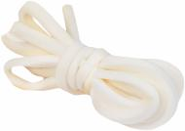  Example image

Bag
Material for bag: Polypropylene  Material for Handle: Belt braid textile, 250 microns (double 2 x 125 microns)  Model: Rectangular bag, zip  Dimensions:  Width 60cm * Height 50cm * Depth 40cm  Colors:  Color of the bag - white, color of the handle - blue | 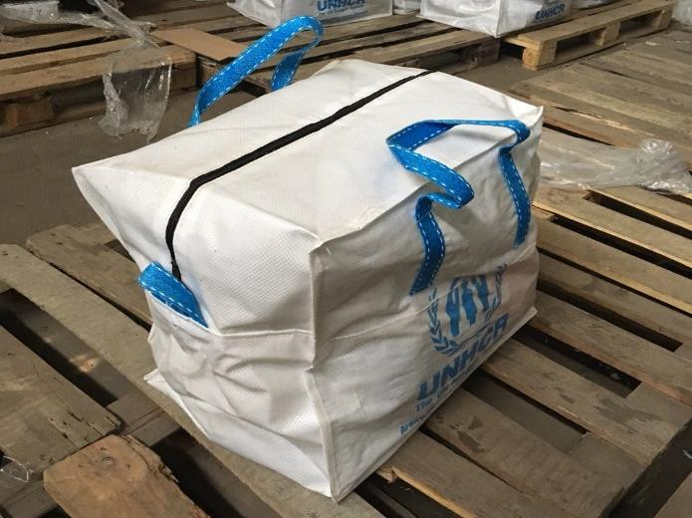  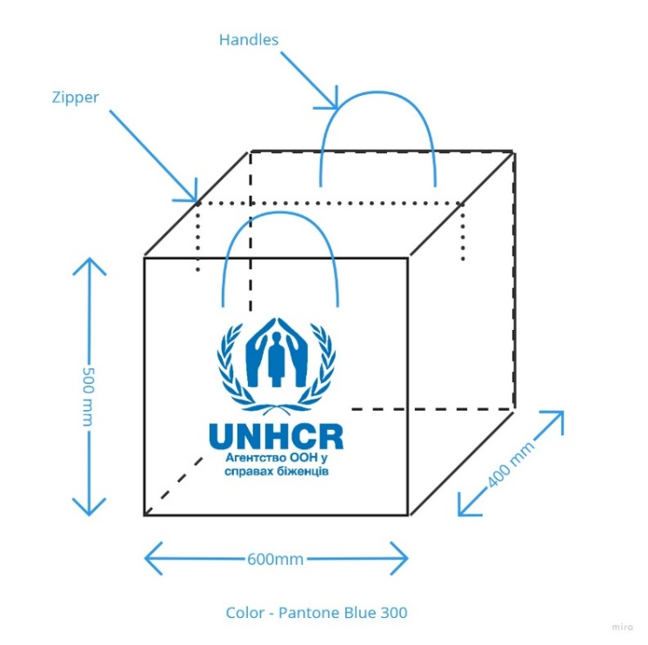
Branding:

Print logo on both sides. The logo must be inserted / printed / hot-stamped in accordance with the above scheme.
Typeface (Font), Color specifications for printing:
Font: Helvetica Bold.
Color specification: Pantone Blue 300 or quadrichrome (CMYK). C = 100%, M = 45%, Y
= 0%, K = 0%

